**Section 37: YelpCamp: Campgrounds CRUD**

387. Introducing YelpCamp: Our Massive Project

388. How to Access YelpCamp Code

389. Creating the Basic Express App

390. Campground Model Basics

391. Seeding Campgrounds

392. Campground Index

393. Campground Show

394. Campground New & Create

* I'm going to group things under campground.



* So if I have multiple campground square brackets, something else, title location, when our data is sent via post request to our express app to the server, everything in the request,
* our body will be stored under campground object, name=”campground[title]”.
* So this is just a dice thing that we can do to group content together.
* ‘req.body’ => body{campground{title: …, …}}
* 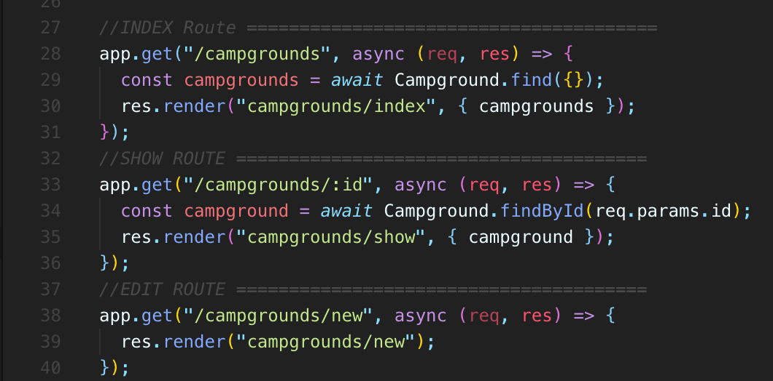
* Can you figure out what's going wrong?
* **We have that route.**
* The problem is the order because we have an app.get (campground/:id) earlier
* **‘app.get(campground/new) well, it's treating the new as the ID**.
* **So we're hitting this route and it can't find anything with the “id” of “new”.**
* **So order does matter here.**

395. Campground Edit & Update

396. Campground Delete

**Section 39: YelpCamp: Adding Basic Styles**

405. A New EJS Tool For Layouts

* There is a package called ejs-mate and ejs-mate allows us to basically add in some fun, useful pieces of functionality to.
* **And then when we care about is something called layout.**
* **So layout is going to allow us to define some boilerplates where we can have code that we insert in between some content.**
* 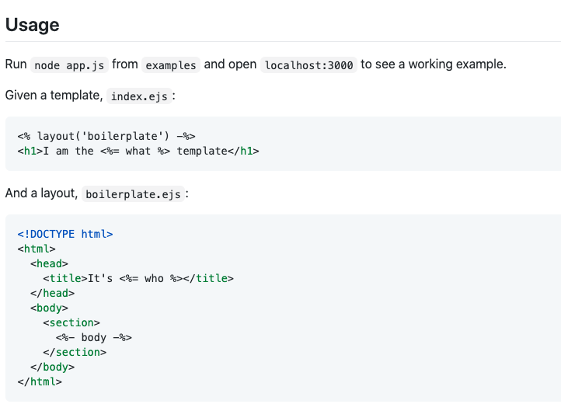
* So what we've seen so far as I can define a partial and I can have a partial for this stuff, we could call it head
* and then I can have a partial for the bottom stuff called footer or something, and then I have to include both of them on my template.
* And that's kind of annoying.
* It's not ideal.
* What I can do instead,
* if I use this package is **I can define a basic boilerplate template that basically everything will use or optionally everything could use**.
* **And it's going to just have a little variable in the middle.**
* **It's called body and I can dynamically add content in there where that body is**
* So this is just one of many engines that are used to run or pass and basically make sense of ejs an we need to tell Express that's the one we want to use instead of the default one it's relying on.
* We should just be able to access our content like normal.
* 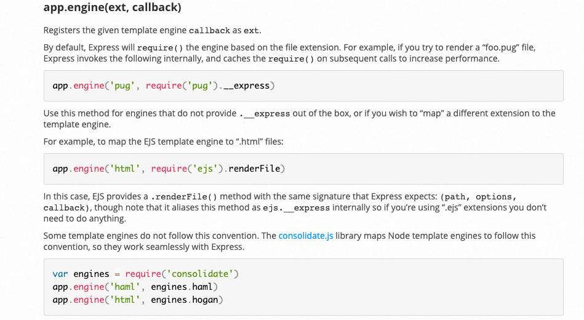
* Nothing has changed.
* It's still just regular old ejs
* **But now I can define a layout file.**
* **So in my view directory, I'm actually going to define a new folder called Layouts.**
* **And then in there I'll add a boilerplate .ejs and this will be my basic boilerplate for every single page.**
* 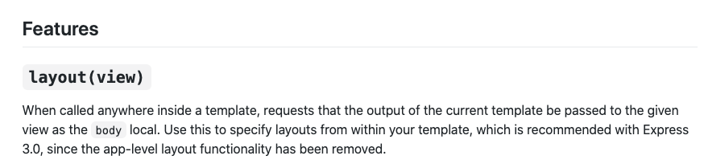
* So I'm going to put some content up top that just says, you know, before and then at the bottom another I'm going to delete all of this
* , but another one at the bottom that says after.
* And then here's how this works right here.
* I use this tag to say body and it does need to be body.
* I have to reference body.

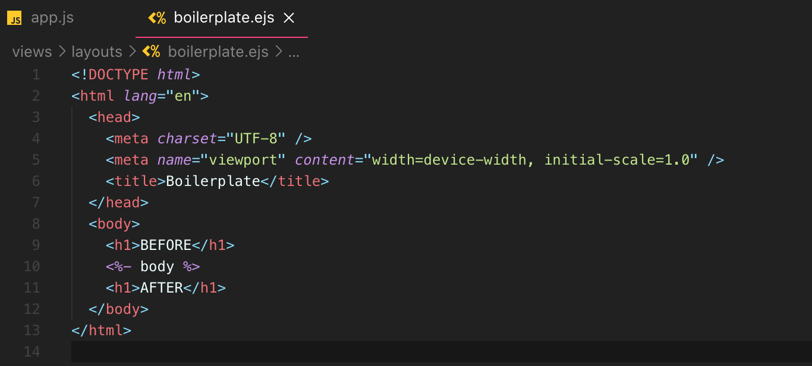

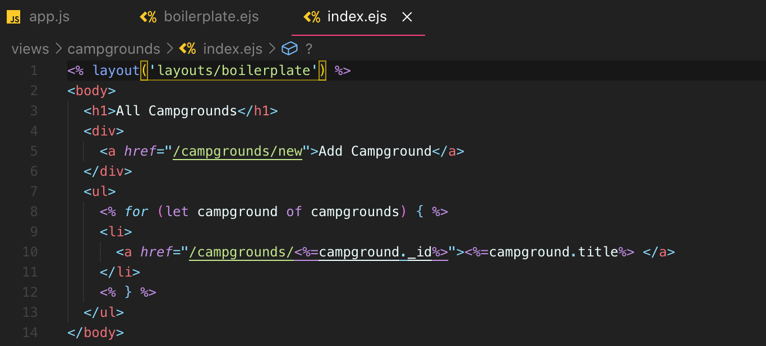

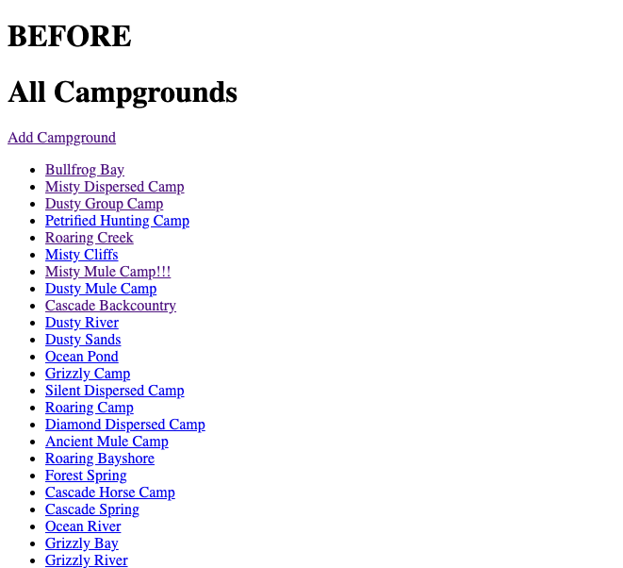

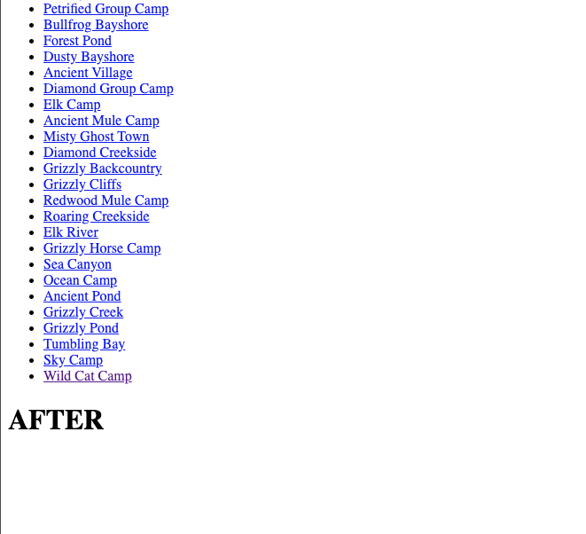

* And you can see this line here whenever I call **‘layout’**, which is what we'll do on the other side of things.
* It requests that the output of the current template be passed to the given view as the body local.
* Now, I'm going to go into one of my templates, like the index page for campgrounds and I'm going to get rid of almost all of this stuff.
* Because the way that I'm going to use this now is I'm going to pass this through to our ‘layout’, so that looks like this right here, layout function.
* And then to get to ‘layout/boilerplate’,
* All of this content will be passed to our boilerplate template as body and it will be inserted right
* So we now are successfully injecting our content in this layout.
* this is great because now it can do things like include my stylesheets, include my JavaScript, whatever else I want, and have a common layout.
* And I only need to include let's say I want to nav bar.
* I only need to include that partial in one place, my layout, my boilerplate ejs file.
* So I'm going to quickly update my other templates to use that.
* So you've got edit get rid of all of this.
* Just like that's new, same thing.
* I just have the plain old content in here, and then I have this layout which is looking for everything in this templates to pass that through as body to our boilerplate.
* That's new edit and show.
* Get rid of all of that.
* Let's see if it works.
* So at a campground before and after show page before and after edits before and after. of course, we don't want an before and after we get rid of that.
* But now, if I want to make changes to any of that stuff that's common to every page, I have one place to do it right here.
* So no longer one before and after.
* But I do want it to go in the body right between opening and closing body tags.
* I'll inject the content in there and then I can put things like a knife bar up top, which is actually
* what we're about to do.
* 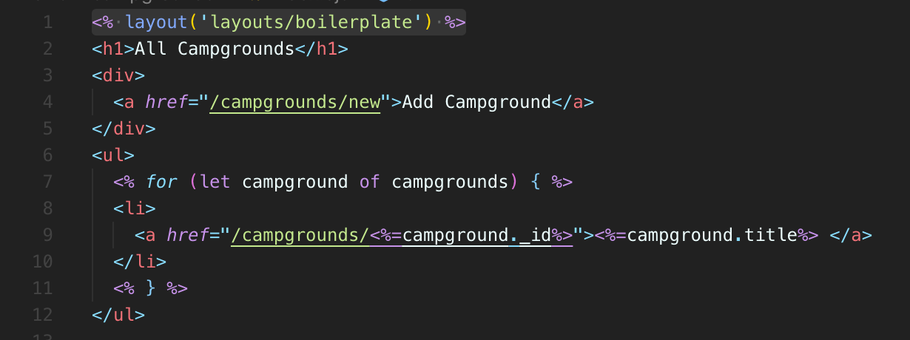

index.ejs

* 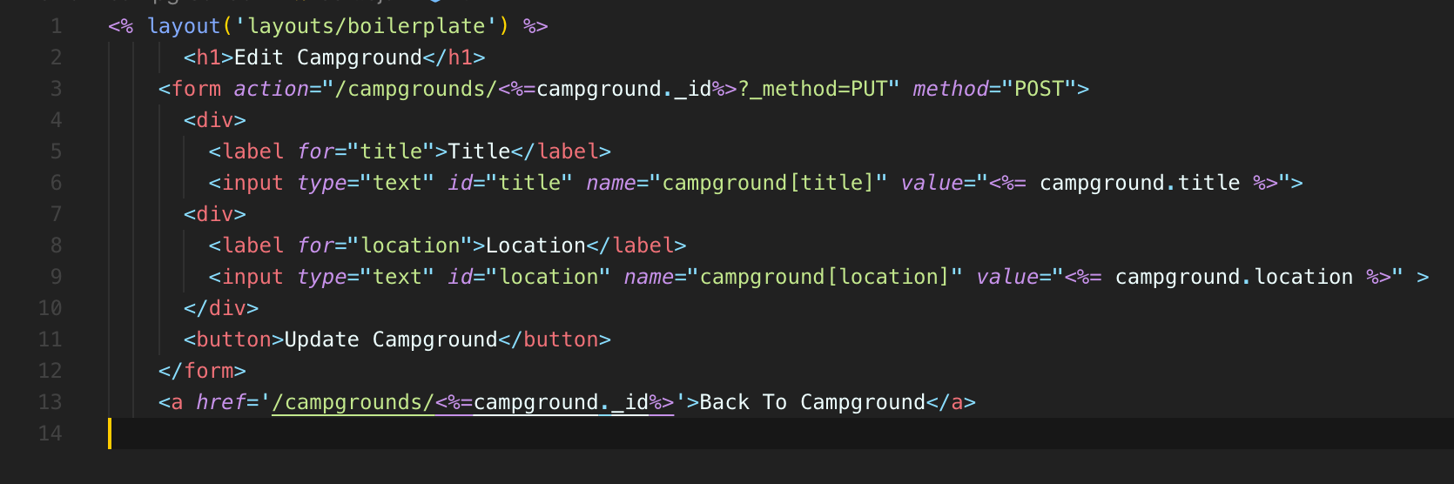

edit.ejs

* 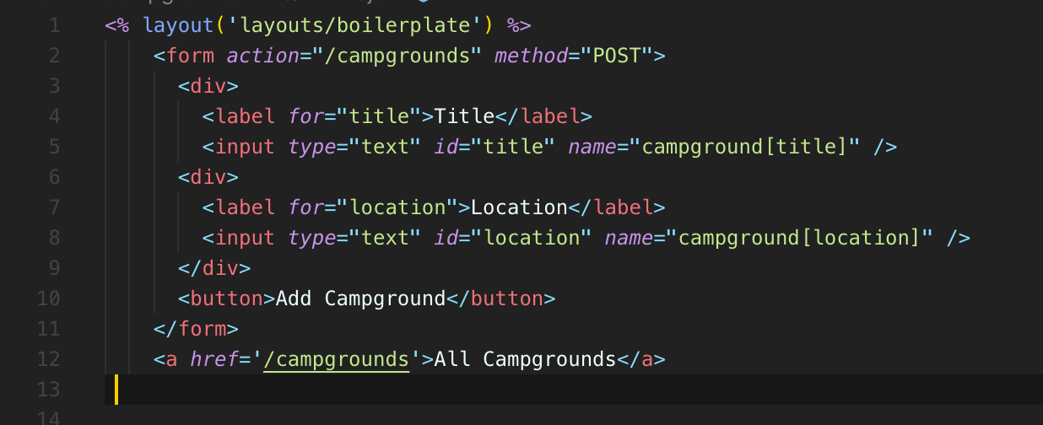

new.ejs

* 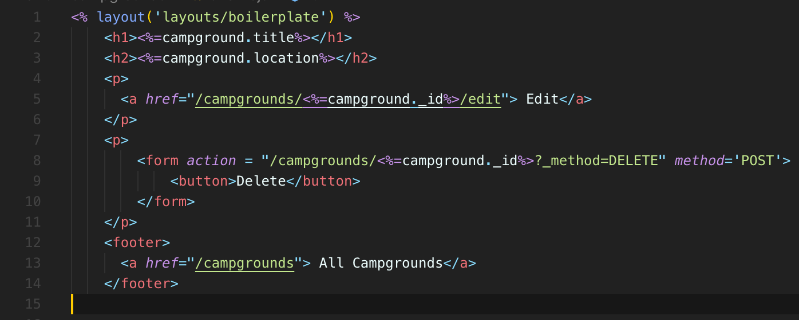

show.ejs

* 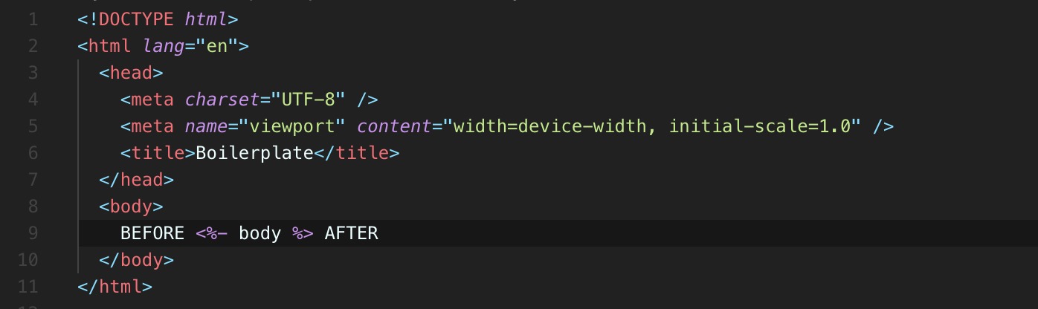

boilerplate.ejs

406. Bootstrap5! Boilerplate

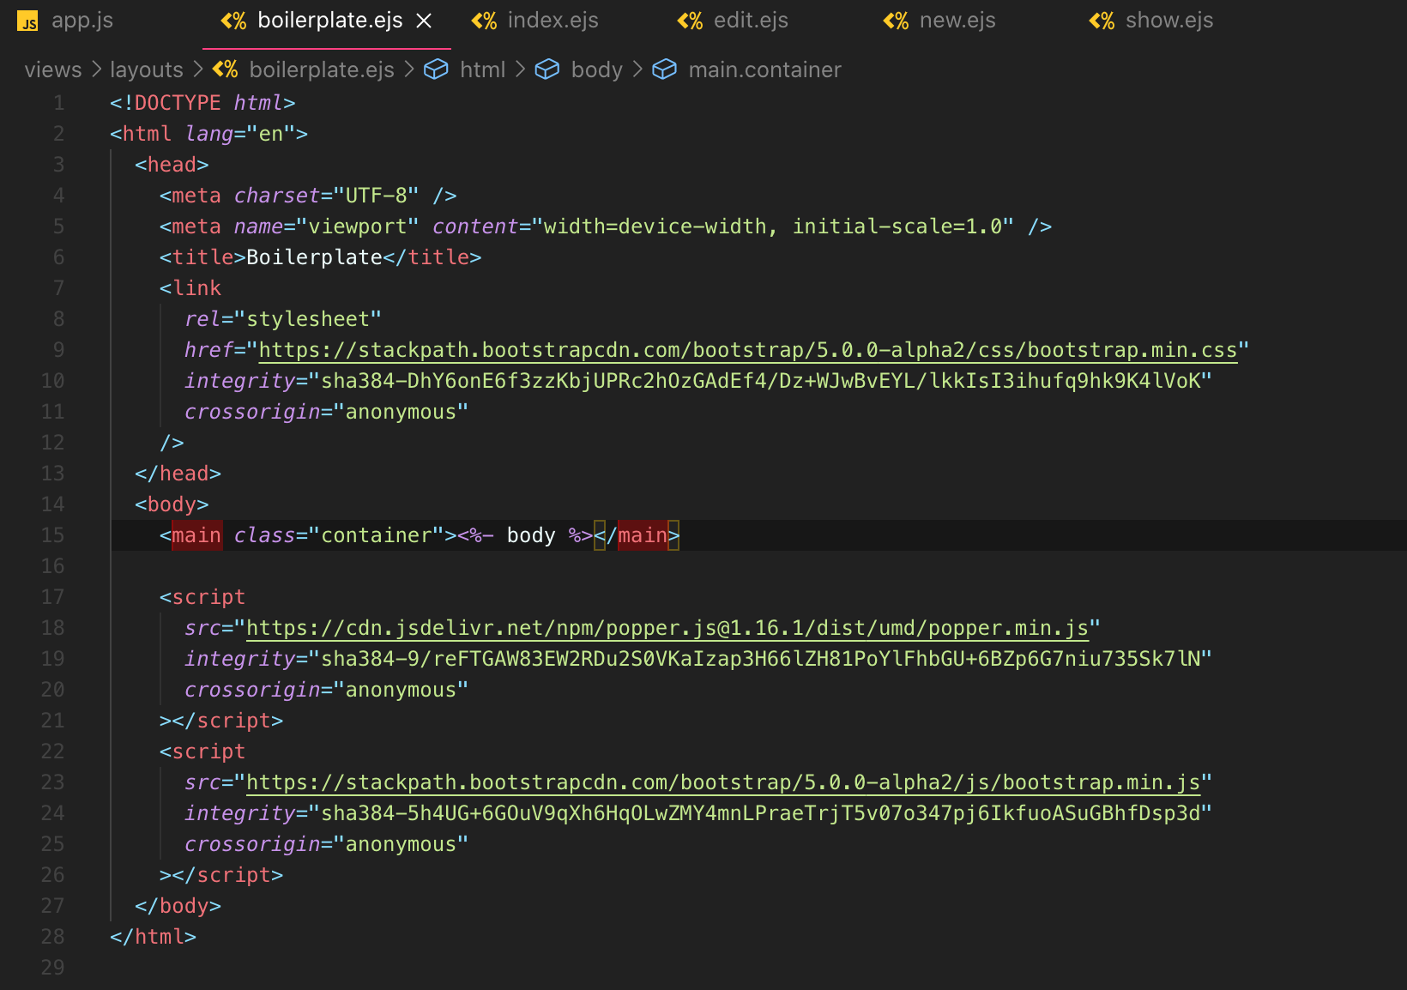

407. Navbar Partial

408. Footer Partial

409. Adding Images

410. Styling Campgrounds Index

411. Styling The New Form

412. Styling Edit Form

413. Styling Show Page

**Section 41: YelpCamp: Errors & Validating Data**

422. Where To Next With YelpCamp?

423. Client-Side Form Validations

* let's just require everything on the form and there are a few options.
* One is just to use the native HTML5, you know, required attributes and depend on the browser to do that validation for us.





* There's nothing wrong with that at all, but it's just not that attractive and it's not very clear to the user that it'd be nice to have, you know, red highlight here if something is required and it's not filled in.
* But also it really depends on the browser.
* The implementation is still kind of spotty across all browsers, or it's at least not standardized because we're just relying on the browser to do that validation.

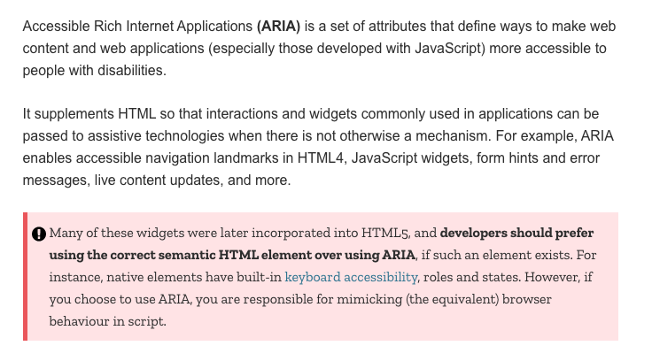

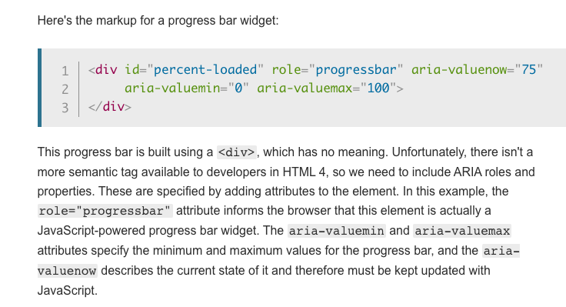

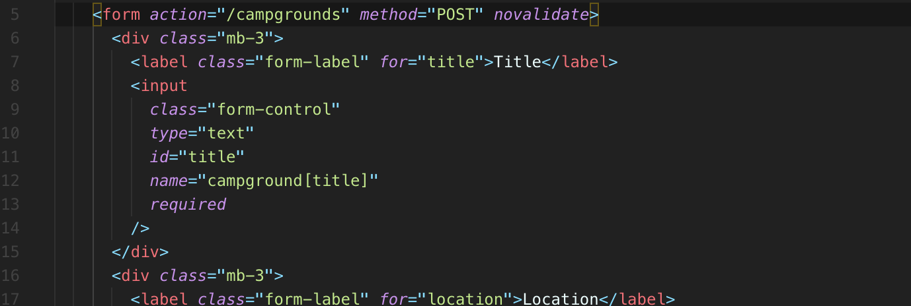

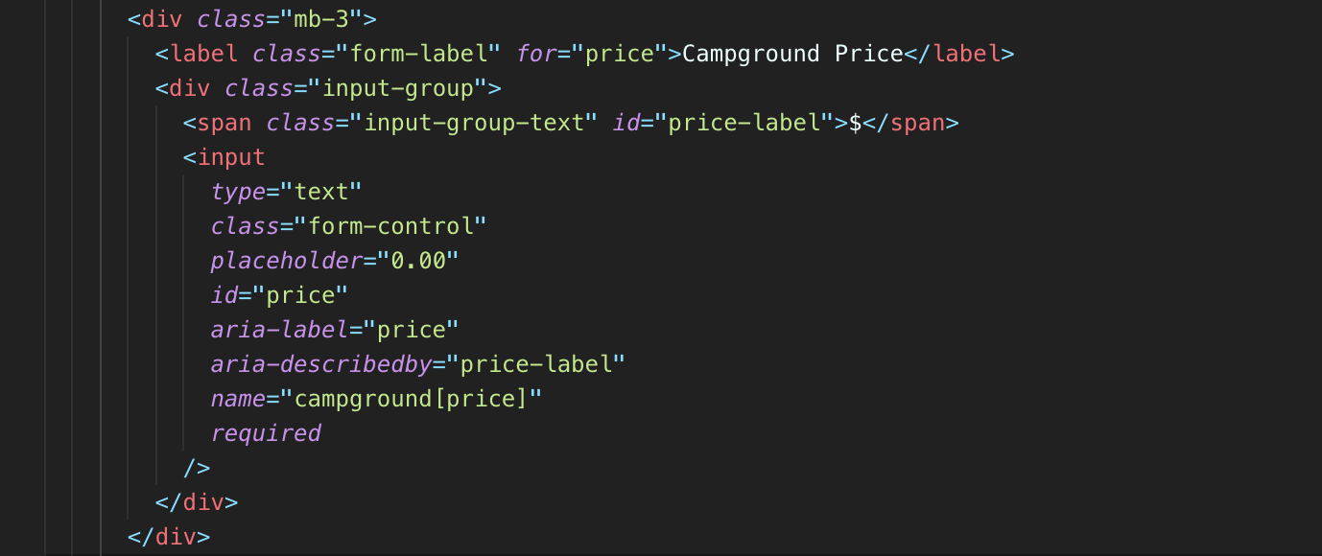

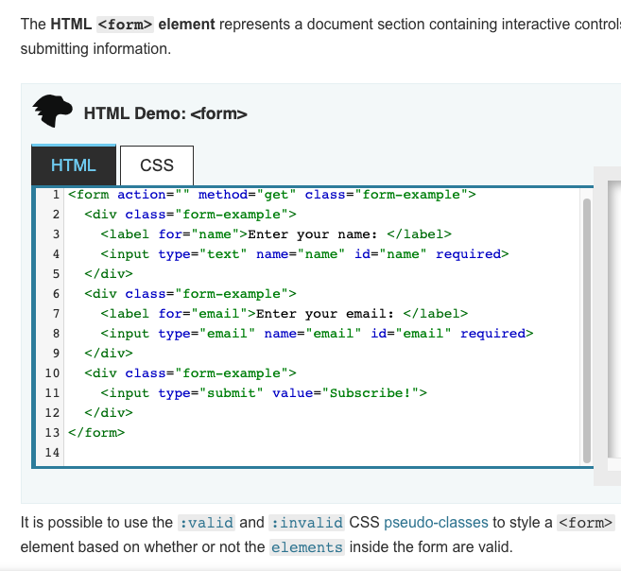

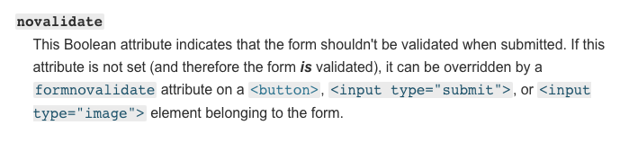

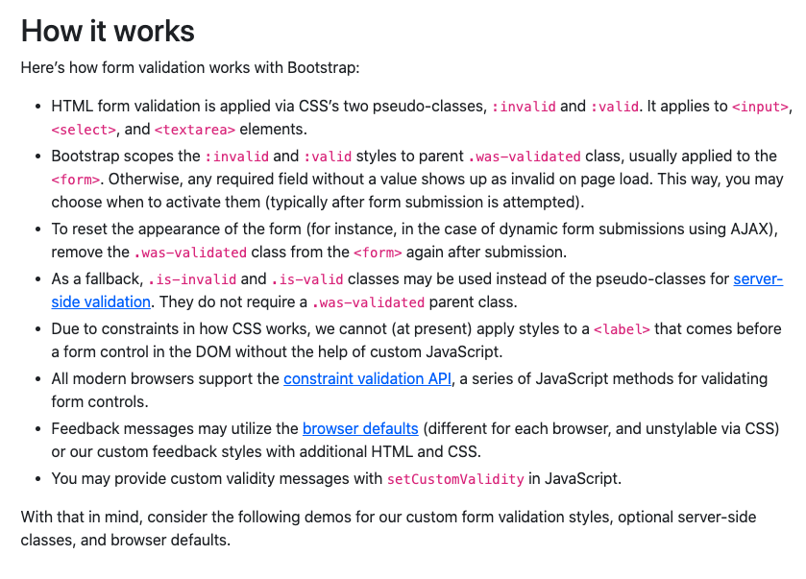

* **So instead, bootstrap comes with its own validation.**
* Helper's you can find it on the docs under forms validation.
* It tells us how it works.
* **Basically it's applied via two pseudo classes, invalid and valid.**
* **That bootstrap will apply to our inputs for us and then we can change with those classes look like, but it will decide if things are valid or invalid.**
* **So what we do is we add on the required attribute wherever we want it to be required.**
* **There are other attributes we can use to, but that's the one we're going to start with.**
* Just require everything so set required.
* **Then the counterintuitive part is**
* **we're actually going to tell the browser not to validate the form and that is so bootstrap can take over instead,**
* **instead of using the native browser validation like**
* **we just saw or required, this will allow Bootstrap to take the arrange.**
* **Unfortunately, we also need to then add some JavaScript in and we will talk about that in just a moment.**

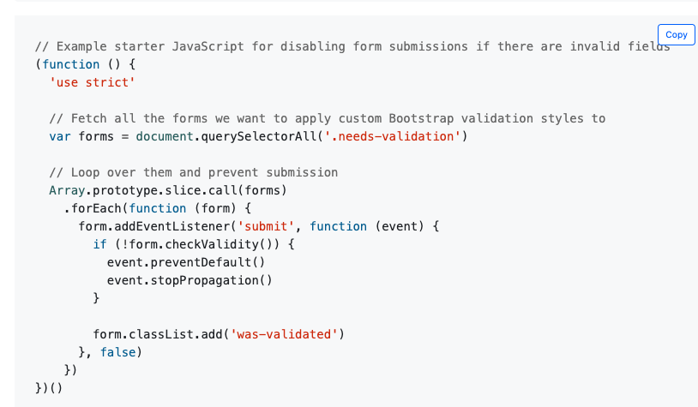

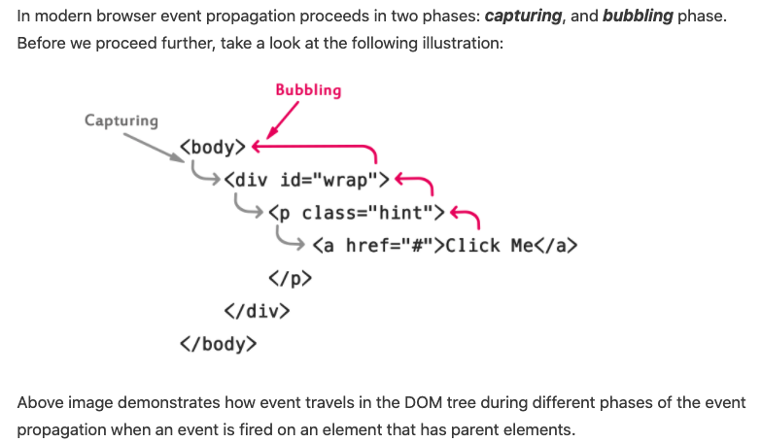

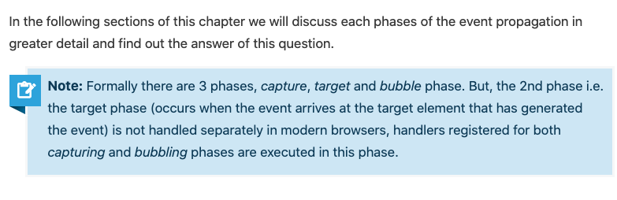

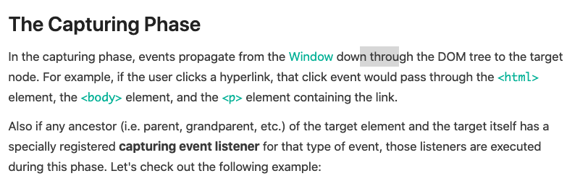

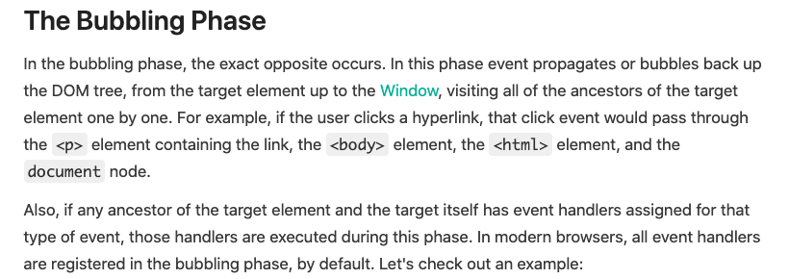

* **Then I'm going to say on the form itself, novalidate attribute.**
* Now this is not going to do anything for us, at least immediately, that we can see here.
* It still allows us to make this new empty campground, although we can tell it's working because novalidate it's preventing all that required stuff from actually requiring anything.
* We don't see that browser message popping up.
* **Now, for the somewhat tricky part, in order for this all to work, we need to use some JavaScript.**
* **And this JavaScript is going to prevent us from submitting the form when things are invalid.**
* **So you can just copy this from the bootstrap docs.**
* I'll walk over or walk through how this works, but basically we're finding all forms on the entire Web page based off of some class.
* So right now, you know, if we're if we were to use this, we would add the class needs validation



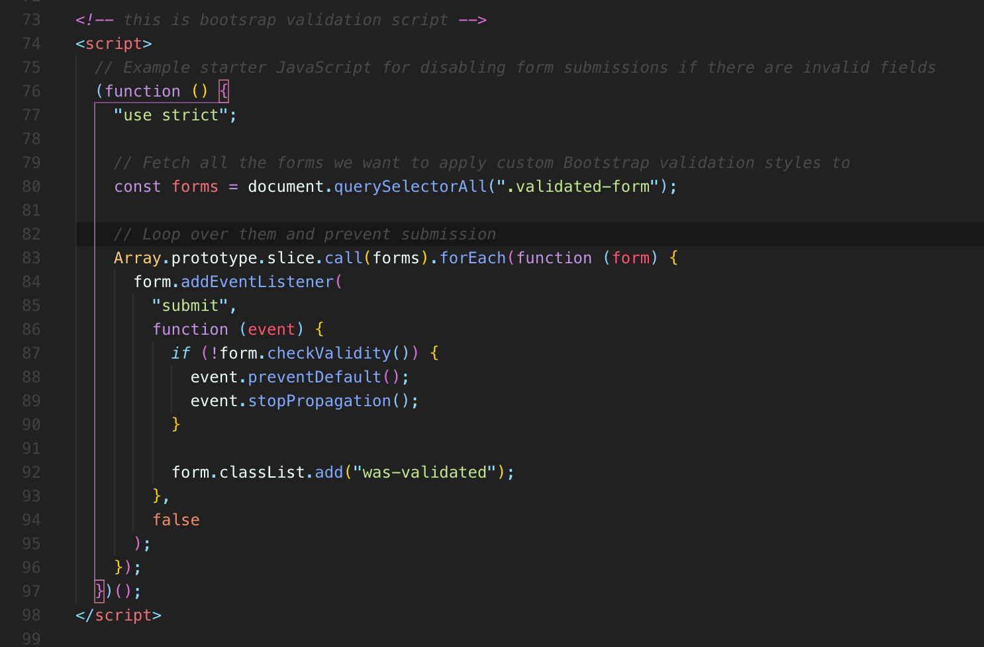

* This JavaScript is going to prevent us from submitting the form when things are invalid.
* So you can just copy this from the bootstrap docs.
* I'll walk over or walk through how this works, but basically we're finding all forms on the entire Web page based off of some class.
* So right now, you know, if we're if we were to use this, we would add the class needs validated-form or I mean, we can go with that or maybe we'll will do class call it validated form.
* So that will be what we select upon or based upon.
* **And then for each one of those forms that we found, we're going to add an event, listener force submit.**
* **If you try and submit the form**
* **, we're going to call !form.checkValidity.**
* **And if not, so, if that returns false**
* **, we're going to prevent the submission and stop propagation.**
* **It's just what we need to do in order to get this all to work**.
* We can step through in more detail, but let's just put it at the bottom of this page in a **script shortly we will set up our own JavaScript file and, you know, do all of that stuff and serve static files.**
* The only thing we definitely need to change is this should not be needs validation.
* That needs to be the cost that we defined, which was validated form, I believe, just double check. OK, so all of these are now required and it's the only form.
* But also I would change this to be const, so select all forms with that class
* loop over them.
* This is basically a fancy way of turning it into an array.
* This is actually the older way of doing it.
* **Now we can just replace this with array “from”**
* **make an array from this thing of forms this whatever query selector returns.**

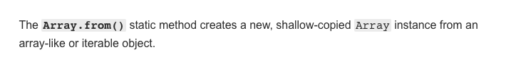

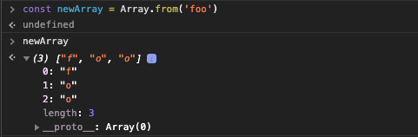

* make an array from it, call for each on it, just loop over at an event listener to each form, check each just validity when the form is submitted and if it's not valid, prevent default, stop propagation.

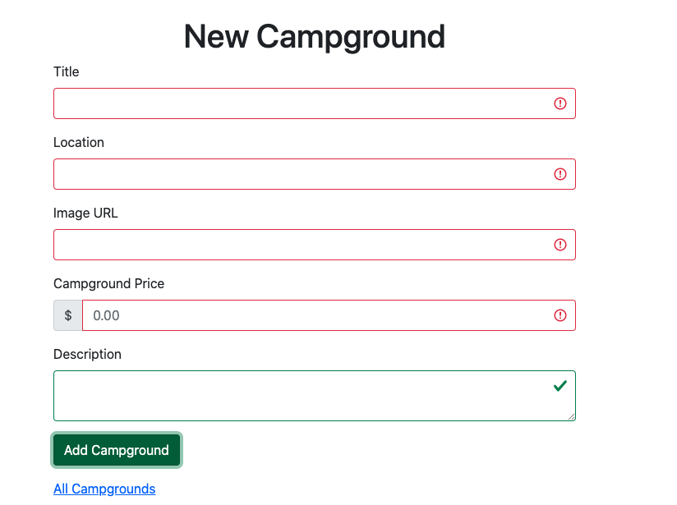

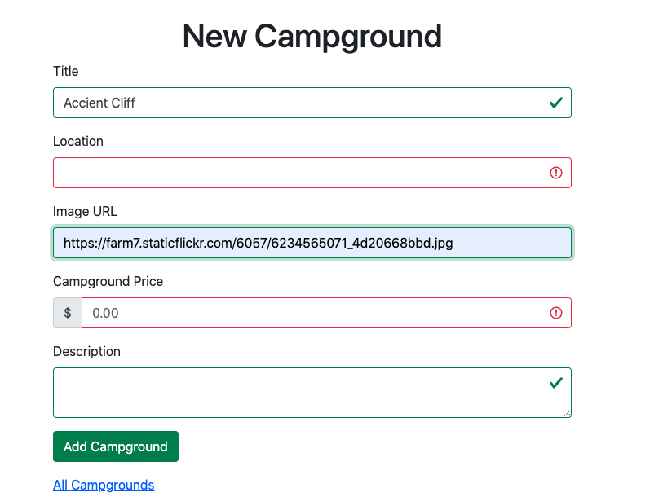

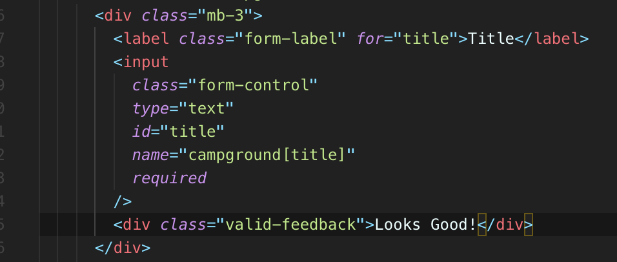

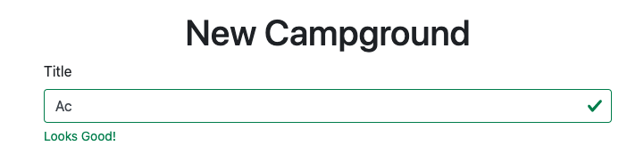

* So we have some basic client side validations, but I can still screw things up on my edit form.
* It's kind of nice to get that feedback and to see the actual color highlight and the icon here. So it's not just colors.
* You never want to just use colors because red, green color blindness is really common type of color blindness.
* **We also want to include some icons or something to indicate that something's valid versus invalid.**
* Don't just rely on green and red.
* So that's kind of it for our client side validations. Next up, we need to figure out what to do with that JavaScript stuff, get that out of our boilerplate template.

424. Basic Error Handler

* **I'm trying to think of a way we could generate an error**
* **If my price is if I just fill this in or something and my price is not able to be casted**, **to a number,**
* **that's what mongoose is going to attempt, because I set the type to be number to try and take that and turn it into a number.**
* **And you can see we're just spinning out here.**
* **So our server freaked out.**

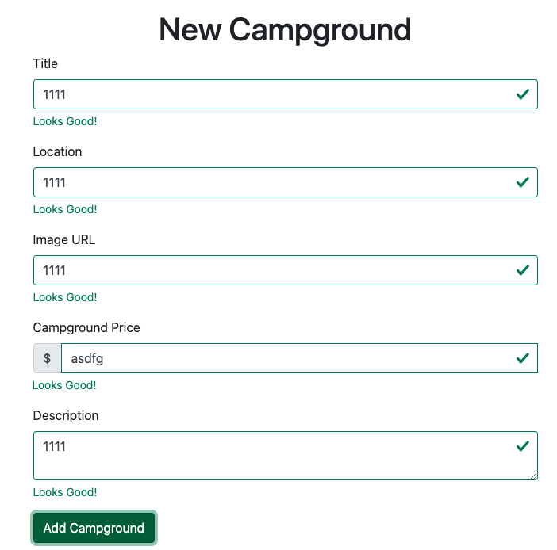

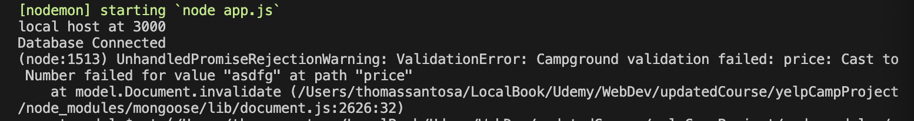

* **We've got a unhandled promise rejection, warning, and the actual error itself is all the way up here.**
* Validation, error, campground validation failed.
* So there's a couple of issues.
* First, there's the error.
* That's an issue.
* **But this unhandled Promise rejection is coming from the fact that it's an asynchronous error.**
* It's happening after the fact.
* **We're not handling it or Express is not able to catch it itself.**
* So this is you know, we talked about this previously.
* **We have to set up our try catch in our async functions and then we can set up our own error handler if we want.**
* Maybe that's where we start with our app.use.
* **Remember our error handling, signature error,**
* **error request response next.**
* And let's just do something really simple to start like res.status and something went wrong.
* **Now, we're not going to hit this because we're not actually handling the asynchronous errors we talked about.**
* So what I need to do is instead of let's see, that was new, right where I was creating a new one.
* Same thing with editing and updating.
* The post request for slash campgrounds.
* We can wrap the whole thing in there with a tri.
* **And then have a catch with an error and then remember this whole thing where we pass that on to next if there is an error.**
* So we need to make sure we have next in here.
* And if you happen to just end up in this section without going through the error handling section, this is probably very confusing.
* It may be confusing even if you did make it through that section.
* But go back and watch that if you need a recap as to why we have to do this weird stuff.
* So catch that error.
* **If there is one** error
* **when we try and save and then call next with the error**
* **, that should hopefully hit our basic error handler at the end that just says, something went wrong**.
* 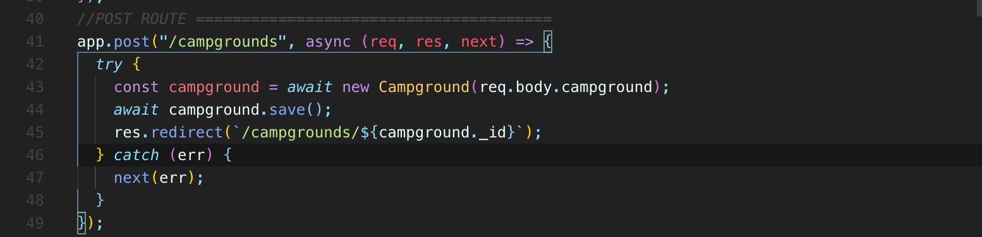
* 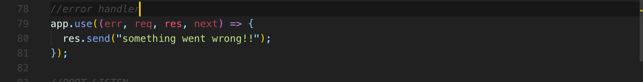
* 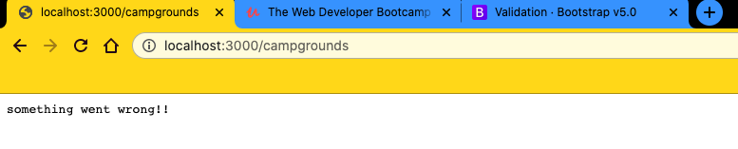
* 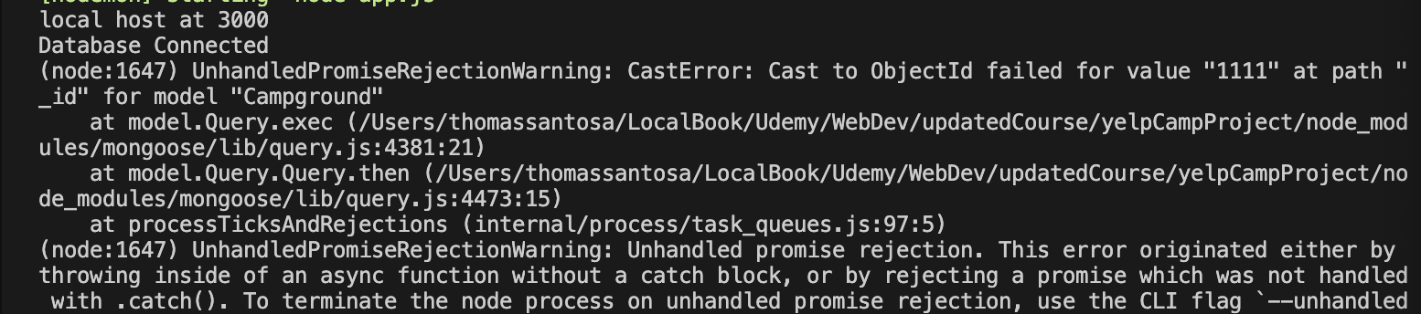
* 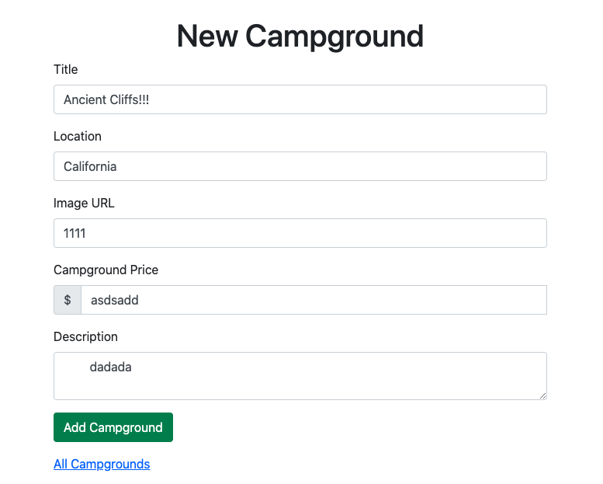
* But in here, we could have a whole bunch of logic to determine, you know, what type of error we're dealing with, how to handle it, and, you know, what kind of incorporate some of that as we go.
* And in the next video, we'll make our error class that we talked about previously, the app error express error, just some standardized error that we can create, that we can throw at will already.

425. Defining ExpressError Class

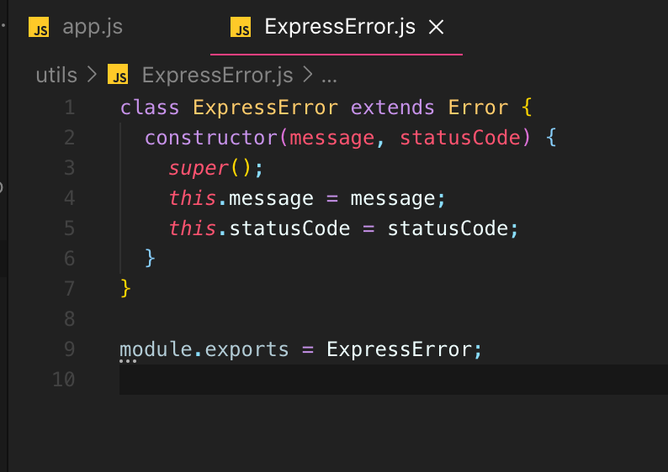

* **So “class” ExpressError “extends” regular built-in Error {} object built-in.**
* And this is all something we've seen before.
* And then what we're going to do is call super right in our in **the “constructor”.**
* **That's going to call the Error regular object constructor.**

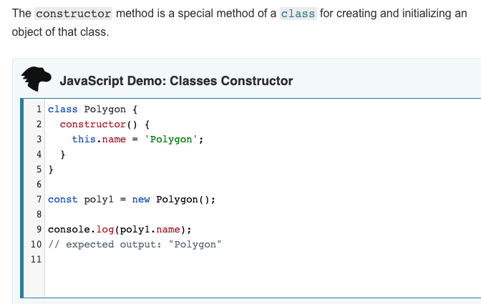

* And then **we could add on any additional information if we wanted to in here**.
* **We could even provide a default value for status code**, although I would prefer to actually be explicit when we are throwing a new express error rather than relying on a default.
* So I think I'll just do that for now and then we'll “export” this “module” .”exports” equals ExpressError.

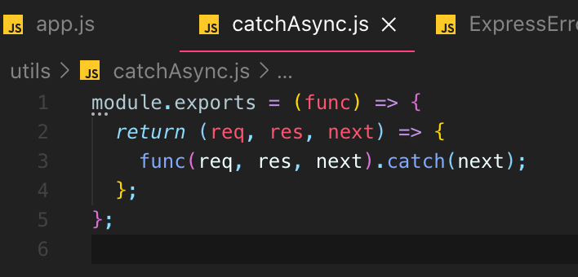

* Basically, **we return a function that accepts a function and then it executes that function.**
* **But it catches any errors** and **passes it to next**
* **if there is an error**, so we can **now use this to wrap our asynchronous functions.**
* So, again, **func is what you pass in**.
* **This returns a new function**
* **that has func (req,res, next) () executed**
* **and then catches any errors and passes them to next**.
* So now if I go to my app, I should be able to first require that.

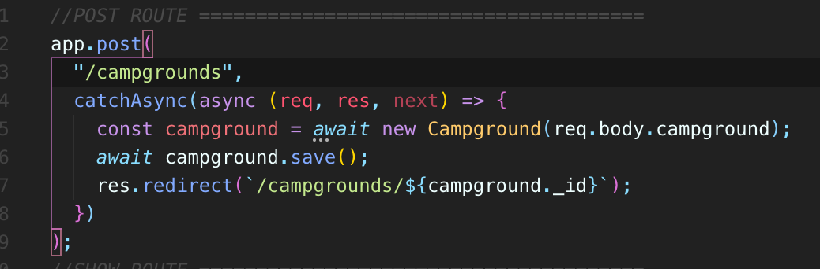

* So there will be an error thrown in here from mongoose if if there is and I'm going to ensure that there is by getting that CastError.
* if that happens, we are going to catch to catchAsync (async route)
* and pass it to next, because that's all that catchAsync.js module.exports whole thing exists to do.
* And next is going to be this app.use((err,req,res,next)=>{}).

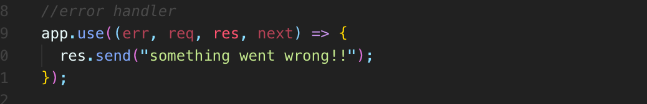

* **We could just write a bunch of if statements in here to decide what to do.**
* **This is our catch all for any error.**
* **And then we could just look at the error and decide what to do from there.**

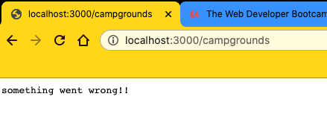

* **catchAsync**
* **If our catch async wasn't working, then we wouldn't see this in our server would crash like it did early on.**
* **So we just basically did some work to recreate what we already had, where we were manually using try and catch.**
* **But now I can just wrap this around any of my callbacks in my route.**

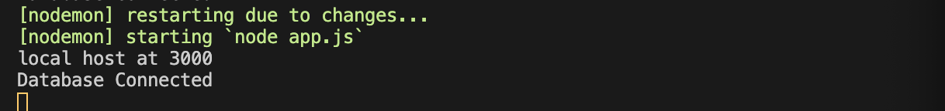

* **Next**
* **It is not trigger any libraries error handler through app.use() error handler**
* **Next(err)**
* **It is not trigger any libraries error handler through app.use() error handler**

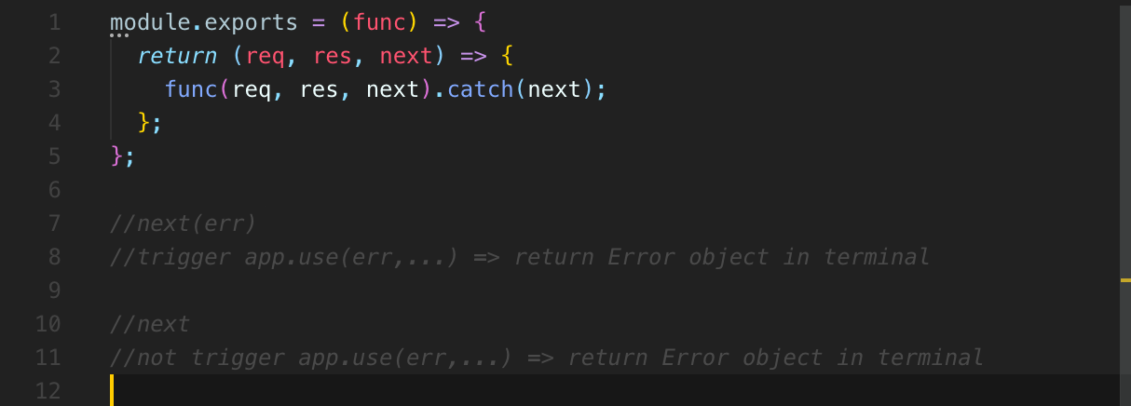

426. More Errors

* If you try and request some, you are we don't recognize.
* 1st option:
* I'm going to do an **app.all()**
* **, which is for every single request and then I'm going to say star**.
* **So for every path we're going to call this call back here**

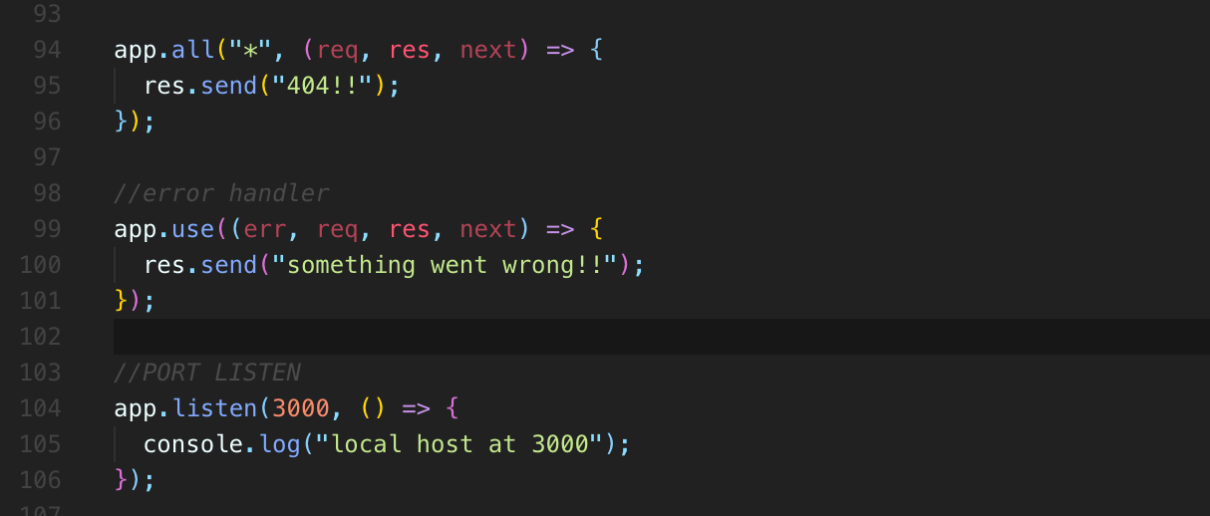

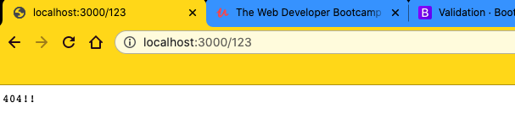

* **Remember *, this will only run and the order is very, very important.**
* **This will only run if nothing else has matched first**
* **and we didn't respond for many of them.**
* **2nd option:**
* 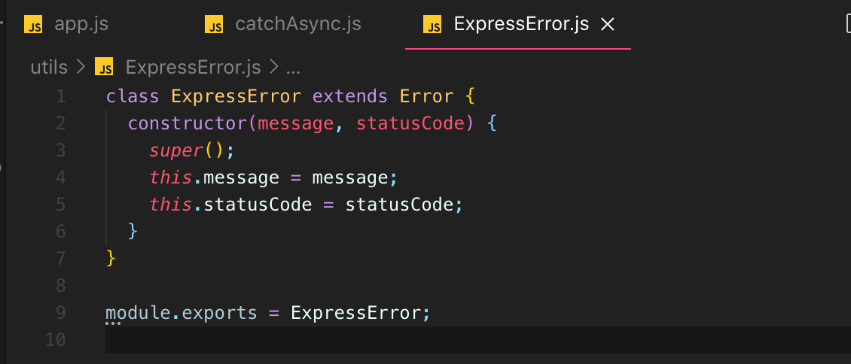
* 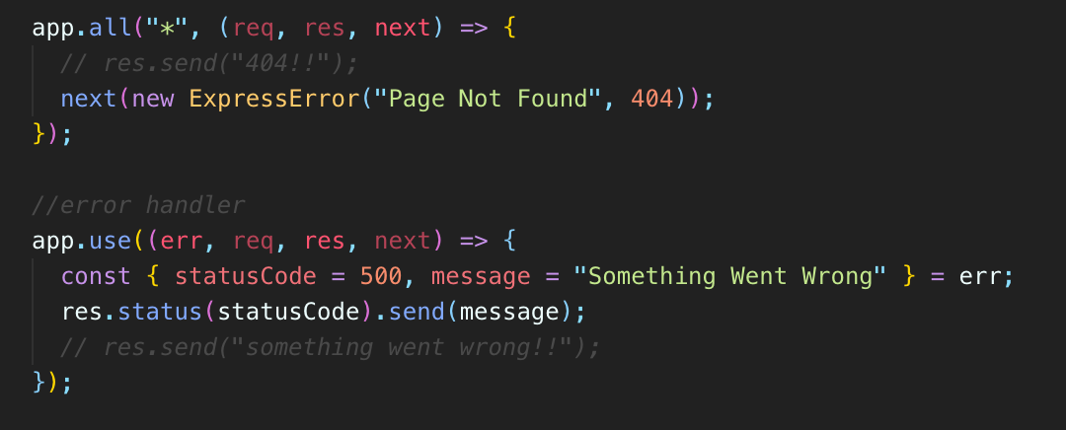
* 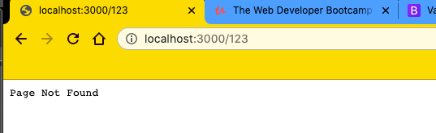
* 
* 
* **I'm going to use this (err)/Errors Object return**
* **because I'm passing this (err)/Errors Object return to next.**
* That means that **(err)/Errors Object return is going to hit**
* **‘app.use((err,req,res,next)=>{})’ error handler**
* and error **(err)/Errors Object return** will be **referred to this new object ExpressError (‘Page Not Found”,404)**
* or it might be another error if it's coming from somewhere else.
* So anyway, **res.status(statusCode).send(message)** will **send back a status code.**
* I'm not going to hard code that is for a forward because there are other situations.
* So instead I'm going to Destructure from error,
* **(err)/Errors Object return : {message, statusCode} = err**
* **Express ErrorHandler change value: (err.message= message), (err.status = statusCode)**
* Just verify that's what we called them equals error
* but **we should really give it a default value: 500 and “Something Went Wrong”**
* {statusCode = <default value>,message=<default value>}.
* {statusCode = 500, message = “Something Went Wrong”}
* maybe 500 for a default and message will just be something went wrong.
* OK, so we can start registering a res.status.send with that status code dot send message.
* 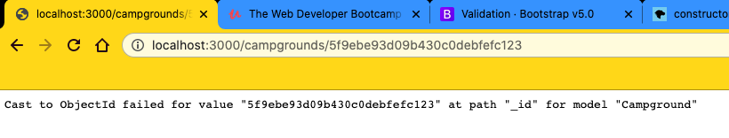
* 
* 
* if I go to some other page that causes an error, like some ID that doesn't exist like that, we're getting this error.
* This is the message CastObject had failed.
* So, you know, we're not overwriting it.
* We're not providing a fancier message.
* But we could the good news is that we're handling it well.
* **And the status code here, the default is 500.**
* So we can specify others.
* **At any point if we throw or if we create a new express error and we call that a we pass that to next whatever that status code is will be used.**
* **Right now we have our client side validation so that if you try that from a form, it physically won't submit the form**.
* **I said physically, but it won't submit the HTML form**
* , **but that doesn't stop someone from sending a request over to, you know, through Postman or through Ajax or something so I could do campgrounds.**

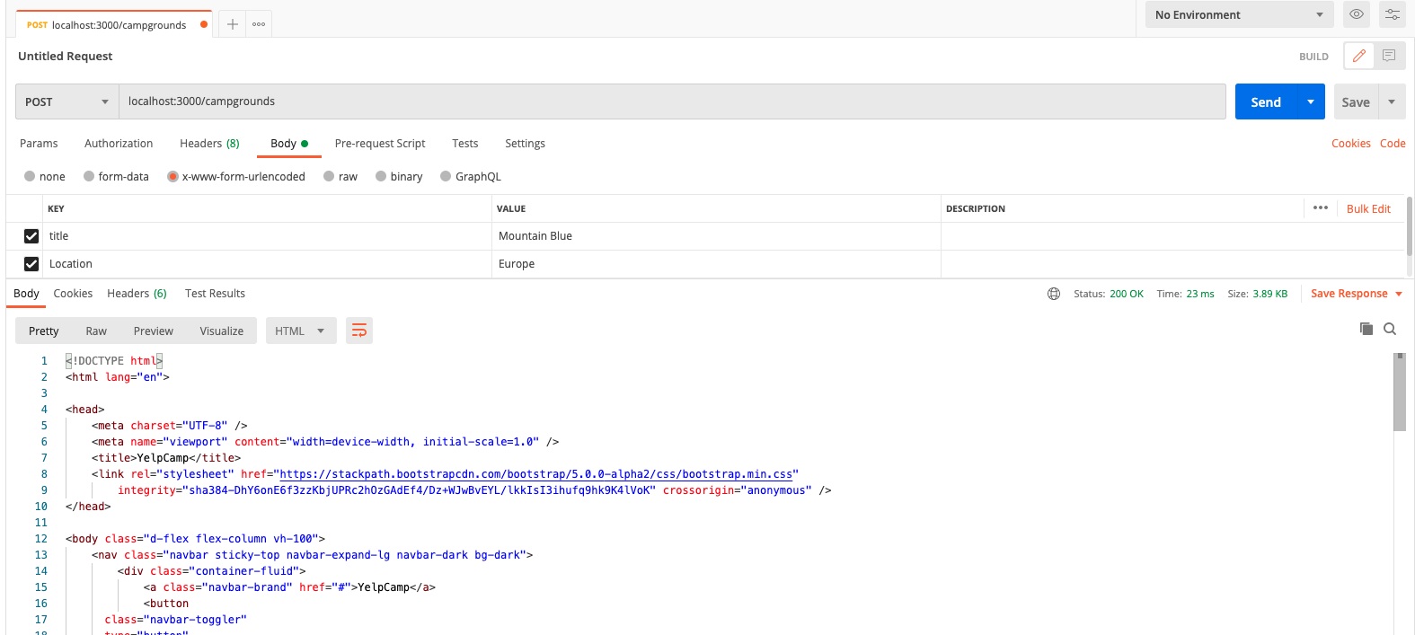

* I'm going to use Postman.
* **Here is a post request of include name or I guess its title**.
* But I'm going to leave off everything else.
* And if I submit this, what do we get?
* Well, **it just went ahead and made an empty new campground for us.**
* I don't know if we can even showing up here.
* Here's the HTML.
* So it's got you know, it's a preview work here.
* Yeah, that's what it looks like.
* **So we didn't stop anything from happening**.
* And there's a lot that we could do.
* **We could use mongoose and just add required**
* **and mongoose probably will.** But for now, **I just want to show you now we could do something simple, like if you don't include request object. body campground**
* **, if that's not there** request object.body.campground.
* **If it doesn't exist, we'll just throw a new express error.**
* Now, **remember, we throw the fresh error here because we're instead of this async function and you throw it true !req.body.campground**
* , then **our catchAsync is going to catch that error**
* **and hand it off to next**
* **, which then makes its way down to this function app.use()**

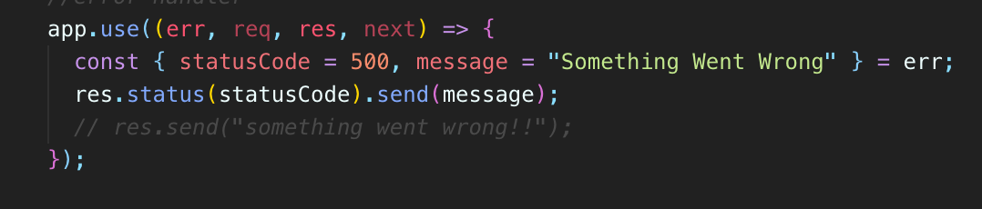

* **So we can specify where are you right here in that express error message**
* like invalid campground data
* and then a status code
* , which I think I would do 400, which is just a client error, like incomplete data, invalid stuff on your end.

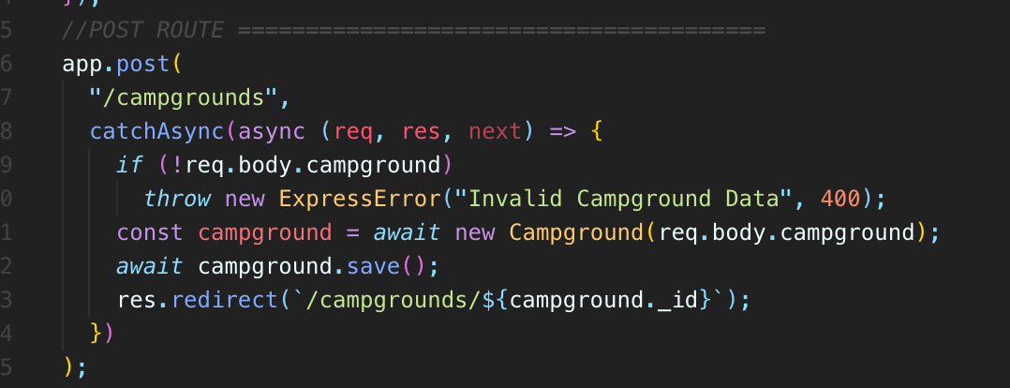

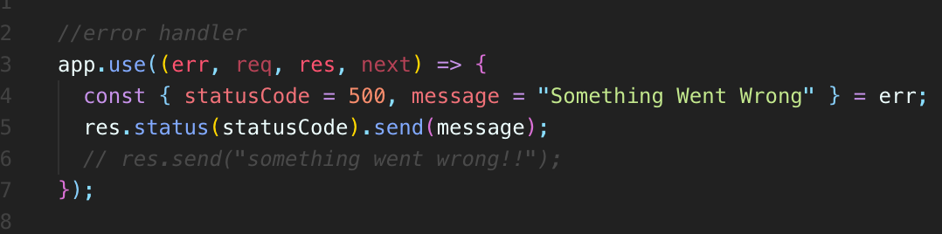

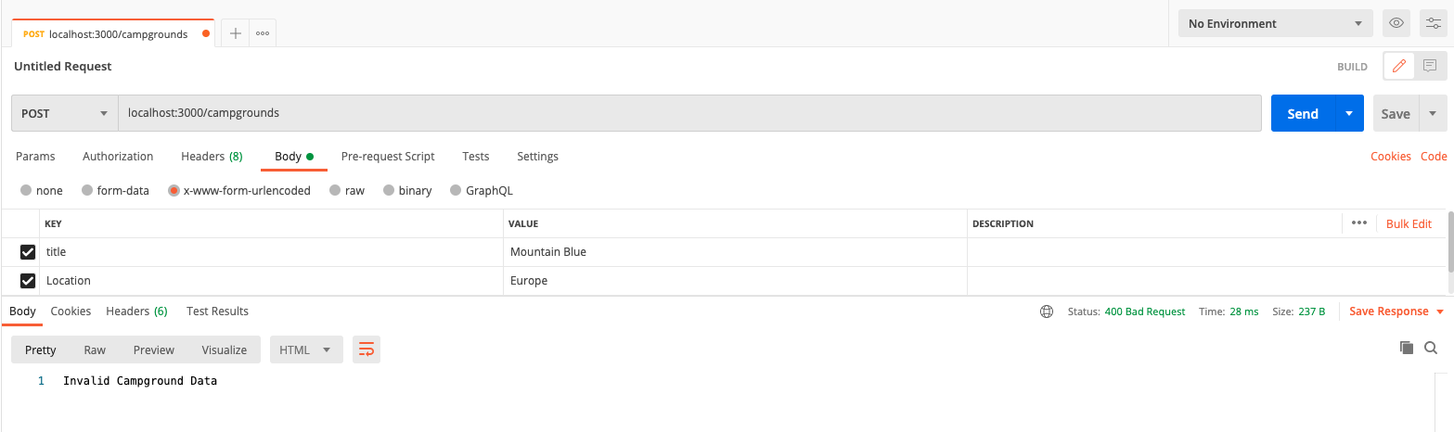

* **And now we have the infrastructure set up where I can just throw one of new ExpressError (message,statusCode) anywhere**
* , specify a message
* , specify a statusCode
* **, and it will make its way down here where we use that message, we use that statusCode, or we provide a default or a backup if nothing was provided**.
* **And then we set that status code in the response and we sends that message.**

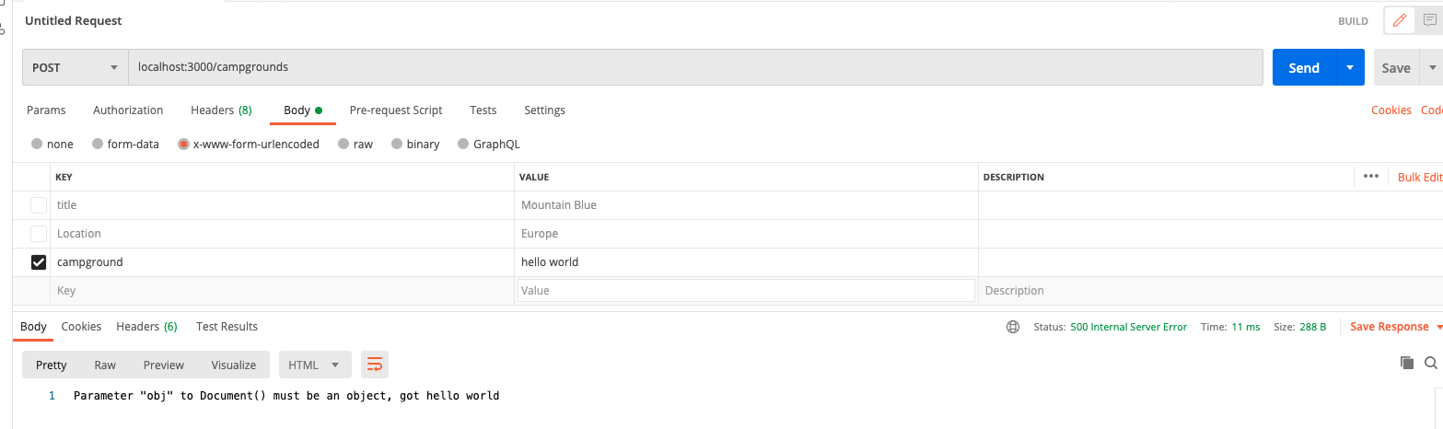

* But now we actually get a different error here, because what happened now is that campground was just a string, if you can see that hello world.
* And that was passed through to make a new campground.
* And then that's a string, not an object.
* So mongoose yells at us and it throws its own error parameter.
* Object to document must be an object got hello world.
* So, you know, we're still catching that error.
* We're still handling it down here.
* But, you know, 500 status code is what we ended up responding with, as you can see right there.
* **If something goes wrong at this point, if it's an asynchronous function, hopefully we've wrapped it in catchAsync**.
* **And if it's an error we didn't throw**
* , it still just makes its way down to this function.
* 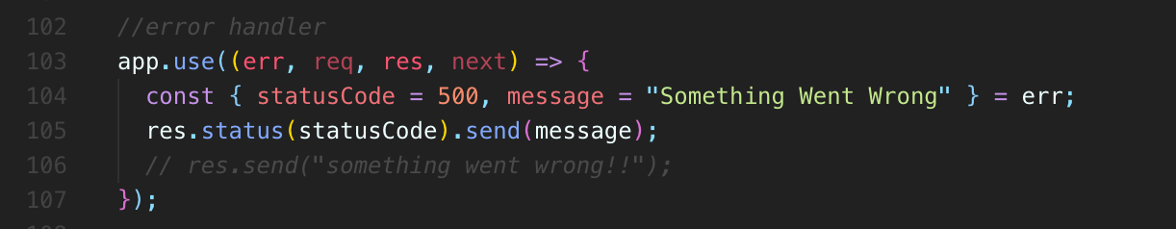
* Here are error handler.
* **If it is an error we throw anywhere like the one we just did here, that makes its way down there too.**
* **And this just allows us to customize the message in the status code and then we automatically use that status code to respond with to set the response status and then we just send a message in the next video.**
* **We'll make a little error template.**

427. Defining Error Template

String Template Error

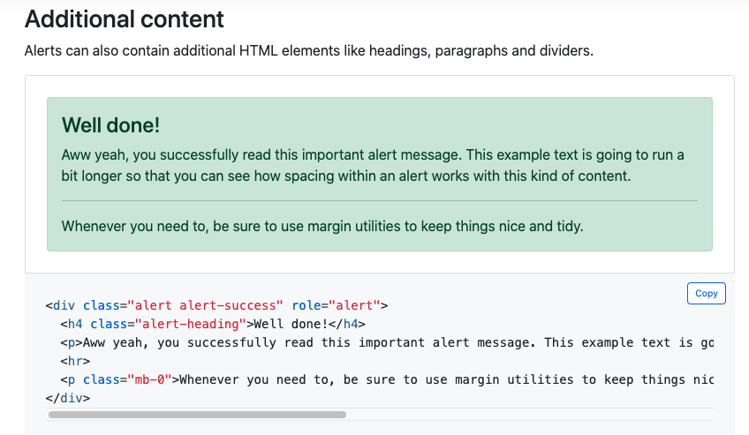

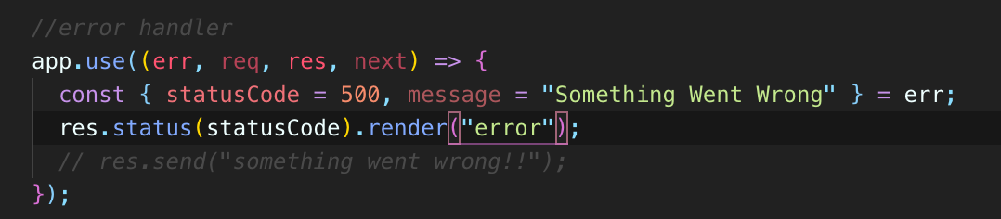

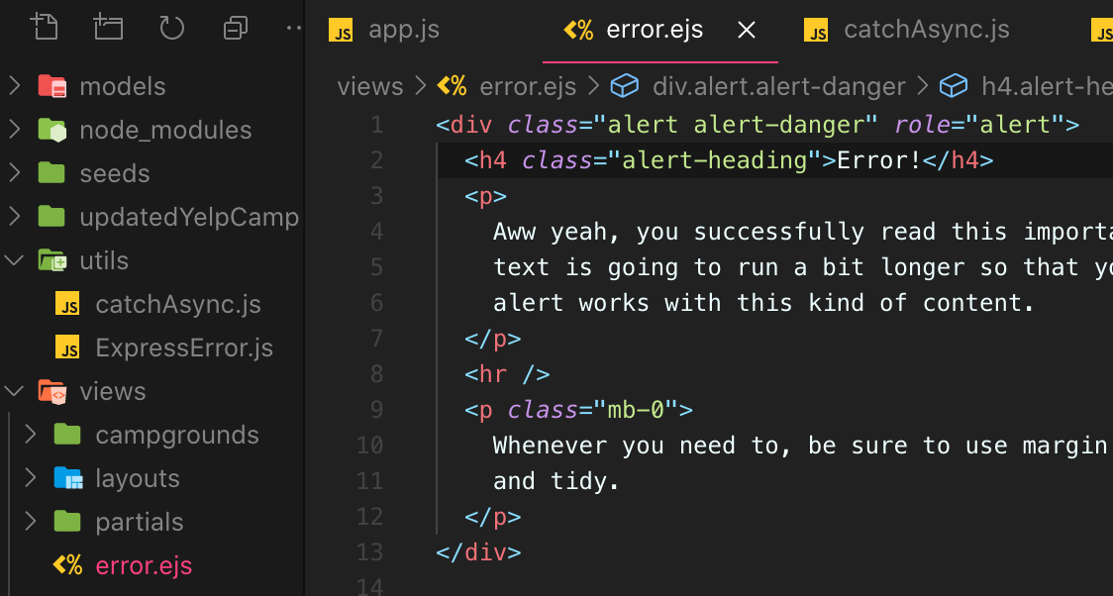

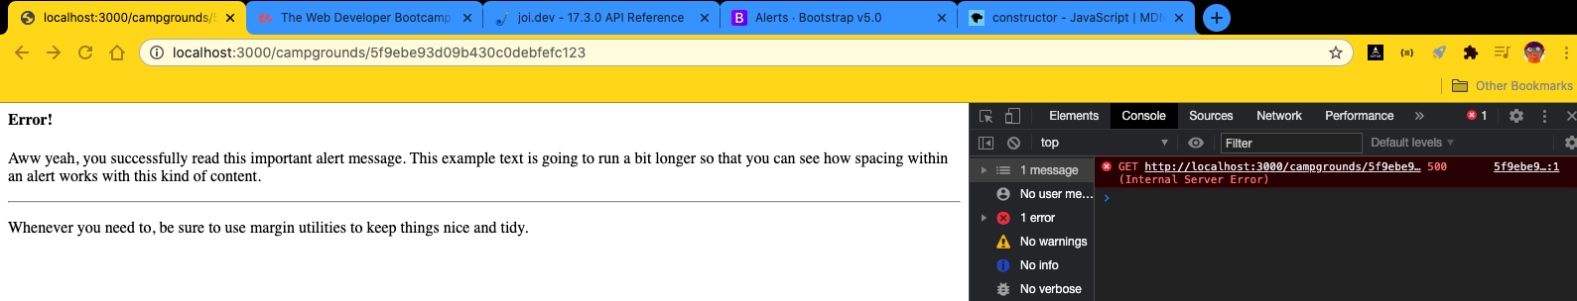

* we are getting that error, although, oh, of course, our styles aren't working
* because we didn't include the layout that were supposed to include our boilerplate.
* So let's just copy that line from one of our other files.
* We need to make sure, you know, bootstrap is included in our JavaScript and all the other stuff we've included in our boilerplate file.
* 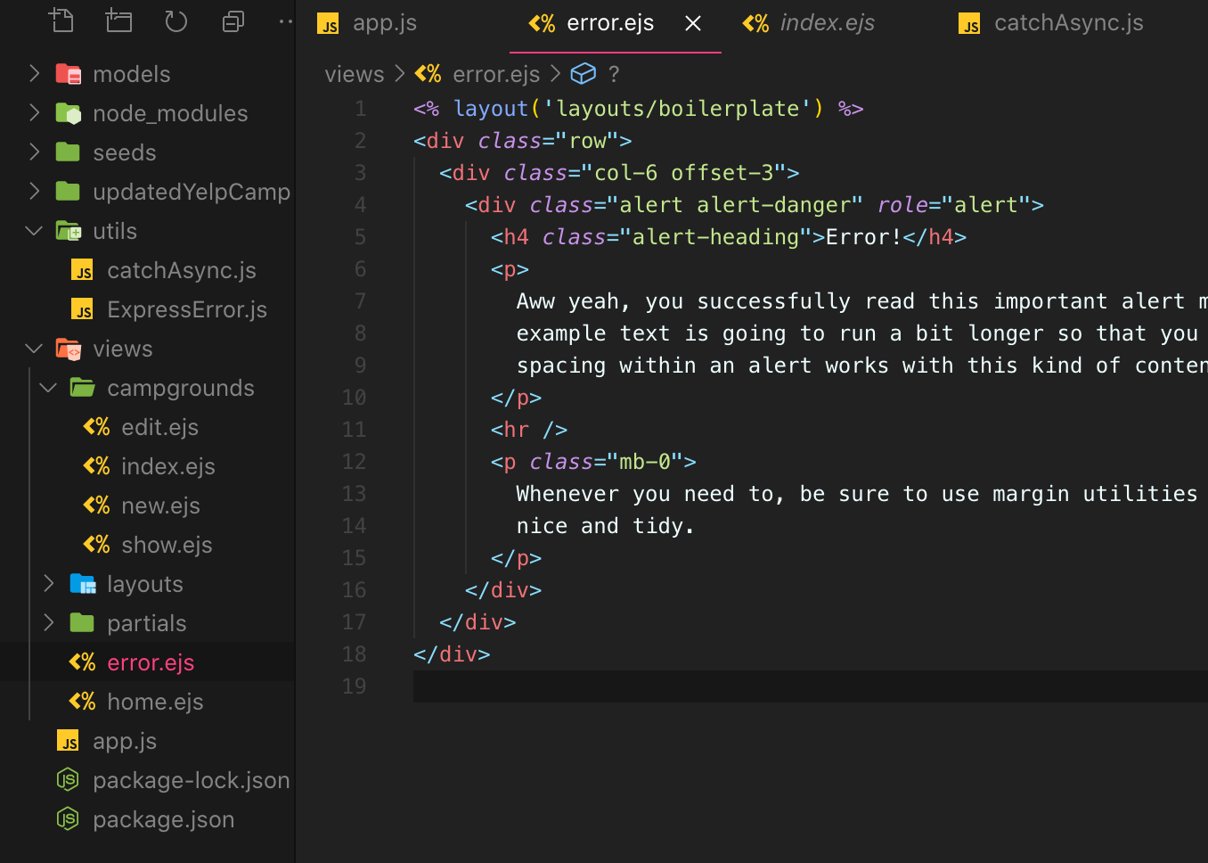
* 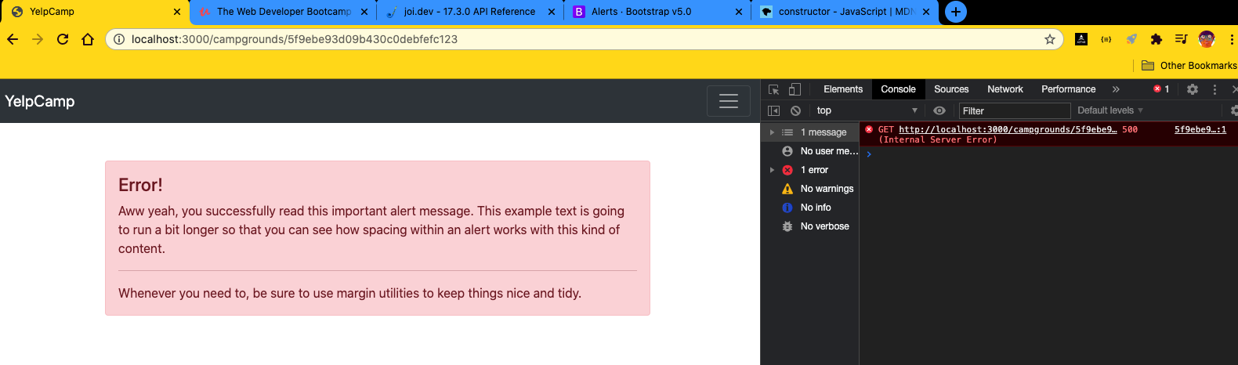
* 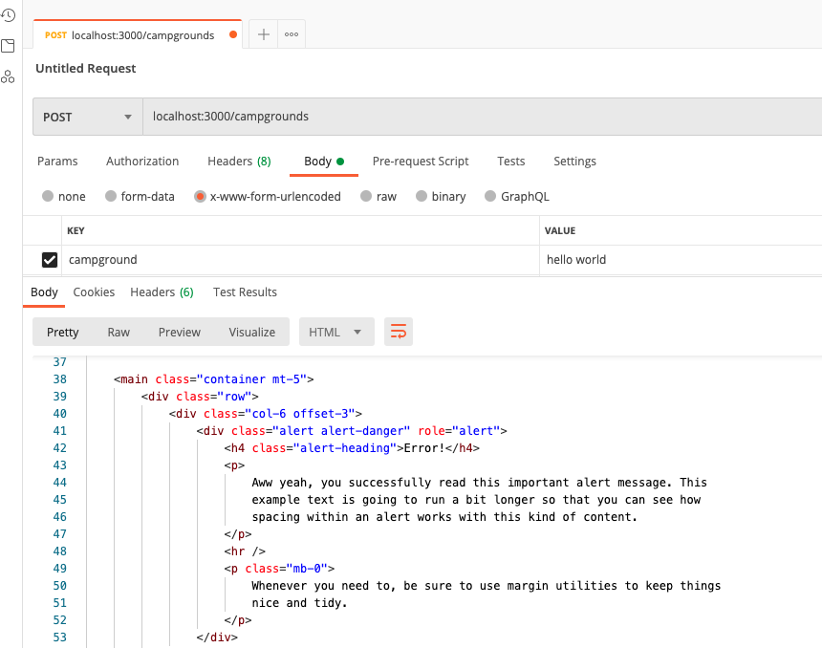
* So we're hitting that error handler and we're always just rendering this generic.
* It just says error and then this paragraph in there.

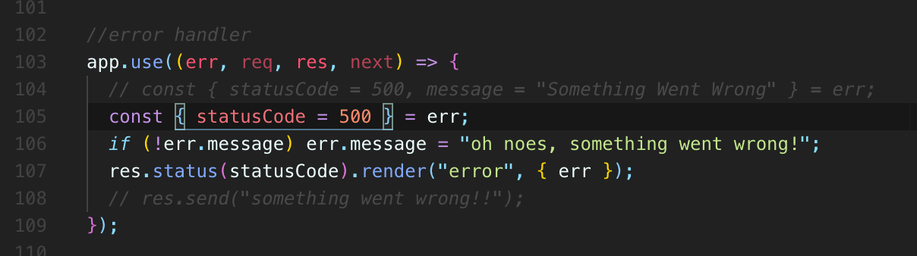

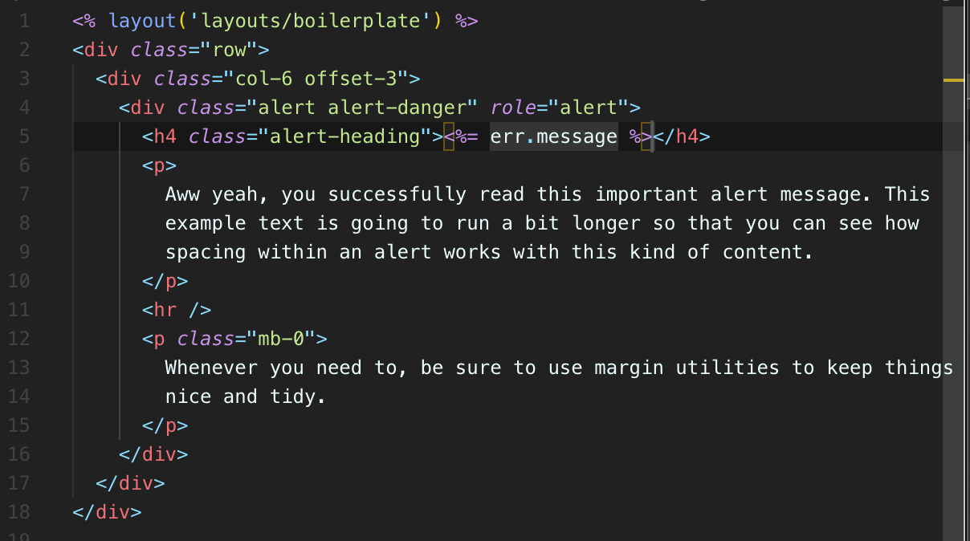

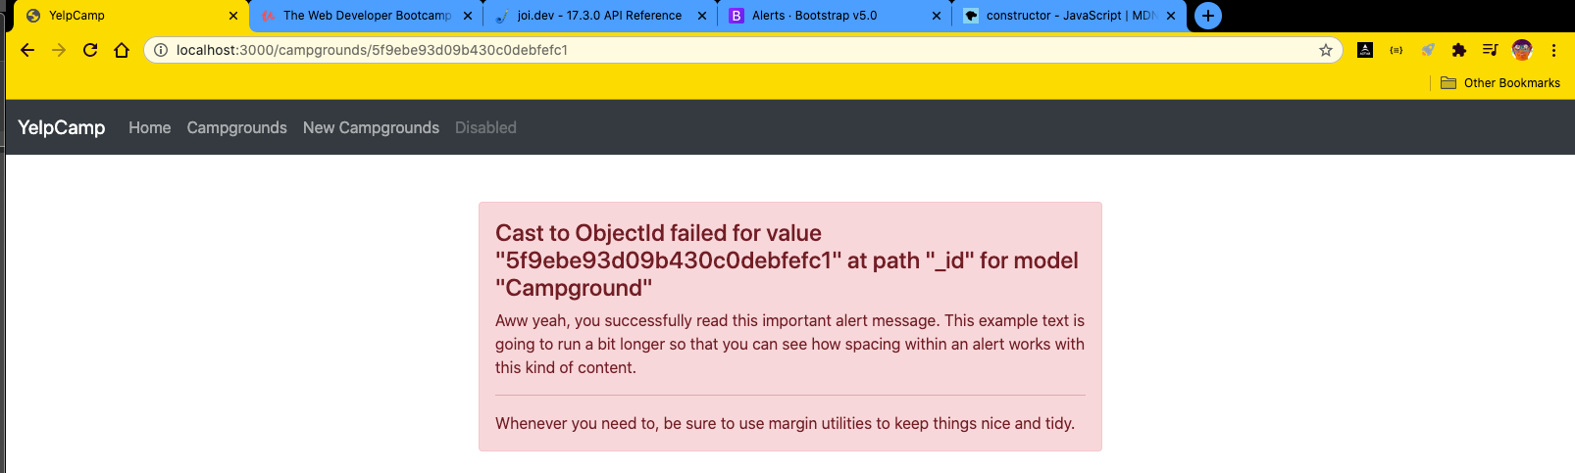

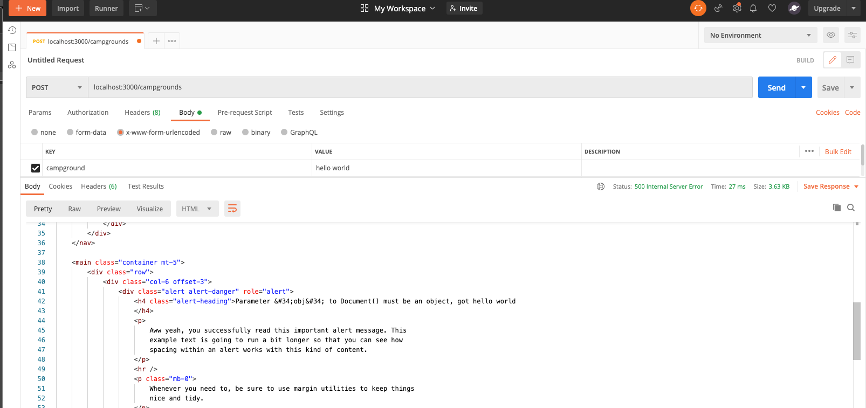

* **What I'm going to do actually, instead of destructuring,**
* **I think what I want to do is pass the entire Errors object.**
* So we I want to pass that through to my template.
* And so I'm not actually setting a default message and the default status code right now.
* So this right here where I'm extracting the status code, that's fine.
* But we're setting the message that's not actually going to work to update the error object.
* I'm extracting a variable from error and giving that variable a default.
* So I'll do something like this, if not an error message.
* OK, so now we should pass through that entire error are to our template and then I should be able to access.

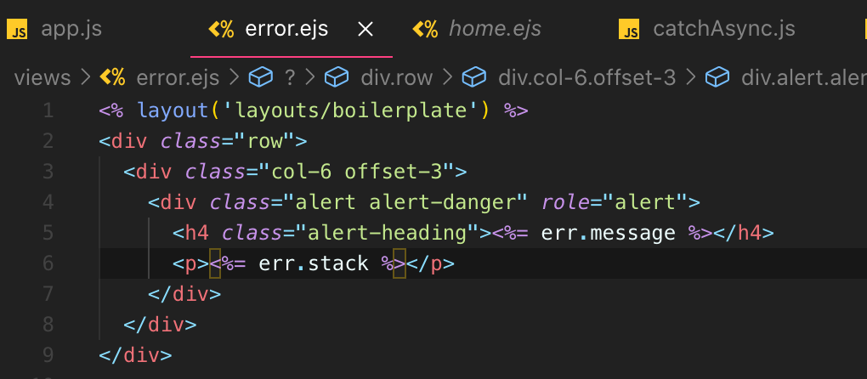

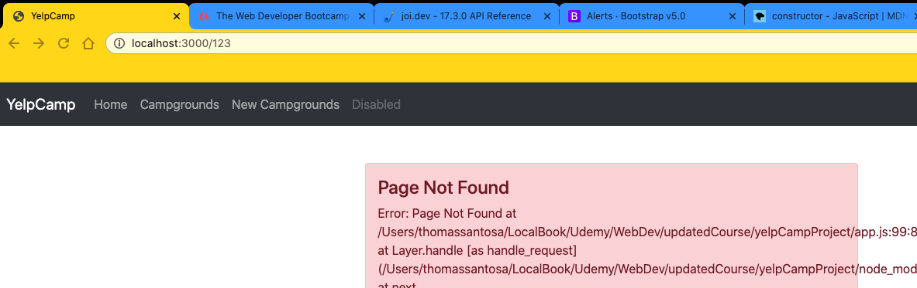

* So if we want that in there, we can leave that for now for development purposes.
* But in production, we definitely don't want to use her to see that we would have a fancy looking for a for message or an error page that has some quirky looking animation or whatever, something an illustration.

428. JOI Schema Validations

* **So the last thing we're going to do right now is validate our campground data**
* **when you post a new campground**
* **or create one or when you update a campground.**
* Now, the way that we're doing this right now is I mean, **we're hardly doing it on the server side at least we have the client side.**
* Validation is done right.
* I can't submit this if location is empty.
* **But as we've seen, I could just go around and used I don't know, I could use Postman like we've seen send a request to campgrounds.**
* **And our only real validation right now is to see:**
* **if you're missing a campground in the body**
* **req.body.campground from input form can breach through POSTMAN.**
* **Like if that's not there at all**
* **, then we give you an error “invalid campground data”.**
* **But I could have a title in there, but no price and no everything else.**
* And it still works.
* **So we're not going to write logic ourself to check for every single bit.**
* **I mean, we could we could do something like:**
* **if not request.body.campground.price, then do something**
* **and then if not request body.campground.image, do something else.**

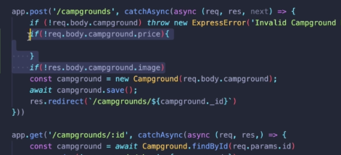

* **That would be really annoying, first of all.**
* **But second of all, to give specific feedback for each one, it would take some time.**
* **And then what if I want to add more a lot more fields**
* **, far more complicated model. This just it doesn't grow well, doesn't scale with the model.**
* **So we're not going to write our own validations.**
* **We're going to use a tool that's been made to do just that.**
* It's something called **JOI**.
* **It's not express specific.**
* **It's just a JavaScript validator tool.**
* It's pretty popular and it is very comprehensive.
* The documentation is rather **so the most powerful schema, description, language and data validator for JavaScript.**
* If we open it up the docs, you click that link to our dev.
* Oh, this took me to a different page, actually.
* Here are the docs.
* OK, that was just our intermediate page.
* There's a nice little demo on how this works.
* **Basically, you define a schema for something, some data in JavaScript.**

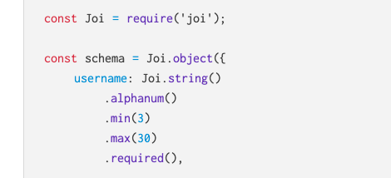

* So **for us, our schema will basically be for the request.body**
* **and we can validate we can make sure that campground** **is there as an object**
* **or title is a string and it's an alphanumeric string.**
* **So it can't, you know, can't have a bunch of weird characters in there**
* **, a minimum maximum length.**
* **, a required.**
* **We can use regular expression patterns.**
* **We can set up numbers where there's a minimum and a maximum has to be an integer.**
* So I can set the schema very simply.
* **I can just create it and then I can validate data by running it through my schema.**

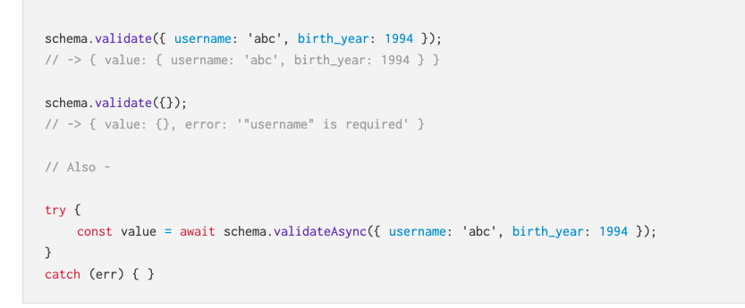

* **And that will give us some error messages potentially if there are any errors.**
* So that's what I'm going to do right now.
* I'm going to install joy.
* Start the server backup, great, then I'm going to require joi
* **Now I'm going to define my schema and to start, I'm just going to do this all in our post about where we make a new campground, and I'm actually just going to comment this part out for a moment.**



* **So this is just our basic sort of rudimentary logic to see if request that body contains campground at all.**
* But I'm going to go a whole lot further here, so we probably won't need that.
* **So I'm going to define my basic schema.**
* **I'm going to call this campground schema.**
* **Now, this is not a mongoose schema.**
* **OK, this is going to validate our data before we even attempt to save it with mongoose**
* **, before we involve mongoose at all, because we've seen those errors are kind of annoying.**
* They're hard to work with.
* This makes it a lot easier.
* **So all we need to do is make our schema Joi.object().**

**Const campgroundSchema = Joi.object({campground: Joi. ‘…’})**

* That's what we want.
* **And then we just pass in the different things that we're looking for.**
* **And we're expecting campground to be a key.**
* **Everything is supposed to be sent under campground.**
* **If you remember what our form looks like, everything is campground square brackets.**
* But do **we have price campground description, so the body must include campground.**
* That's what we were checking for here.
* **So I'm going to say it needs to be a Joi.object().required()**
* **We expect it to be an object and I expect it to be there.**
* **It has to be required.**
* **just saying something should be an object**
* **it is not the same as saying it also is required.**
* **.object() is type**
* **and .required() is required.**
* So **then I can pass in different keys that are nested under campground**
* **because I expect request.body to look like this:**
* **where we have title a string, we have price, which I want to be a number**.
* **So I want that to be nested under campground.**
* And inside of there I'm going to say title is a Joi.string().required() and it's required.
* I'm going to say price is a Joi.number().required(),min(0) and it's required
* I can even do things like give it a minimum, like the minimum is allowed to be a zero.
* We can't have a negative price.
* We can just start with that.
* Let's just see if that's going to work for us.
* **And then once we have our schema defined, all we do is pass our data through to the schema.**
* So that looks like this schema.
* **So campground schema dot validates request body and let's just save that results.**
* **We'll call this const results and just print that out so you can see what happens.**
* **So there's no errors at this point.**
* **We're just going to print it out.**

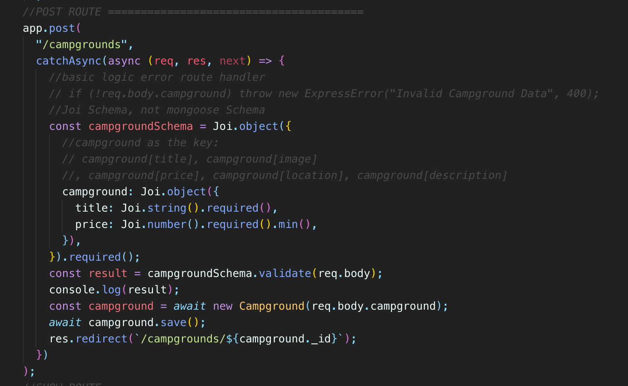

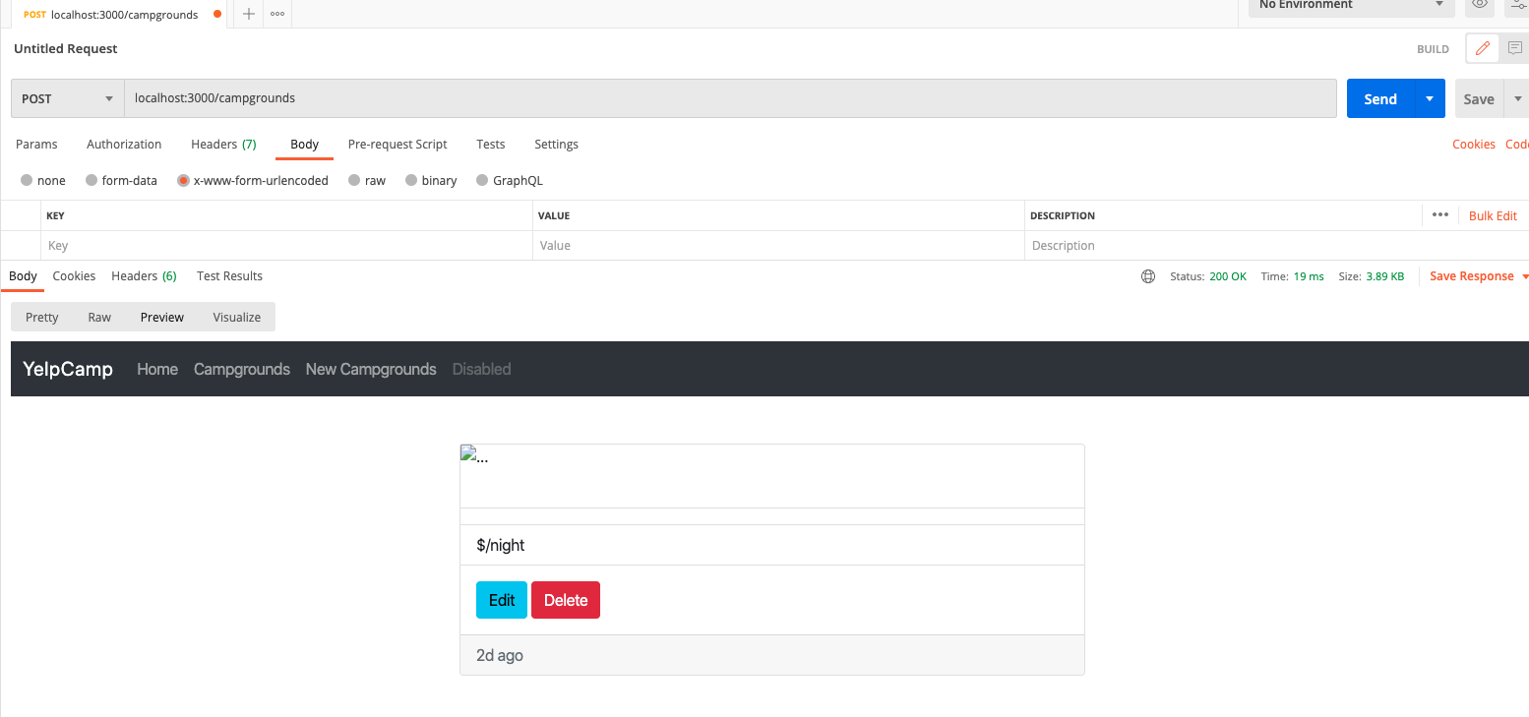

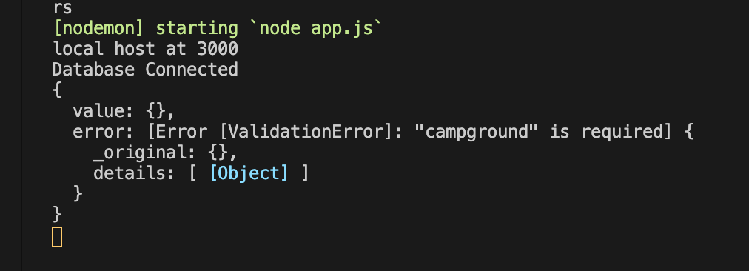

* Let's see what we get.
* So **I'll send something missing everything, our body has nothing, and I'm going to hit that route :**
* **and what did we see says campground is required.**

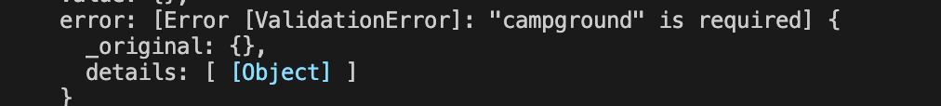

* **All right, so that's in something called error.**
* That's the field.
* So we could narrow this down a bit, console.log.
* Well, let's just do a search start now.
* **If I include campground, but I leave off, you know, it's just campground.**

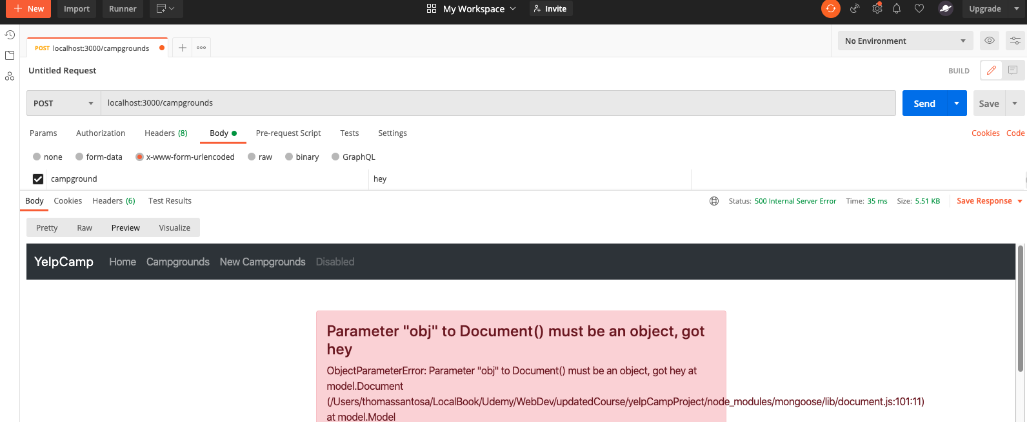

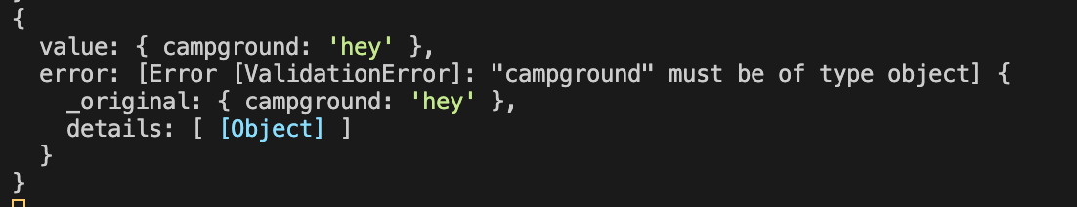

* I don't have anything nested.
* This is what we see.
* **A campground must be of type object.**
* **So now if I set it to you know, this is not an object here , but Express is going to pass it and turn it into an object will include title.**
* **But it's going to complain now that price is required**

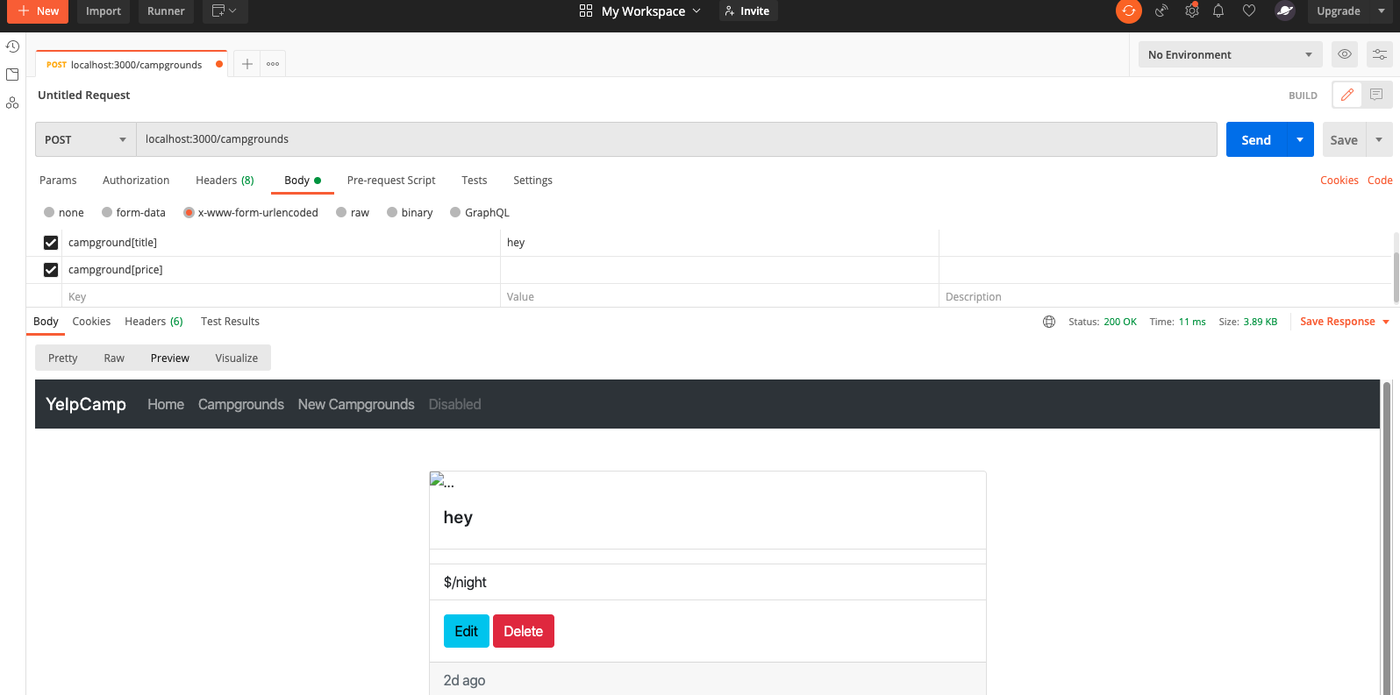

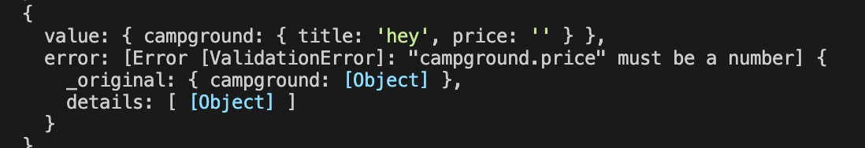

* **so I can include my price, but if I make it a non numeric value, we see campground price must be a number and I can make it a number.**

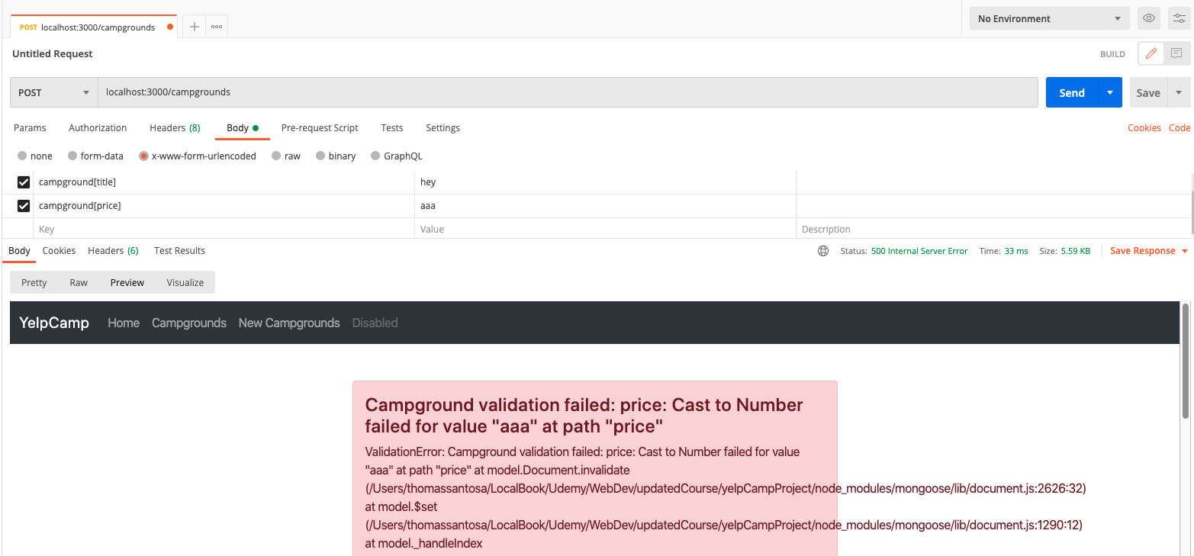

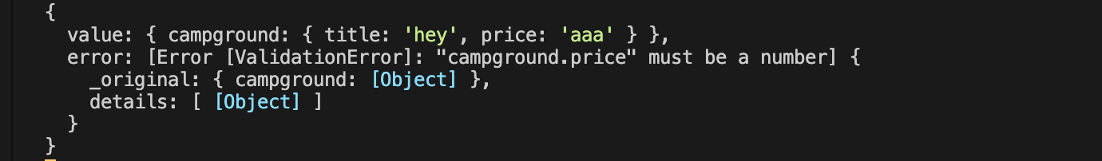

* But what if it's negative?
* What do we get?

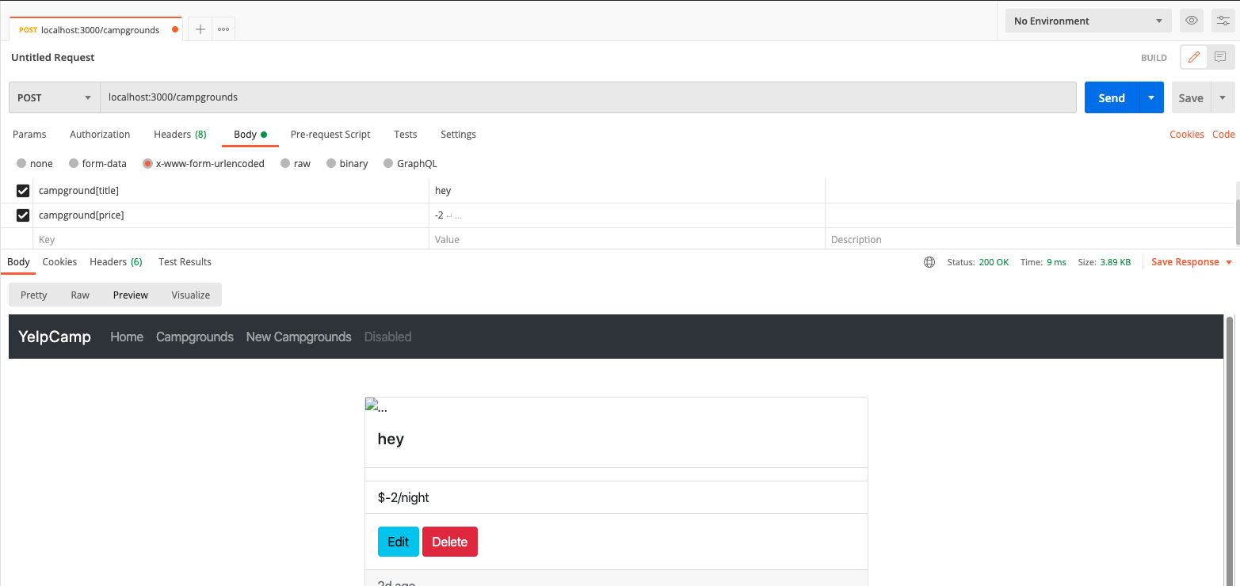

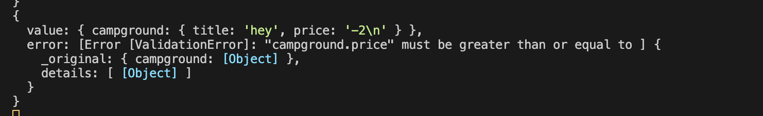

* Campground price must be greater than or equal to zero.
* **So super easy to define that schema.**
* **Now we just need to flesh that out and then also figure out, you know, if there's an error, if we validate and there's an error, then we definitely want to do something.**
* **We don't want to just allow you to make a new campground, which right now we are we're just looking to see if there's an area.**
* We're printing it out, but that's it.
* So let's fix that.

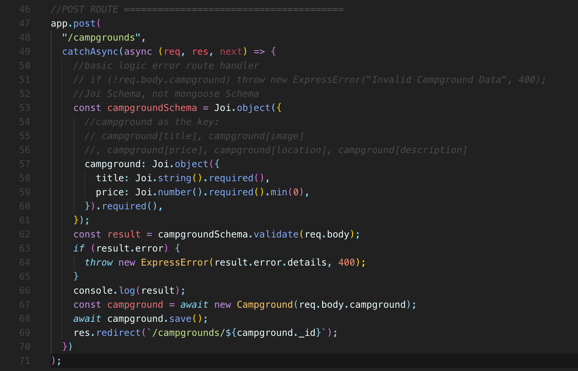

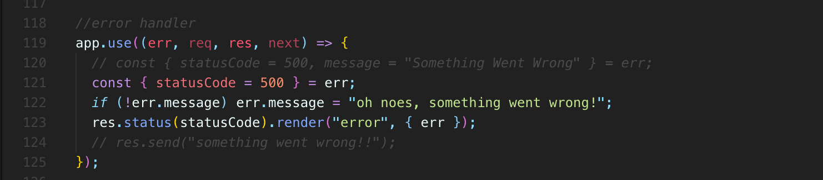

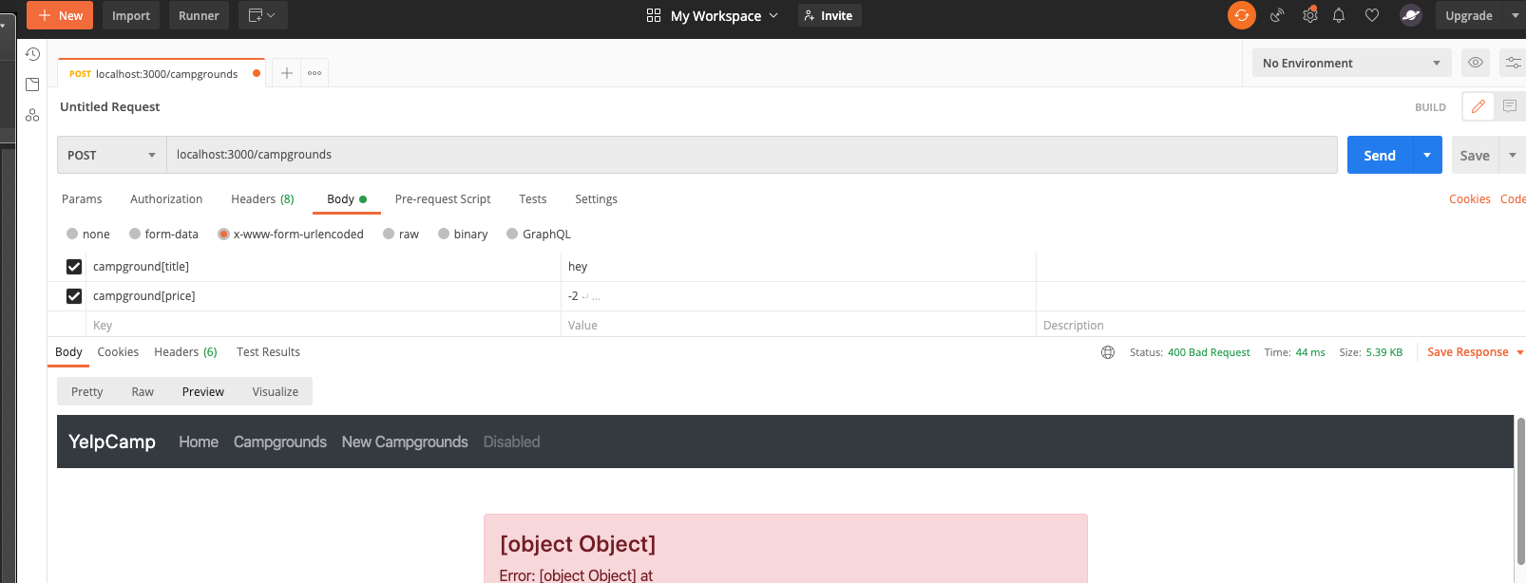

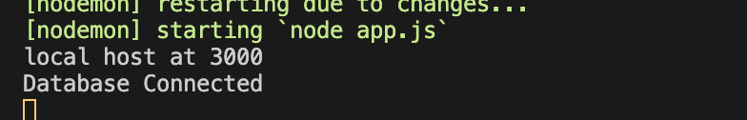

* **We've got our results variable here and let's just check if result ever.**
* If that's the case, well, **why don't we just take information from the errors we've got error dots**, what is it?
* Error.details, I think is **what we want error.details so we can just throw a new express error right here**
* if we wanted to.
* **We are instead of our async function, so we throw that error, it should be cut and pass down to this App.use this error handler.**
* **So if there is a result, that error, we're going to throw that error, ExpresError and we'll pass on in.**
* Result.error.details and the status code will be maybe 400 to start.
* So let's see if that does it for us.
* Let's see what happens.
* Hopefully this never even prints out.
* We don't actually make a campground.
* We should see our error page, our template we made.
* So if I include a negative price.
* **Object, object, so the details, I mean, it worked.**

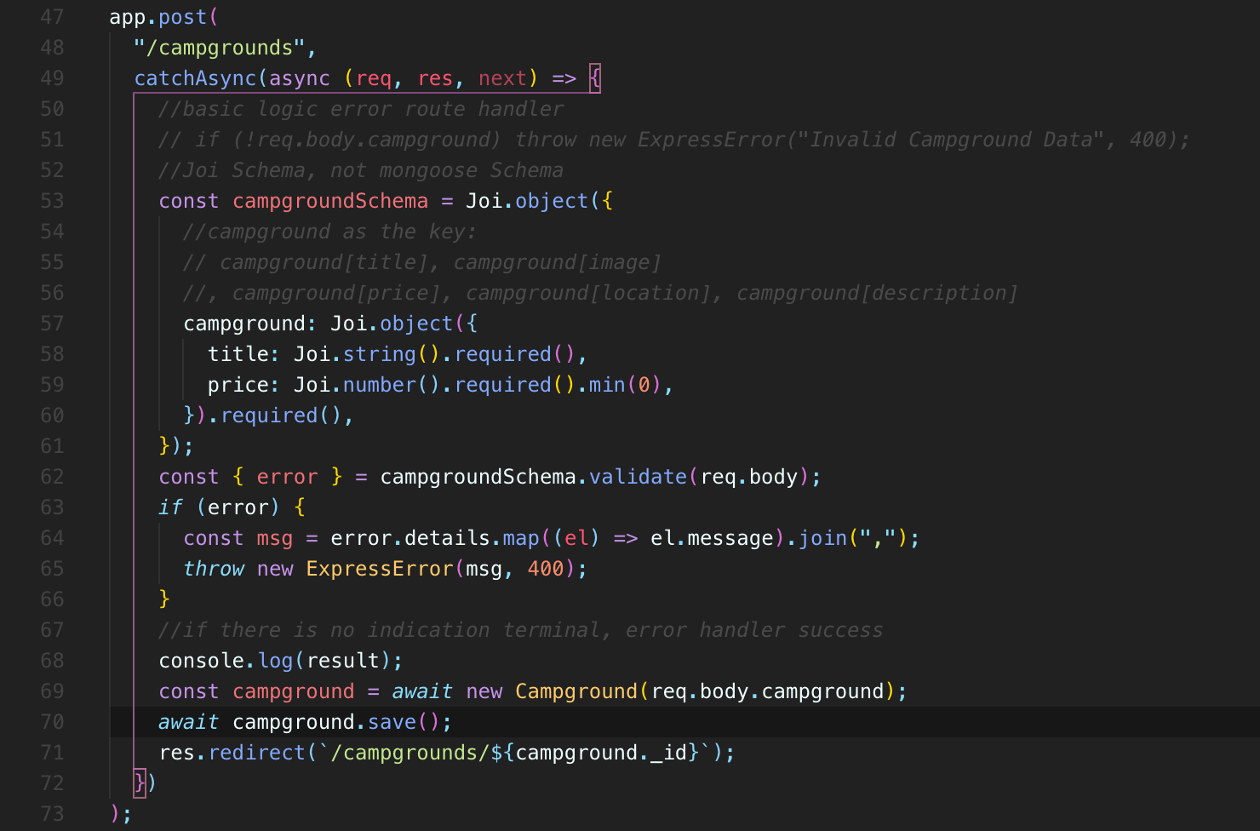

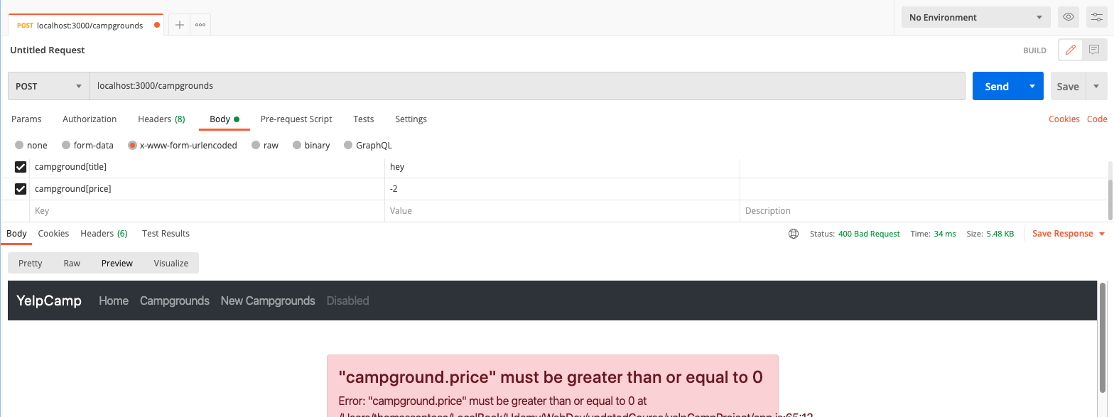

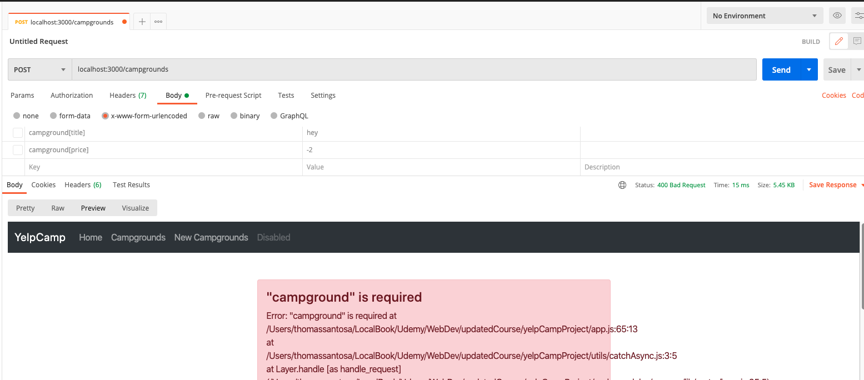

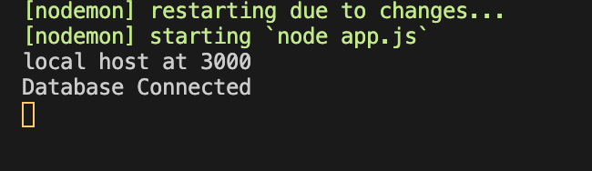

* **We actually didn't create a new campground and we threw an error, but result error details in an array.**
* **So what we need to do is map over that and turn it into a single string and join it together.**
* So that's what I'm going to do here.
* **I'm going to destructure from results.**
* I don't really need results.
* I just want the error portion.
* So if there is an error, we're going to map over error.
* I'll do this on a separate line.
* Const message equals error details dot map.
* And then for each element, I'm just going to return the message.
* This is basically something I did earlier.
* **So I remember how this works and we'll join together on a comma if there's more than one message in there.**



* **So this is just basically to take if we go back here,**
* **think you can see details is an array of objects**
* **and we only have one thing in there**
* **, but we could have more than one so we can map over them, return a single new string that we “join”**
* **Const msg = return a new array that we “join” on a comma into a new string.**
* OK, so that is what we're going to pass through here.
* Thrown to express error with that message status code 400.
* So now let's try a campground price must be greater than or equal to zero.
* If we leave off price, it's required if we leave off title.
* Required, so we only see this if we make it past the client side validation anyway, but this is pretty cool that we have this.
* **You know, it's easy and scale's if I change my model,**
* **all I have to do is, you know, add in, for example, image.url string required location, joy, dot string that required.**

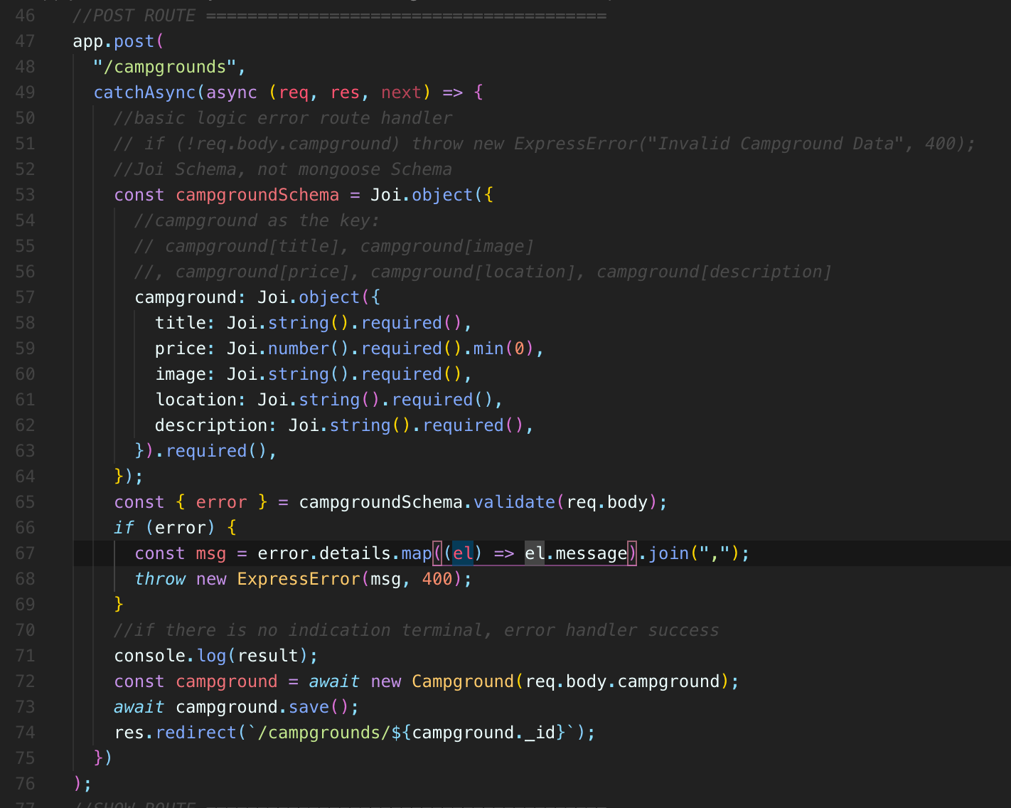



* And there's a lot more that we can do with joy.
* But this is just a simple introduction.
* And I think what else do we have?
* Description.
* Joy, string dot required and I forgot my parents here, so now those are all going to be required as
* So we'll refactor this into a middleware in the next video.
* **But now I can't get through even if I try and cheat using Postman or Ajax or something, I still am validating the data, at least on creation.**
* Not so much when you're updating.
* **So we've got two layers now.**
* **We've got validation on the client side**
* **so that you can't submit an empty form, you can't be missing location title and so on.**
* **And we have our validation here on the server side.**
* **In case you make it past, we've got this second layer that says, number, those things are required.**
* These fields have to be in the body.
* So you better conform to those standards.
* **And now we're handling those errors.**
* **We're throwing this new express error and it's being handled down here and we're rendering our error template cool.**

429. JOI Validation Middleware

* OK, so at this point, **we have our client side validation for edits and for creating a new campground on the form itself,**
* **then we have our server side validations with** ‘**Joi’**
* I've always said Joi,
* I don't know how you're supposed to pronounce it.
* And right now we're only covering our poster out to make a new campground.
* We **should definitely add this logic in for updating a campground**, right
* when we put this put request slash campground slash ID.
* **And that's probably the only two places right now where it makes sense.**
* **Eventually we'll have other models** and **we'd likely like to do the same thing instead of campground.**
* You know, **maybe it's review**
* **or user**
* **or, a larger application**.
* **There's a million things that we might be wanting to validate**
* **a sort of schema for anyway.**
* **The way we're doing this right now is is OK to put this logic**
* **in the route handler itself.**
* **But generally, especially if we're going to use this in more than one place**
* **, we should move this out into something that's more reusable.**
* **And as we just recently learned about middleware, that is what we're going to do here.**
* **We're going to build a middleware and I'll call it something like Validate Campground**
* and **we'll just be able to use it on POST route**
* and **we'll be able to use it on PUT route**
* and **anywhere else where we**
* **would need to validate the request.body.campground and make sure all the important pieces are there**.
* **So we'll make a reusable function to do that.**
* And I'll start by just cutting all of the stuff out.
* **So everything up until we're finding the new campground.**

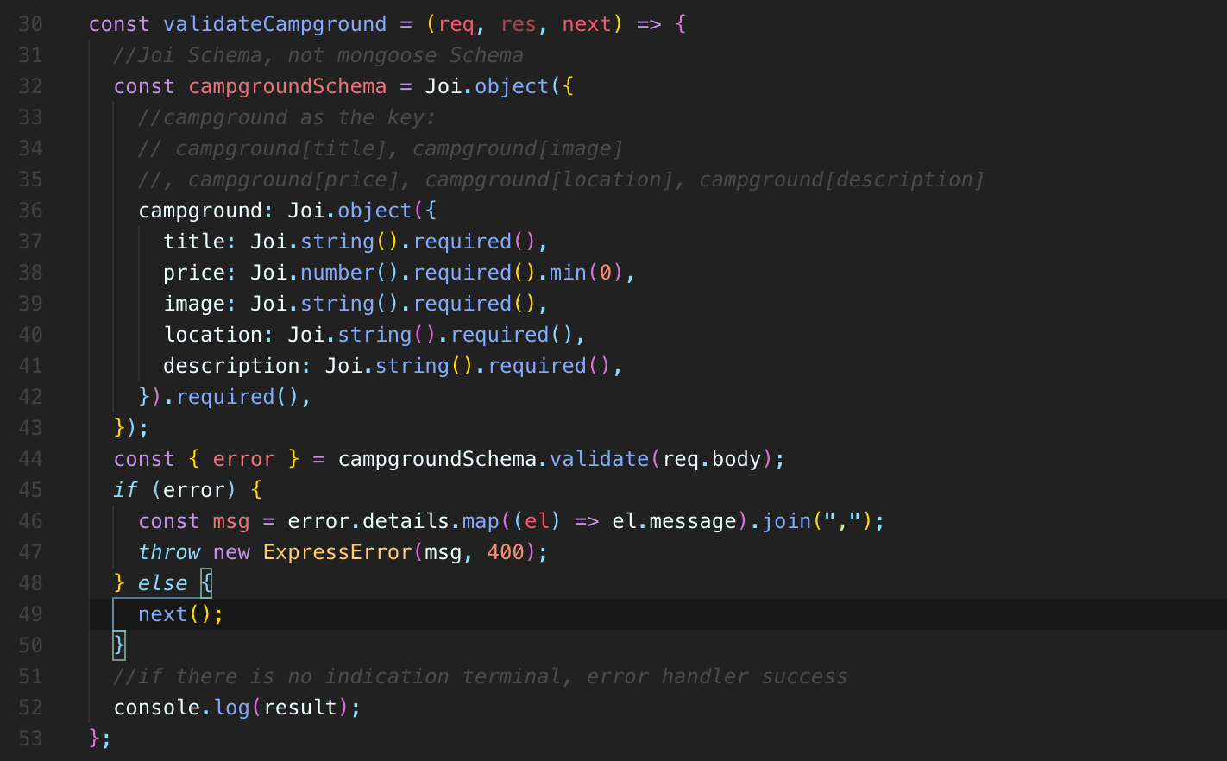

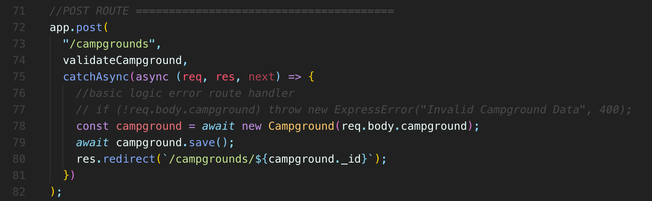

* **OK, then I'm going to go ahead and define my middleware.**
* **So I'm going to start by just writing my middleware function in this file.**
* **Eventually, that would be and it would be crazy to put everything in this one file**.
* It's already quite long, but we haven't talked about **express router, different ways of breaking up our roots.**
* So just keep that in mind for now.
* **We're just keeping it all in one file.**
* **So I'm going to define a function and I'm not going to do an after use.**
* **I don't want this to run on every single route.**
* **I want this to be selectively applied and we've seen how to do that.**
* **So I'm going to define a function here.**
* I'll just call this ValidatesCampground.
* **It's a middleware function.**
* **So the signatures request response next.**
* And then I'm just going to paste the code I already had.
* So we have our campgroundSchema.
* **I am redefining it every time, which will probably move that into a separate file and a bit.**
* But here we are, validate campground requests, response.
* Next, we're going to define our schema.
* Then we **validate** with request Ubaydi.
* **We make sure that request.body.campground and all of these other pieces are in there.**
* You know, they're required that price is greater than zero or I guess it can be zero as well.
* And then if there's an error, we're going to map over the errors, error details to make a single string message
* , take that and pass it through to a new express error that we're throwing in here.
* OK, so that should work for us here.
* Let's see what happens.
* So I'm going to we don't need to console.log result anymore
* , but I can just selectively apply this
* and remember how we add a middleware in to one of our route handlers.
* We just added as an argument so wrapped up post to slash campgrounds, we're going to call ValidateCampground first.
* And if we make it through there
* , which at the moment I'm missing a very critical part
* **, which is we absolutely have to call next if we ever want to make it onto this actual root handler, if we ever want to make it into here.**
* So let's give it a shot.
* Let's see what happens.
* Here's my server running.
* So this is an invalid campground.
* And we get campground up, price must be greater than or equal to zero cool and our route itself
* , the handler for that, for our routes, has no validation logic in here at all or just calling validate campground.
* Same thing over here.
* **You know, if I submit this title location image, but my price is negative.**
* Price must be greater than or equal to zero.
* Now, you know, eventually it would be nice to just keep the user on the same page or refresh the page and show the error up here for form errors instead of just taking them to a weird error page like that.
* But this is fine at the moment.
* Let's also apply it to our app output right here.
* **So that's going to be a validate campground middleware that runs first and then we'll have this run assuming it calls next.**
* So let's see what happens now.
* Let's try and update one.
* You know what?
* Let's start by doing it here.
* In the browser.
* I think the only thing I really can do
* **because I can't just delete something right now, I can actually submit it, but I can do a negative number here.**
* **Or I think it will also work if I have text in there, yeah, price must be a number.**
* So if we take a look at our console, no errors, everything's being handled just fine and we are now validating campgrounds.
* So the last thing I think would be worth doing is just moving this campground schema into its own file
* so that we could have schemas, you know, later on somewhere else.
* The only thing I'm not sure about, just what I want to name that file, because calling it, you know
* **, campground schema is going to confuse some people because we also have our model schema.**
* **And this is not the same as a model.**
* **This is just some validation we're using.**
* **We're employing it before we ever insert something or update something.**
* So, yeah, I'm just going to copy this right here.
* I'm actually going to cut it out where we're making our campground schema and I'm going to move it into a file.
* **I'll just call it schemas.**
* So I'll just put that right here in the top level of my app schemas, js, and then I'll paste it in, and require Joi
* And then I need to make sure I'm exporting this schema and I may have multiple eventually I will have multiple schemas.
* So that's why I'm just calling it schema.js, because they're pretty sure.
* And I'll just you know, I'm not going to put other logic in this file.
* It's purely here for our joi usage in our main app file.
* So I'm just going to do a module exports that which we call this one.
* So we just go with campground schema for now equals I might just add them on like this.
* OK, and then we can add on our others if we have one for review or for user or for whatever else,
* and remember, there's a lot more we can do with joy if we just take a look quickly at the types of validations we have.
* You know, we have things like string, which we're using right now.
* **Something is supposed to be a string, but we can also say, you know, it needs to be a email match, an email pattern.**
* And there's a lot of options for there, you know, multiple or max and min domain segments.
* So how long the domain segments are at the end of an email?
* What else do we have?
* A credit card validation.
* **There's a million things you can write your own custom once, you know, you can say this needs to be an array that's in a particular order.**
* So there's a lot more than what we've covered at this point.
* But this is good enough for now.
* So let's make sure we got this set up correctly.
* So in my app.js, I'm now going to require const campgroundSchema.
* **And I'm going to structure it here because I plan on eventually having multiple schemas that we're exporting,**
* so campground schema equals require and then dot again schema.js
* And then down here in our Validate campground, we can still just call campground schema validate.
* So let's see if that still works for us or if we've broken everything.
* OK, price must be greater than or equal to zero.
* So let's set that equal to, I don't know, fifteen dollars image is required.
* So we'll just add those in, just do it through postmen first to make sure it still works.
* Image, it's just some random thing, location is required as well.
* And it appears everything is working great for us, so here's our location.
* And finally, description.
* Description like that, and here's our description, and we successfully made a new campground, right,
* **so we're not validating that image is a real image or anything like that.**
* We're just making sure it's there.
* So we did create that.
* I'm probably going to go ahead and delete that very soon.
* But that's good news.
* I mean, it's all working pretty well at this point.
* It's a much better experience.
* That's a lot of haze.
* And let's go ahead and delete that.
* And that's pretty much it for now.
* So I know it's been a lot of everyday stuff.
* Oh, we can't get rid of joy in this file.
* **We don't need it anymore because we're exporting our schema from our schemas file.**
* **and that depends on joy, so everything should still work great, so hopefully that's just cause one of those validations to fail.**
* Location is required.
* **You can provide custom error messages if you want with joi**
* But I'm just trying to keep this simple.
* **And I thought this is a good opportunity to introduce a new tool that's helpful, but definitely not mandatory.**
* **You could write those to yourself.**
* **It's just a lot of work.**
* **So using joy, we moved our schema, which is not in mongoose schema.**
* That's confusing.
* **It's just a pattern for a JavaScript object that we've defined in our schema file using joi methods.**
* **Then we use that to validate by calling campground schema dot validate on the request up body on select incoming requests.**
* **In our case post when you're creating a new campground**
* **and the request when you're updating a campground**
* **, both of them use validate campground.**
* **OK, so we validate if it all goes well, we just call next.**
* **It's a middleware so the next thing runs.**
* **If it does not go well, we throw in the ExpressError, which is what we did.**
* The first part of this section, we made our express error class.
* then wrote CatchAsync, we wrote the 404 Handler or the 404 error app that all call.
* And then we set up our default error handler with an error template that we render

**Section 44: YelpCamp: Adding The Reviews Model**

445. Defining The Review Model

* Now we're going to implement the basics of our review model rating or review
* , I think we'll go with review because it's not just going to be a numeric rating, but it will also have text
* We are going to create review model

446. Adding The Review Form

447. Creating Reviews

* 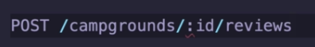
* “Post” that would be our normal
* place to create a review of her following the same restful pattern that we've been following.
* Instead of that, I'm going to just do campgrounds slash and then slash reviews as a post.
* Now, we don't really need full crud or we don't need full restful routes for review.
* So we don't need like an index for reviews and then a show page for single review.
* We're just going to look at them all reviews for a single campground so we don't need everything.
* But in this case, we certainly do want that campground ID so that we can associate that to a single campground with some new review. So that's where we'll post the data to let's make that route.
* 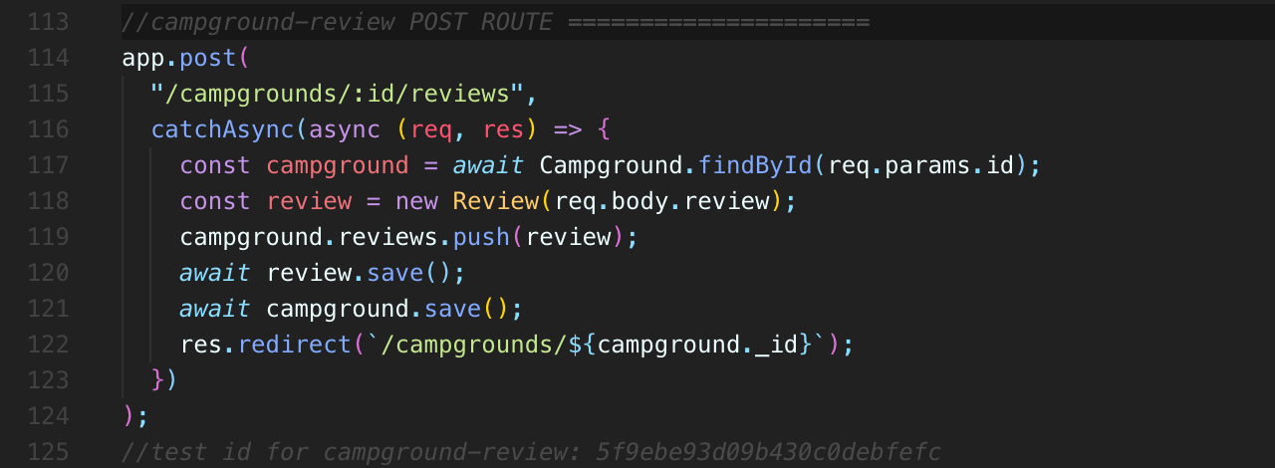
* 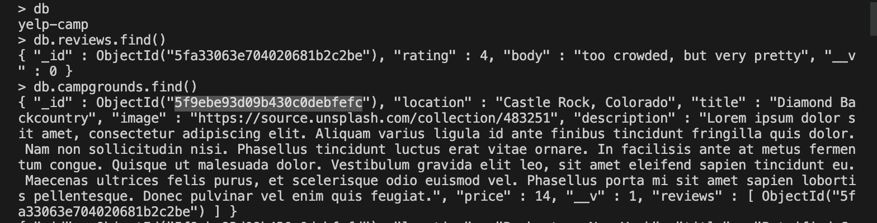
* So for the input of range type, I was a weird way of saying for range and **puts the they're going to have a default value already.**
* **I don't think there's a way to make this have no value**.
* **So we don't need to require it because there aren't really there isn't an option to validate it.**
* **Like when you load the page, I think it just starts in the middle.**
* **That is going to be a value.**
* **It's three.**
* Our text area**, we do want to make sure that there's something in there for the review, so we'll put required there.**
* **But then remember, we have to do this weird thing where we tell the form not to validate with HTML validations**
* , but **then we have the JavaScript that we set up that right now it's just on our** on the boilerplate rather that's looking for a class of validated form to then add the validation logic.

448. Validating Reviews

449. Displaying Reviews

450. Styling Reviews

451. Deleting Reviews

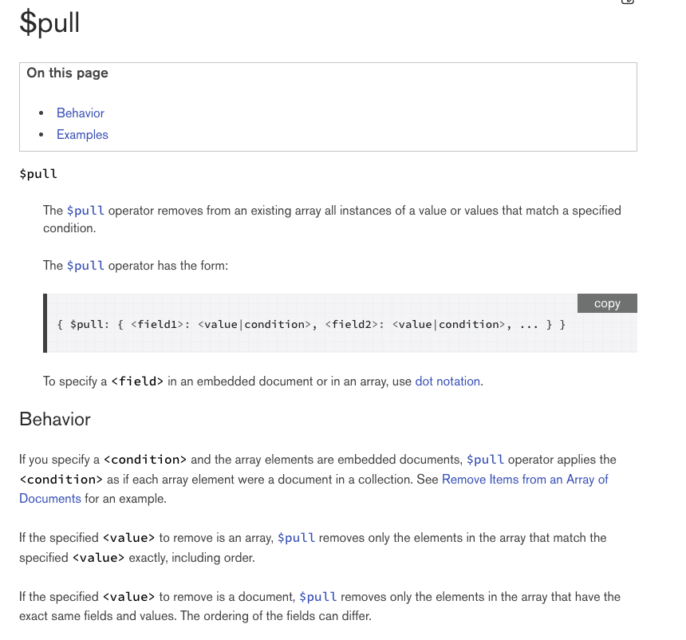

* Basically, we can use an operator in Mongo called $pull and the pole operator.
* It's one of those dollar sign operators.
* **It removes from an existing array all instances of a value or values that match a specified condition.**

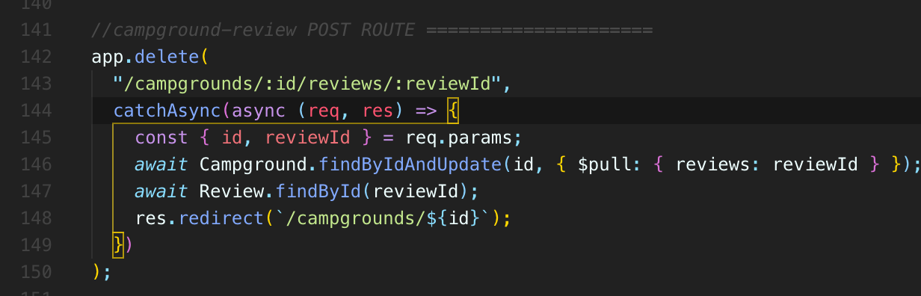

452. Campground Delete Middleware

* All right, so the next thing we need to tackle is deleting the reviews associated with the campground when you delete a campground.
* Otherwise, if we don't do that, which we're not doing at the moment, you know, if I make some very distinct review in here
* Well, just repeat that a couple of times so that we can see it clearly in our control, just very obviously.
* And I'll leave a bunch of reviews with that text on this one campground.
* Let's pretend, you know, imagine there's thousands of reviews in a very popular campground.
* **But the point I want to make here is that when we delete one camp, I'm going to delete it, go to my mongoshell, I'll look at all reviews**
* **All of our loyal reviews are still there, but we're never going to access them, show them they're never going to be queried out of our database, because the only way, the only context we were ever showing reviews was for a specific campground, find all the reviews, populate them for this one campground.**
* **But that campground is gone now.**
* **So those reviews are orphaned.**
* **We're just going to do something pretty similar to what we did previously with our farms and what was it farmed and products or something where we need to basically have our delete cascade down to the review and any reviews that are stored in the campground model.**

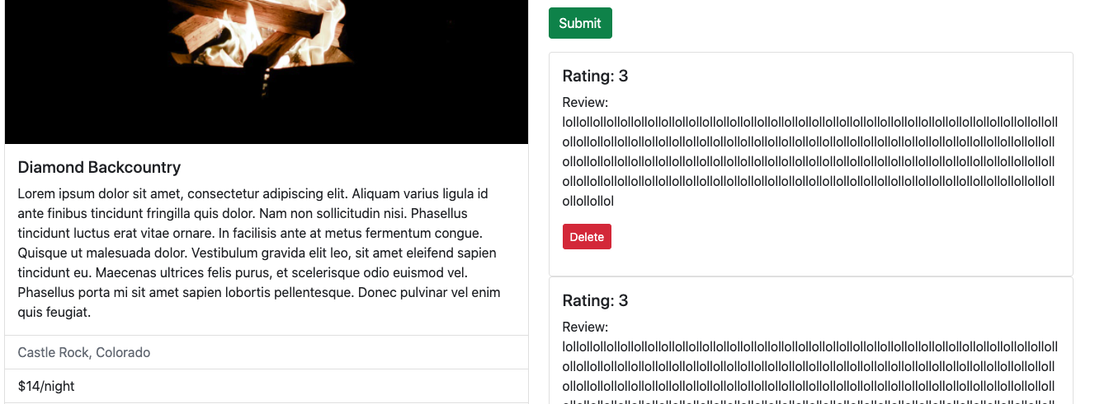

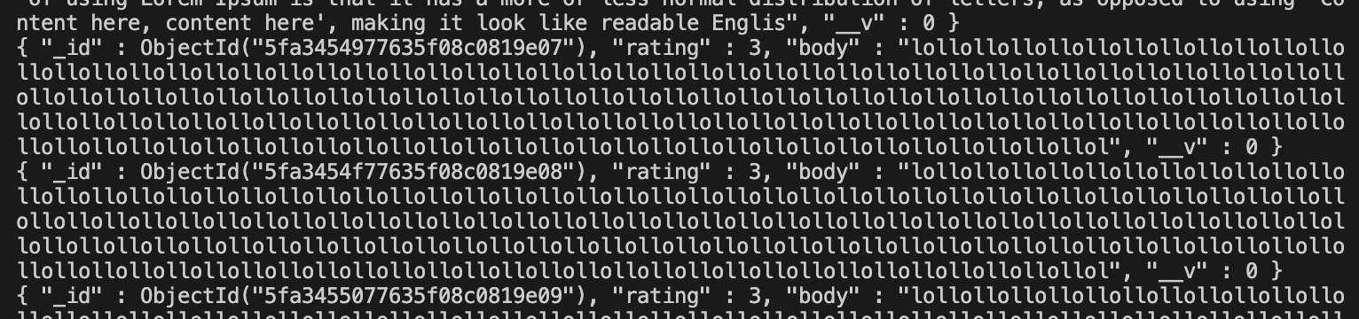

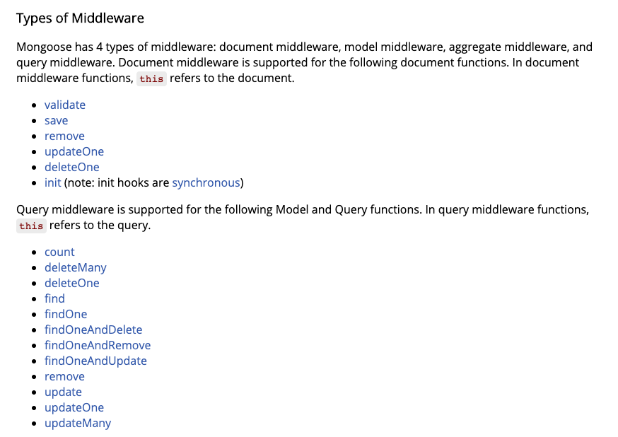

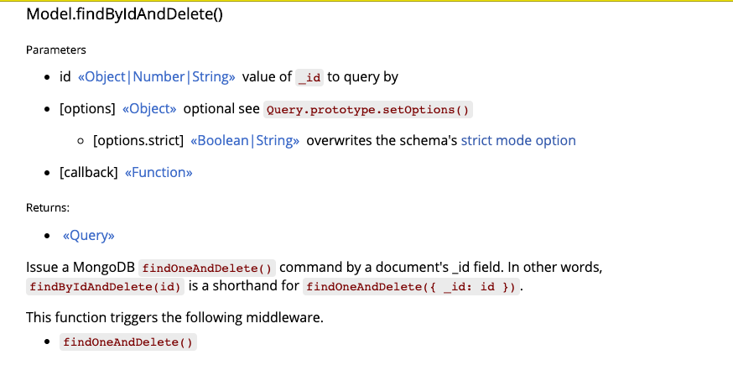

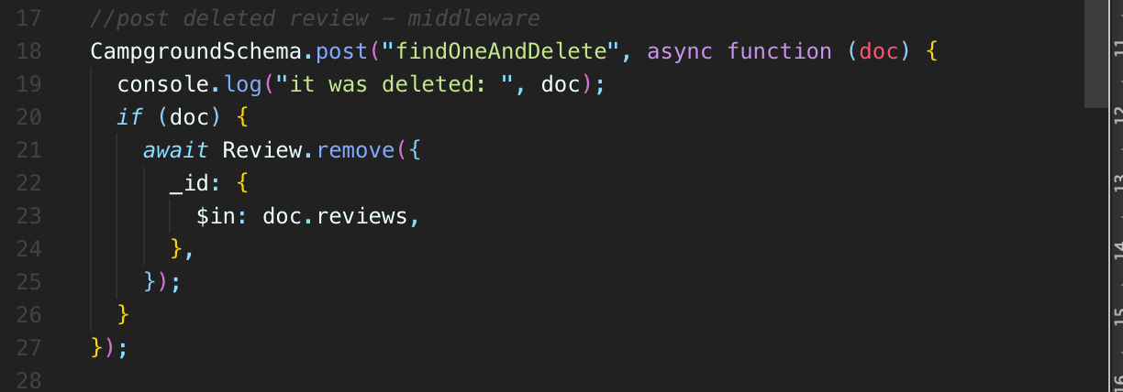

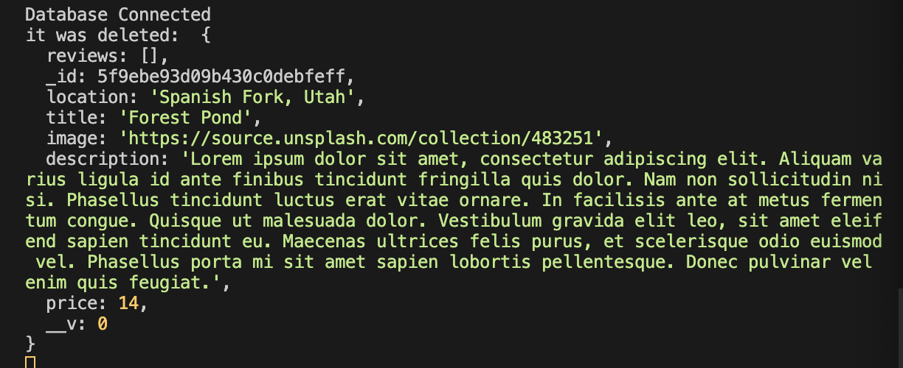

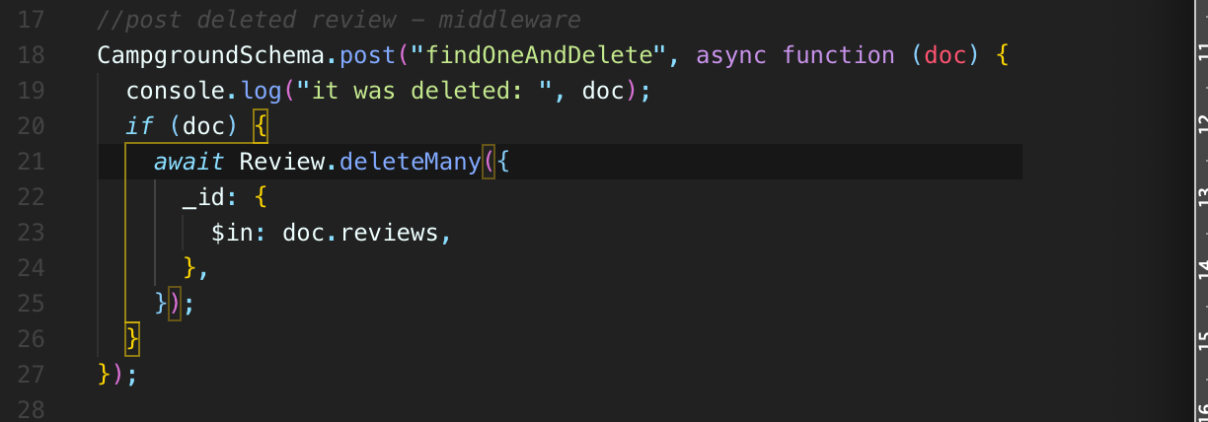

* Now, just to be very clear
* **, if I change the way I delete a particular app.js campground, which is right here, I'm doing fineByIdAndDelete.**
* But if I did something else, like I used the removed method or deleteMany, well, that is not going to trigger this middleware.
* I wish there was just a and there might be a better way of doing just a generic if any campground is deleted ever.
* I don't care how we probably could write a middleware that kind of handles all those situations.
* **But since we're just doing our easy option, findByIdAndDelete that only calls, findOneAndDelete middleware**.
* So we need to define that middleware and it's just annoying anyway.
* So that's that we are successfully deleting associated reviews for a given campground.

**Section 47: YelpCamp: Restructuring & Flash**

467. Breaking Out Campground Routes

468. Breaking Out Review Routes

* You know, any time we break things up, we're going to have things that they go wrong because we have dependencies.
* We've got to move certain requires over into the right folder and change their path.
* 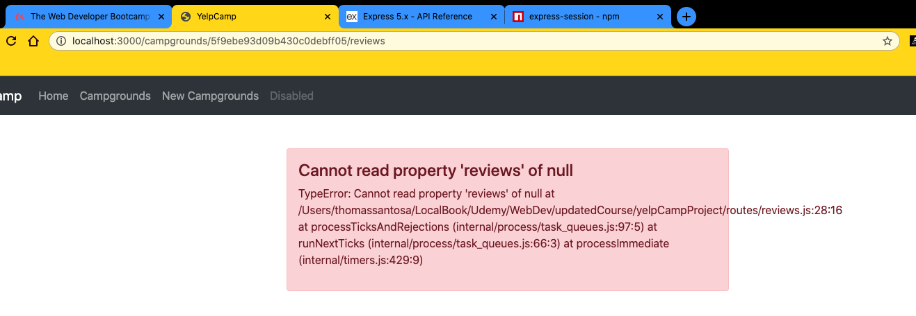
* 
* Why would that be NULL?

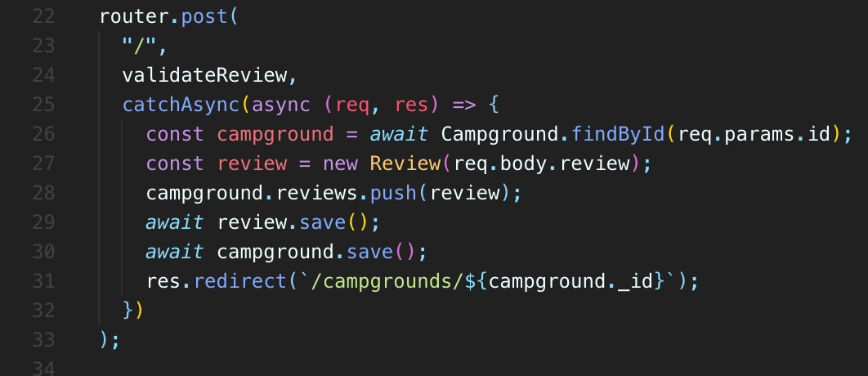

* It's not able to find a campground with this ID.
* Why is that?
* Well, if we look at the request.params where the idea is supposed to be.

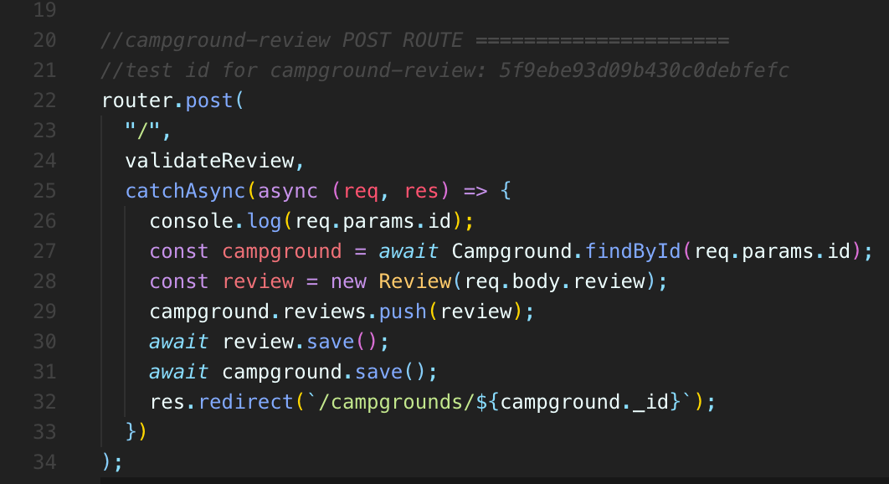

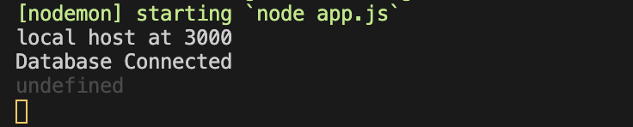

* **And I send this request that we just sent, we'll do it one more time.**
* **There is definitely an idea in there, but why don't we have access to it?**
* **It's just empty.**
* **This is kind of an annoying thing.**
* You also have been saying that a lot.
* **But it comes it comes up occasionally when you're working with the express router.**
* **Express router likes to keep them separate**.
* **So over here, we're saying there's an ID in the route in the path**
* **that prefixes all of these routes.**
* **But by default, we actually won't have access to that ID**
* **in our reviews routes**
* **, routers get separate programs and they are separate.**
* **But we can actually specify an option here, which is {mergeParams: true}**
* **and set that to true.**
* **Now, all of these programs from over here are also going to be merged alongside the programs in reviews file.**
* **So we'll have access to that ID hopefully, and if I refresh and trying to try it again.**
* **It now works and you can see that my Purim's does have that ID in it, so that's mildly annoying that you have to be aware of that it's not a problem for our other one for campgrounds, because the idea that we need in our campground routes**
* **, it's all defined in this route, in that path, and we're simply prefixing with such campgrounds.**
* But if we need access to this parameter req.params
* **, if we need access to that parameter or more parameters that we define in this file when we're using the routes**
* **, we need to make sure we set merge parameters to. True.**

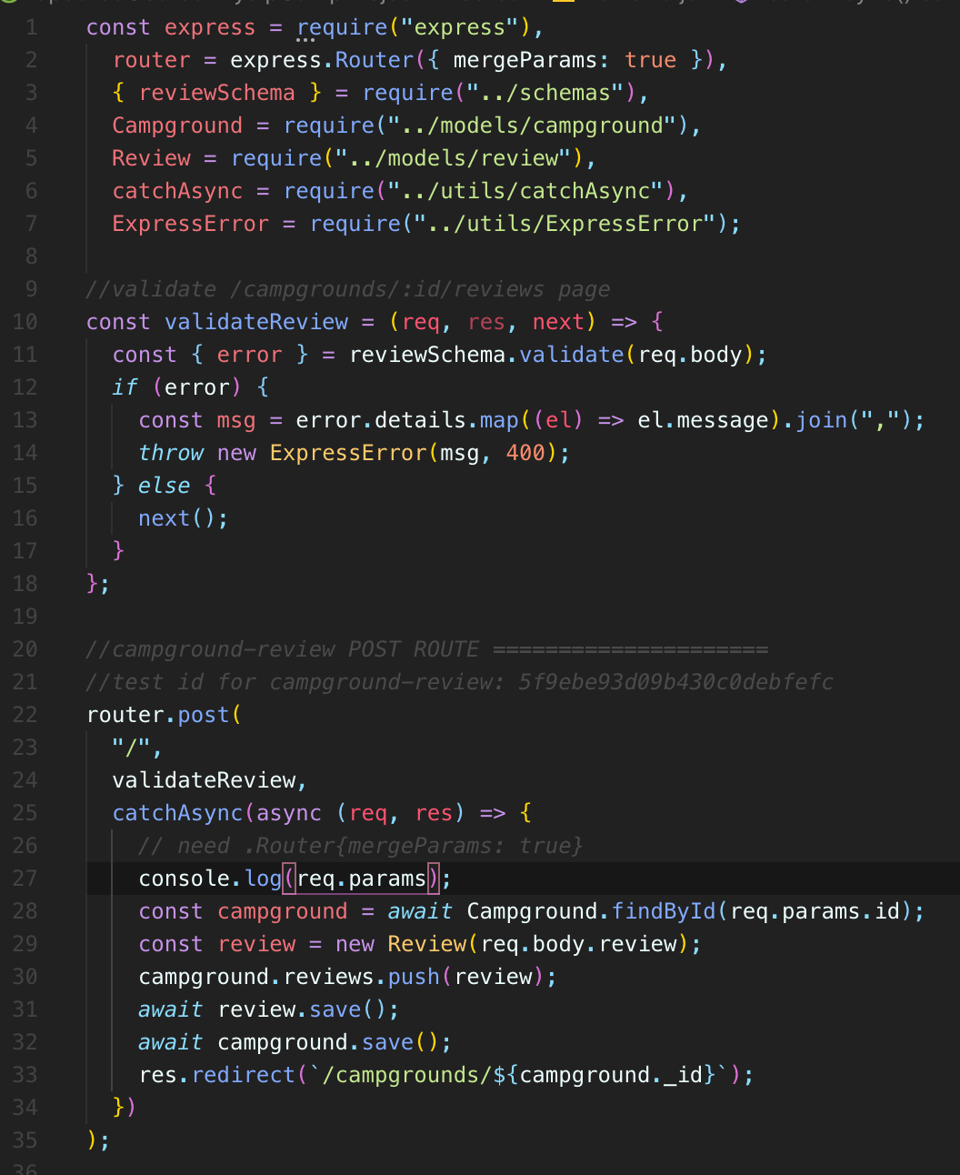

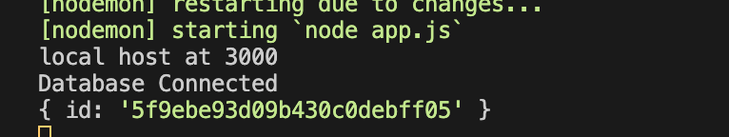

469. Serving Static Assets

* So we need to make sure that we are telling Express to serve our public directory.
* our static assets so that we could have images and custom stylesheets and JavaScript that we can respond with.
* So we're just going to make a directory to start. I'm just going to call this one public.

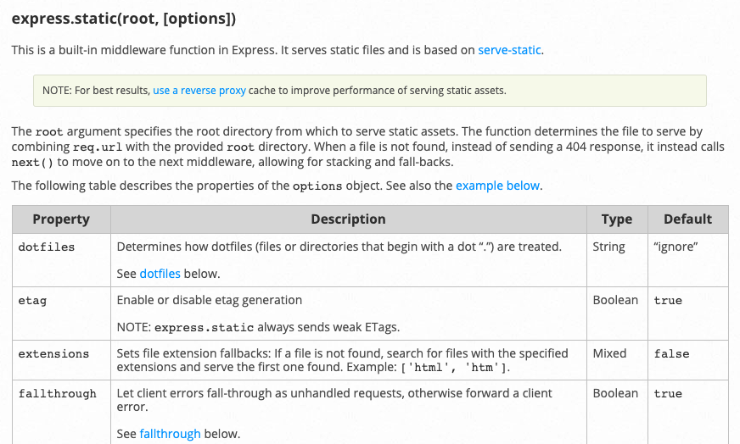

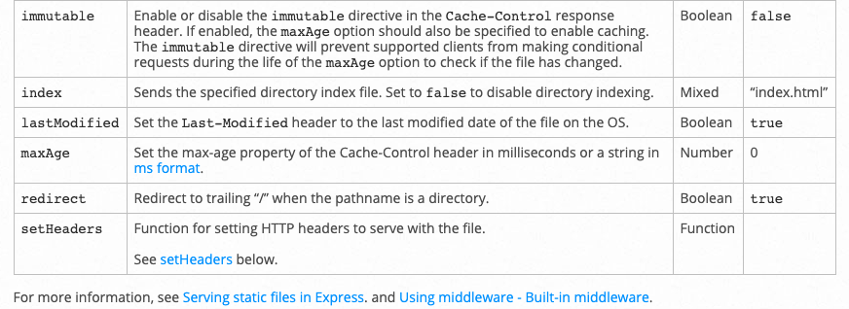

470. Configuring Session

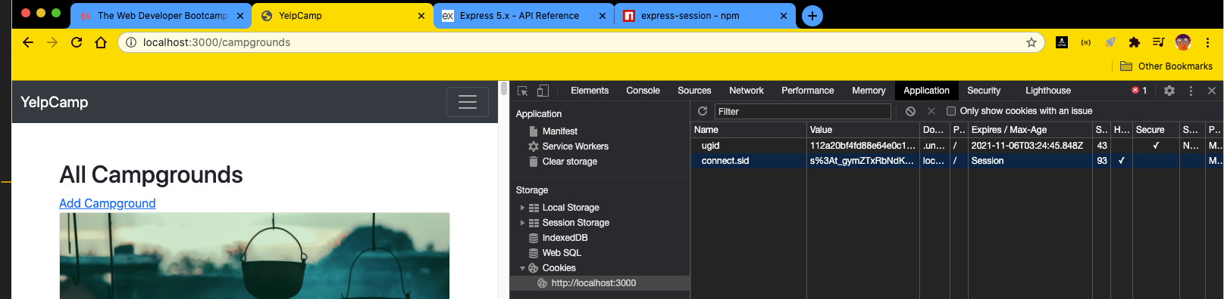

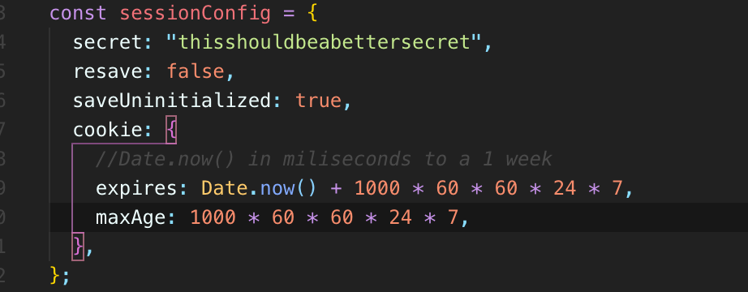

* You'll see the cookie that we get back has an expiration on it, which is a week from now, September 11th today, and this is going to expire a week from now.
* 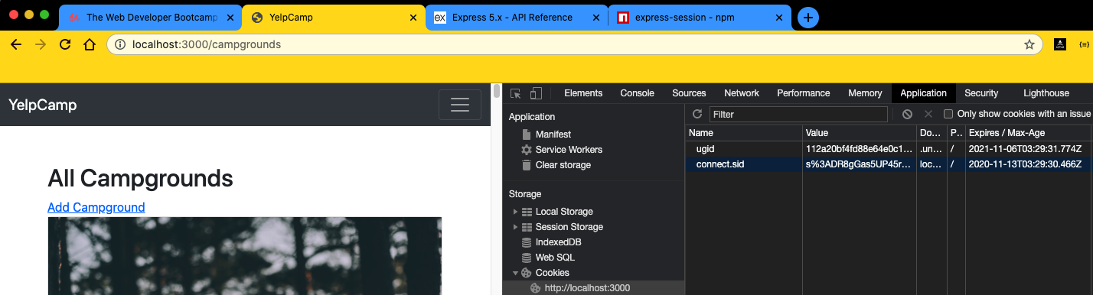
* 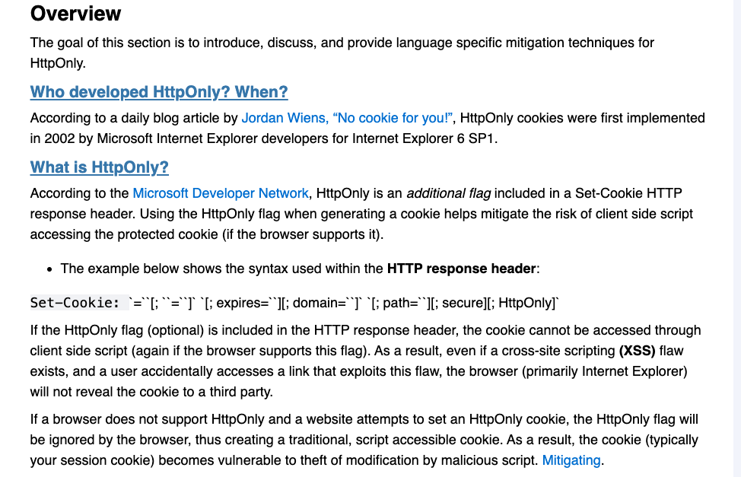
* **But for now, I'm just going to set this while we're setting up our session.**
* There's an option called HTTP.
* Only you can see that here.
* Actually, I guess the default is to enable it.

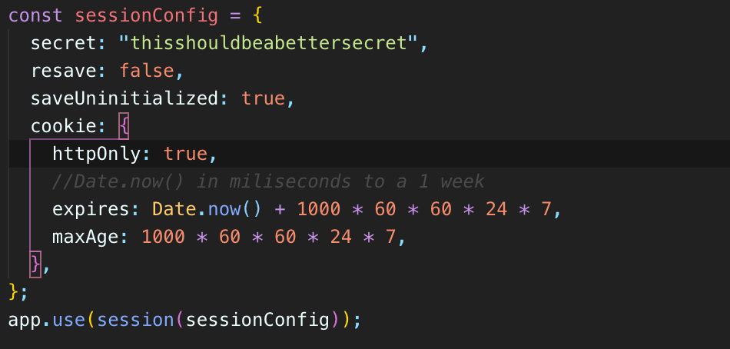

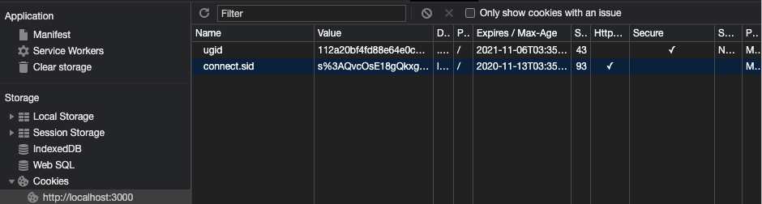

* But **we're just explicitly going to set HTTPonly to true**
* and according to this spec here, this document, and explains
* **that if this flag is included on a cookie**
* **, the cookie cannot be accessed through client side scripts.**
* **And as a result, even if cross site scripting:**
* **, which is really not something we've discussed yet,**
* **but even if that exists and a user accidentally accesses a link that exploits this flaw**
* **, the browser will not reveal the cookie to a third party.**
* **It's just a little extra security thing that we should add in.**
* So I didn't teach this when we introduced session, but it's just a good time to introduce it now.
* HTTP only will be set to true.
* Now, I guess that is the default these days.
* So we don't see it still.
* It's just set to HTTPonly with that check mark there.
* But what's more relevant for now is setting this expiration date.
* So we definitely want to have an expiration in there, otherwise someone would basically just stay once
* **we use it for authentication, they could stay locked in forever on a computer just by signing.**
* **And once usually we don't want that.**
* **And there's a lot of reasons, you know, we want this to expire eventually, but that's one of them**.
* **Anyway, we've got our session set up.**
* **We're getting that session ID or that cookie coming back called session ID, and it has an expiration**
* date set up a couple of other options that we didn't talk about.

471. Setting Up Flash

472. Flash Success Partial

473. Flash Errors Partial

**Section 49: YelpCamp: Adding In Authentication**

487. Introduction to Passport

* We're going to be using a tool called **Passport**
* **, which is a library. It's very popular and it helps you add authentication into node apps.**
* But what's really cool about it, and I mentioned this a while ago**, is that it also comes with a bunch of possible strategies, different, different ways or services to log someone in using.**
* **So that could be Facebook and Twitter login, Google login, or it could be local login, which is what we're going to begin with.**
* **But I want to use this and I recommend using something like passport because it can grow with your app if you decide.**
* **We also want to support Twitter login and Google login.**
* **You can add that using passport and it's relatively easy if instead you had implemented your own path from scratch like we've already done.**
* And we do that with Yelp camp.
* **And then you decide, I also want Twitter login.**
* It's kind of a huge headache, to be honest with you.
* **So if we get into this passport ecosystem, it's way simpler for you to change your mind or to add on cooler or I shouldn't say cooler, but other login strategies.**
* **But I really hate teaching Passport as the first entry point into authentication as your first exposure to how authentication works, because it hides stuff.**
* **It's very magical seeming if you don't understand what it does behind the scenes.**
* **So you should have an understanding.**
* **If you watch that authentication section, you should understand hashing and, you know, Bcrypt and the session and what role the session plays in how we keep track of a current user, how we log someone out, how we log somebody, and how we actually store a password or rather don't store the password.**
* **But what we store instead, all of that, hopefully you understand at a conceptual level, because with passports, it is going to hide a lot of that from us.**
* So it's a great tool to use.
* **Very popular and it's extremely useful.**
* But I think it's a horrible way to learn authentication the first time.
* So I'm doing it the other way around.
* **We've already learned the basics of off and how it works.**
* **Now we're going to level up and use the fancier tool that hides a lot of those basics.**
* **OK, so we're just going to do basic passport, local login, which is just username and password.**
* It's still relatively easy.
* **You'll see that we have to make a decent amount of changes in a couple of files.**
* We've got to make some new files.
* It's not like you just plug it into your app and you're done.
* We still have to do some work here.
* We just don't have to do as much work.
* So we're going to use passport local, which is one strategy.
* But in addition, there's actually a specialized tool, passport, local mongoose, which makes it even easier if we're using a mongoose database.
* So we're going to install all three of those.
* They if we want to use passport, local mongoose, it does require passport, local, and that requires passport.
* And then again, later on, you could add on passport, Facebook and passport Twitter if you wanted to.
* So I'm going to go ahead and install all three of those right now.
* I think I'm just going to copy this line that they recommend.
* Just so you have it.
* NPM install, passport, passport-local and passport-local-mongoose.

488. Creating Our User Model

* Now we're going to create our user model.
* We're going to store user information, you know, username, password.
* Also, I'm going to add an email so that maybe eventually we could send an email at some point
* , whether it's password reset or maybe just some sort of tool, I don't know, something involving an email address.
* It's always good to have.
* Plus, I just want to show you that you can add on additional fields when you're working with passport.
* 
* Just pass **in the result of requiring that package that we installed to use your schema plug in**,
* **and this is going to add on to our schema a username**.
* **It's going to add on a field for password.**
* **It's going to make sure those user names are unique.**
* **They're not duplicated.**
* **It's also going to give us some additional methods that we can use.**
* **So this is why, you know, when I said using passport is great, it's also a horrible teaching tool because it's totally hidden.**
* **We don't know that it's adding a password and adding a username field.**
* **Unless you have somebody tell you that you look at the ducks like it doesn't make it very clear at all, but that's what it's doing for us.**
* 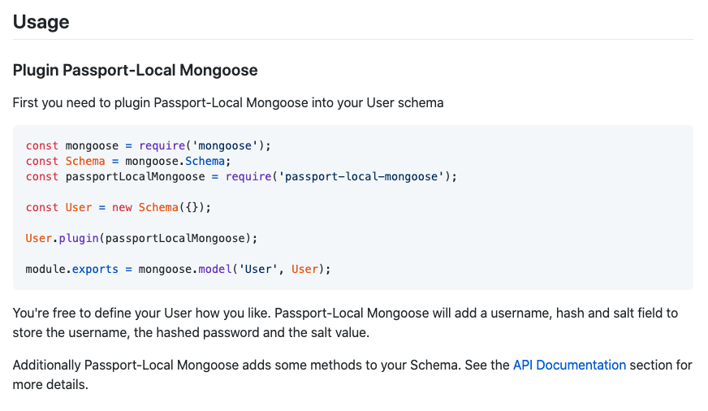
* **User model**
* 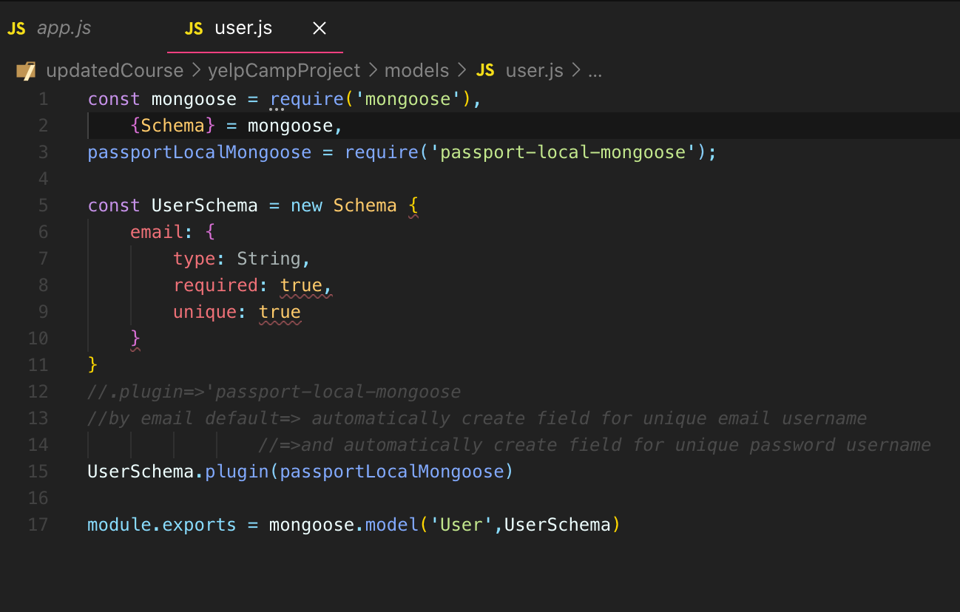

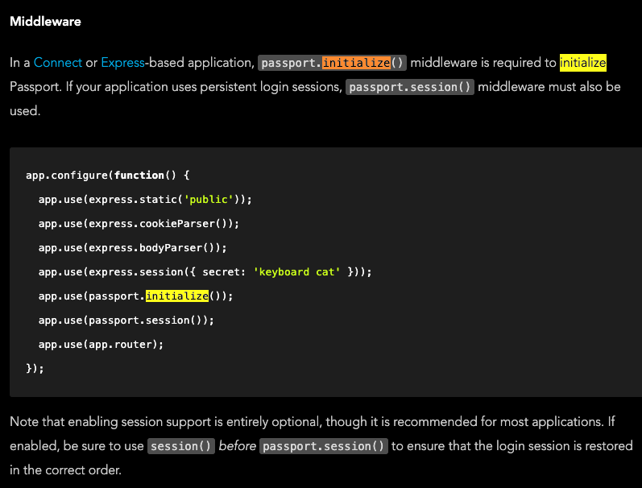

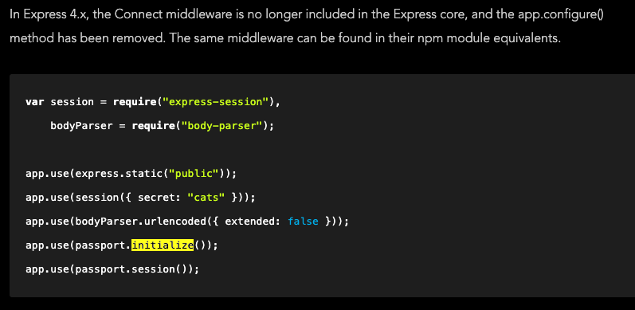

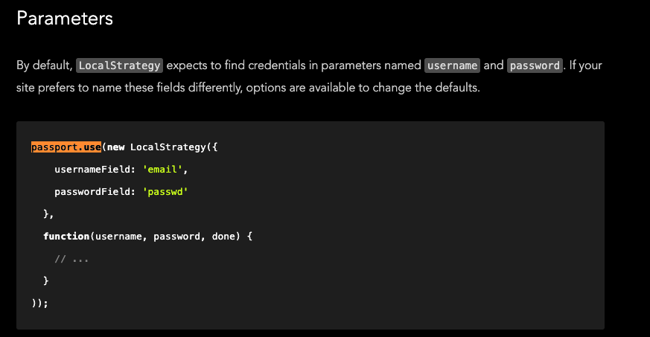

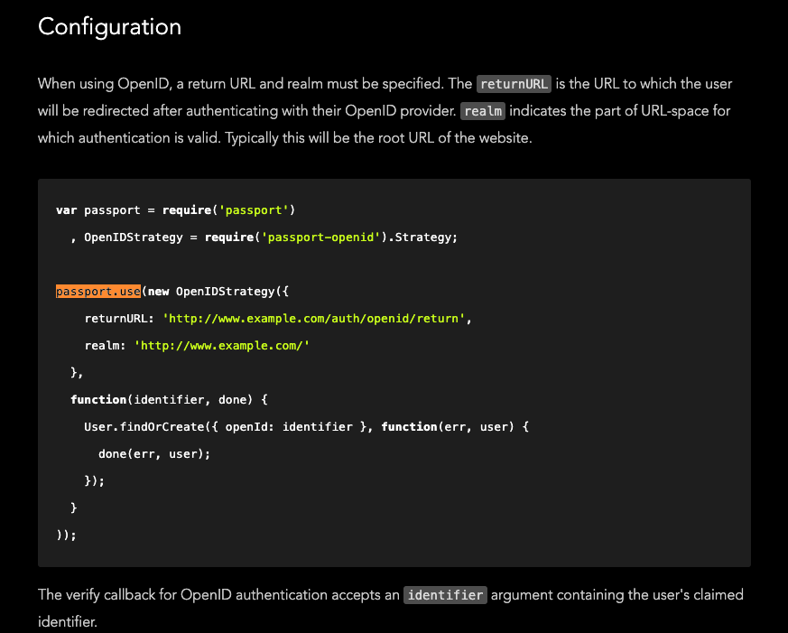

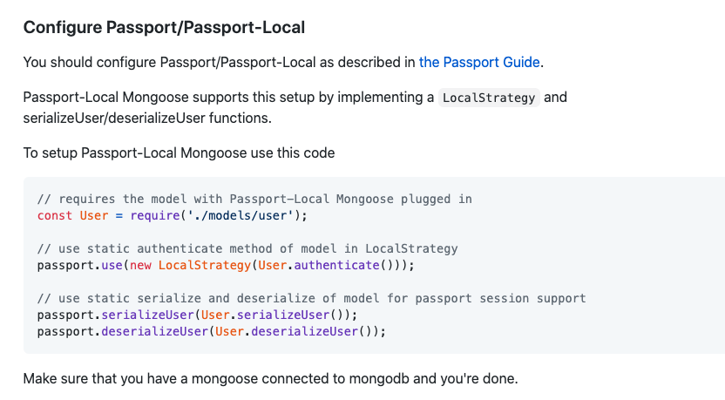

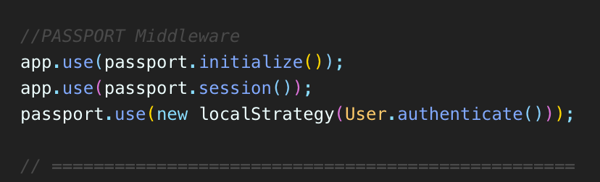

* **what we're saying here is that**
* **, “hallo, passports, we would like you to use the localStrategy that we have downloaded and required and for that localStrategy, the authentication method is going to be located on our User model, and it's called “.authenticate” (“User.authenticate()”**).
* Now, we don't have a method on here called authenticate, at least not one that we made.
* But again, it's coming from this passport, **local mongoose on the docs** for that.
* **It tells us these are the static methods that have been added in, automatically authenticate right there generates a function**
* **that it's used in passports, localStrategy.**
* So this is why it's you know, I don't want to teach this stuff first.
* It's fast, but very confusing if you don't understand what happens behind the scenes or at least if you don't have a basic understanding of how authentication should work.
* 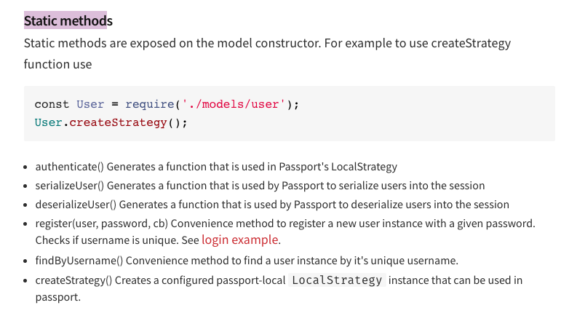

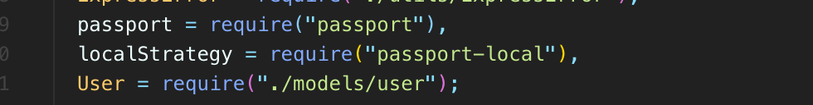

* 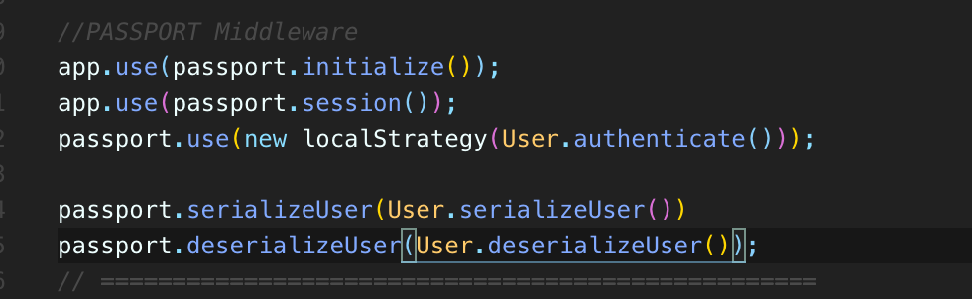
* **Passport.serializerUser()**
* is telling passports **how to serialize a user**
* and **User.serializeUser()**
* refers **to basically how do we get data**, **how do we store a user in the session?**
* And then the opposite **passport.deserialize**()
* **How do you get a user out of that session user**
* Once again to methods that have been added in thanks to this **plugin (passport-local-mongoose)**
* So **whatever strategy we're using in this case**
* , we're telling **Password** to use **localStrategy**.
* **We can have multiple strategies going at once**
* , but in this case, **just this one**, **we need to specify the authentication method which was added for us automatically**
* **and have to write that**
* and **how to deserialize and serialize a user basically how to store it and onestop in the session.**
* **And those are two methods that we're specifying here on our user model.**
* **They've also been added in automatically for us.**

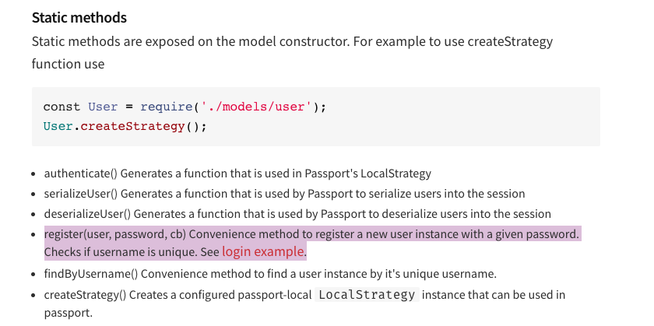

* 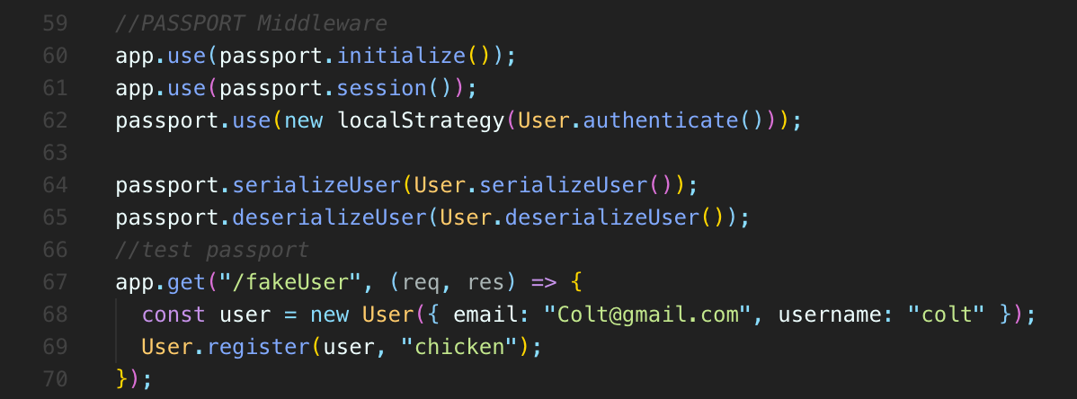
* **Now I don't pass in the password right now because what I'm going to do next is call the register method**
* **which is provided as a helper thanks to our passport-local-mongoose**
* **mongoose plugin convenient method “.register()”**
* **to register a new user instance with a given password.**
* **Also checks if username is unique.**
* **So users register takes that entire user model,** **the instance of the model**
* **, and then a password and it's going to hash that password**
* **, store it hopefully correctly.**
* So we will await that.
* It does take time.
* So we'll call this new user or, you know, registered user.
* OK, so let's see what that does for us.
* **so we didn't have to write this method, we didn't have to really do a whole lot in terms of our model.**
* **But hopefully this will work and you'll see that all we do is provide a user object and provide a password and it takes care of the rest.**
* 
* **It hashes that password takes a salt, stores of salt and the hash on our user.**
* 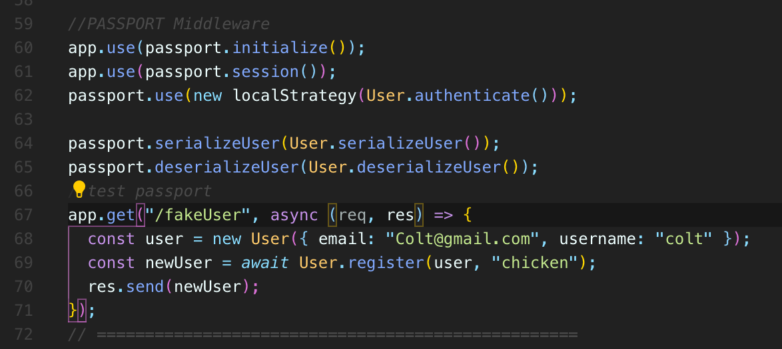
* 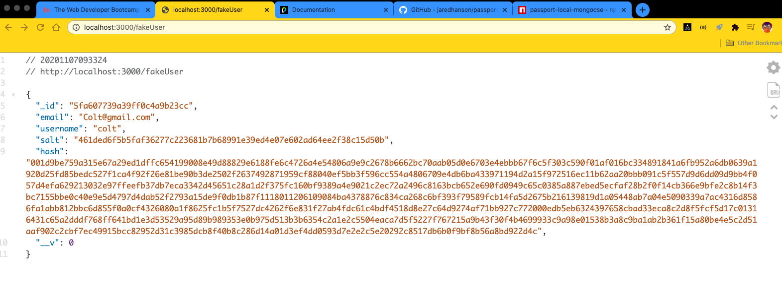
* 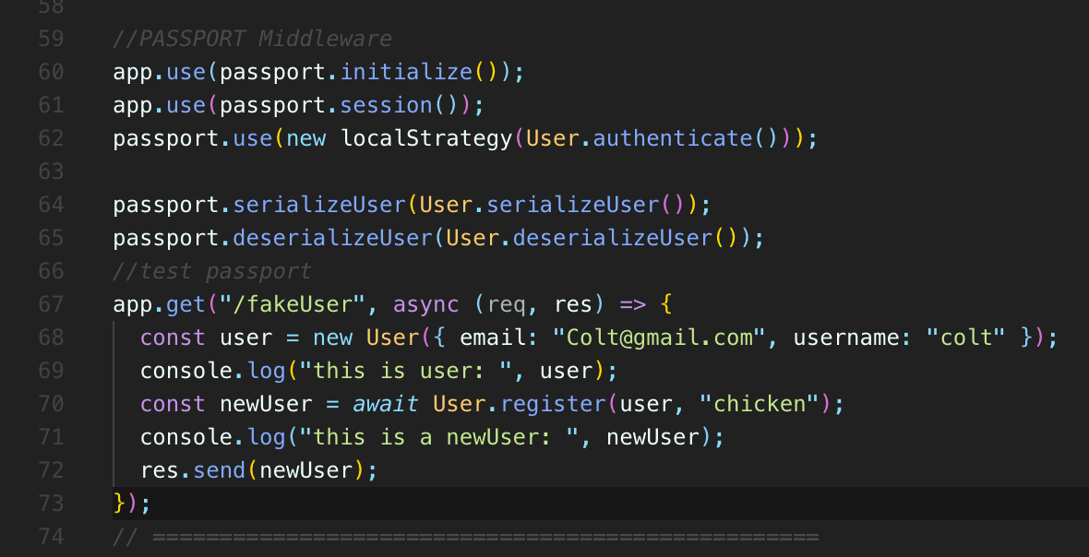
* 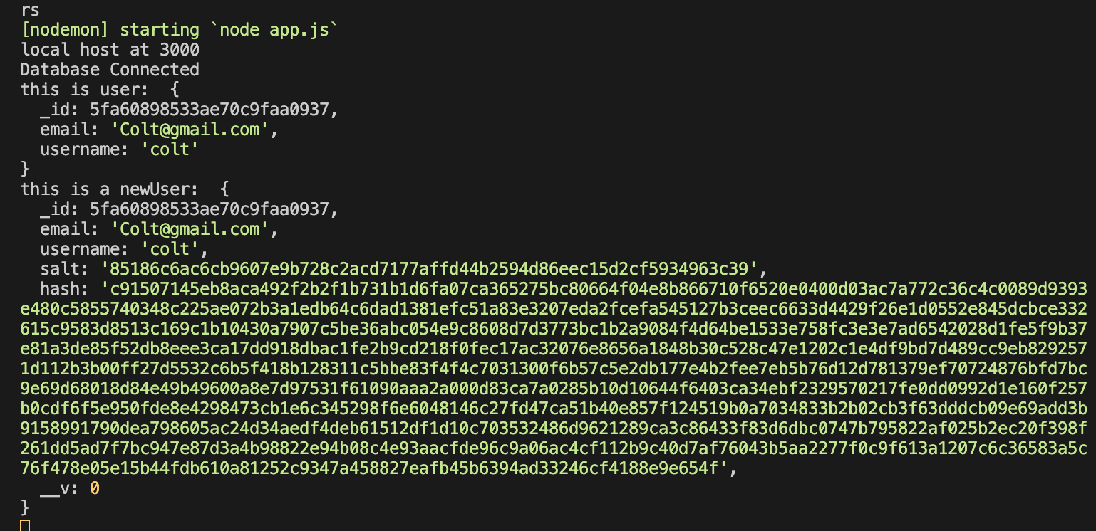
* So we've got an :
* **_id,**
* **,an email**
* **, username**
* **, salt.**
* **, hash.**
* **Also checks if username is unique.**
* 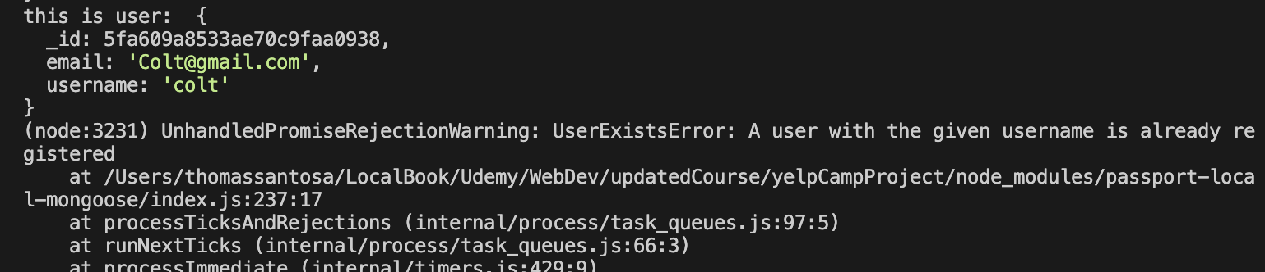
* **So hash, I never did any of this.**
* **I didn't even say that there should be a hash field.**
* **I didn't say that there should be a salt field, but it worked already.**
* **If we want to register a user, all we need to do is call this user register method and there's also a login method that we'll talk about.**
* There are other things you need to do, a log out method, but basically passport and passport, local and passport, local mongoose combine to give us a bunch of these methods and tools that we would have to otherwise define on our own.
* So next step will set up the register routes and also set up the form to register and we'll go from there

489. Configuring Passport

490. Register Form

491. Register Route Logic

* **So it's important to remember that we're not logged in in any way.**
* **We simply have set up a route to create a new user.**
* **But we're not actually keeping track of who is logged in or anything like that.**
* I don't want to just go to a default error handler.
* I'll show you what I mean if I try and register, that's kind of not a great experience just to show an error page like this and then have a user, you know, go back and have to deal with default stack trace error again.
* **It would be much better to flash the message up here.**

492. Login Routes

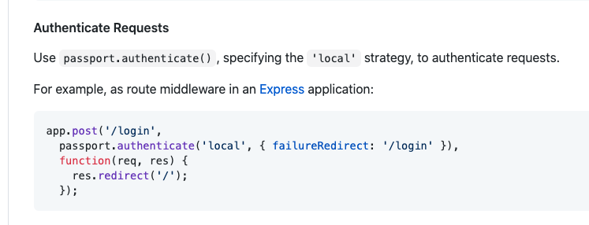

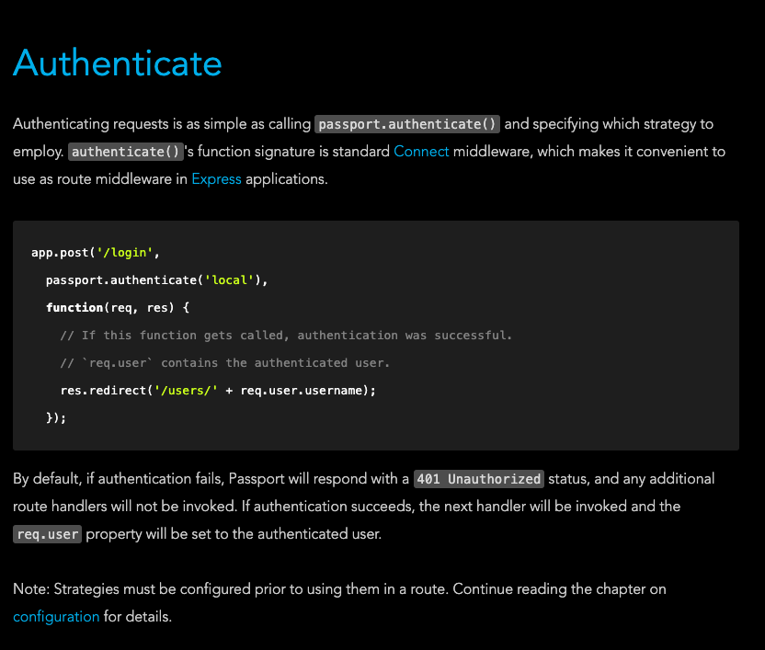

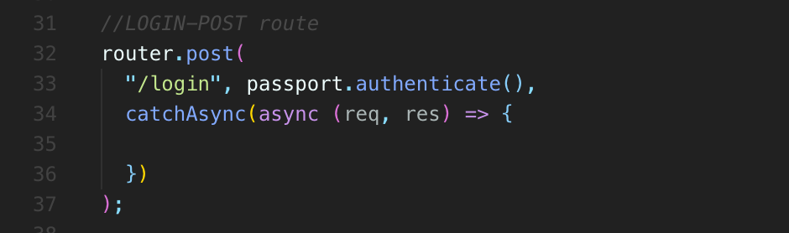

* **Passport gives us a middleware we can use called passports.authenticate**
* and **passport.authenticate().**
* **We can just throw right in there just like any other middleware.**
* **And it's going to expect us to specify the strategy ‘local’**
* , **but we can have multiple so we could set up a route to authenticate local**
* and then a different route to authenticate Google or Twitter.
* **So after that, we have some options we can specify in an object and I'm going to do failureFlash is one of them, which is true.**
* **It's just going to flash a message for us automatically and then we'll also set failureRedirect if things go wrong.**
* **I want you to redirect to log in again.**
* So this is kind of weird, I especially for what we've done and seen so far.
* **It is odd you can move this to its own middle where if you wanted to, but this does it for you. It's pretty straightforward.**
* If you just read it, at least it's hard to remember for me.
* **But password authenticate using the local strategy here, the options redirect to login.**
* **If there's a failure, redirect to or flash sorry, a failure message if there's a failure as well.**
* **And then if we make it into this part here, if we make it into this log in route into this handler,**
* **we know that somebody was authenticated successfully.**
* **And so now we can just do something like request object.flash success**
* **, welcome back and then redirect somewhere like campgrounds.**

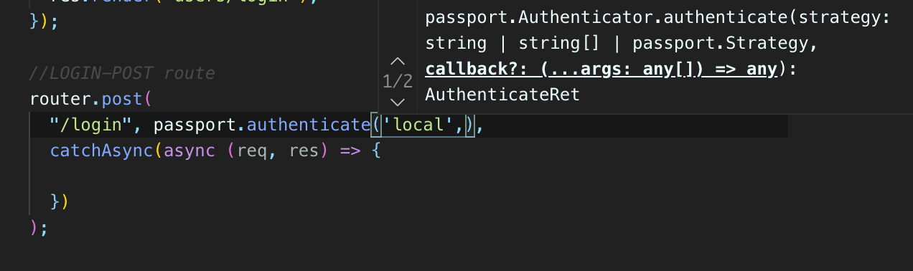

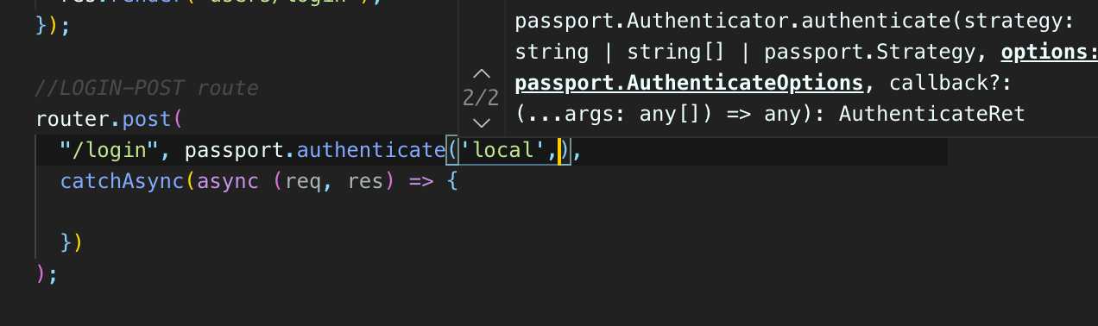

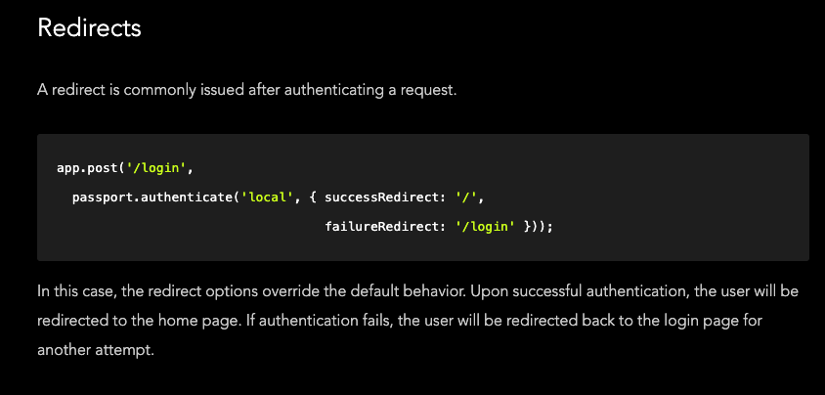

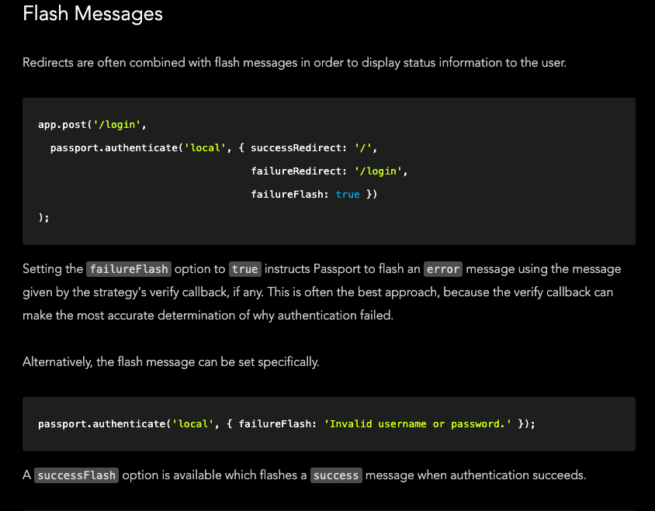

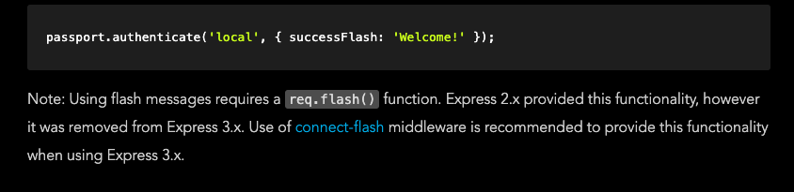

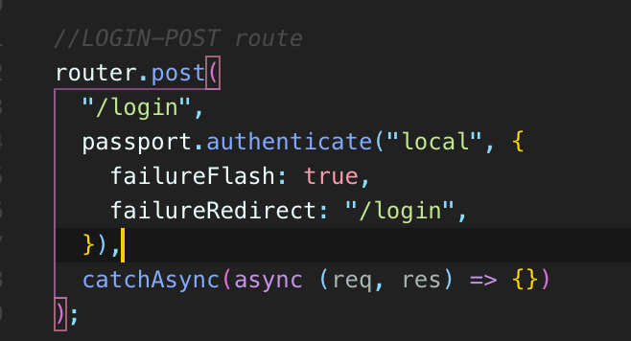

493. isLoggedIn Middleware

* Now that we have the ability to log in
* let's protect one of our basic routes, like making a new campground.
* **You can't submit a new campground unless you are currently signed in.**
* **So how are we going to do that?**
* **Well, there's a couple of things.**
* **One, we need to know or be able to check if somebody is currently signed in or if they are authenticated.**
* Now**, when we did our off from scratch, we would store a user ID or something similar in the session and just look for that.**
* And we could do something like that ourself.
* **But passport actually gives us a helper method.**
* **It uses the session to be clear and “passport.” stores its own stuff in there.**
* **(passport:{ isAuthenticated() , deserialized() , serialized()})**
* **And it's the whole deserialize and serialized user**
* **, if you remember those words that here that all has to do with how information is stored and retrieved from the session anyway.**
* **What we can do is use this helper method that comes from passport**
* **, it's called isauthenticated ()**
* **and it's automatically added to the request object. passport.**
* **Request{ passport {…}}**
* So I could start I mean, I could do something like in my campground routes if you try and go to new. Which is right here in here
* , I can try if requests is authenticated.
* Then we'll do this, or maybe I'll do if not request is authenticated,
* if that's not the case.
* if you're not authenticated again, **that's coming from passport**
* , we can then do something or rather request that flash ever.
* You must be signed in or something and then redirect.
* 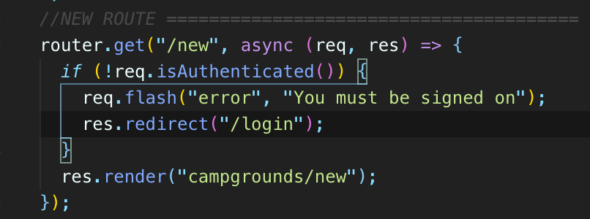
* 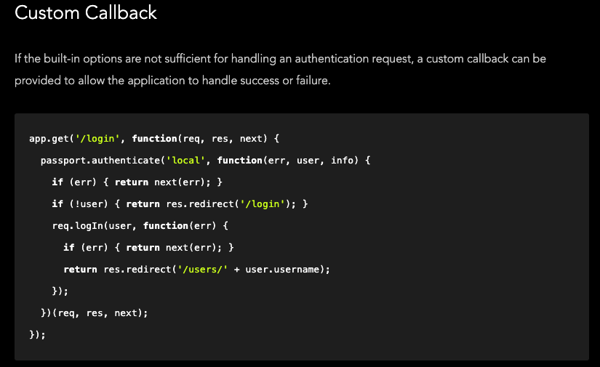
* 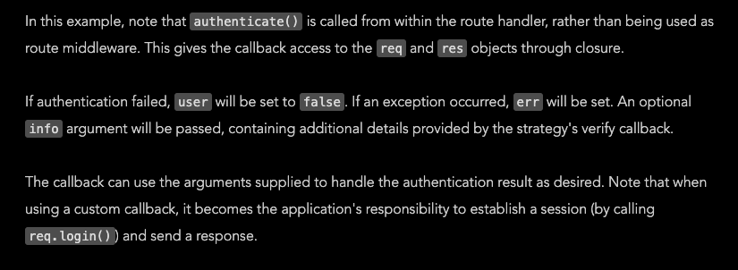
* **Now we're just protecting the form itself.**

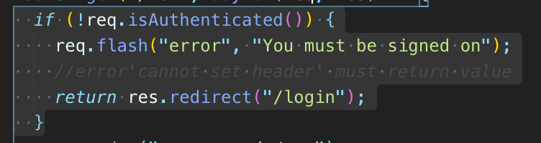

* **You could still send data in using Postman or Ajax or something and make a campground.**
* **We're not requiring log in at this point.**
* **So what we could do now is basically move this into a middleware.**
* **We could write a middleware called, I don't know, ensure log in or something like that and or maybe just is logged in and we can use that middleware on any route.**
* **We want to ensure a user has to be logged in before they can access that route.**
* **Now, this is not an API, just to be clear, we haven't set up an API.**
* **We're not expecting somebody to do this, but we just want to make sure nobody has that secret entrance into our application where they don't need to be logged in.**
* **Somebody could just try and, you know, send new campground information and make a whole bunch of campgrounds or delete campgrounds.**
* If they are not logged in, we could hide the form, but if they know what they're doing, they could just send a request anyway.

494. Adding Logout

* **let's give the user the ability to log out seems somewhat important, and with passport,**
* it's actually very easy.
* **There is a method added to our request object automatically**
* **called req.login(), req.logout().**
* you could add some other stuff in to see if a user is logged in, then like them out.
* Otherwise, what would you even do if someone tries to log out when they're not logged in?
* But normally.
* Right, we just have a link or a button.
* Someone clicks, they're not typing slash log out.
* So we just show and hide that button, which is what we'll do shortly.
* So let's actually sign it.

495. currentUser Helper

* how we know if someone is logged in.
* **Currently, Passport is just taking care of, you know, basically giving us this nice method.**
* **isAuthenticated**
* **, but how can I easily get access to the actual user itself, the object or the ID or something around the user?**
* Well, it's really easy.
* **There is something on the request object .called ‘user’**
* **to automatically put there for us request.user.**
* **So that will contain information about the user.**
* **We don't have to look in the session even though it's stored in the session.**
* **We don't have to deal with that.**
* **So let's just maybe just print out the user to start.**

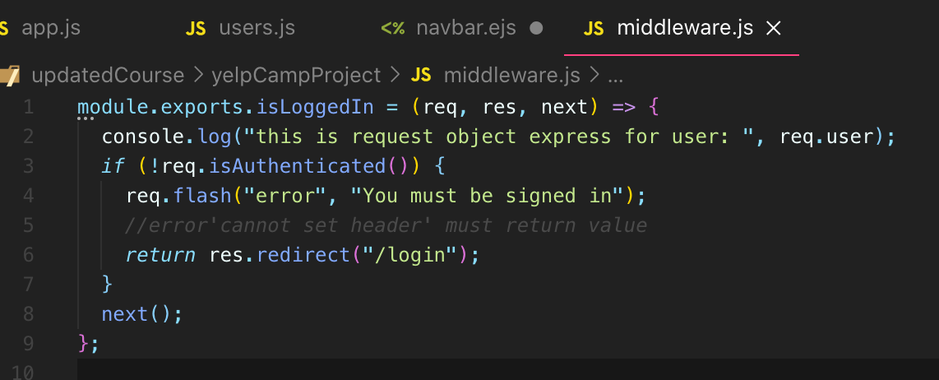

* **So that's put there once again by passports**
* **and it is going to be automatically filled in with the deserialized information**
* **from the session (request object.session)**
* So **the request object.session**
* **stores, the serialized user passport is going to be serialized on serialize it and fill in:**
* **(request object.user) with that data.**
* So **let's make a request to log in or out of our new campground right now, I'm not signed in,**
* 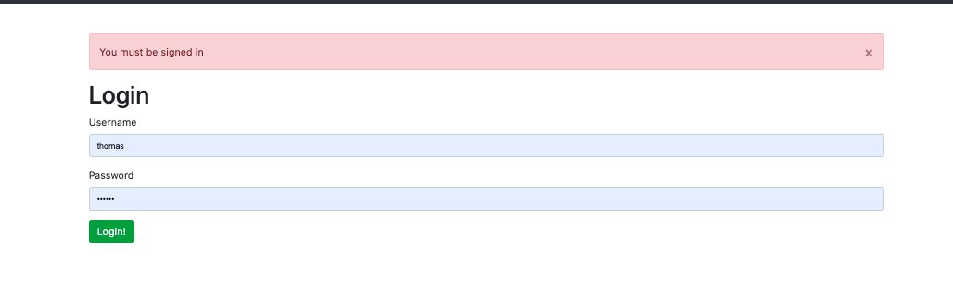
* 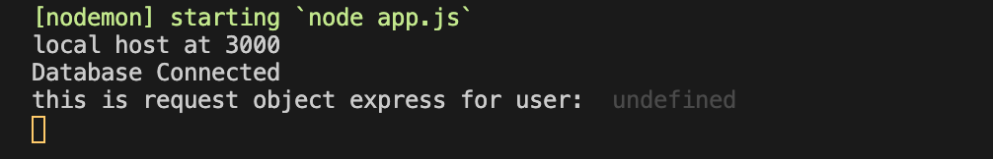
* 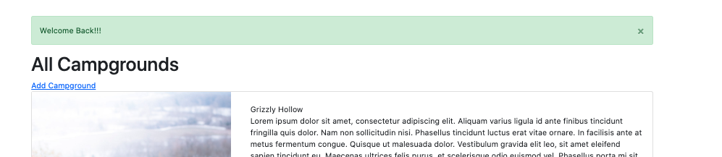
* 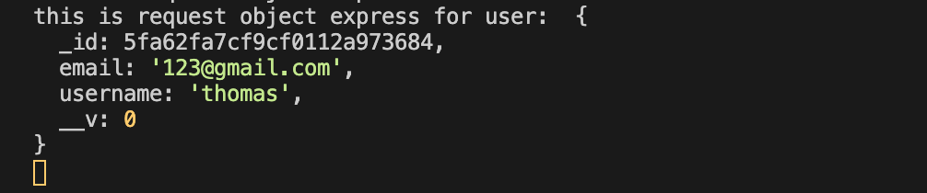
* we see this information.
* **This is user information that is stored in the session.**
* **It is request object.user{}**
* **, which is again coming from the request.session.passport.user{} thanks to passport.**
* **So we have the ID and the username and the email.**
* And thankfully it doesn't include all the other stuff we don't care about, like the **hash and the salt.**
* **We never need that, certainly**.
* Or maybe there's a time if you're implementing like a, you know, change password method, but not really.
* You never really need to access it.
* 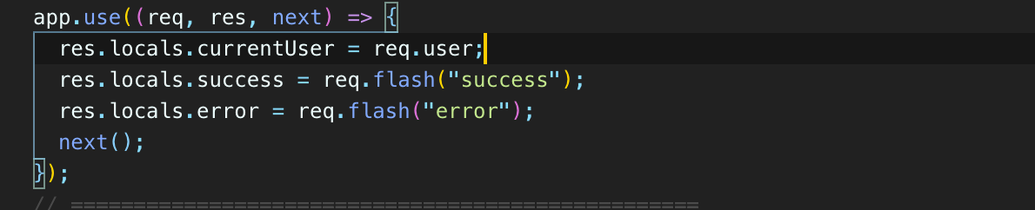
* These are global things I have.
* I mean, they're called locals, but I have access to them in every single template.
* **So now in my templates, all templates, I should have access to current user so I can go into my navbar**
* **and decide if I want to show these two or this thing, depending on if there is a current user (1st login/register & 2nd logout)**
* , **because it will be undefined if nobody is signed in.**
* So here's how we would do that.
* 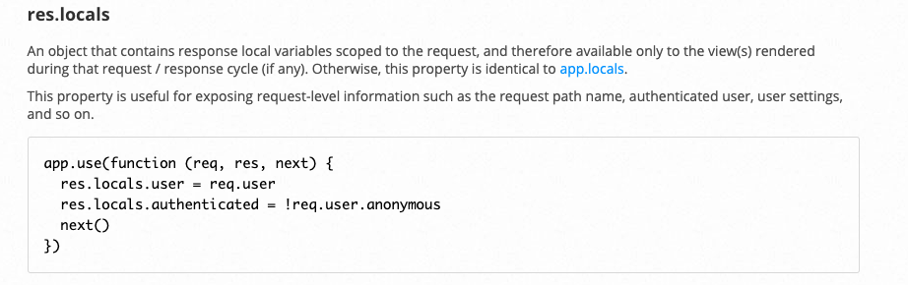
* 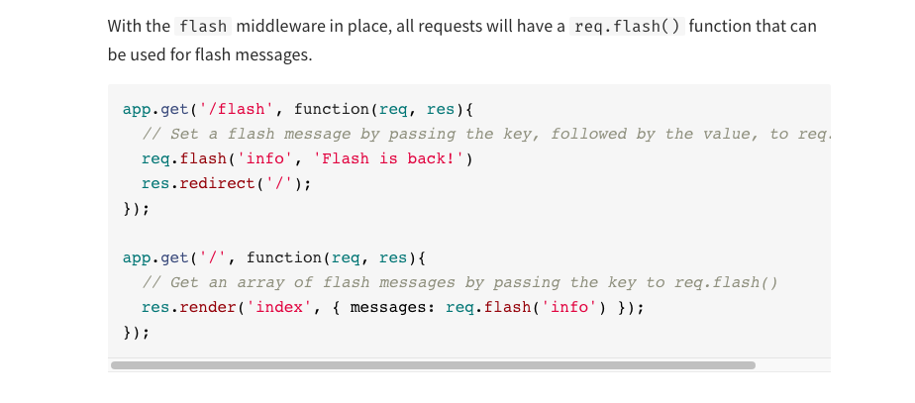
* 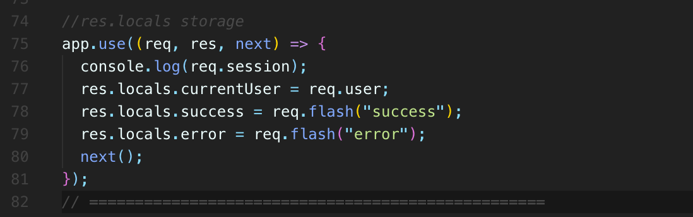
* 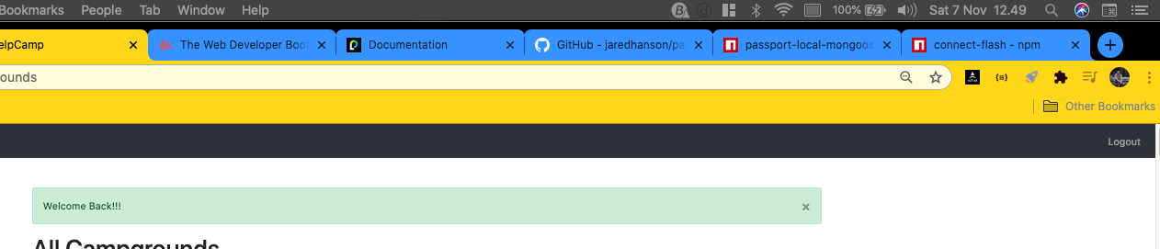

‘request object.session’

* 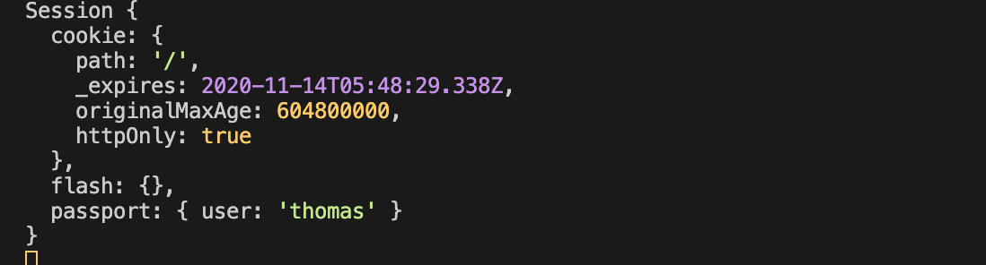

‘request object.user’

* So we now have this nice little helpful variable in all of our templates.
* **currentUser.**
* **I could even display the current user's name if I wanted to.**
* currentUser.user name

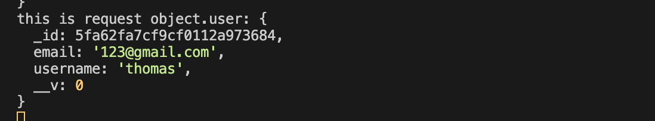

‘res.locals.currentUser’ = req.user

currentUser.username

currentUser._id

currentUser.email

* **It is that object that looks like this, at least for me when I'm signed in with this username.**
* **So very useful will actually need to use that frequently.**
* **For example, when we create a campground and we save it to be associated with the user, we need that ID.**
* **We need to know who is the current user who's making this.**
* **But that's ahead.**

496. Fixing Register Route

* So I'm going to register and that works.
* It appears to work.
* I made a new user.
* **We know that, but I'm not logged in.**
* **I then have to actually log myself in afterwards which is a gross experience.**
* **It works like, you know, nothing technically went wrong, but it's just not a good experience.**
* **So what we want to do is when a user registers and we successfully make that user, we don't want to just flash and redirect.**
* **We actually want to log the user in.**
* **And the way that we do this is there's a helper method called log in on our request.**
* 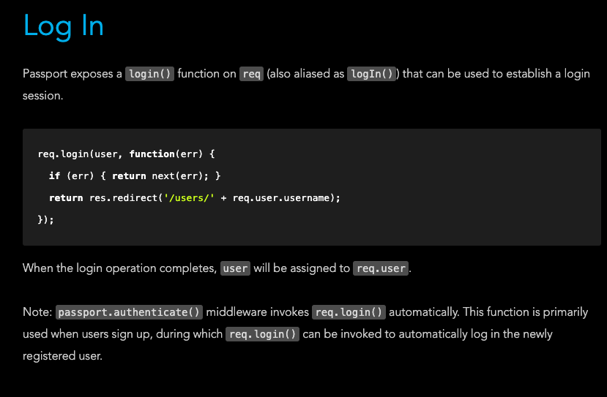
* **The annoying thing is that this function still requires a callback so we can't await it.**
* **So we do need to pass in our callback, which just has an error parameter.**
* **And if there's an error.**
* **So now hopefully we register a user that saves into the database, hashes the password.**
* **Then we take that user and we log them in and then redirect in flash and all of that down here.**
* **You know, for login, we use this passport authenticate helper.**
* **This just does it all for us as middleware.**

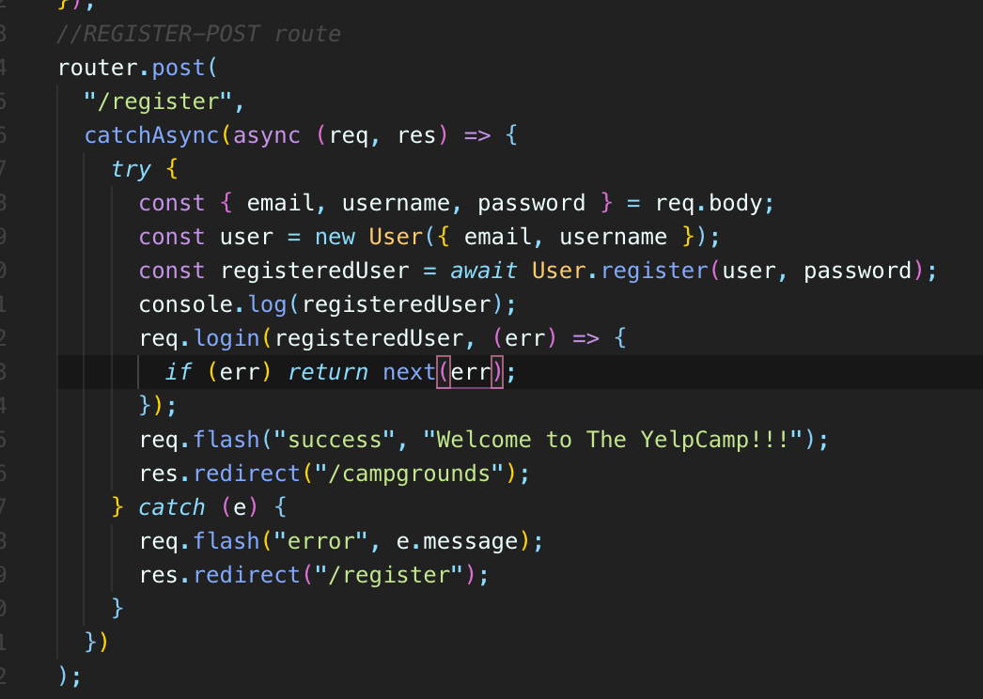

* **But we can't authenticate someone until we've created a user.**
* **So we have to use this request login, just another passport quirk.**
* 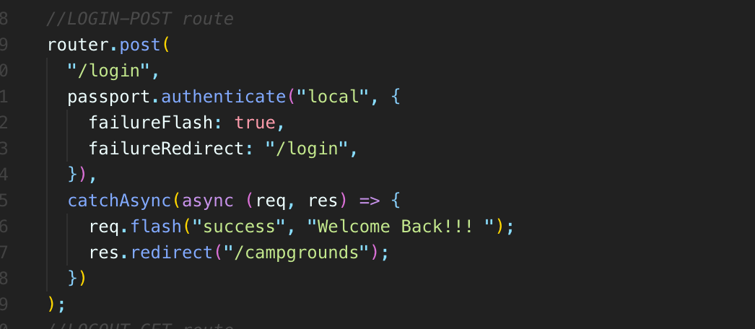
* 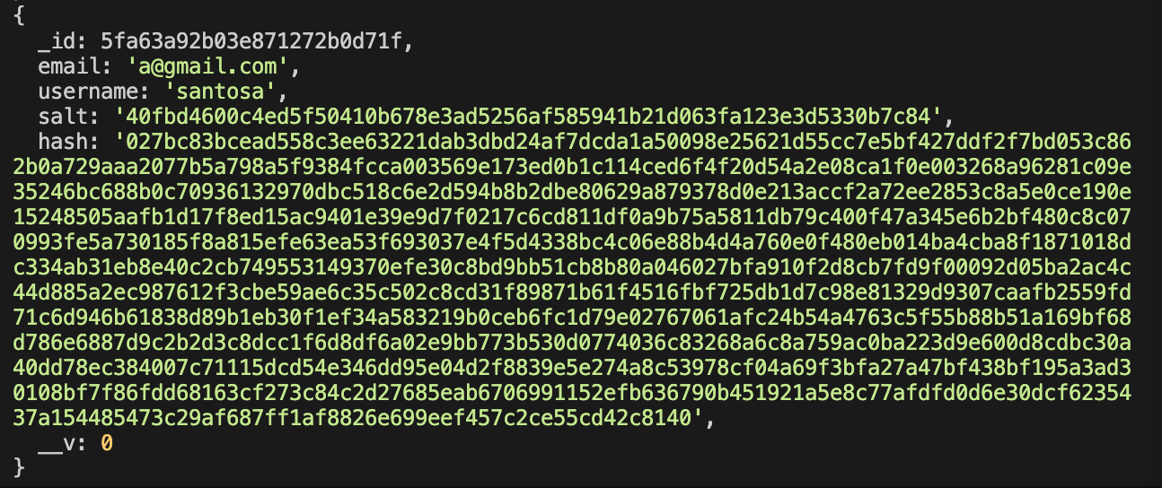
* **It was just a bad experience to have to log in after you already register already.**

497. Return To Behavior

* So the final thing we should tackle, at least in terms of our basic authentication functionality, **is redirecting a user back to wherever they were trying to go.**
* **what we could do is keep track of where a user was initially requesting when we're trying to log them in isLoggedIn() or when we are verifying that they are isAuthenticated.**
* **If I try and edit when I submit this form, when we handle it in my post root for Log-in right here, instead of redirecting to slash campgrounds, I could look to see if we stored you are allowed to redirect to.**
* **So I'm going to store on the session so that we have some persistance between different requests.**
* **That's how we add some state fulness.**
* **So I'm just going to figure out what I want to store and I already know the answer.**
* 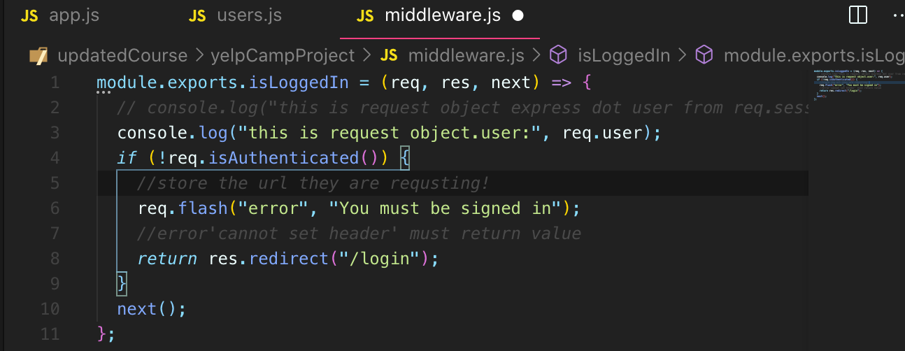
* But there are two things that we could use.

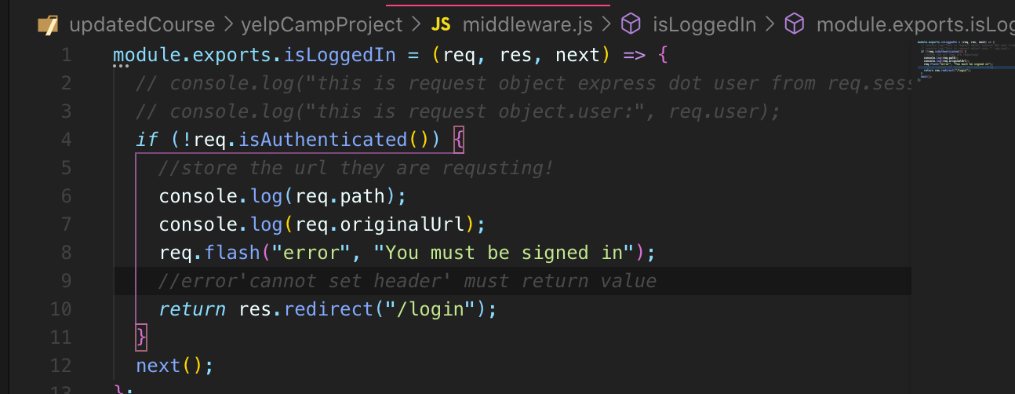

* **These are both added to the request object, req.path and req.originalUrl**
* Not signed in and enter /campgrounds/new
* 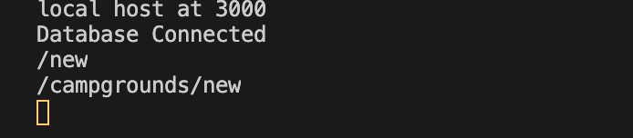
* So that's what we want to store the originalUrl.
* **So I'm going to put that on the session.**
* 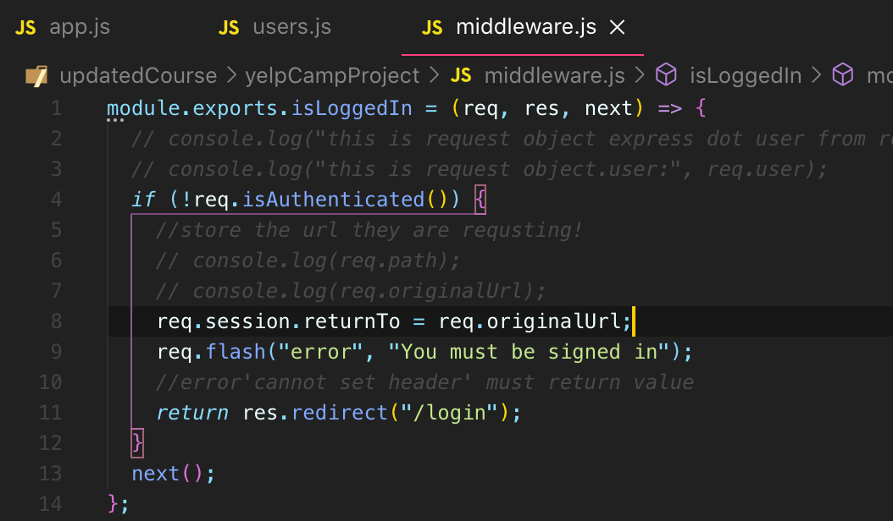
* 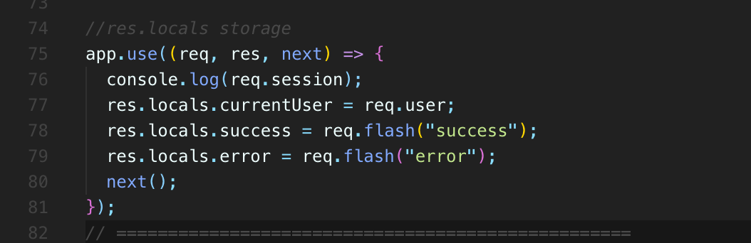
* 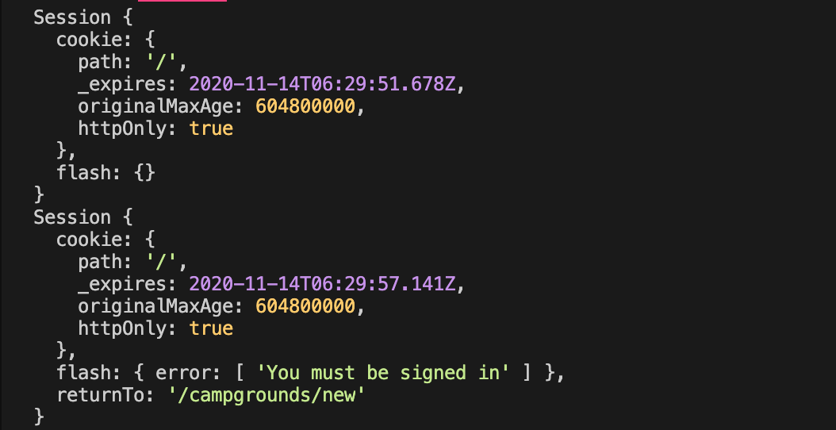
* **the session includes a return to campgrounds new.**
* **We could look to see what requests object .session.returnTo** is now
* **, it's possible there is no return to because a user could just go to our Web page and click login without ever being redirected to login.**
* So I would do something like request object.session.returnTo
* our service redirect your URL equals return to or campgrounds. and then we do our redirect to that redirect you.
* 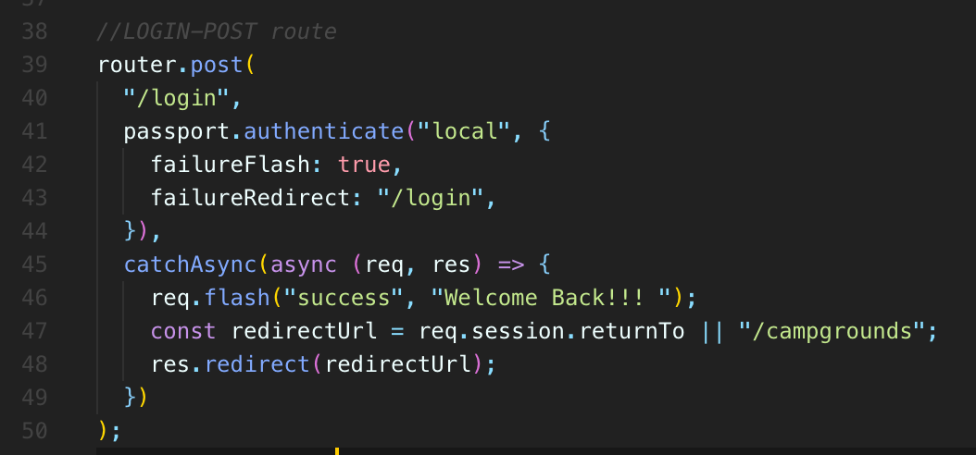
* **what's in the session, says return to campground ID slash edit.**
* **So now I'll log in.**
* **And it takes me to my edit campground**
* **, the annoying thing that we should take care of, though**
* **, is we don't want this just to sit in the session.**
* **So after we redirect you or after we make our variable to delete something from an object, we can use delete.**
* 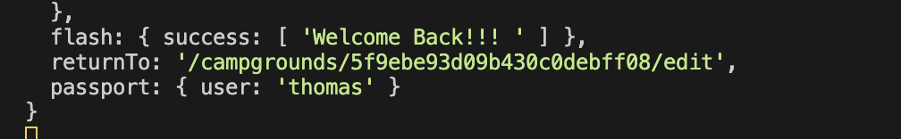
* 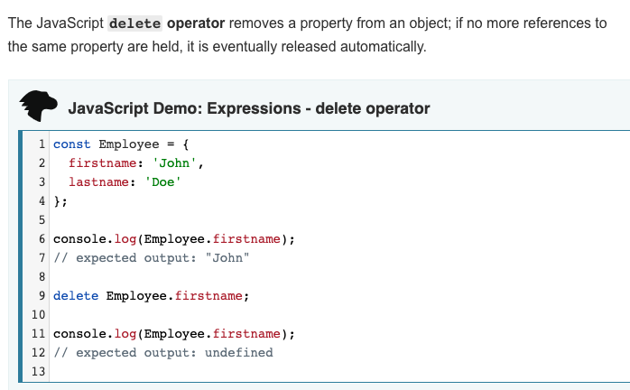
* 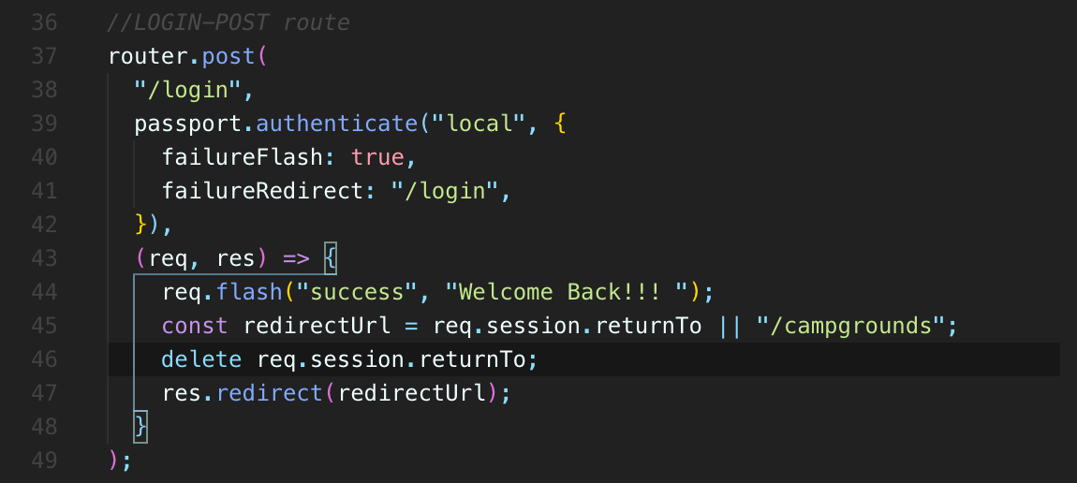
* **And so now there req.session.returnTo should be no remnants**
* **Because the user don’t want sit back in the same place again due to session save it to req.session.returnTo**
* 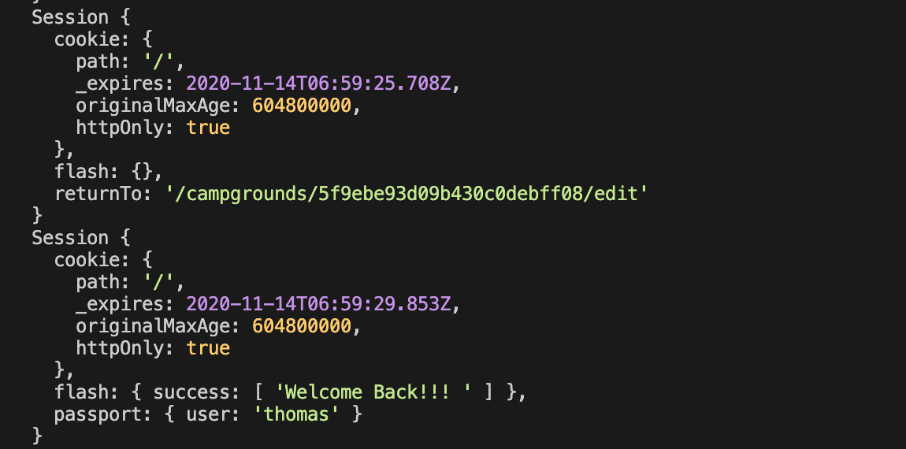
* **Well, stuff including our user, but nothing for return to and let's just try one more time if I go straight to login.**
* **It should redirect me to campgrounds.**
* **And it does**
* **, but if I go somewhere else like new, it remembers that, and that's where I go after I log in**
* **, and that's the last bit of basic functionality for now in terms of auth.**

**Section 50: YelpCamp: Basic Authorization**

498. Adding an Author to Campground

* **Go ahead and connect the user model in some way with particular campgrounds**
* **and particular reviews so that I can create a review**
* **and it will be associated with my account.**
* **And I'm the only one who can edit it or delete it or same thing for a campground.**
* **let's start with the campground model will add a field to each campground that is just a user ID.**
* We'll call it owner or author.
* And when you save a new campground, when you create one, rather, we will take your current user ID, whatever is stored in, request that user and save that on the campground.
* Then we can look you up, we can look the user up for each campground.
* So if we make it into this point
* **, we know that there's some currentUser or a request object.user.**
* If we're in the routes, **request object.users** there, thanks to passports in our templates, **we have access to the local variable we set up called currentUser**
* **‘res.locals.currentUser = req.user’**.(Passport was created object: request object.user from request object.session)

499. Showing and Hiding Edit/Delete

500. Campground Permissions

* **So we definitely want to protect this route as well, not to mention the actual put and delete routes**
* **, where somebody could just send a postman request or an Ajax request and delete or update somebody else's campground.**

501. Authorization Middleware

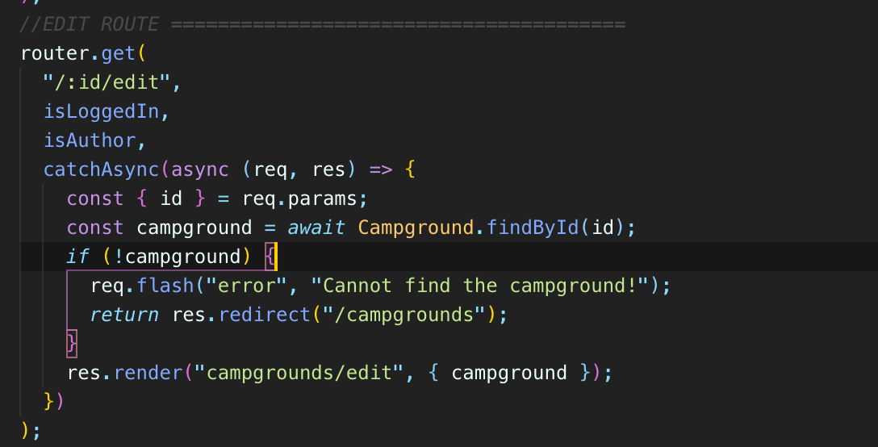

* if you're logged in, because **we could get away with just doing is author**
* but **isLoggedIn, allows us to provide more specific feedback. Because if you're not logged in, we redirect you to log in**
* and we tell you, **please do this first**.
* Is Authors' something we would do afterwards anyway
* **Because we need to make sure that there is a currentUser before we run is author anyway.**

502. Reviews Permissions

503. More Reviews Authorization

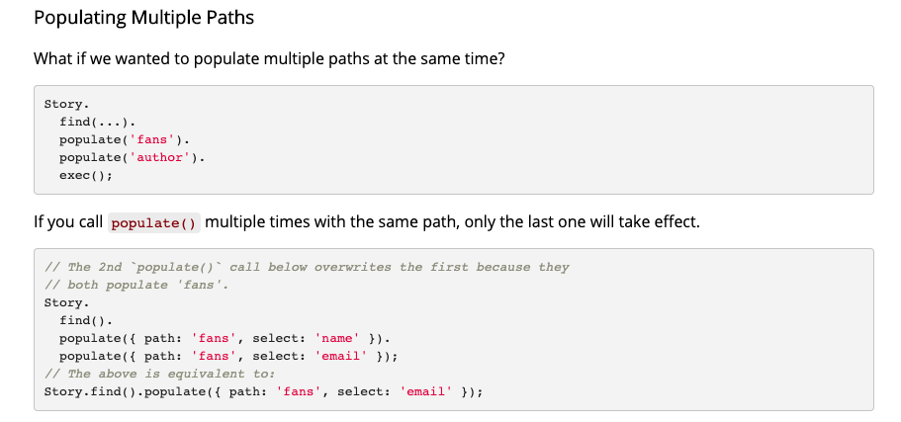

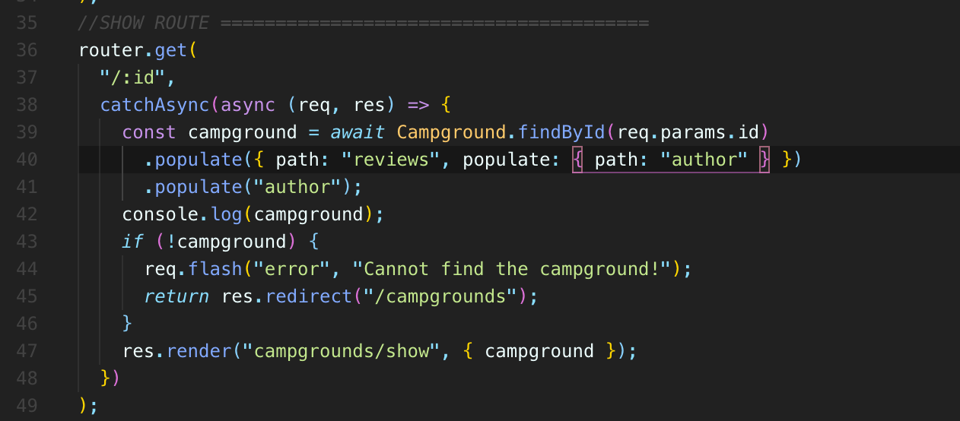

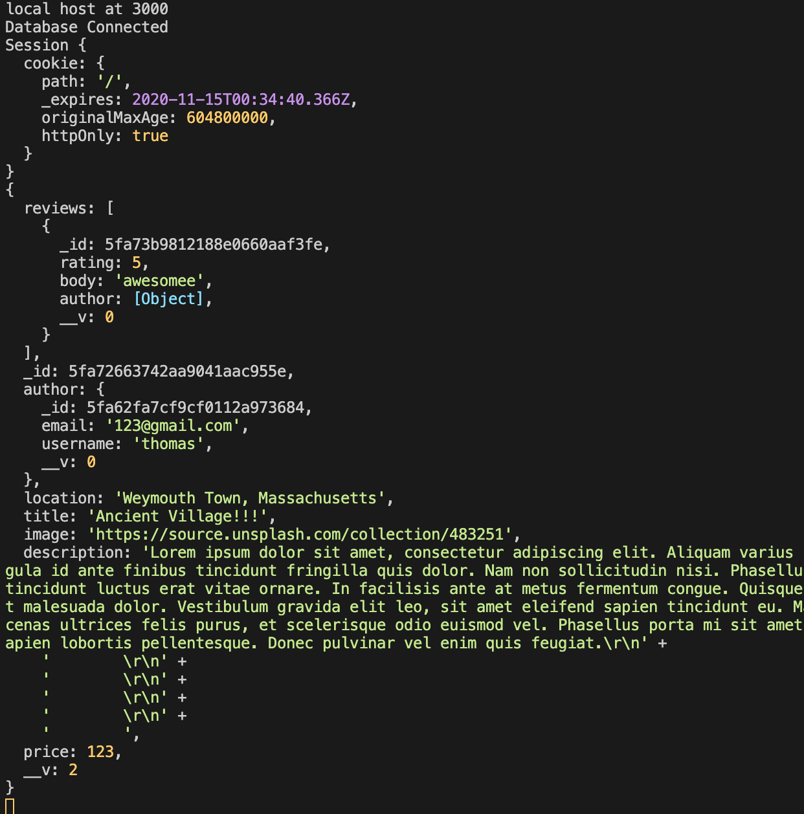

* **These are the sort of questions you need to ask yourself.**
* **How am I using this data?**
* **Does it make sense to populate every author on every review?**
* **What would be smarter on a larger app, at the very least, is to limit the number of reviews that we get at any given point, because if a campground has like thousands of reviews, it's a popular one.**
* **We definitely don't want to get all of it at once and populate all of their authors.**
* That's just unnecessary.
* We would limit it to, you know, 50 or something or 20 and then patinated or set up infinite scroll and get new reviews as you scroll.
* Anyway, now we have access to the user name and other information for each author of each review.
* This is a bread and butter of any app defining your models, connecting them in some way, usually having authentication and involving users with some of those models or multiple models with relationships.
* And then we have authorization, you know, forms and showing users feedback and all that stuff.
* and then it really just comes down to what your app does, any special features, special routes, special functions and any libraries, any tools you're going to integrate like maps or image upload or sending emails or, you know, a chat, all sorts of things that you can add in.
* But the backbone and I'm just talking about typical Web apps, not, you know, every single app, but:
* your typical app is going to have a similar structure, have your roots, have your models, have your authentication.

**Section 51: YelpCamp: Controllers & Star Ratings**

504. Refactoring To Campgrounds Controller

505. Adding a Reviews Controller

506. A Fancy Way To Restructure Routes

* **what I'd like to do is instead introduce a pattern that it's not unique to express in any way.**
* **We're going to define what we'll call**
* **controllers for campgrounds**
* **, a controller for review**
* **, a controller for auth**
* **So the term controller comes from MVC (stands for: models views controller)**
* **, which is a pattern MVC model view controller frameworks, or**
* **it's just an approach to structuring applications.**
* You know, we've been using models, the term models.
* We have a model directory.
* We've been using views.
* **We've got a used directory so we can set up controllers as well.**
* In general, **the concept is that you put all of your data heavy stuff here**
* , **modeling of the data in the models**
* **, you put all of your view content** , **the layouts**
* **, everything a user sees and views**
* **and then controllers is where you really structure tend to the heart of your application.**
* **It's where all the main logic happens that where you're rendering views and you're working with models.**
* But for us, it's just going to be a name, essentially.
* **So I'm going to make a new directory or call it controllers, controllers like that.**
* 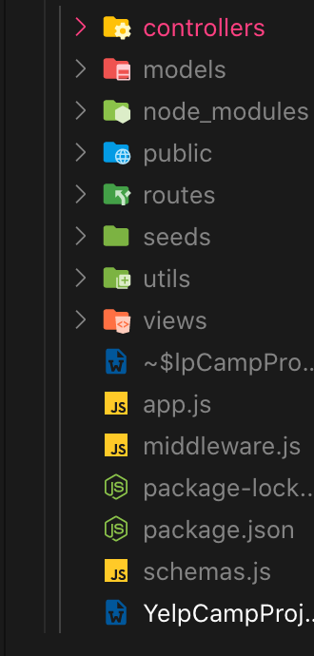
* **and then in our controller file for campgrounds, we will export specific functions, so, for**
* **example, we can have one called index and index just does this.**
* **It's a function that does this right here.**
* So it's super straightforward and short and simple.
* But that's kind of the main idea
* This is the index page and it's just going to find all campgrounds and render campgrounds index so I could move this entire async function.
* 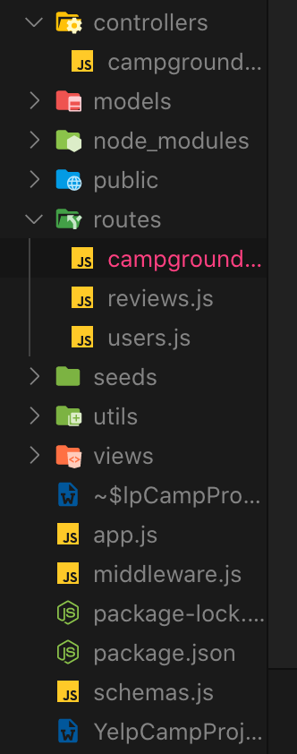
* 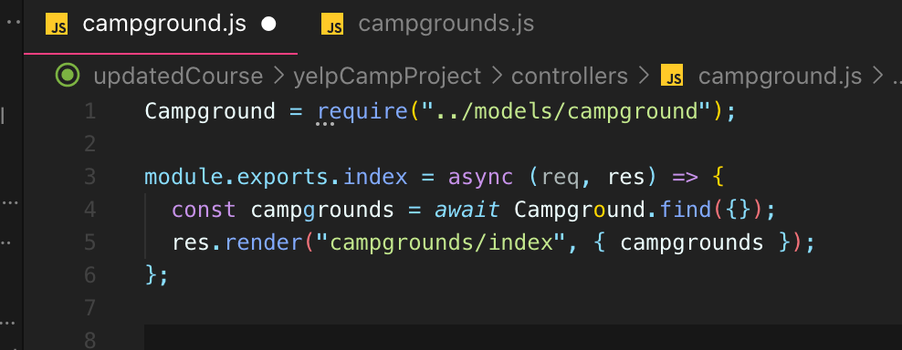
* 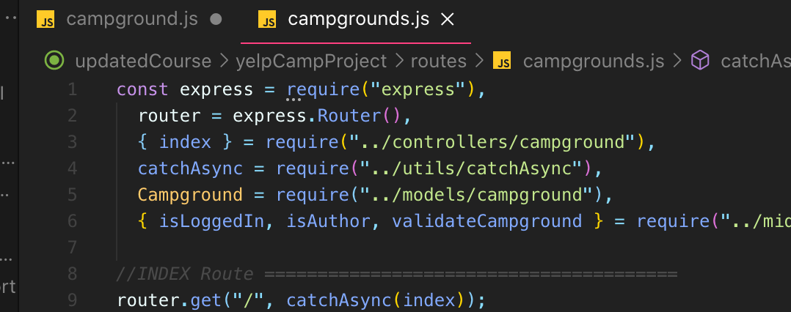

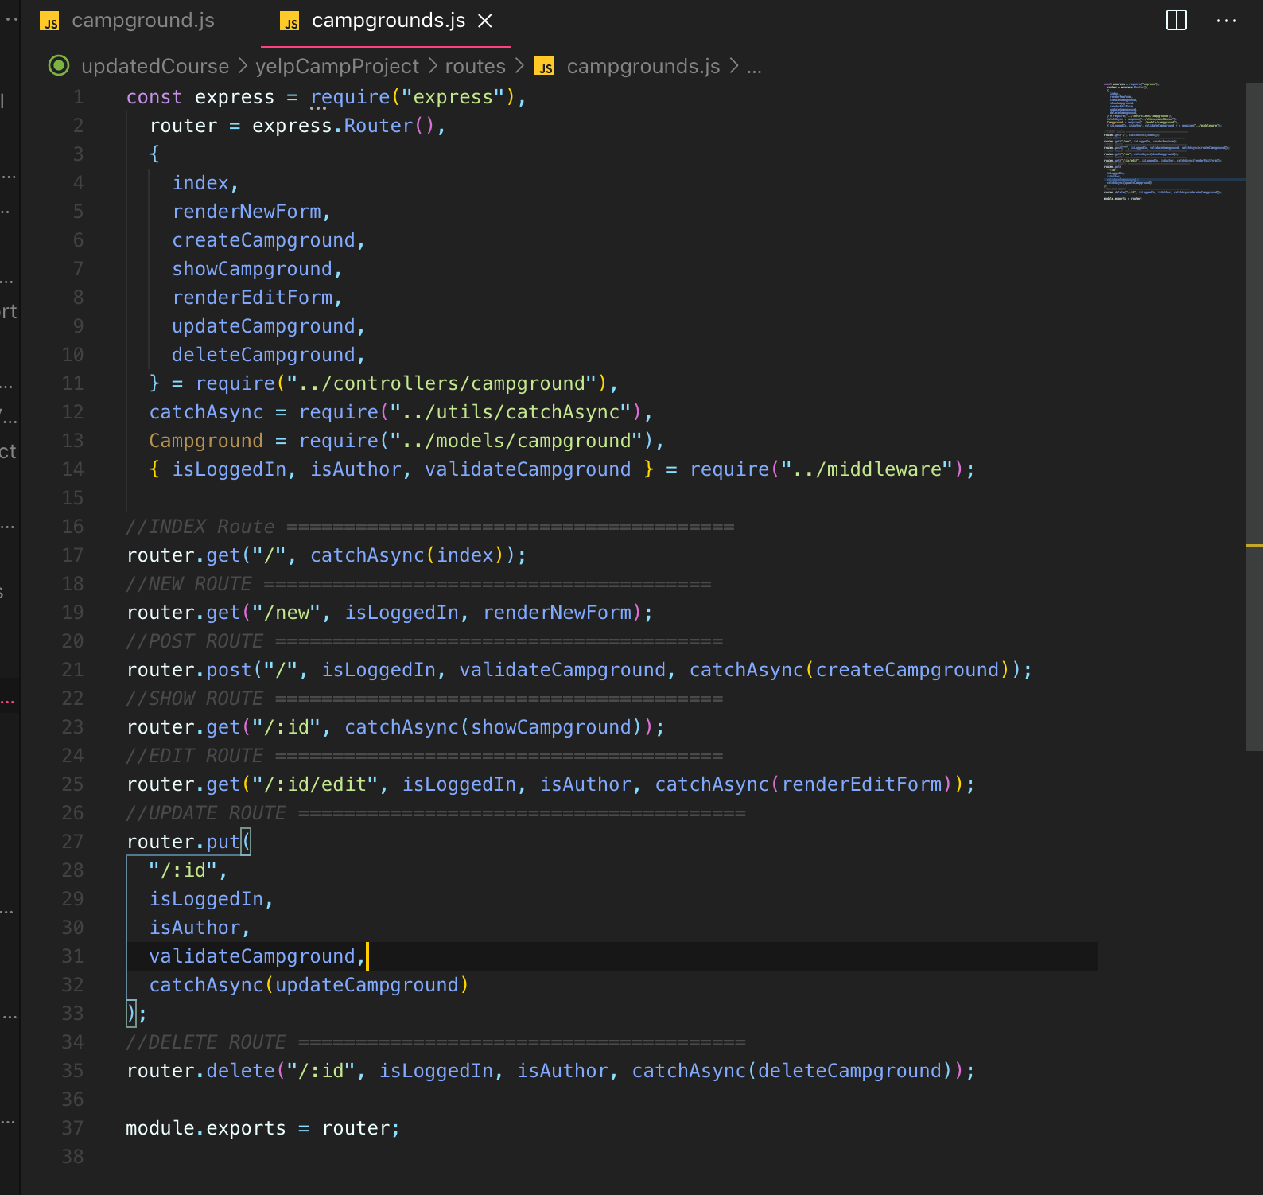

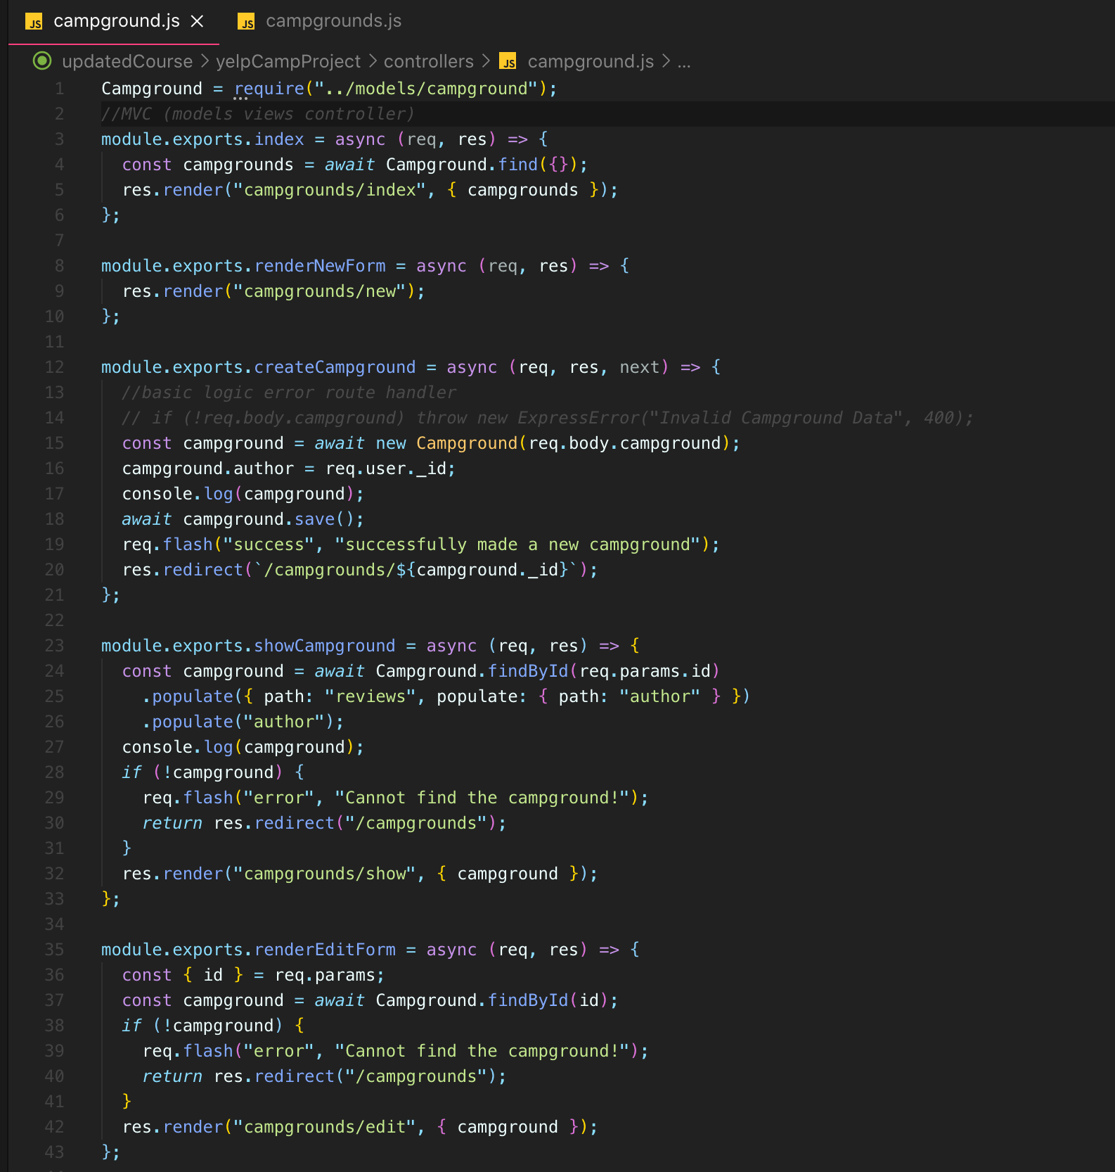

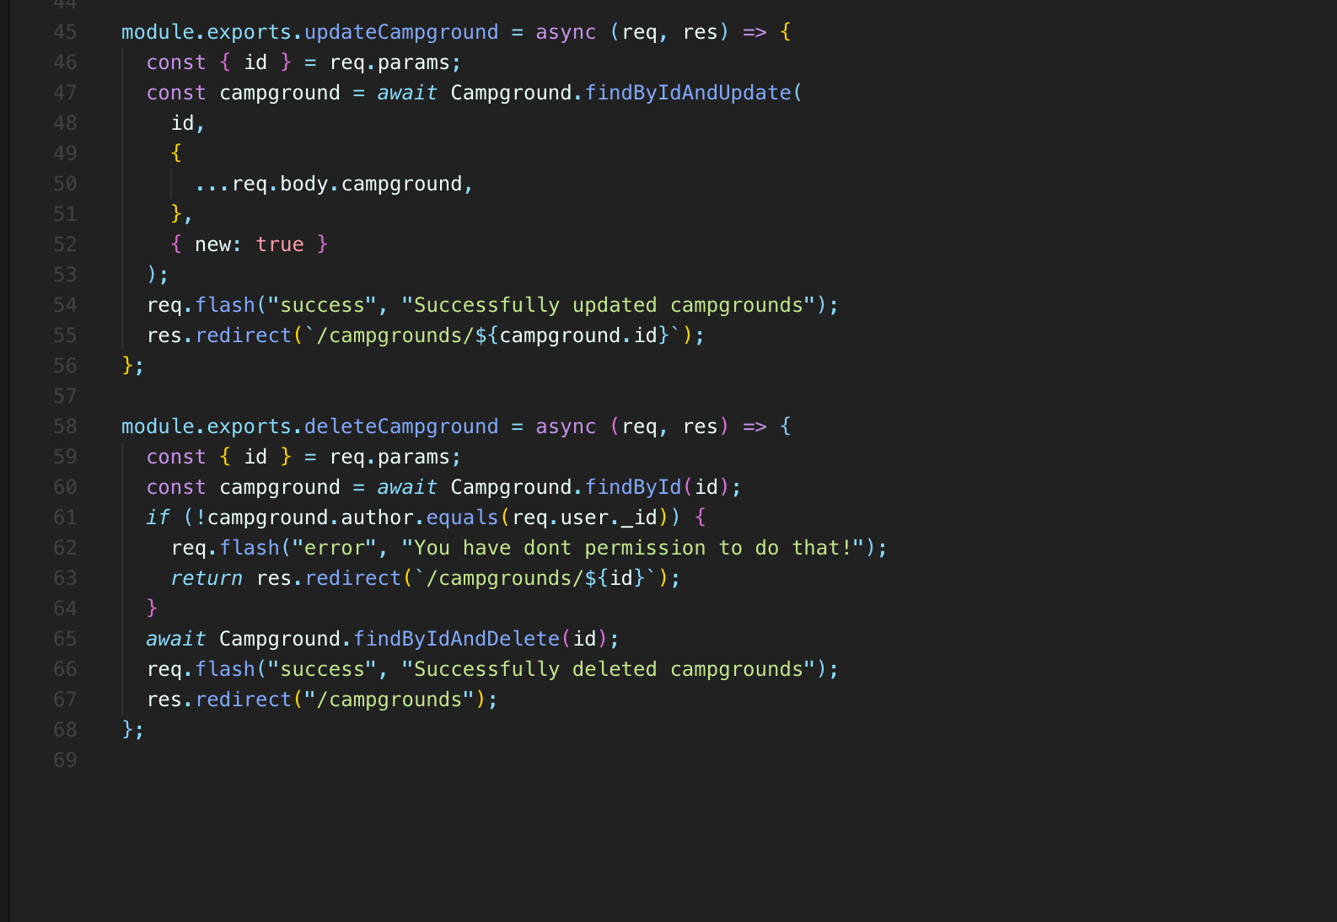

* we'll see a way of **grouping similar groups together, or rather routes that have the same path, but different verbs.**
* If we go to the Express docs, you go to the router docks, we're using the express routes write.

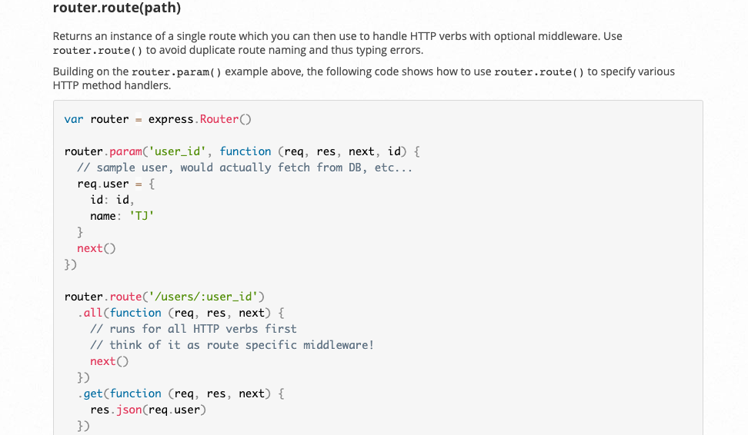

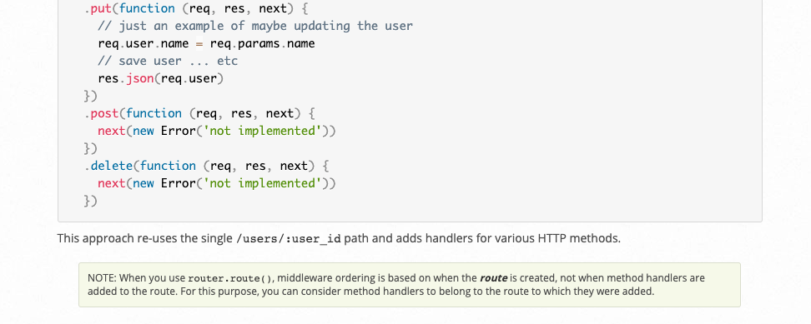

* It allows us to basically define a single route which then handles different verbs.
* For example, router.route( path, , we chain on a get, put, post. So .post() code here runs on a post request is sent to that router.route(‘path’,….
* .put runs when a put request is sent to that router.route(path,..
* so we can then group together some of this stuff.

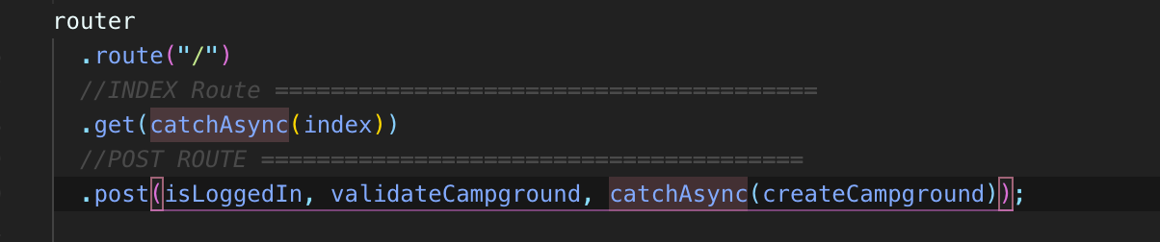

* **so it just groups things together a bit, I think I have semicolons that's**
* **If you're changing things, you can't put a semicolon in between.**
* **And then we can just leave these to a standalone because they just don't make sense.**
* **Well, we can't group them together.**
* **They have different paths.**

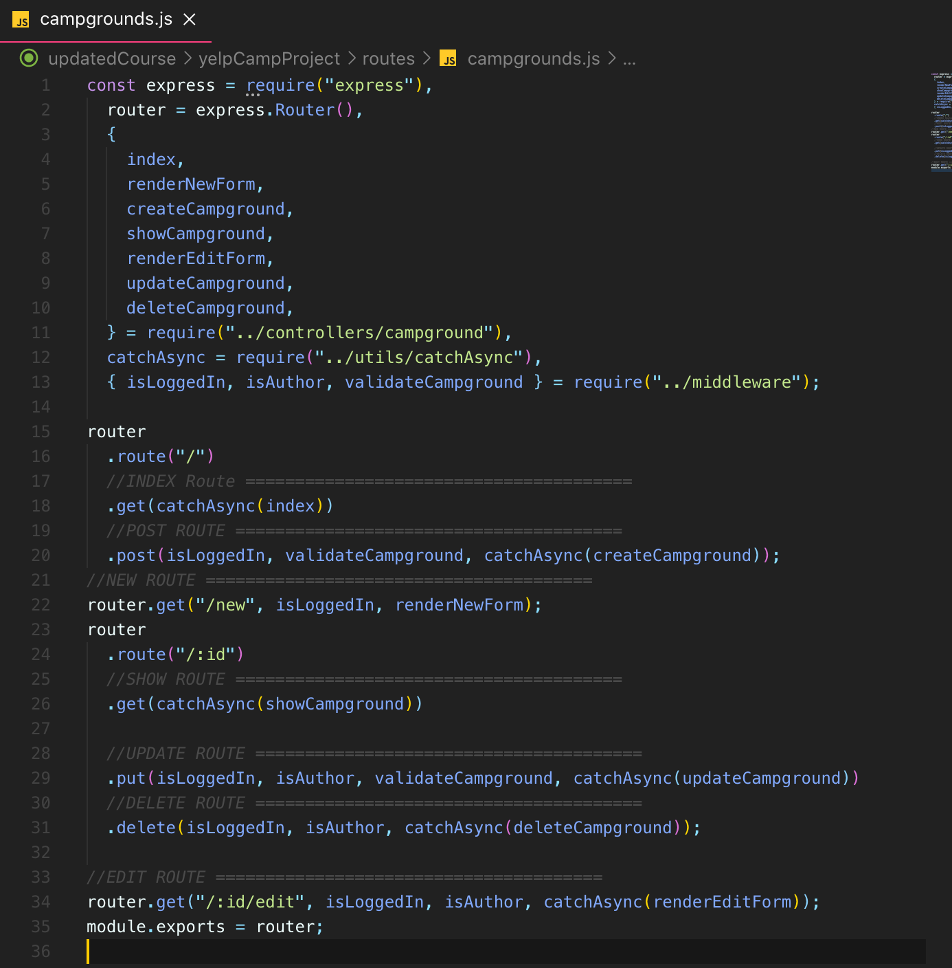

* So our routes, I mean, they've gone from being bloated and confusing to look at to very clear now.
* And it's, you know, it's technically more code, right.
* To require them and move them into separate files.
* We're adding a couple of lines, but it's far clearer when you look at what's happening.
* You can read this and see very quickly, OK, this is the function that's called.
* It's not anonymous, although we could have added names into our root handlers anyway.
* But it's just a nice structure to follow.
* It's always good to have some pattern to help you structure a bigger.

507. Displaying Star Ratings

* Let's display five stars or three stars so we could do this from scratch ourself especially for reviews
* 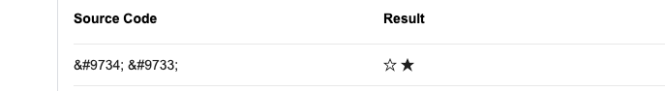
* **But we're not going to do that for a couple of reasons.**
* One, it's annoying to do, but two, it's extra difficult or annoying to make accessible.
* And that's important.
* You know, these are just entity codes.
* if this is what your screen readers reading out loud, it doesn't make much sense at all.
* So what we want to do instead or what we're going to do is use a tool to help us.
* So there are many libraries out there.
* 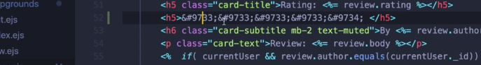
* This one is called Star Ability. It's really just a CSS file.
* So this is accessible and so that's important.
* It's also somewhat responsive.
* It has some behavior for smaller screen sizes and overall a good choice for us to use.
* So to use it, there's two places we'll use it.
* One is will allow a user to rate using the rating selector.
* But the other is what I just showed you where we just display the rating.
* So now we need to include that in my layout or at least on the file where I want to use it and
* I want to use it on the show page.
* So there's a couple of options since we only have one of our boiler plate layouts right now in our views.
* I mean, we could include it in here and it would just be included like we're doing bootstrap the stars functionality would be included on every single page.
* It's only a couple, I don't know, a couple of hundred lines to see.
* It's not a big deal.
* But if we had a lot of functionality that was only for one page.
* We may want to either make a different layout or add a conditional in here to check what the current rate is and, you know, decide if we're going to include the stylesheets and whatever other assets.
* But we could also just go to our show template.
* 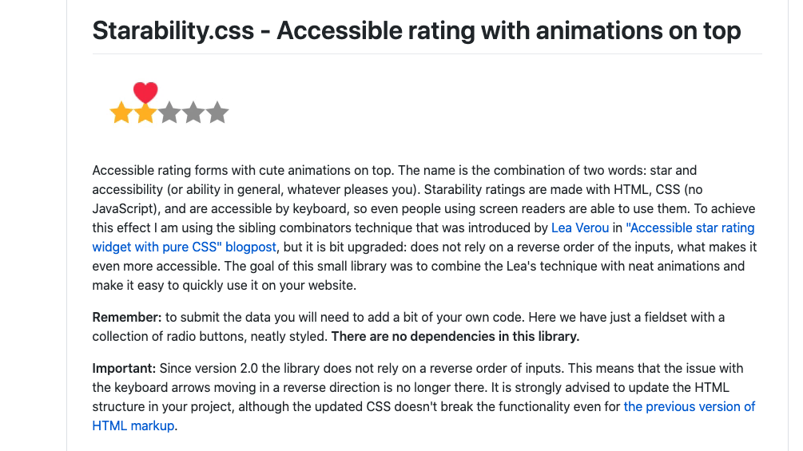
* 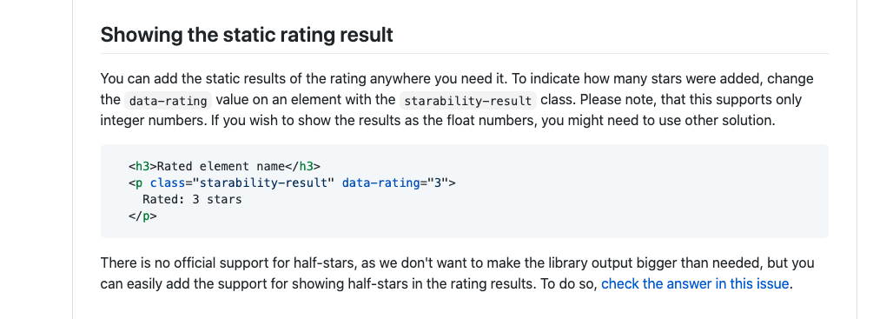
* it shows up and it's controlled by this one property called “data-rating”.
* So if I set that to one, we get a one star output.
* If I set it to five. We get a five star output
* , so what we want to do is basically, instead of displaying the text rating
* is equal to five like we're doing right now, we can just put this paragraph in there.
* we don't need any JavaScript to make this work.
* This will be an accessible animated star selector for a form without any JavaScript.
* And we really don't have to do anything except copy some important structure code.
* 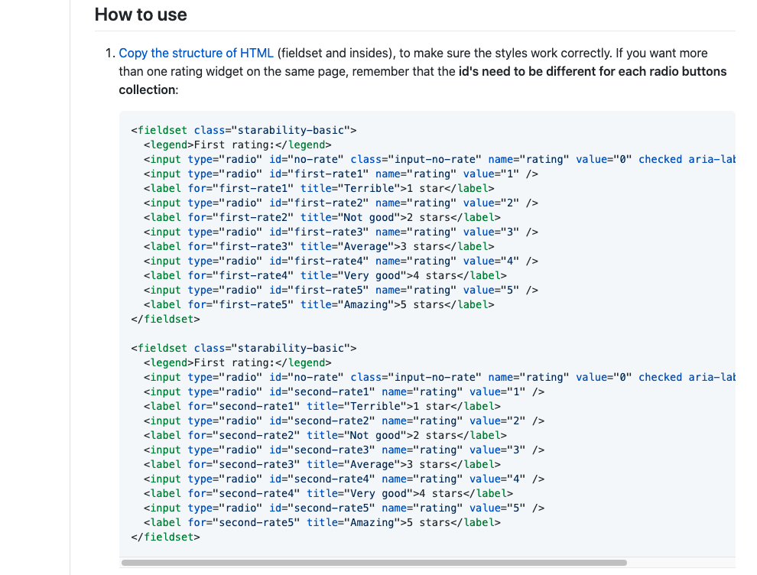

508. Star Rating Form

**Section 52: YelpCamp: Image Upload**

509. Intro To Image Upload Process

* **It's just an extra nice to have and it is image upload.**
* **So I would like to be able to upload one or actually multiple images even fancier.**
* **A lot, of course, to show you one image, but multiple it's a little more work.**
* Well, it's not that bad.
* **So instead of typing an image, you are which is just garbage.**
* I mean, that's really a bad experience.
* **What if we could upload a file or multiple files to be associated with a campground that's closer to what something like Yelp or other similar websites do?**
* **For a restaurant, you can submit your own photos of the restaurant and the food and whatever else.**
* **Now we're just going to allow the user who owns the campground, at least for now.**
* **We'll just allow the user who owns the campground to submit images.**
* **But it wouldn't take much more work to allow anybody to do it.**
* **So this is a multi-step process.**
* **There are two things you have to know up front.**
* **One is that a regular HTML form is not going to be able to send files to our server.**
* **So we're going to have to change our form in order to do that.**
* **And the second issue is that we need to store the images somewhere and typically we don't store them in Mongo.**
* **We don't put images in Mongo because images are very large and there's a decent document size limit of sixteen megabytes.**
* 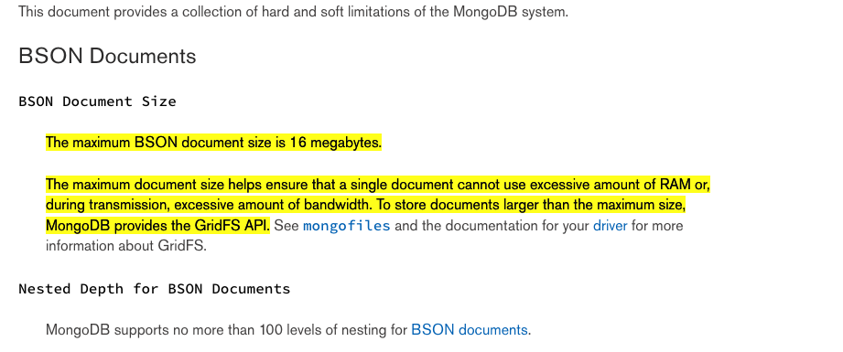
* So that really does not work in our favor.
* There are workarounds.
* **There's this thing called GridFS that helps you store larger files, but we're not going to bother with that.**
* Instead, we're going to use a tool called Cloudinary
* **and Cloudinary is a website that or an application**
* **that's really commonly used and it stores information for us.**
* **It will store photos on their server, on their database that we can retrieve relatively easily.**
* **And we can also retrieve like different sizes, different thumbnails who can transform the images, compress them.**
* **So it has a bunch of features.**
* **So it is a paid tool.**
* **But if we're going to use a free tier, which will work fine, it does a lot, as I mentioned**
* **, but essentially it's just one of many similar tools that will store images and videos and assets for us.**
* **There are many other similar services.**
* We also could have used something like AWS
* This is just very relatively painless compared to other options.
* **So the way that this is going to work is that**
* **we're going to set up our form so that we can accept files.**
* **Then we'll submit that form and it will hit our server and hit our endpoint somewhere. One of our routes.**
* **Then we're going to take the files, the actual information that has been sent along with our form, the data.**
* **And we're going to store that in cloud and we're going to send it to cloudinary.**
* **And then cloudinary is going to send us back some yourself.**
* **Here's, you know, the images I have stored for you.**
* **Then we take those you URLs and we store those in our Mongo database.**
* **So our database is just going to hold you URLs.**
* **But those URLs correspond to images that have been uploaded and saved with clodinary**
* **OK, so that's a basic process.**
* **And you can swap in or out cloudinary for other tools, but that's a really common workflow.**
* **User uploads something.**
* **You send the data somewhere else, whether it's your own service, something like AWS or something like** cloudinary
* **, then you have a you URL that you store in the campground portion or in the campground document.**

510. The Multer Middleware

* So, as I mentioned, **the first thing we have to understand in order to upload files is that with our generic forms**
* **, all the forms we've created so far, we can put a file input in them.**
* **But the file information will not be sent properly.**
* I don't even know if it's sent at all.
* **If it's uploaded, it just doesn't work if we're using a default HTML form.**
* **And that all has to do with the encoding type attribute on a form.**
* **So every form we've done so far is a url form.**
* **We're parsing the body in our pages right with where are you?**
* **You are all encoded.**
* **That is what we're expecting our form data to look like.**
* So this is the first step that we have to do.
* And this is going to break things for us for a little bit.
* We're going to step away from fully creating campgrounds from moment.
* So let's go ahead and take this form, which is on the new template for campgrounds, and we're going to set it to have a and type of multipart form data.

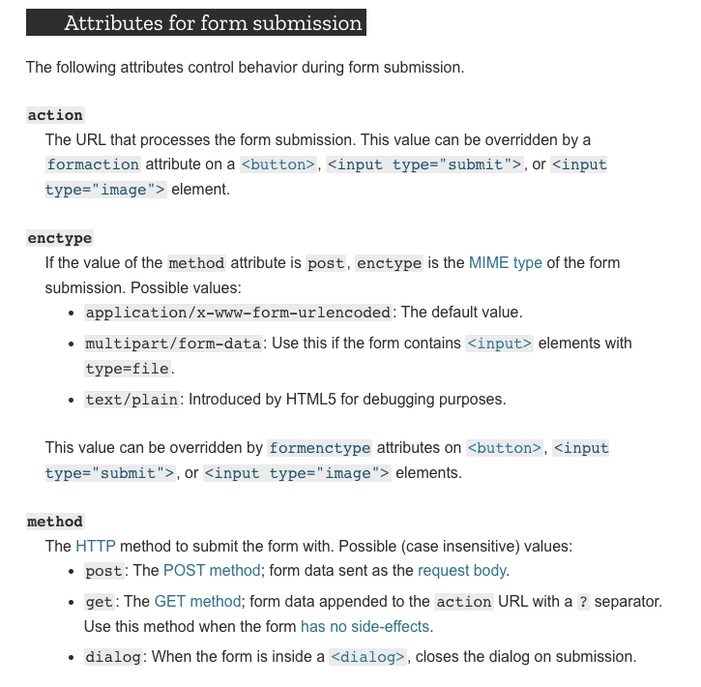

* **Well, if we want to upload files, we actually need to set the “enctype” encoding type and type attribute to be “multipart form data”**

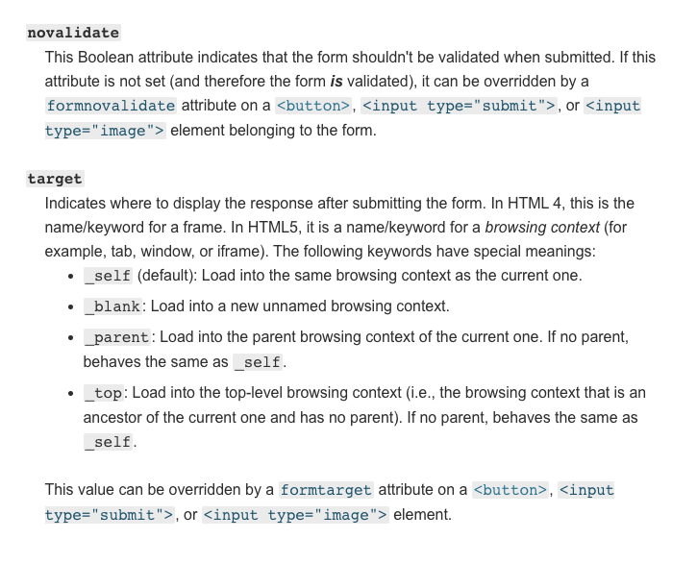

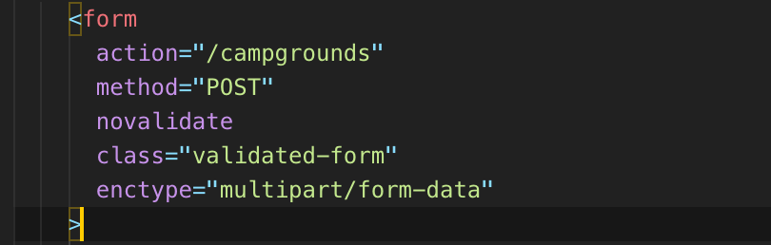

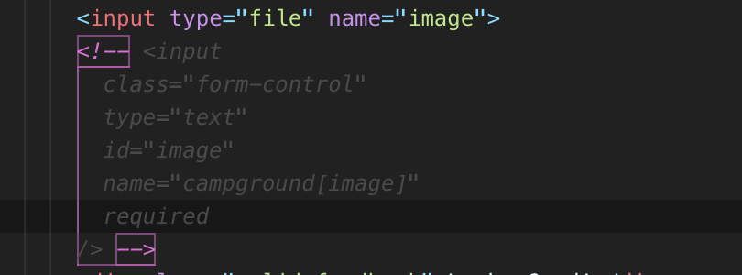

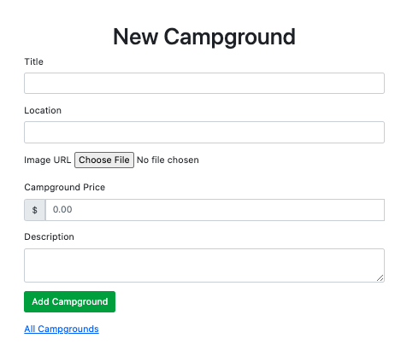 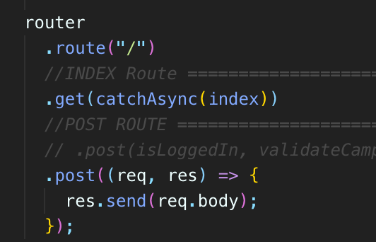



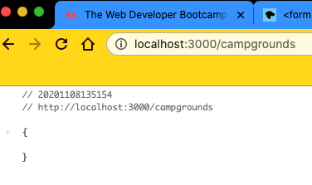

* Well, we hit that route, but it looks like there's nothing in the body.
* What's going on there?
* OK, so this brings us to the next point, which **is that in order to pass multipart forms that attribute that we said on the form right there**
* **, encoding type multipart form data, in order to pass that, we actually need to use another middleware.**
* **This is there's multiple, I believe, but this is the most popular one called “multer”.**
* So it's for Express.
* **And all that it helps us do is pass our handle multiplatform data, which is primarily used for uploading files.**
* 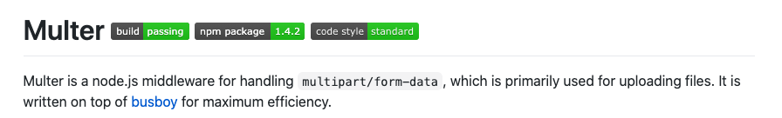
* 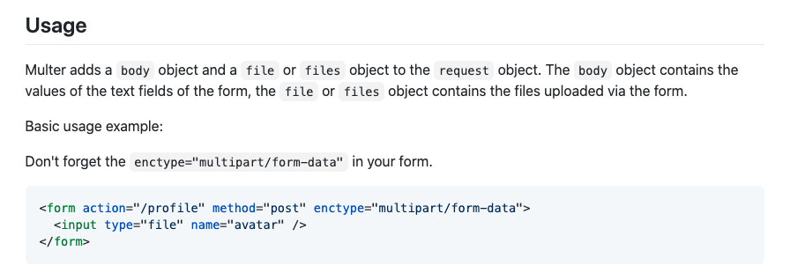
* **It says it adds a body object and a file or files object to the request object.**
* **The body object contains the value of the text fields of the form.**
* **The file or files object contains the files uploaded via the form.**
* **So that's the goal.**
* **Multer is there basically to do what the built-in body parsing middleware does so that we can pass JSON or that we can pass.**
* **You are encoded data from forms, but to use it, it's a little bit different.**
* But we need to do is first require multer
* **so we can start there and then we have to initialize it or execute the function and are supposed to pass in a configuration object.**
* **And here what they're specifying is just a folder path, a destination for the files.**
* **Now remember, we are not going to be trying to store this is just a demo.**
* **You wouldn't do this in the real world.**
* **You wouldn't store stuff locally.**
* **But basically, if you don't specify something like cloudinary or AWS or some other location, it can use local storage.**
* **And I think they talk about it somewhere on here. Storage, disk storage is what they call it.**
* **And then you have memory storage as well, which is just for like really simple basic testing purposes.**
* You wouldn't do that in the real world anyway.
* We're going to go ahead and do this.
* 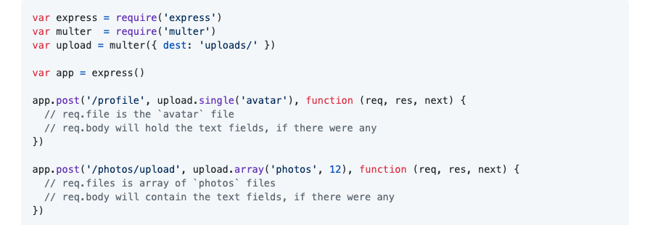

<form name=image >

* **Next, what you need to know is that at any point we can now add in this middleware upload.single and upload.array.**
* **And if we use this, if we call upload any of these methods, multer is going to do its thing.**
* **It's going to pass the form information**
* **, the multiplatform**
* **, and then it will store the file or files on request file slash files and then any other information from the form on request body.**
* So there are some options here.
* **If we look at how this works, we specify a field name and that needs to match with the name is from our form.**
* 
* 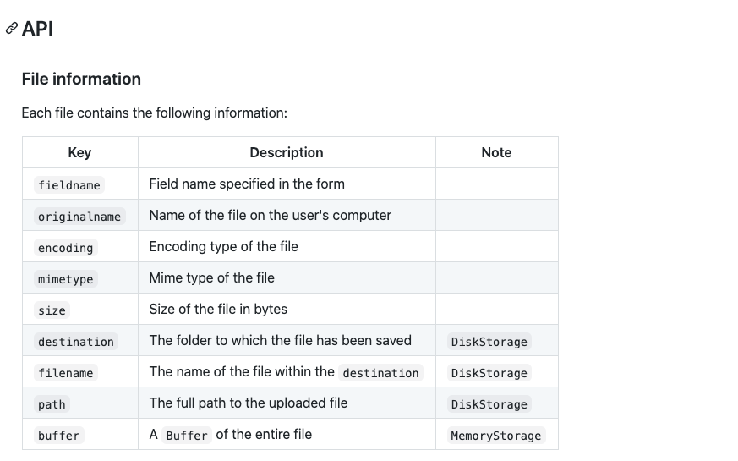
* 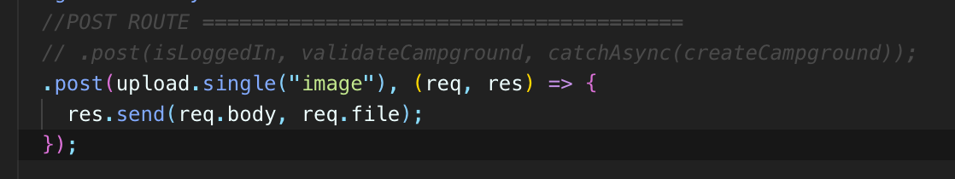
* 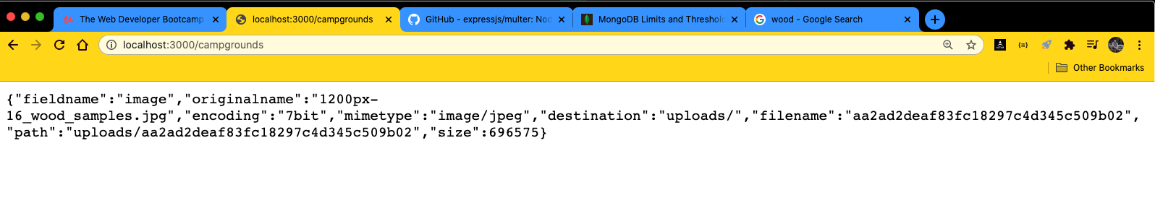
* **This is what we sent back.**
* **You can see that there's a bunch of different pieces in here, but a path to this upload, we've got file, name, destination.**
* **So this just tells us information about our file and where it is.**
* **And you can see we actually have an upload folder created now and it's encoded.**
* **It's not going to display it for me, but that's where our file hopefully is.**
* **Again, that is just a temporary thing.**
* 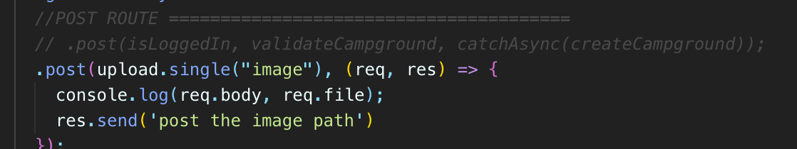
* 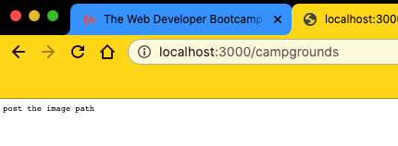
* 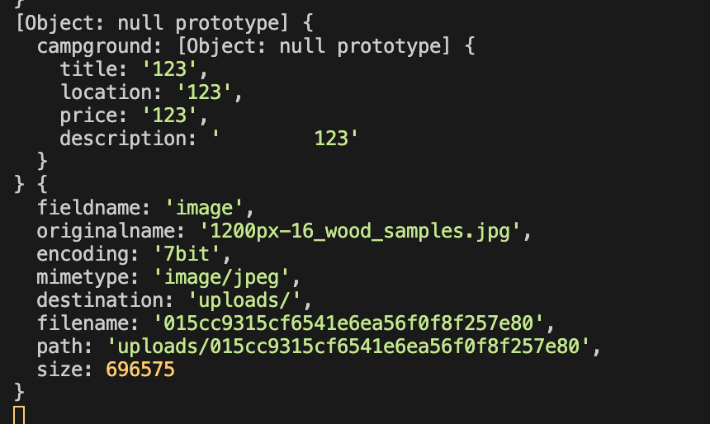

‘req.file’

‘req.body

* 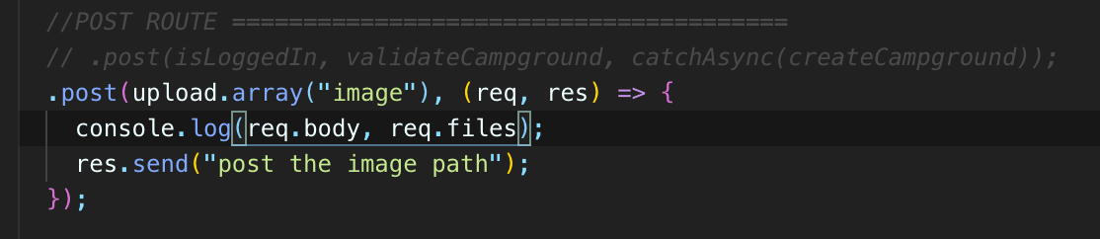
* 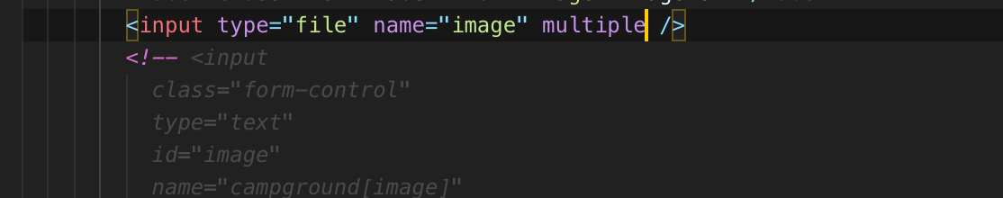
* 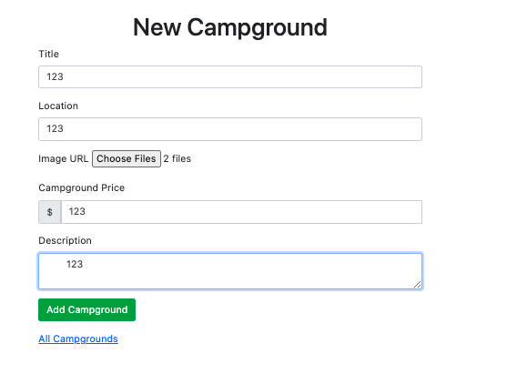
* 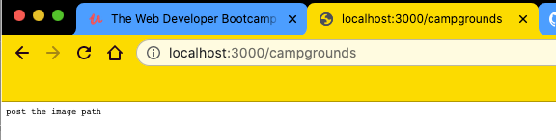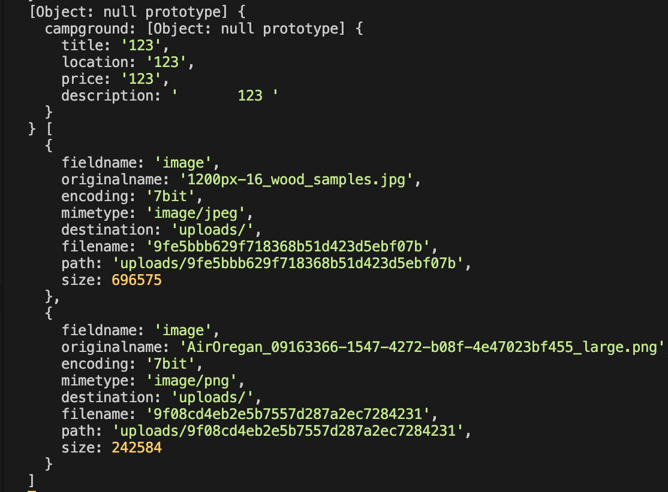
* **so that's the basic idea behind setting up our form and adding in Malter the motor middleware.**
* **Now, we just need to get multer middleware to actually store these images in a better place, not to store them in a uploads folder locally.**
* **That's absolutely a horrible idea.**
* **What we want to do is get them on cloudinary or some similar service, and then we want to take those stored URLs eventually**
* **and put them in our database and associate them with the campground and go from there.**

511. Cloudinary Registration

* we move on to Cloudinary, which is the service will be using to store our image and the file uploads and then it gives us back to where we store that you URL and we can do fancy stuff, as I briefly mentioned, like transform the images, shrink them down, compress them, manipulate them in other ways.
* 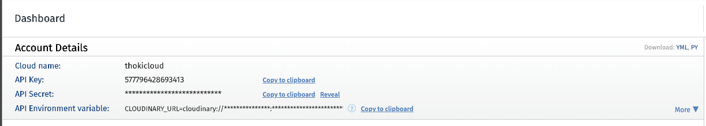
* And there's a reason, you know, they're blurred out here anyway.
* You can click to reveal or just copy the clipboard.
* I will show you what to do with those in just a moment.
* We are not going to put those directly in our code.
* **So we will need the API key, the API secret in the cloud name.**
* **But we don't want to embed that directly in our code and then put it up on GitHub, for example, because if anybody sees that code, they then have access to our credentials.**
* **And if you do eventually connect your credit card to this app and you have a larger, you know, a real application with lots of users and it's important you've got a credit card connected.**
* **Somebody can use your credentials and just store a bunch of their stuff in your Cloudera account, and that could get very expensive.**
* **And that's not just limited to cloudinary.**
* **Any time you have API credentials and anything associated with an account that is especially connected to a credit card, but and in any way sensitive, you don't want to put those credentials directly in your app.**
* So that leads us to **env files**, which is the topic of the next video.

512. Environment Variables with dotenv

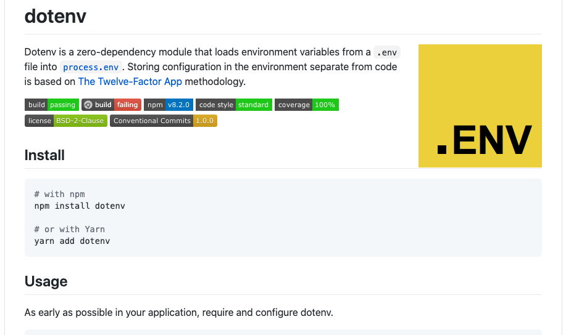

* **OK, so I just talked about at the end of the last video how we don't want to be directly embedding any API credentials or secret keys right inside of our application.**
* So what we do instead is we **store** them in a **secret file**.
* **It's not really secret, but we store them in a file that we don't include when we submit our code to GitHub as an example or a file that we don't, you know, share with other people.**
* **It's a file that stays on our machine locally and it's called typically dotEnv.**
* **So that dots makes it a hidden file.**
* **But that doesn't mean it's, you know, secret from the world automatically.**
* **It just means most users don't see it if they're browsing with, you know, a file pic or something.**
* **But it's there just like any other hidden file.**
* So I'll start by showing you how to just set up a dotEnv file.

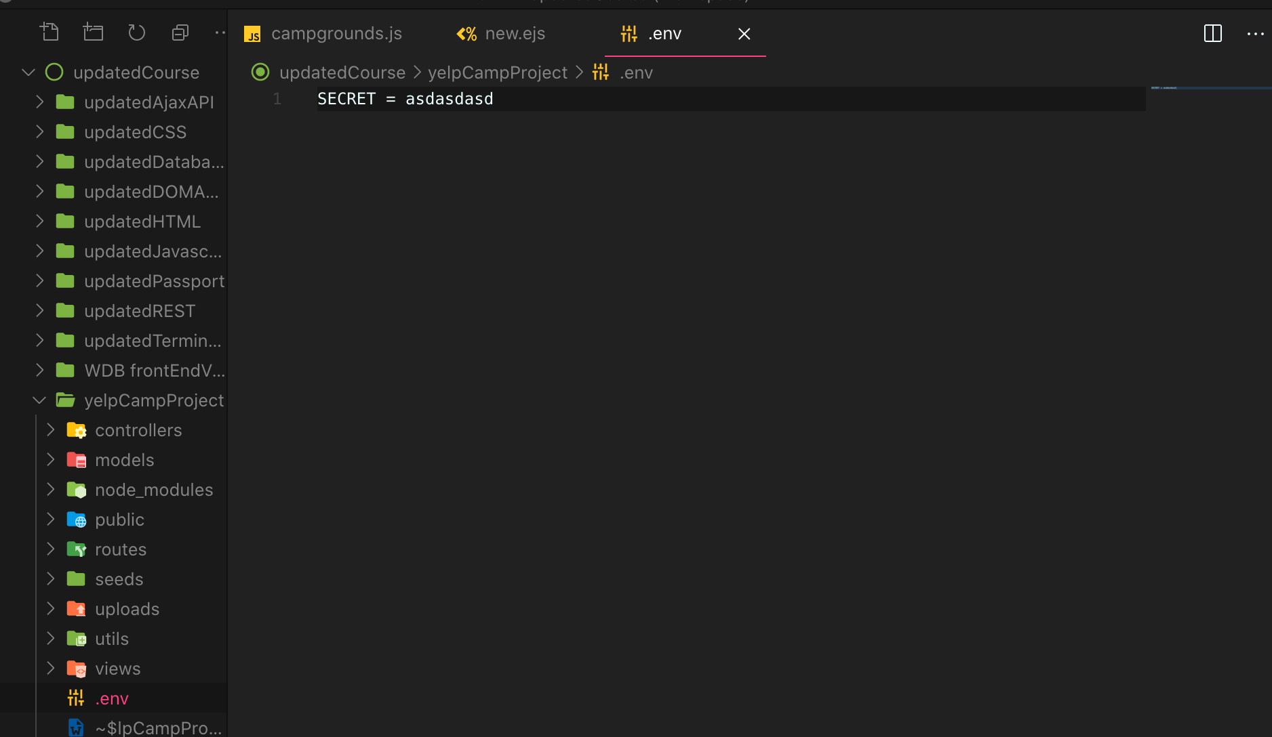

* **So secret equals, you know, that what we're going to do, though, of course, is put our cloudinary information in here and you can come up with any name that you want.**
* **This is the syntax, though.**
* **Something equals some value and then I can get access to whatever is in here in my code.**
* **And now in order to get access to this information inside of my application, I'm going to use a package dotenv**
* 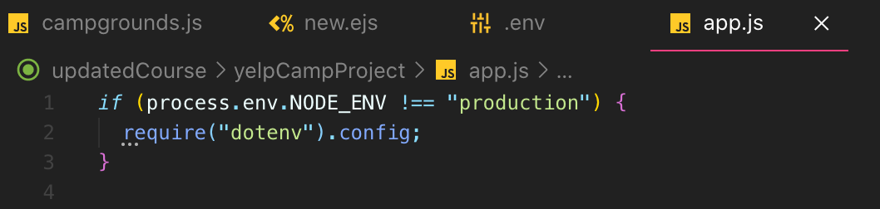
* OK, so what is this?
* Well, **process.env**
* **process. environment is an environment variable that is usually just development or production.**
* **We've been running in development this whole time, but eventually when we deploy:**
* **, we will be running our code**
* **and production and we're saying if we're running in development mode.**
* **So everything we've done so far, if we're in development, yes, we are in development**
* , **require the dotenv package**, **which is going to take the variables I've defined in .env file and add them into process.env.NODE_ENV**
* **in .NODE_ENV so I can access them in app.js file or any of my other files.**
* **Now, in production, we don't actually do that.**
* **There's another way of setting environment variables where we don't store them in a file and we just add them into the environment.**
* You'll see once we get there.
* But for now, this should work for us.
* 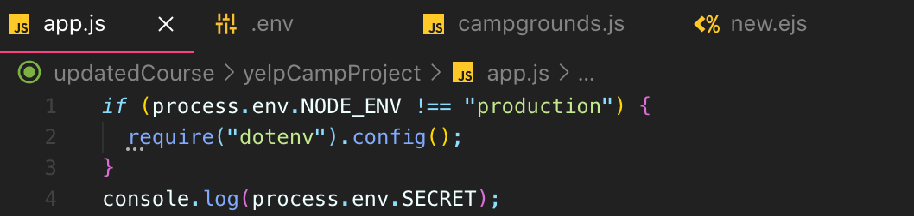

That was a name of the variable (SECRET)

* 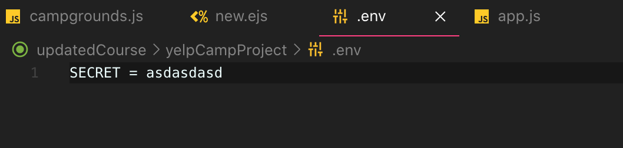
* 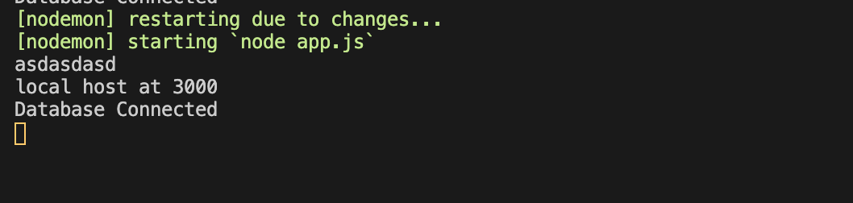
* And then I have access to it in my code with **process.env.secrets** or **process.env.API_KEY**
* 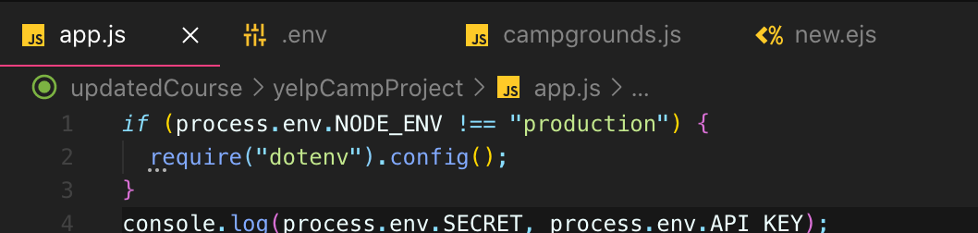
* 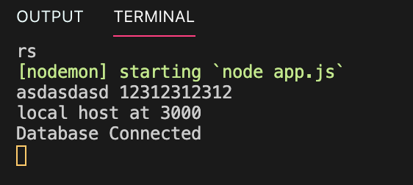
* **So if I was using it**
* **or if I was going to upload this code somewhere, I would just ignore this file**
* **and not include this file so everybody would be able to see, oh, there's some environment variable called .SECRET or called .API_KEY**
* **, and then it's up to them to fill that value in.**
* **Or if app.js is in production**
* **, our environment would just have that value set up, which is not something we've covered yet, but we're just in development mode.**
* **So require(dotenv).config condional statement is always going to run and will be grabbing our data, our variables out of .env files**
* **So let's go ahead and add in the three things I want to store in there.**
* **And the first one will be our cloud in every cloud name.**
* And I'll show you where to find that in just a moment.
* **The second one will be Cloudinary Key.**
* You can name these whatever we have to access them out using these names, so if you want to follow what I'm doing, it'll be easiest quaternary secret.

Don’t use quote and space

* 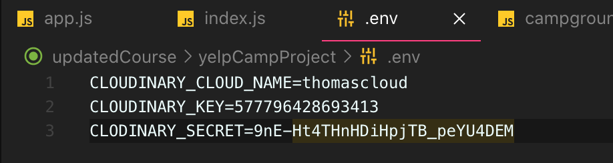

API Secret

API Key

Cloud Name

* so the cloud name from cloudinary, it's just whatever you see
* 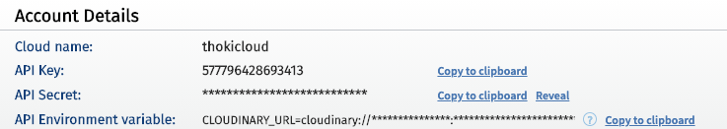
* Now, **if you ever make a new account, if you don't know something changes with your ordinary accounts**, **you would need to update that file and put the real new value in there.**
* But now in our app, we'll have access to:
* process.env.CLOUDINARY_CLOUD_NAME
* process.env.CLOUDINARY_KEY
* process.env.CLOUDINARY_SECRET
* And that's important because in the next video, I'll show you where we need to use them.
* So we've stored them in .env file
* We have access to them because of this if process.env.NODE_ENV line
* We're always running in our development environment by default.
* So require(dotenv) code runs, which is going to take a EMV file.
* It's looking for that one file with that name in the route directory.
* So don't try and name it something else
* and then it's going to just pass it
* and put all of these and process.env very common practice.
* And once we get to production and actually deploying apps, you'll understand what this line means and where these values would be defined otherwise.
* But for now, they're just always in this file.

513. Uploading To Cloudinary Basics

* **The next step is to take these files that multer middleware is able to pass from that form data and actually upload them to cloudinary.**
* And again, you could swap in something else.
* It won't be word for word or character for character what I'm doing here.
* But it's the same process.
* **And to do this, there's actually a very easy tool called multer-storage-cloudinary that works with multer**
* **, which are already using and it works with cloudinary to just make it a pretty smooth process overall to upload files that multeris parsing to cloudinary.**
* **And then it also works so that once we get the url back from cloudinary**
* **multer, add those in so that we have access to them in our route handling callbacks.**
* 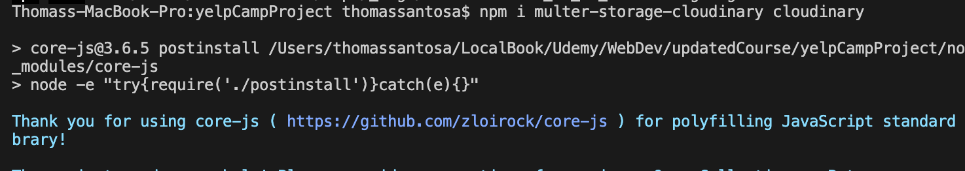
* 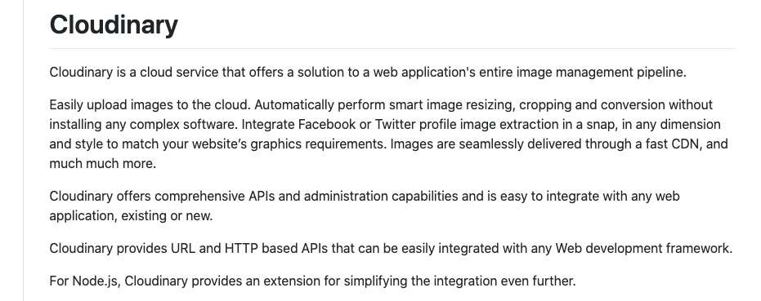
* 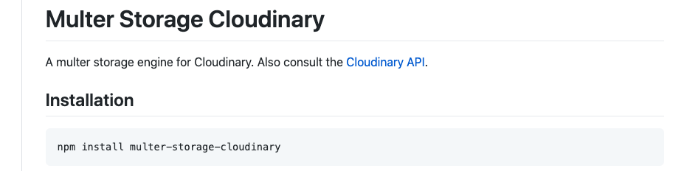
* 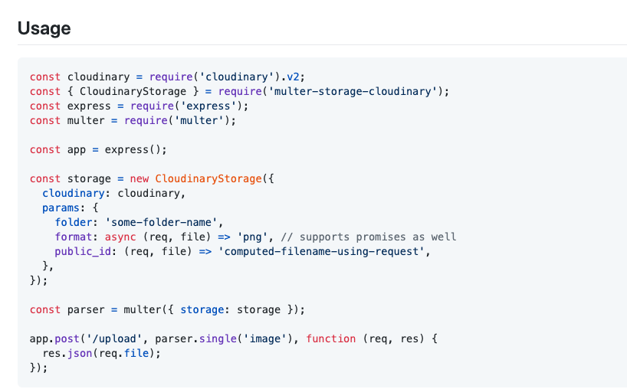
* **So this is basically associating our account with this cloud in every instance.**
* **So process that invoked cloud, very secret.**

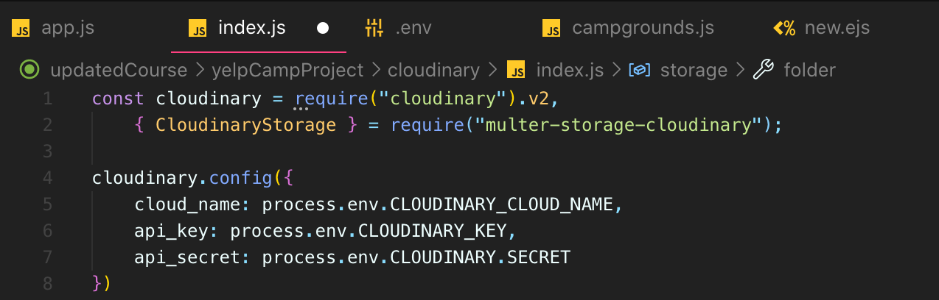

* And we need to pass in this cloud and object that we just configured.
* Then we have some things that we can specify, like folder, which is the folder cloudinary that we should store things in.
* We can also specify allowed formats if you want, so we will allow JPEG, PMG, also JPEG spelled that way and there are other things we can specify too.
* 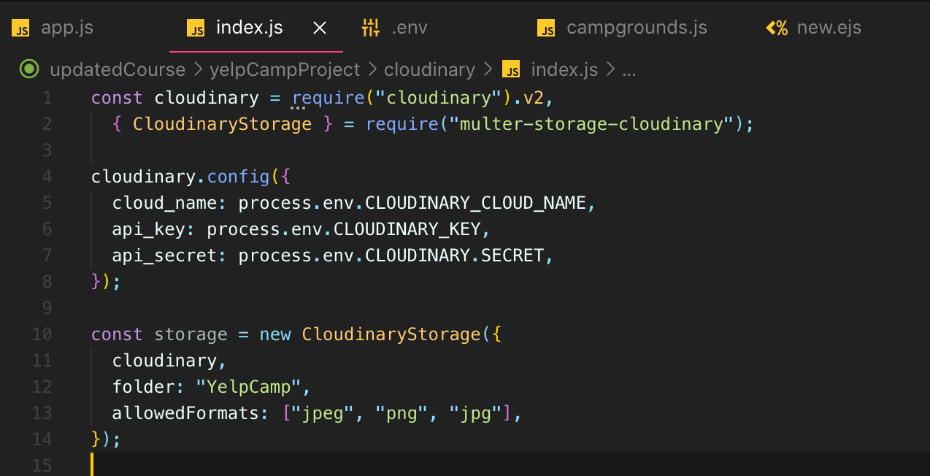
* Basically, this cloud, energy storage is now configured.
* It's set up so that it has the credentials for our particular cloudinary account and we want to upload things to your camp and these formats are allowed.
* Then what we're going to do is go into for now, we'll just do it in our routes file.
* 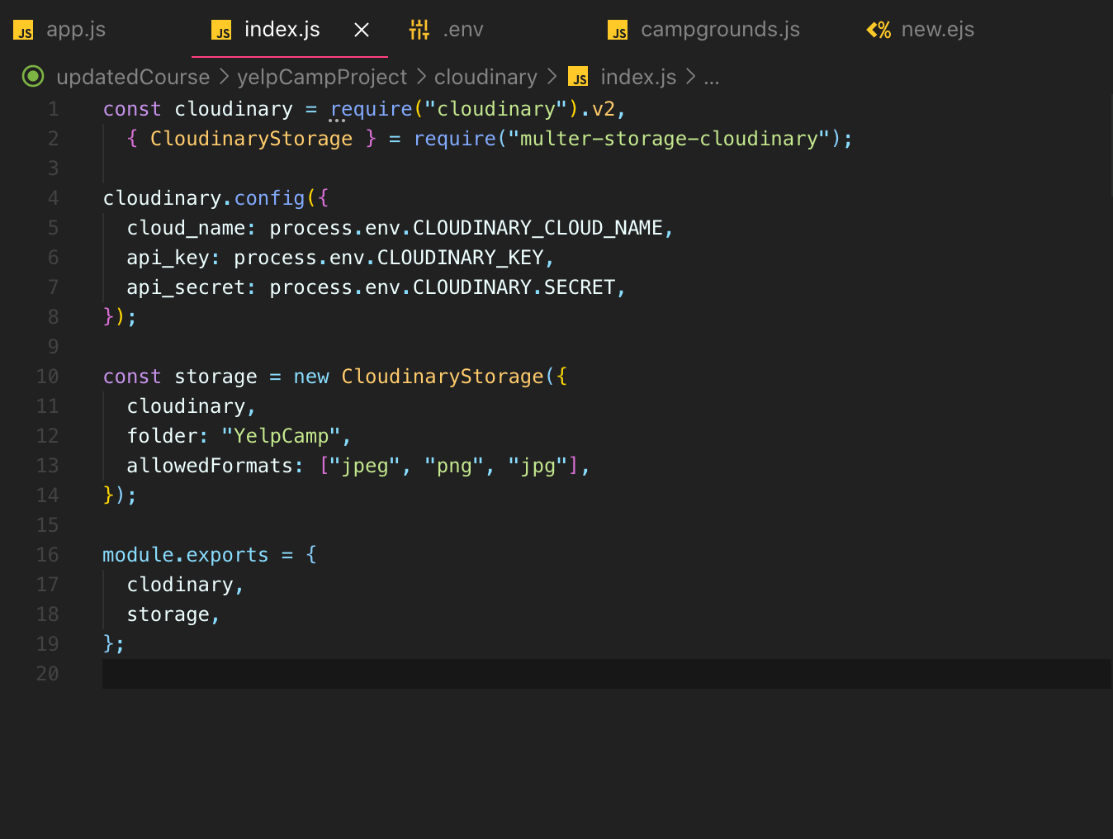
* Right now, it's just Malter where the destination is local.
* 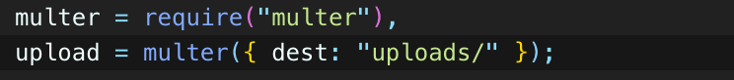
* 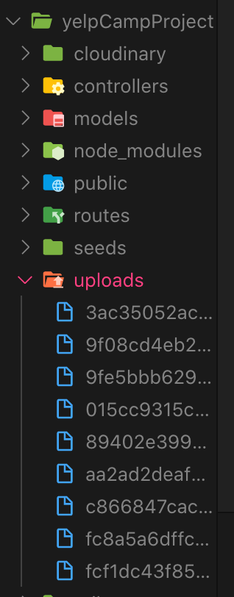
* Now we're going to specify actually multer : “I want you to store it on cloudinary”.
* 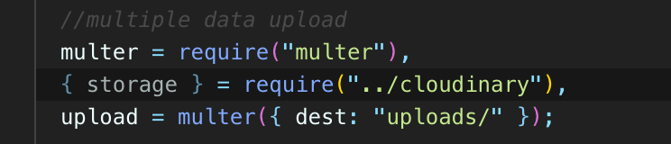
* 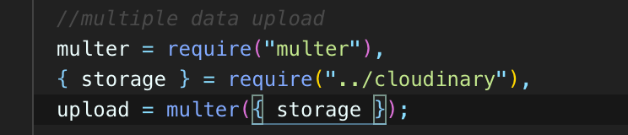
* **But now we've told multer to store things in a different destination.**
* 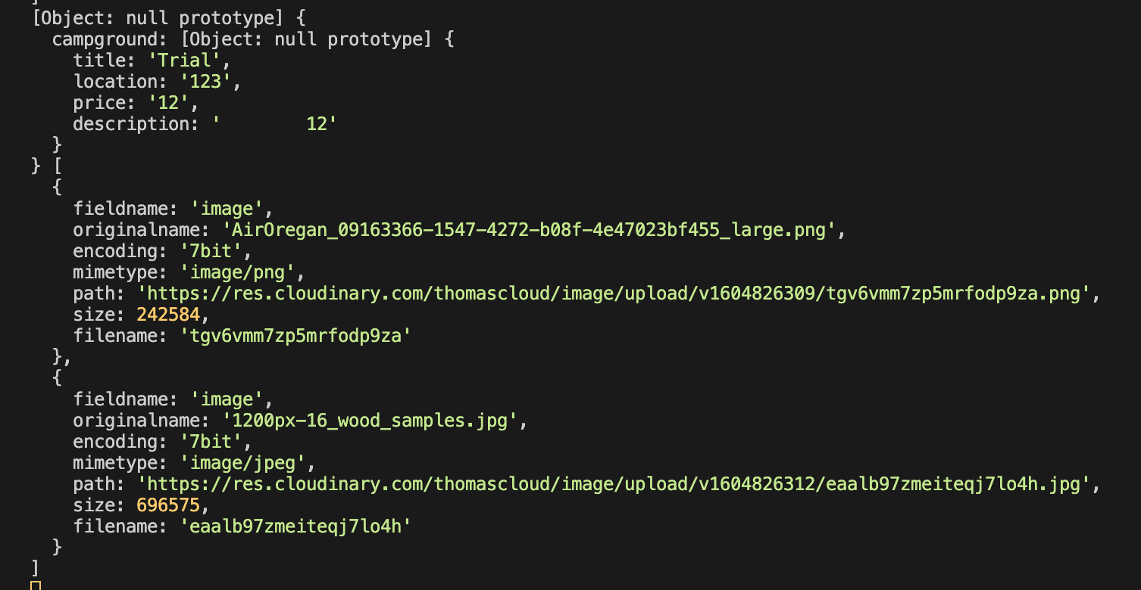

Req.files

Req.body

* 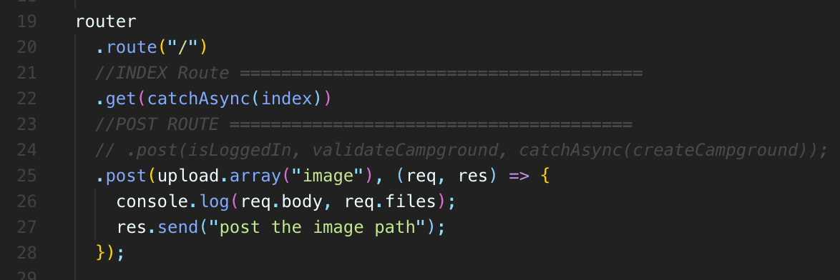
* 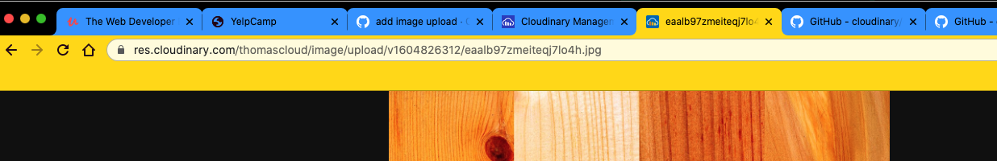
* **So theoretically, if I just copy this URL and I pasted in somewhere.**
* That asset, yeah, it's stored on cloudinary, and so there's one of those images that is now uploaded, it's on cloudinary itself and I can go to my ordinary account
* 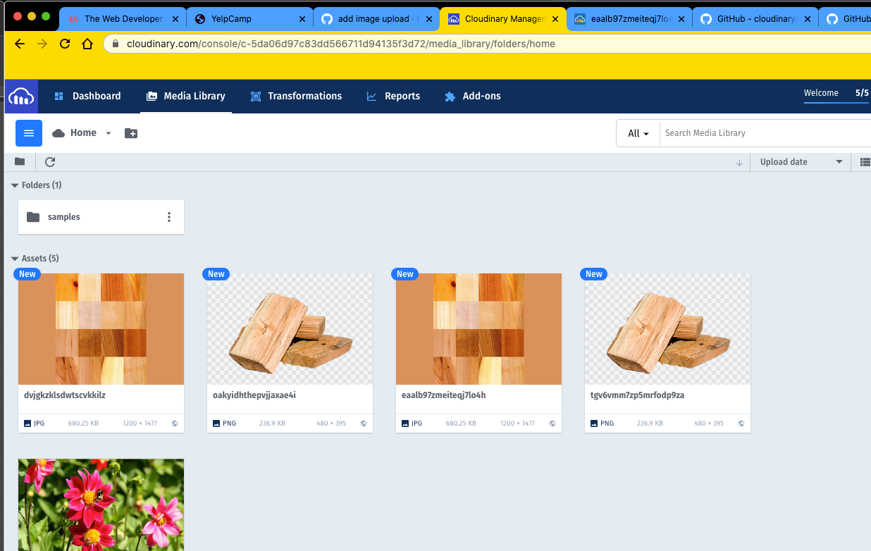
* **We want to make sure that, you know, we don't have conflicts if two people both upload an image name:**
* **We definitely want to have these unique file names.**
* **we need to make sure we take those and store them in our Mongo database so that**
* **we can then reference them.**
* **But we now have successfully implemented upload images can be uploaded to three more and we can take a decent amount of time.**
* **If you're trying to upload a bunch, we can actually set a limit on how many.**
* **But just remember, like nobody very few people just know how to do this off the top of your head. I have to look up. You know, the docs are all the tools we're using and I've done it before, but I had to jog my memory and, you know, things will change.**
* And they actually did change from the last time I did something similar.
* So this is very different than your everyday express functionality or setting up templates and routes and Mongo stuff.
* That's kind of the bread and butter.
* It's just something you do, but not like every single day.
* So it requires work.
* It requires research.
* So I kind of spend through it.
* Again, you can use other tools besides cautionary but ordinary plays.
* Well**, with multer because of this package that we used.**
* **So again, specify our credentials, we make this new instance of ordinary storage**
* **and we pass that through to multer instead of doing our local storage in that uploads folder right here, which I can now just delete.**
* **We're storing things on ordinary and we get back because it's this nice integration with multer.**
* **It just automatically gives us in our requests object.files we look at our routes**
* Request object.files is now populated with information coming back from Cloudinary
* We will store that information and display it.

514. Storing Uploaded Image Links In Mongo

* I just realized in the previous video was configuring the folder and the allowed formats, I don't know if you noticed, but my uploads actually did not go into this folder.
* You if you're following along, you probably won't even have a webcam folder made.
* I haven't made because while I fix the problem, I tested it.
* I uploaded it a new image and it was in here and then I removed it.
* So I have an empty folder, but it doesn't matter.
* You may not have it there.
* It will be created for you.
* The only thing is I didn't actually correctly configure this.
* And if you look at the docs for this tool, we need to put it inside of params.

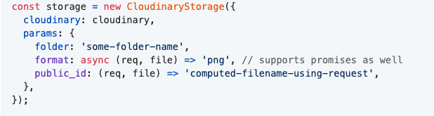

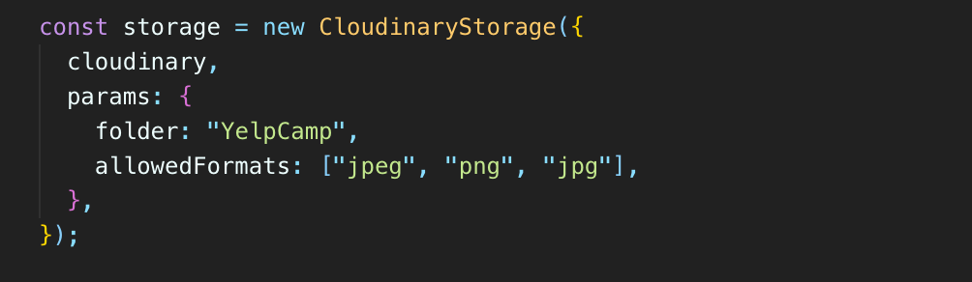

* 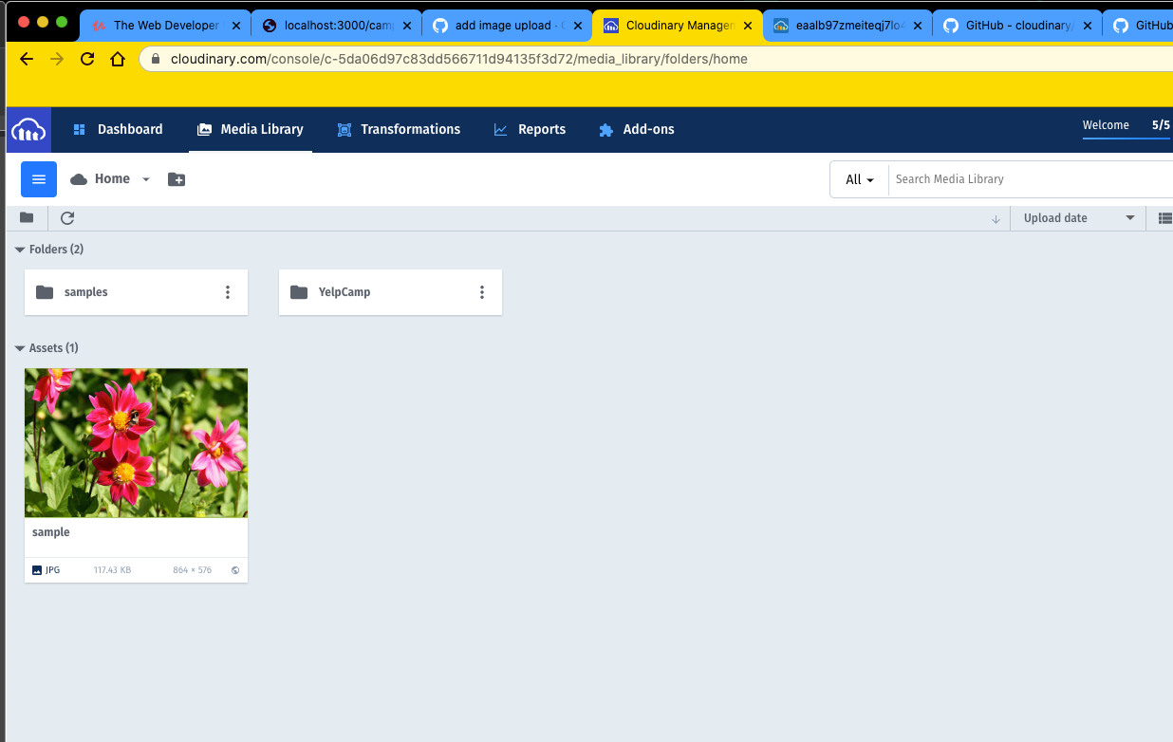
* 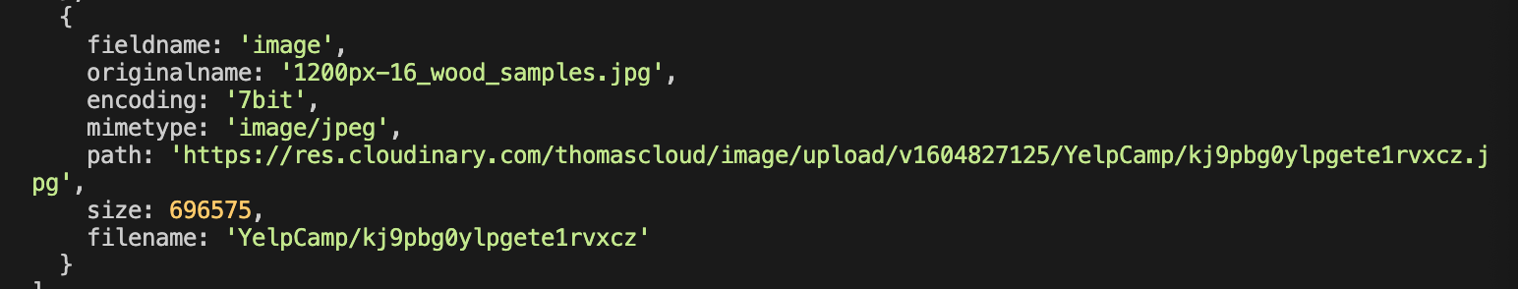
* So over here and my terminal, we see that path to that file.
* We also see this file name and we're going to want to store both of them.
* We want the path so that we can, you know, set up an image with a source and display the image.
* But we want the file name in case we want a user to be able to delete a particular assets on cloud.
* And one of the easiest ways to delete something is just pass in the filename.
* So what I'm going to do is update my model.
* So we're going to store **“path” as you URL** and **filename as filename**.
* 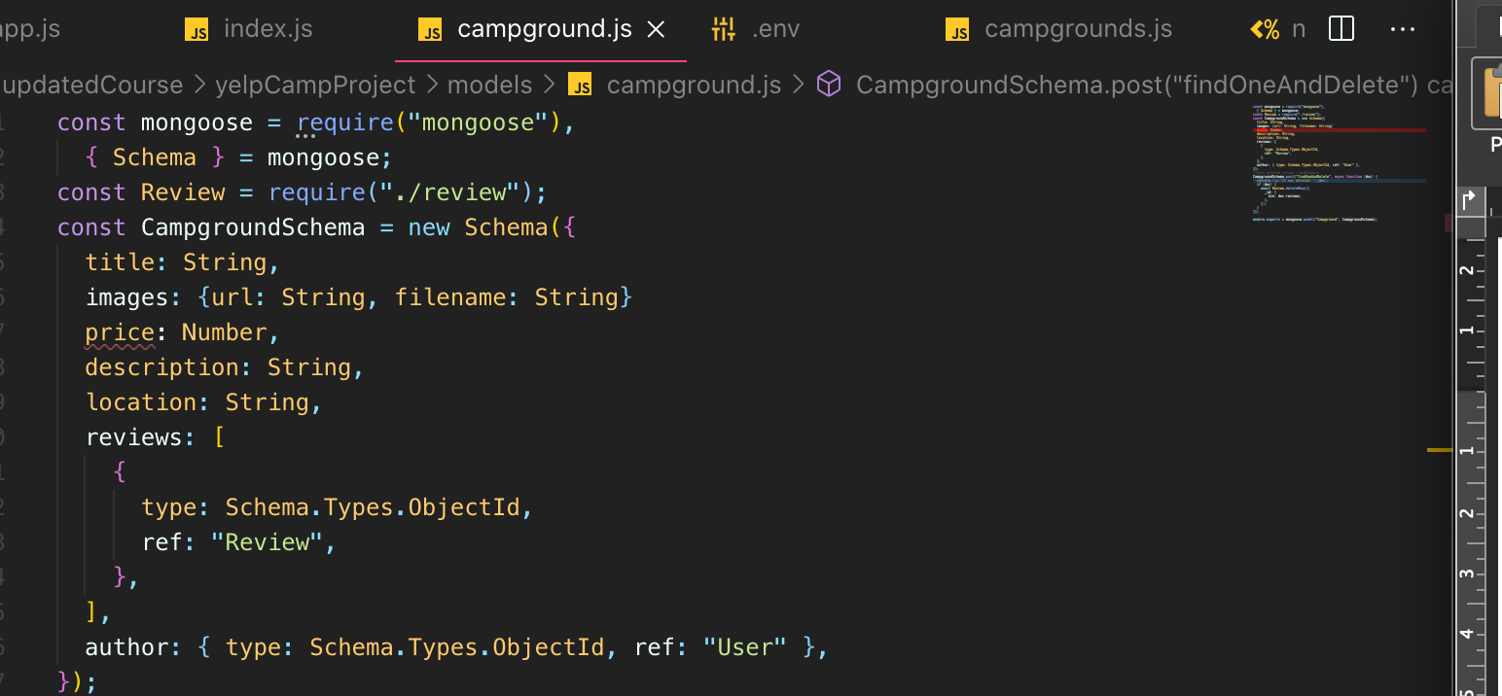
* 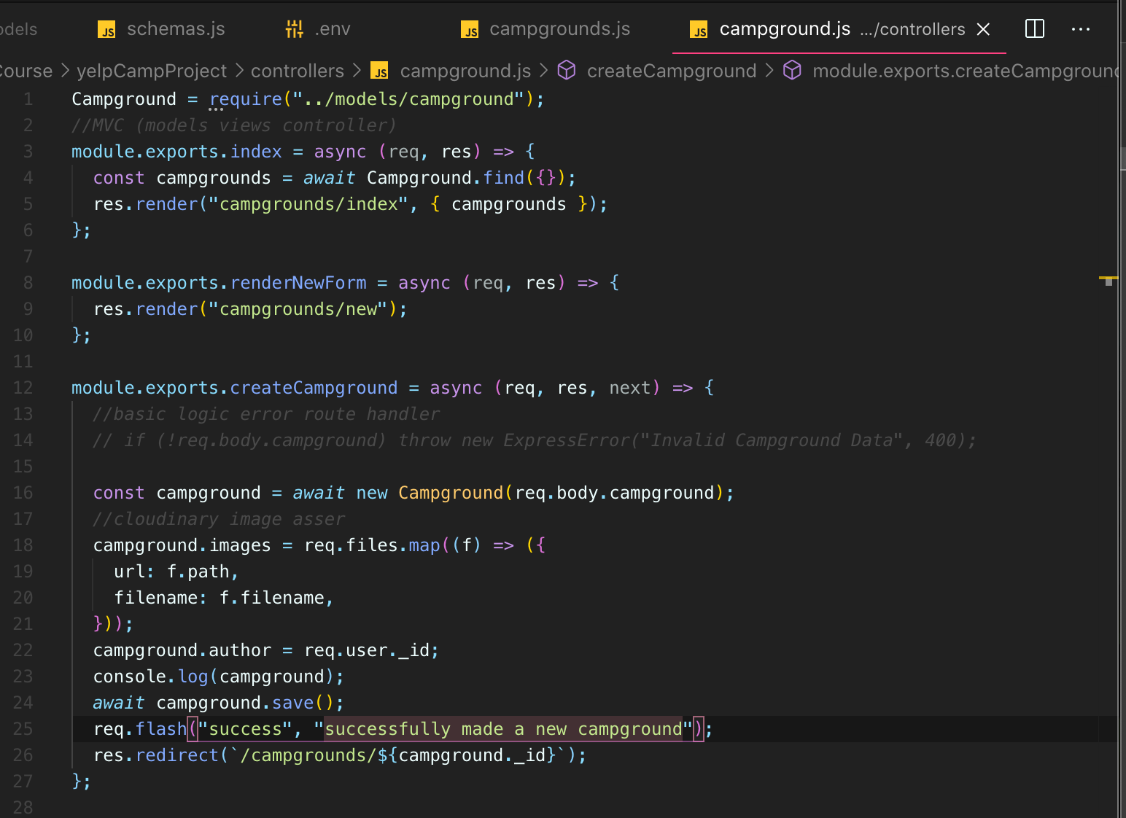
* 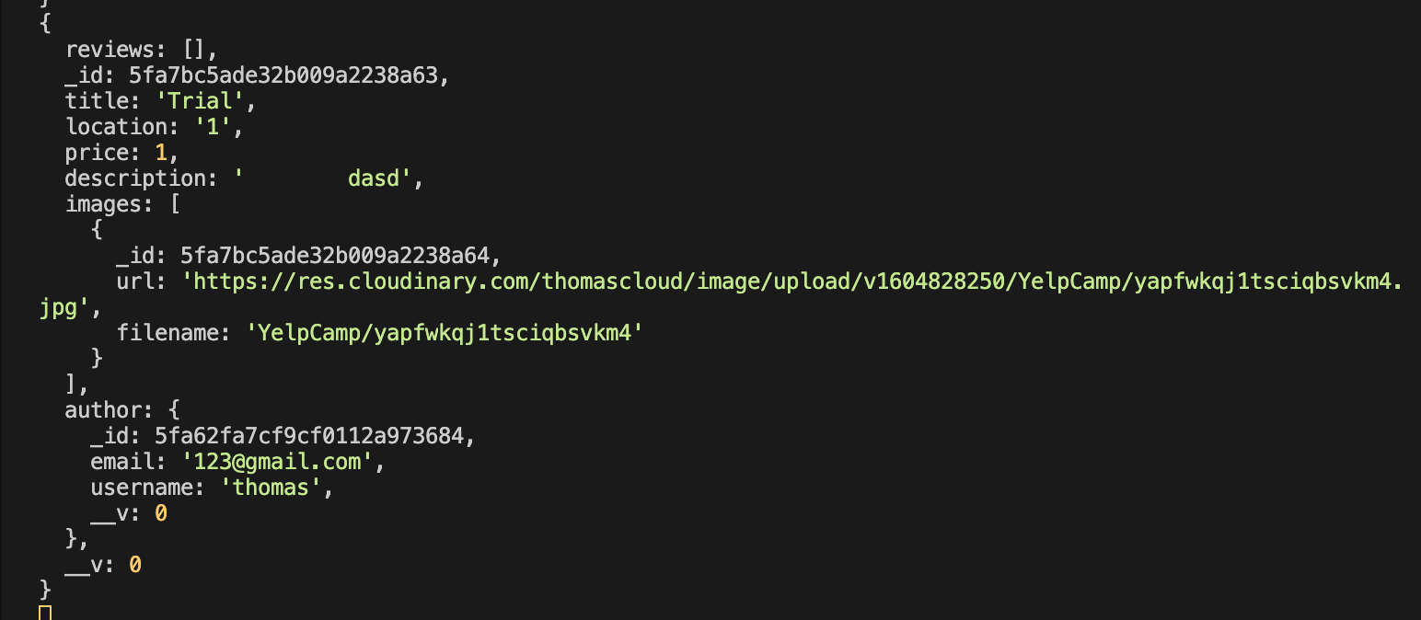
* 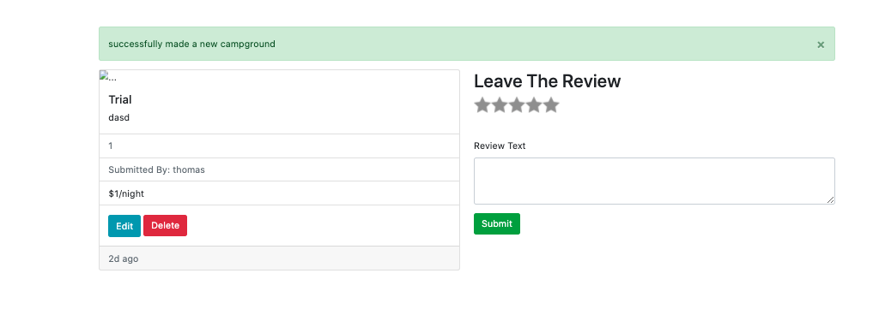
* 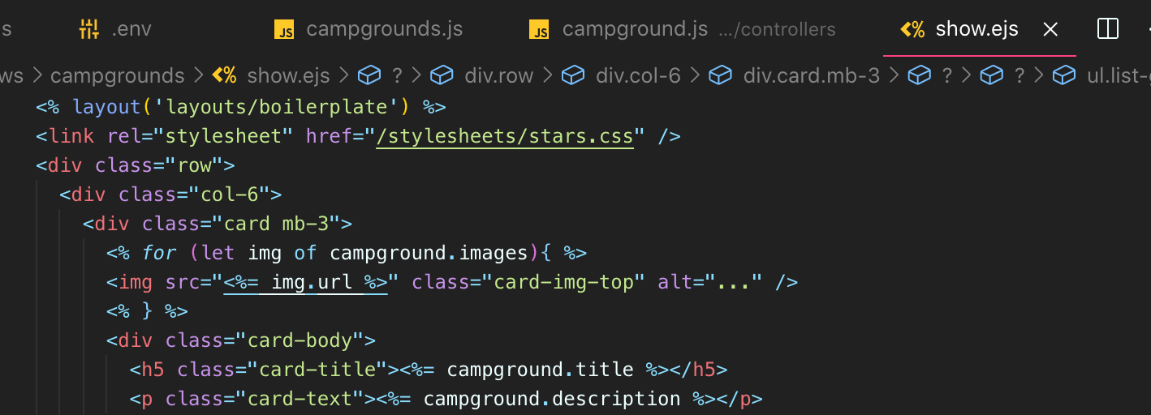
* 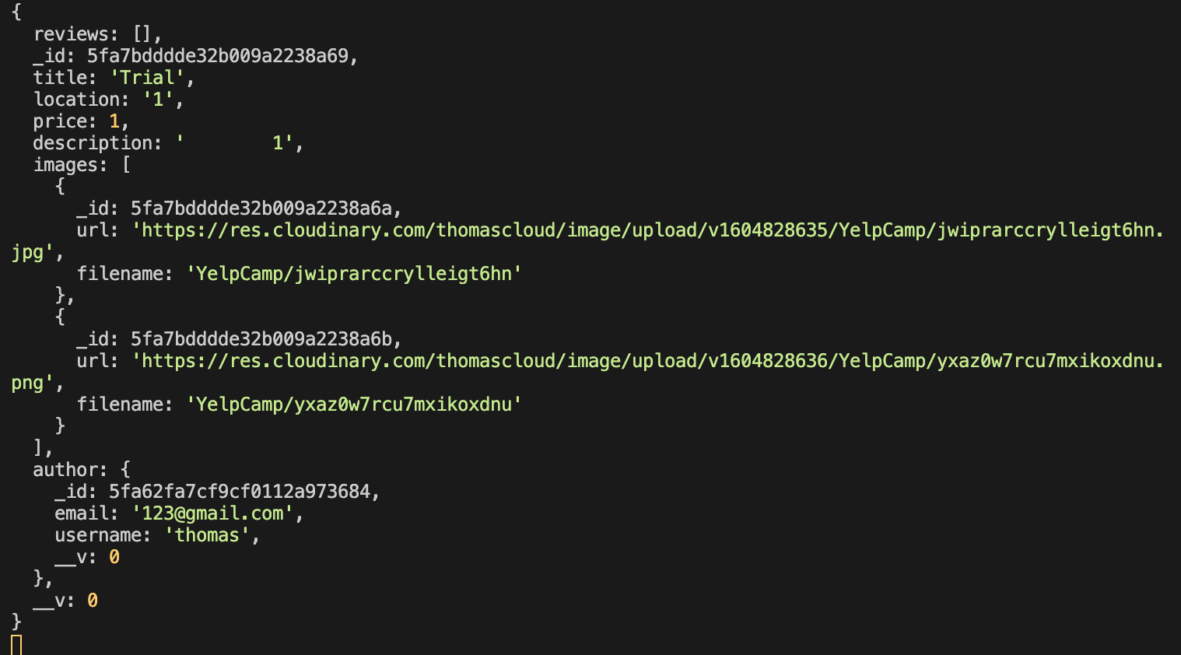
* 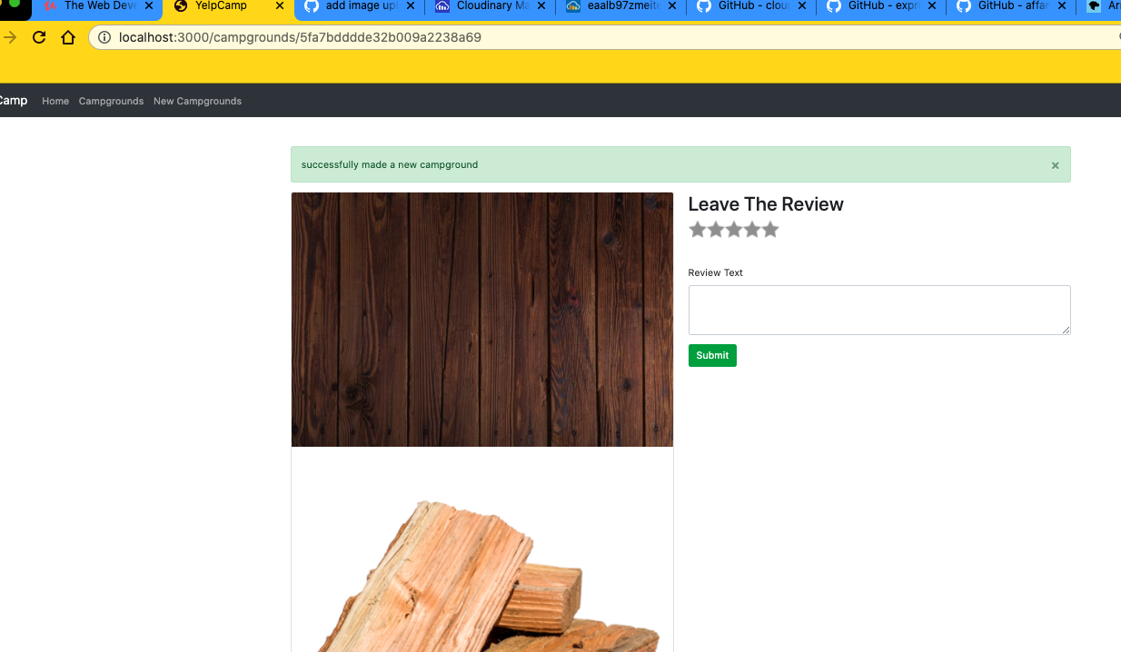
* **We have completed the upload image upload sort of cycle where we start by setting up our multiplatform data form.**
* **And then unfortunately, that means that we can't pass the body the regular way we had been doing it.**
* So then we need to make sure that we use multer.
* And then multer plays well with cloud Inari.
* So we pass that form information.
* We send that on up to cloudinary, we get back to are those you URLs as well as other information about each upload.
* Well, as we saw, we get more information back and that information is going to be added on to a particular property on the request object called request.files, which we then had access to
* and we were able to take the information from request files and use it to update our particular model instance and save that.
* And then in our template, we have access to your URL and file name for each image and we just render that you are OK who.
* So the next thing we'll do there are a couple of tasks, really.
* **One is we might want to change the button here and make this look nicer.**
* **Unfortunately, that's actually more work than you might expect too.**
* **We should make a carousel and display those images if there are multiple images.**

515. Displaying Images In A Carousel

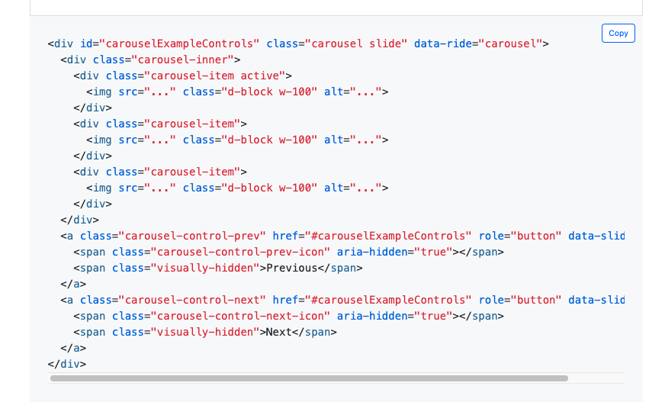

* But if we look at one of them right, we've got two images for this.
* We uploaded them at the same time.
* We also you may want to give users the ability to upload more after the fact, of course, which right now we don't.
* So that's something you definitely could set up using basically everything we've already seen.
* You would just push on to the array of images in your model instead of overwriting it as a new array.
* OK, so to make a carousel, it's a lot of markup.
* We're going to use bootstrap.
* It comes with some JavaScript that makes it work behind the scenes CSS.
* 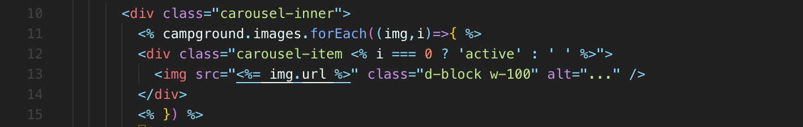
* 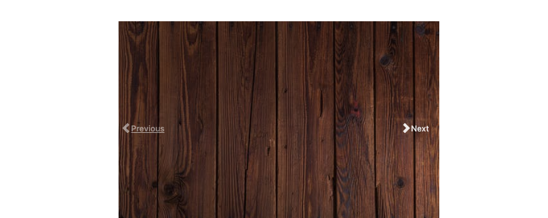
* And there are lots of other things we could explore with Cloud Chinnery.
* First of all, you can compress things, you can make thumbnails.
* And, you know, if you want to optimize, you may not.
* If somebody uploads something massive, we may not want that image and its original size.
* And and it would be more efficient to render a smaller size.
* Also, you know, we've got to figure out what we're going to do around editing.

516. Fixing Our Seeds

517. Adding Upload to Edit Page

518. Customizing File Input

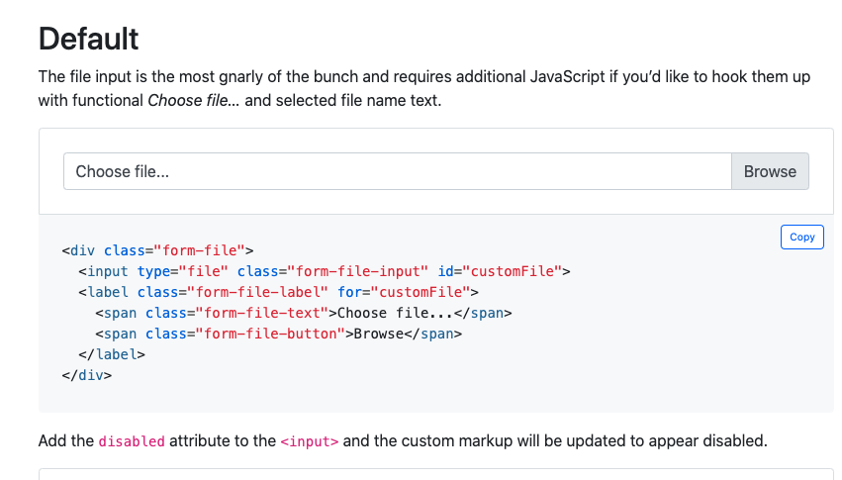

519. A Word Of Warning!

* So that's pretty much it for image upload, at least at this point.
* **I just want to leave off by highlighting some problems.**
* **One of the main problems**
* **, really, they all stem from the fact that we're not limiting how much somebody can upload for a single campground.**
* So right now, you know, I could go in here and select all of these images.
* And upload them all, and it's going to, first of all, take a long time, which is not a good experience,
* but also we don't want somebody to be able to upload.
* Well, we can decide.
* Maybe we do.
* Maybe we don't.
* **But we probably don't want someone to be able to upload like hundreds of images for one campground.**
* Usually there should be an upper limit.
* So what we could do is implement some sort of limit on the server side for each campground, you know, only store 10 or however many images in the campground model itself.
* **Or we could add some kind side validations to make sure that, you know, we look at how many images there currently are for this campground, how many are trying to add.**
* **And then we just don't let you submit the form until, you know, the total is less than 10.**
* Now, I'm not going to do that right now just so that we can keep moving.
* **You know, I'm concerned as we add these new features, really, you know, fixing and and finding every tiny little issue can take a lot of time.**
* You know, it probably 10, 15 lines to JavaScript.
* But then we would also need to do it.
* When you create a campground, we want to make sure that you're not uploading 20 or a thousand photos at once.
* And by the way, it's still going I mean, it's taking quite a while.
* Then we've got the other side of things.
* You know, how large of a thing can somebody upload?
* And if you do end up paying for a service like cloudinary or AWS, like in the real world, you know, those images people upload, they don't cost a lot of money.
* But if you have a lot of users, then it definitely costs money to store all that information.
* So you need to start thinking about how do we impose limits.
* People could have used this and just end up charging us money by spamming new photos over and over and over.
* If we don't have some sort of protection now, we don't have a credit card attached to this anyway.
* But that's just another thing you should keep in mind.
* So I don't want you to think that this is production ready image upload, because we're not validating the amount, the number of images and the size of the uploads.
* But this just shows the basic mechanics.
* And that's kind of a trend with this project.
* Building an actual clone of Yelp like this is still very, very tiny, tiny compared to actual Yelp, but even fully fleshing this out and getting it ready for the real world.
* It takes a long time.
* And in the real world, it would take multiple people and you would take a lot more time and really go over each feature in detail and make sure things work, figure out the edge cases.
* So we're just going over the basics of image upload.
* image upload basics, but not perfect.

520. Deleting Images Form

* let's update our edited form so that a user can actually view the currently uploaded images and delete some of them or all of them, although we'd have to figure out what happens if there's no image to display.
* But anyway, instead of just always adding more images, we may want to add more images and also delete existing images.
* 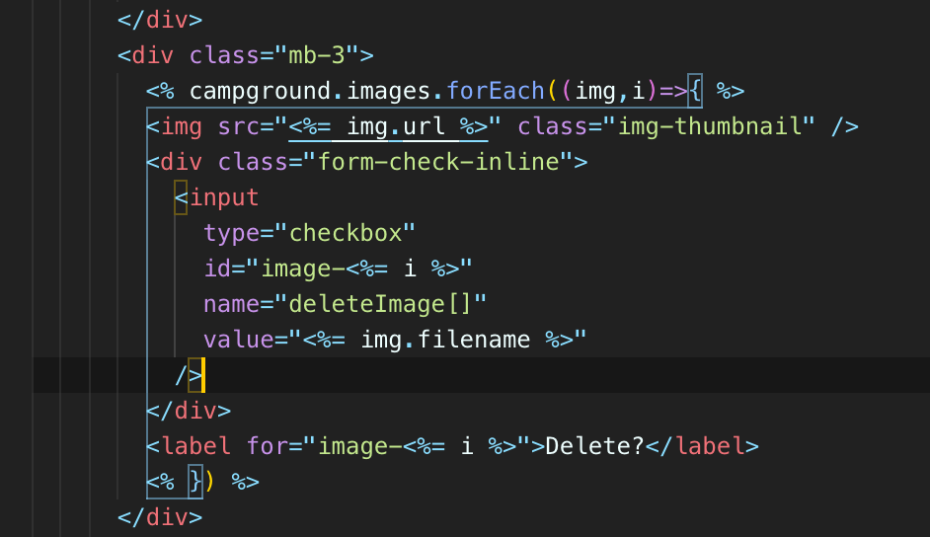
* 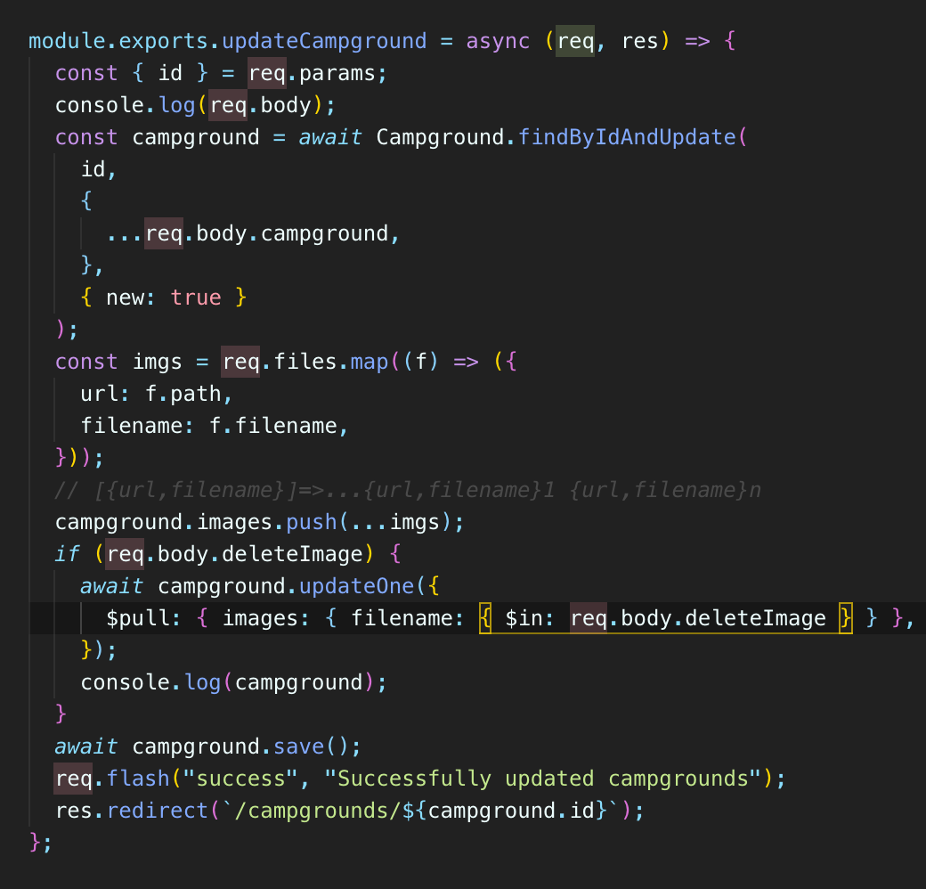

Removing url, filename: only mongoDB

* deleteImage[] is an array.
* And it contains things, those two items that were checked.
* So we just set in our templates.
* We set each checkbox to have a different value and then we set them all to have the name of delete images, square brackets, any checkbox that was checked.
* Its value is added to deleteImages [] and it's an array when we pass the body.
* So the good news is in our campground route or in the controller function here, we have access to deleteImages.

521. Deleting Images Backend

* 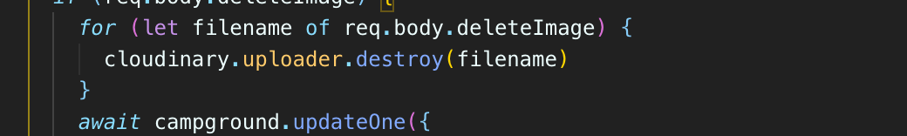

Removing filename: cloudinary

* **Uploader.destroy this method destroyed on the or you pass in the filename and it should delete that particular file and we can await each one.**

522. Adding a Thumbnail Virtual Property

* **I'm going to show you a pretty nice trick, it's not a trick, but a feature of the cloud binary API to help us display thumbnail images on the edit page.**
* **We don't want to display the full size images.**
* **This isn't even full size here.**
* **This is bootstrap constraining the images.**
* **We could also use some success to just say, you know, 200 pixels wide for every image on this page.**
* **But remember, some of these images are quite large.**
* **Here's one of them that I uploaded, and this is, I don't know, over a thousand or 1500 pixels wide.**
* **It doesn't really make a lot of sense to request this entire image just to display 200 pixels of it.**
* **And then if we have a bunch of them, it's just a waste of time.**
* **It takes time, honestly, to request those resources.**
* **So what we can do instead is use Cloudinaries Transformation API to request a modified version, a small thumbnail version.**
* I don't know if you can see this here, but basically there's a bunch of parameters, things we can do, like change the opacity, the rotation at a border, change the color you can do a cropping with and height that we want with in height for now.
* 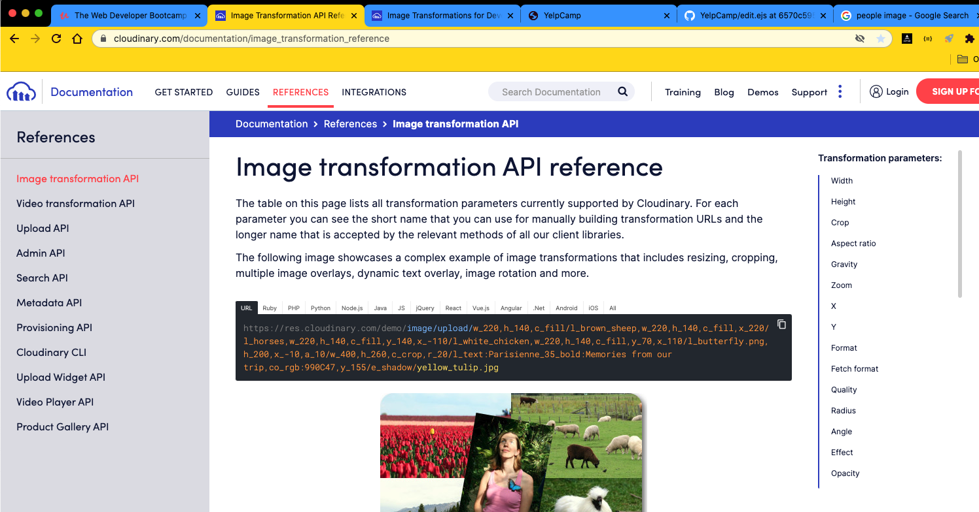
* 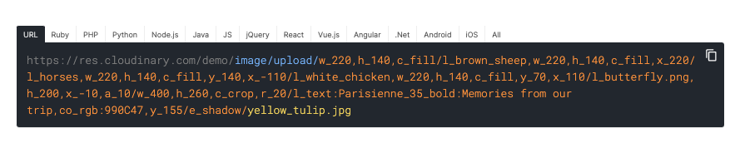
* Anyway, you can specify all of this in the url.
* **So if you notice the pattern here**

**it's image/upload/<parameters in orange there >/<our actual path name for the file>**

* So if we look at what we have, here's one of them.
* This is actually from cloudinary area.
* **You URL the location, the identifier for our particular resource.**
* What we are after is just setting that width to be 300, let's say, or 200.
* **So we don't have to store this in the database.**
* **We already have in our database we have the url, the entire URL.**
* I'm just going to copy this and put it in my text editor so you can see what I'm referring to in our database.
* 
* We have something like this right here, except we don't have this with 300.
* So it's kind of annoying is **if we want to use this transformation API to make a small thumbnail, I need to add in dynamically this little bit after upload.**
* And that's kind of annoying, right?
* We've got to like split it up or replace this portion on the fly.
* And I don't really want to do that in our template.
* We could, but we try and avoid doing any heavy lifting or any real logic or manipulation, rather, in the template. We try and keep it templates as javascript free, as logic free as possible.
* So I'm not going to do that.
* I'm actually going to show you a fancier way.
* **If you remember, in Mongo with Mongoose, we can set up these virtual properties and that's exactly what I'm going to do on my model.**
* First of all, unfortunately, I can only add virtual properties to a schema, campground schema
* But why I say, unfortunately, is that what we actually want a virtual property on is each image.
* Because what I want to be able to do in my template is basically something like,
* img.thumbnail => url with transformation api
* And that should give me this you URL for each particular image.
* So the reason we use a virtual in case you skip that video, is that we don't need to store this on our model or in the database
* because it's just derived from the information we're already storing. We're storing that.
* 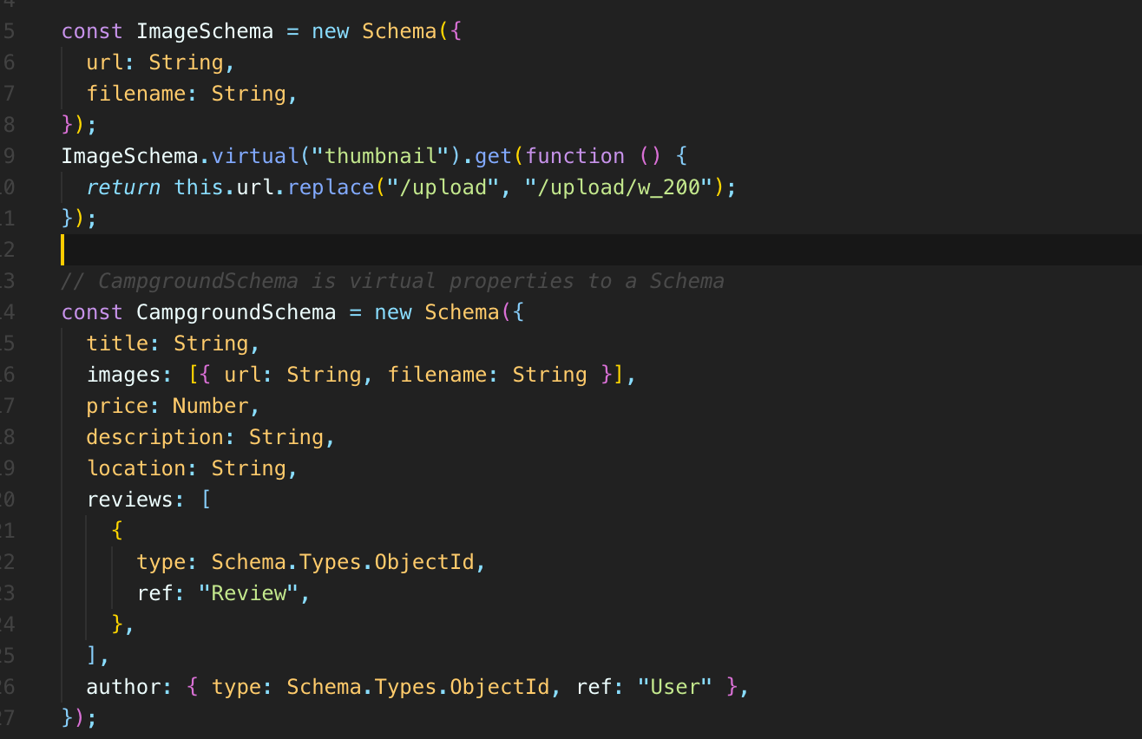
* If we're going to allow users to upload images and we want to display those thumbnails, it just make more sense to display an already small version of that image instead of a massive version that we just scaled down in the browser.
* Why? Why bother?
* Just get the small version from the from the very get go and display that.
* But anyway, it's just mainly an excuse to use a virtual and to show you some of these image transformation apps.
* OK, so yeah, things don't look amazing, but it works.
* We've got this edit form.
* We can upload multiple photos.
* When you make a new campground, we can specify a bunch of photos and that's pretty much it for now.
* But there's a lot that we could still do with images.
* I'm pretty sure.
* I'm positive that you will find some issues with our images and with uploading.
* We haven't really tested it.
* Like what happens if you use a forbidden type, like you trying to upload a gif or like a video, an MP4 for file.
* Also, we haven't done things like what happens if you delete all images?
* We should have a backup, just a default that would give you, you know, normalizing the height or displaying them in the same way so that it looks nicer.
* We could use the transformation API actually to do that.
* And that might be something we come back to because we can crop them all to be the same exact same size.
* And that makes for a nicer experience.
* As you can see here, it's not that noticeable, but we are shifting like the text moves up and down and some of the other ones are certainly more noticeable, for example, here.
* That's a pretty big shift in just a clunky like just accordion effect.
* It's not nice.
* So we could normalize the size for success.
* We can set CSS or we could use a Transform API and then we can get more specific about saying we want to keep the center of the image and crop it or we want the bottom and upwards.
* And there's a lot we could do anyway.
* You know, this could go on for hours and hours and hours just just on image upload and really improving these features.
* But we're going to move on and talk about maps up next.

**Section 53: YelpCamp: Adding Maps**

523. Registering For Mapbox

* **So the next big feature we're going to add in is maps**
* , so we're going to start small.
* **We'll basically just display a map on the show page for a given campground with a little pin on it that represents the location of the campground.**
* **And we're going to do something that we haven't talked about and we haven't covered maps at all.**
* **But we're going to cover “geocoding**“as well
* **so that a user doesn't have to enter in like latitude and longitude coordinates.**
* **That's what the map tools all expect.**
* **They want you to pass in latitude and longitude for a pin**
* , but we're not going to do that.
* Well, we will.
* **But a user is not going to provide that**.
* **They'll provide a location and we can take this location and geocode it to figure out latitude and longitude.**
* **So that's obviously something we can't do manually.**
* **There's not a formula that we could do**
* **, but we use tools and APIs to take this**
* **, turn it into latitude and longitude**
* **, take that latitude longitude**
* **, store that in our database alongside the location**
* **, and then create a pin on a map.**
* **Now, there are lots of map tools out there**.
* **There's Google Maps, open street map and the one we'll be using that's really popular for developers is mapbox.**
* **Map box allows you to customize things.**
* **I mean, you can see the companies that use it.**
* Facebook snap.
* We work Adobe like very big companies.
* **They like map box, as far as I understand.**
* **I mean, for us it's great because it's free.**
* **You don't need a credit card to get started, but also it provides tons of pretty powerful tools.**
* **You can customize how things look.**
* **I mean, look at some of this fancy stuff, augmented reality navigation for directions.**
* **Let's see what else Mapbox Studio allows you to design your own maps.**
* You can change colors and fonts, features, camera angles, all sorts of things.
* We're not going to deal with any of that.
* We will be able to style things if you want, but we're going to just get a basic two dimensional map.
* So the first thing you'll need to do is create an account and it's free.
* You don't need a credit card.
* Obviously, it's a paid company if you use it on a large scale.
* But for our purposes, just for maps on a small app, it's free.
* So you'll sign up for that account.
* And then the next thing we'll do is just take our credentials.
* We get from MapBox who actually signed in over here.
* **If you go to the Tokens page once you're signed in, this is important to understand.**
* **These tokens are not secrets.**

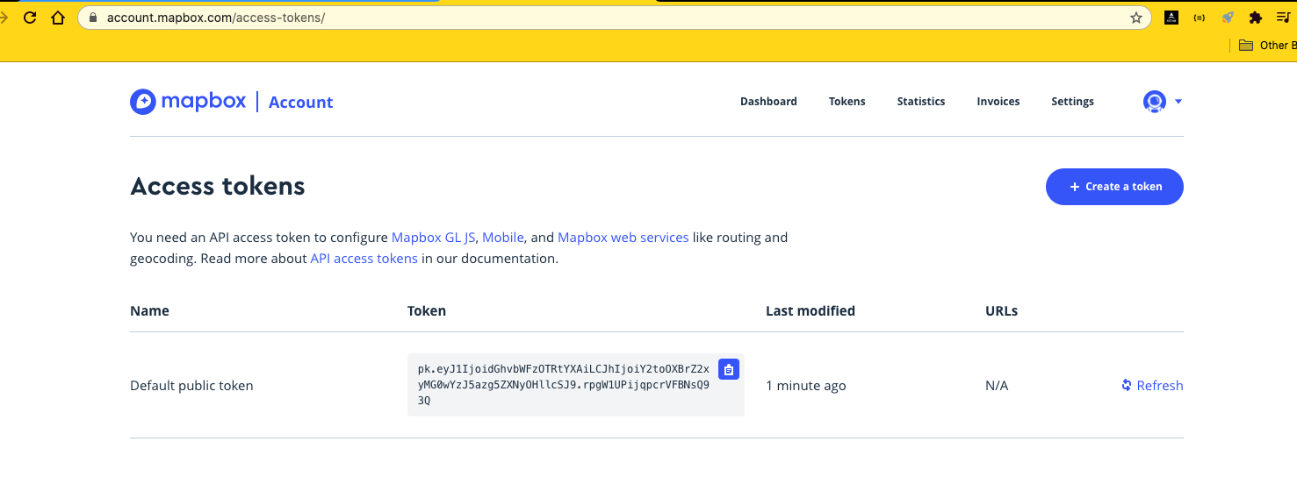

* **These are not something that you can prevent people from seeing because actually the mapping libraries, all that stuff happens via JavaScript on the client side in the browser.**
* **So we have to provide our token to map via JavaScript in the browser.**
* **So that token is going to be visible in our JavaScript if we just take a look in our developer tools so we don't hide this.**
* **This is not a secret.**
* That doesn't mean that you should go around telling people everything, telling people your, you know, your mailbox token because it is possible for people to abuse them to you know, you've got to monitor the usage of your mailbox account.
* They have some articles on, you know, detecting fraud and all of that.
* But for us, we're not putting our credit cards into it really does not matter.
* **So we need to get a public token.**
* You should just have a default public token.
* You can also make a new one.
* **There is a difference between public and secret tokens or different scopes.**
* **So MapBox has a lot of features that you can create a secret token for that you do on the server side,**
* **we are not going to use any of these features, so we'll just make a nice public scope token**
* **so you can make a new one or you can just use one that's already been made for you.**
* **And then we just need to copy that token.**
* **We'll add it into our .env file just like that.**

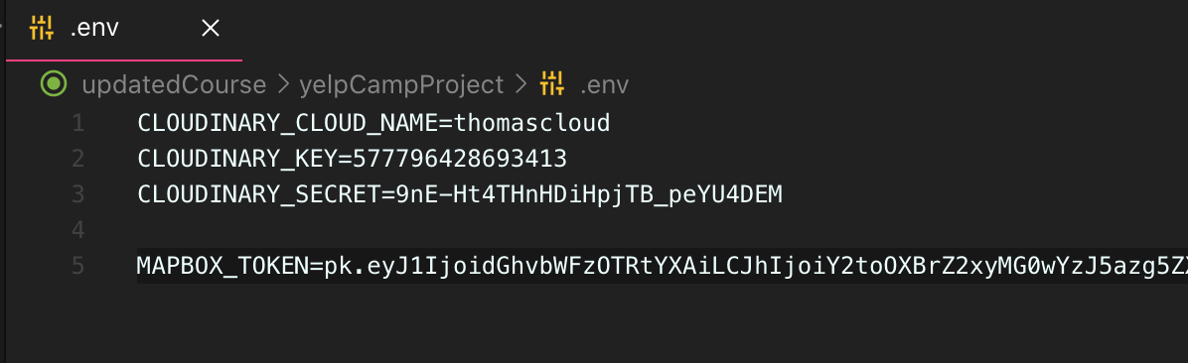

* **Now I have my other ordinary stuff, but I did get rid of that just so that you don't steal it.**
* So MapBox Token equals and then some key.
* **So we're putting it in here not because it needs to be secret, but just that we can group things together.**
* And there are again, there are mapbox tokens for certain features that you would want.
* They force you to use a secret token.
* But again, we're just grouping things together.
* And then also this is nice because when we do go into production, we can just use the exact same process,
* the same tools for specifying our keys if we put all API keys in this file.
* OK, so that token is in there now.
* And in the next video, we'll go ahead and get set up with our map box tools so that we can do the first step, which is to take a location that a user types in, like Bellevue, Washington and geocode that to get latitude longitude coordinates.
* And then we'll save that in our database and then we'll worry about rendering a map and a pin and everything.
* All right.
* Here we go.

524. Geocoding Our Locations

* OK, so now we're going to work on the geocoding process when our form is submitted to make a new campground and have to sign it out.
* **When I specify a location, we're going to take that text.**
* And I'd say it's just Texas or Spain or a specific city or even a specific address in a city, in a country, whatever it is
* **, we're going to take that an attempt to get latitude and longitude coordinates for that.**
* **And the way that we were going to do this is by using map boxes, geocoding API.**
* Now, there are lots of tools to help you geocode.
* **There are standalone APIs that are just for geocoding.**
* There are like Google has its own API for it.
* Lots of other companies do as well.
* But we'll be using the mapbox client to do it so we can make a manual request ourself.
* If you go to the docs for mapbox
* , there's a geocoding service where you can actually use a playground to play around.

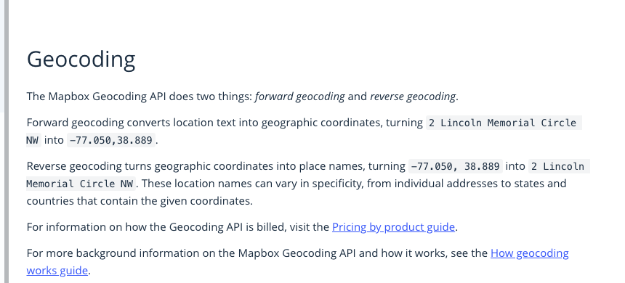

* But basically you specify information like a search string to Lincoln Circle, Lincoln Memorial Circle, and it will spit out Seventy-Seven or negative 77 in 38 degrees anyway.
* Then there's the opposite. That's called forward geocoding.
* There's also reverse where you can take coordinates and then get the name, the address, the city for a particular set of coordinates.
* **We could just make our own request manually to do this, like just an endpoint where we specify information.**
* 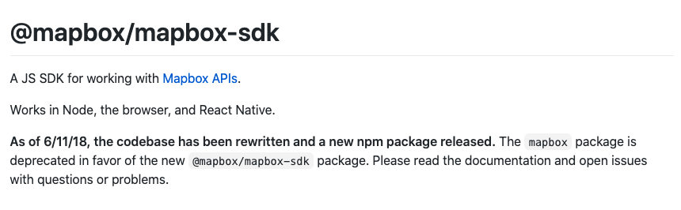
* But we're not going to do that because mapbox s has a node client called the MapBox SDK that we can include in our app or just going to go ahead and install that.
* It does have this at sign in front of it.
* So make sure you get that.
* What we're after is the geocoding service, specifically forward geocoding.
* 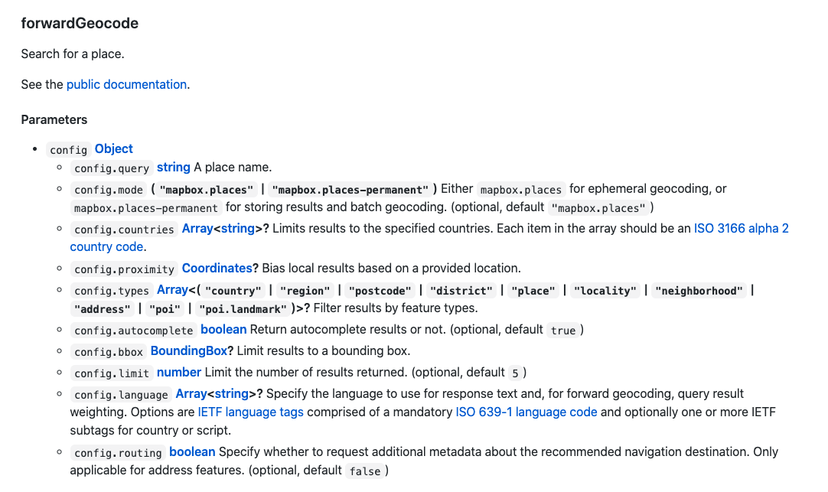
* 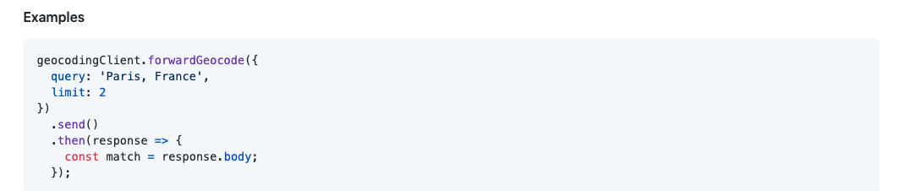
* then we call Forward Geocode, which takes some query like Paris, France.
* And then we also specify how many results to unpack, the number of results we can limit to one to we're going to do one for simplicity's sake.
* But often in a more complex app, you would get a couple and then you might ask a user, you know,
* which one of these looks most correct?
* And that's actually more for reverse geocoding anyway.
* **OK, so we're going to call geocoding client forward geocode and then send and then we can await that and returns a promise and then response.body should include the information that we want or whatever we named the variable.**
* When you create a new campground right here, let's just our end goal is to console that log latitude and longitude.
* Let's hope that it works.
* So I'm going to start by importing what we need from map box.
* 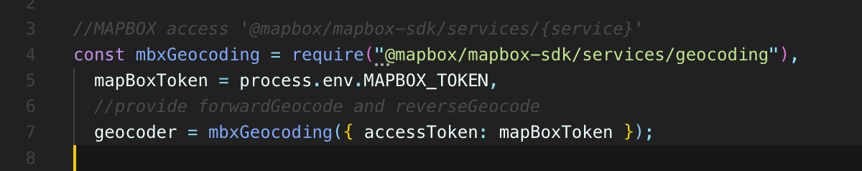
* 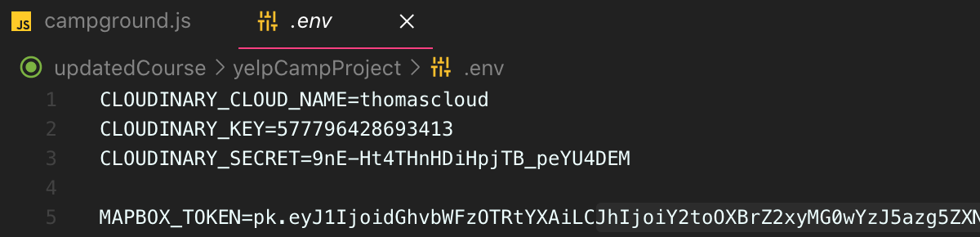
* 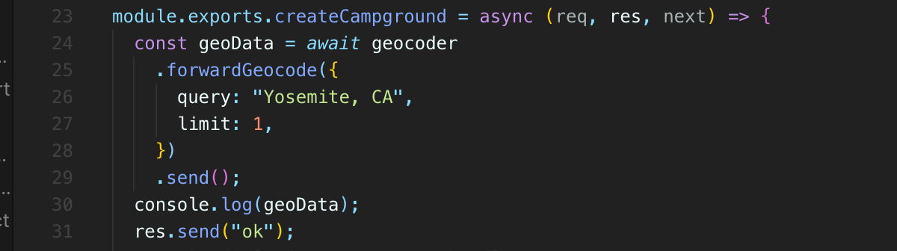
* 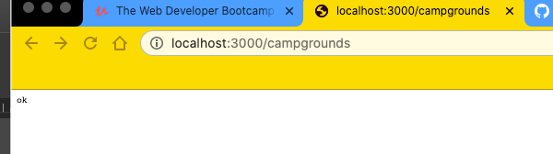
* 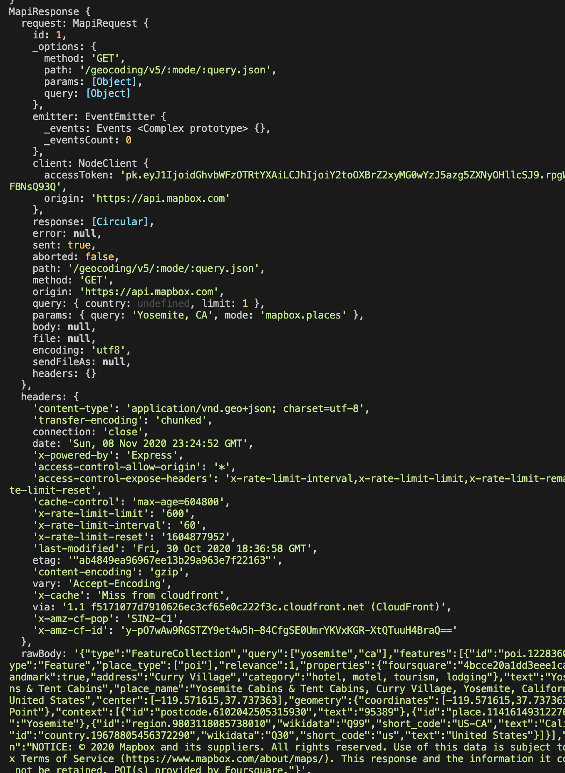
* 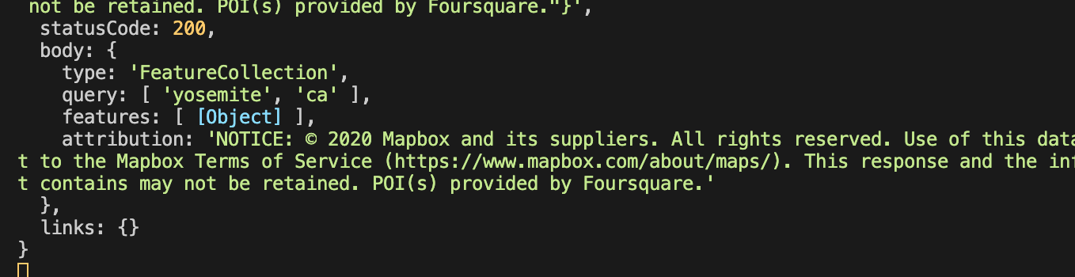
* 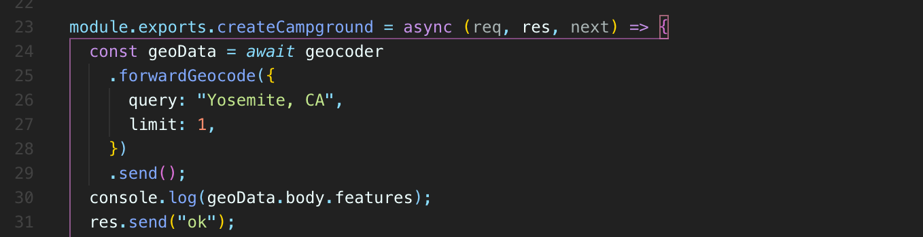
* 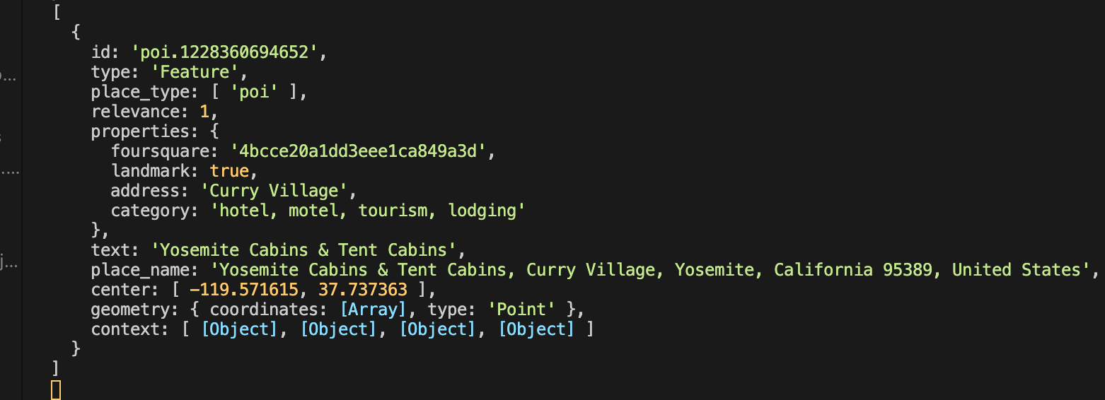
* Well, it's an array and we only limited it to one result, so we just get one.
* Well, we have information about Yosemite, its location, and **specifically we want this geometry instead of geometry.**
* We have coordinates so we could even get more specific geometry that coordinates.
* 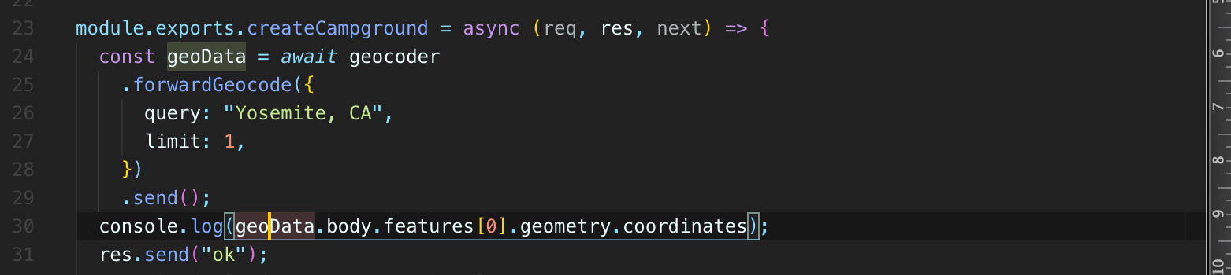
* 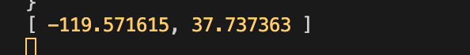
* That's our mapbox coordinates, longitude and latitude.
* In googlemaps: latitude and longitude
* 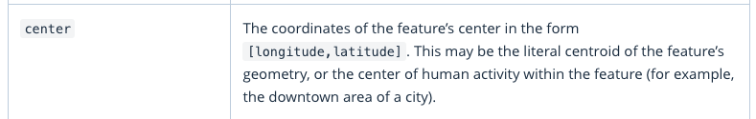
* 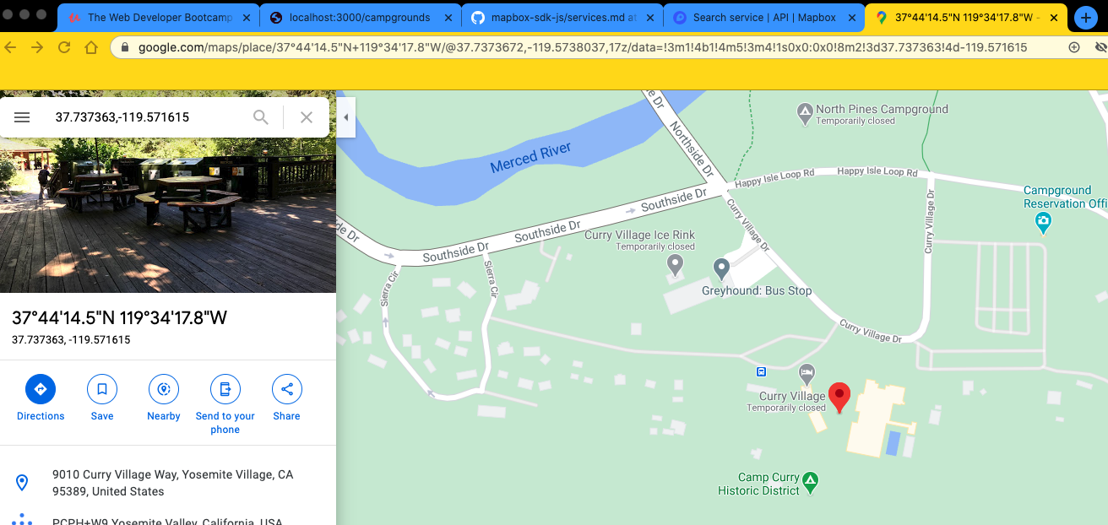
* 
* **And then we also ‘limit’ specify how many results to unpack, the number of results we can limit to one to we're going to do one for simplicity's sake.**
* But often in a more complex app, you would get a couple and then you might ask a user, you know, which one of these looks most correct?
* 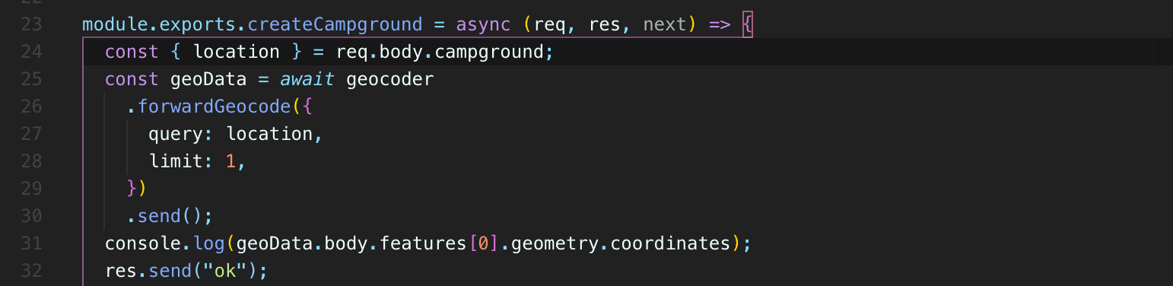
* 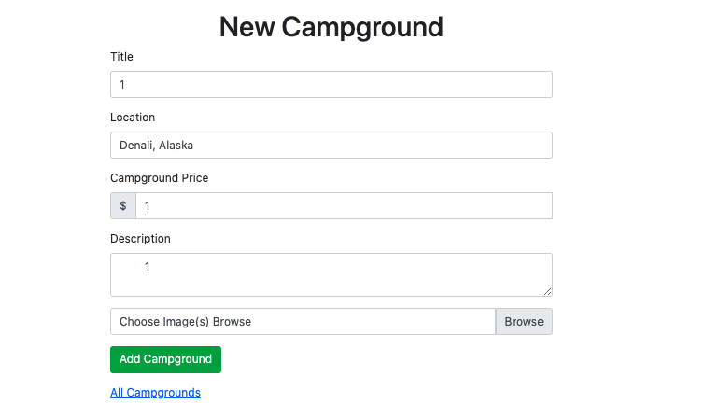
* 
* 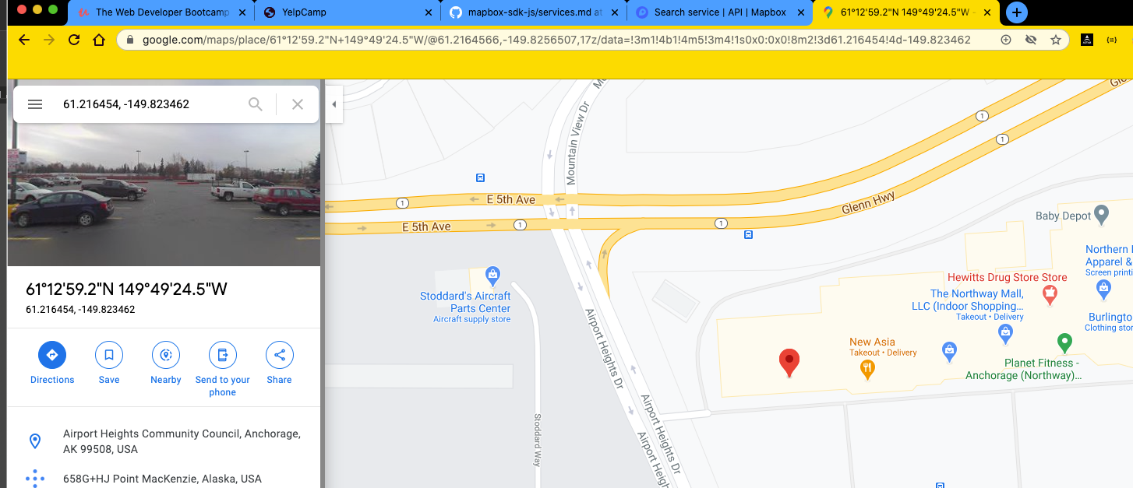
* We're getting those coordinates in the next video, we're going to take them and store them in our database so we actually have them so that we can use them to display a map after that.
* So that's geocoding.
* These forward geocoding where we're getting the coordinates from some string and then the next step is to save those coordinates in our database.
* So we need to update our model.
* And then the next step after that is figuring out maps and rendering those coordinates as a point on a map.

525. Working With GeoJSON

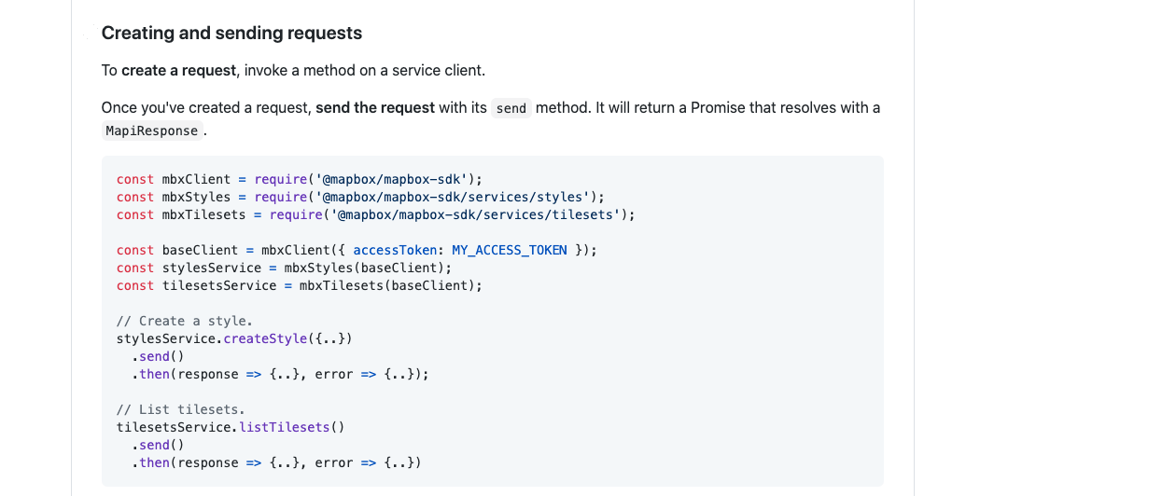

* **so the next thing we need to do is actually store this information that we get back to the longitude and latitude, the coordinate point from MapBox**
* **, we want to store that in our campground model.**
* 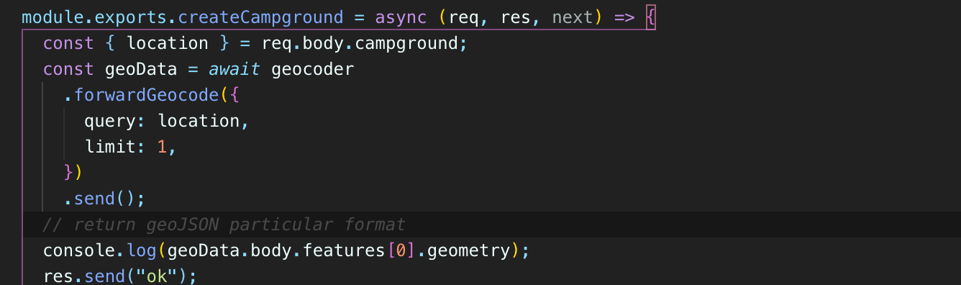
* 
* Geo.Json follows a very particular format where we have a type field and in our case it's always going to be **“point”** and this is coming from mapbox.
* But geoJson is bigger than just mapbox, just like json is bigger than one API.
* It's a standard that's very common.
* So we have type “point” and coordinates is this array.
* So we're going to store this entire thing, like we would just copy this and put it in our model.
* 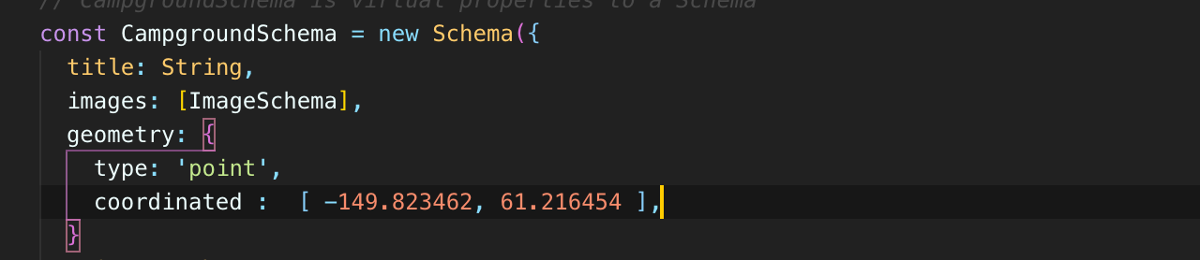
* We basically want to say type is a string and it actually has to be point coordinates as an array of two numbers.

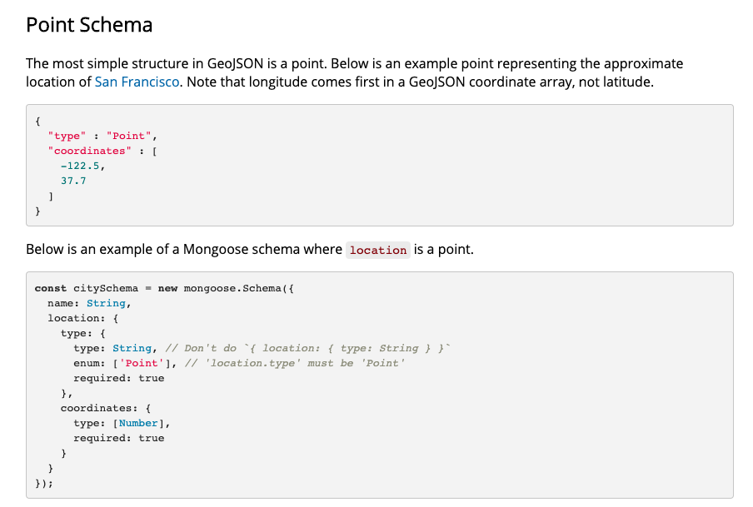

* mongoose actually shows on their documentation exactly what we want.
* They call it ‘location’.
* We can call it location or geometry or whatever.
* Actually we already have location, so we'll do geometry where there's a type string.
* enum has to be there and it needs to be ‘point’.
* So enum is how you provide specific options and if you just provide one, we're basically saying type has to be the string point and then coordinates is an array of numbers.
* So that matches the exact format we got back.



* And this is important because mongo itself supports a lot of geoJSON functionality.
* 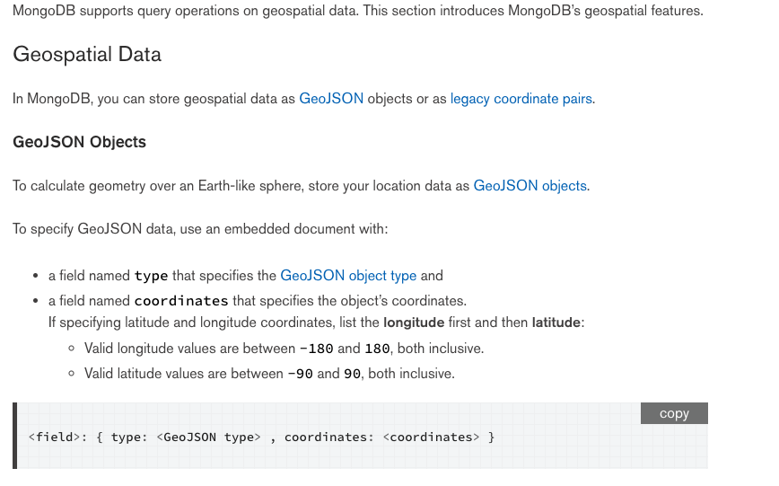
* This is the mongo Docs geospatial queries.
* You can do things like find locations within a certain radius or find what else distance is set up, indices or indexes.
* We can find intersections between things.
* There's a lot that you can do here.
* There's different operators that work specifically for geoJSON.
* **So that's why we're storing things in what looks like kind of a weird format.**
* Why store an array of coordinates?
* Why not just have Latitude longitude long separate?
* **Well, we need to follow this geo JSON pattern if we want to use some of these operators later on.**
* So that's why in mapbox already works in that ecosystem.
* It returns to Geo JSON.
* So it's really easy if we define our schema correctly, which we'll just go back and just copy what we took or what we saw in Mongoose on their docs.
* We'll call this geometry.
* Geometry like that, and then we'll set type to be string enum is a point, it has to be point, that's
* the only option.
* If we had something else in here, we'd say there's two possible options for type.
* 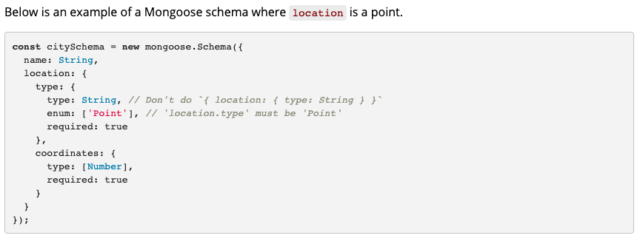
* 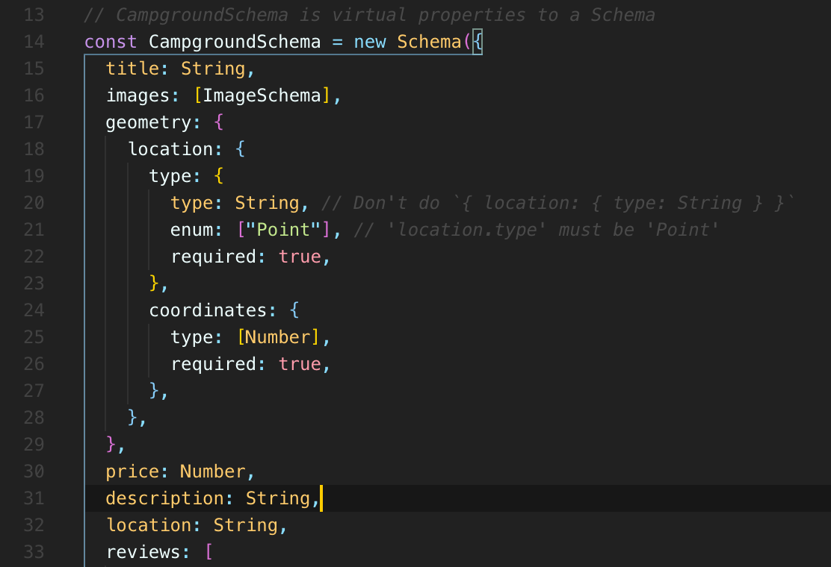
* 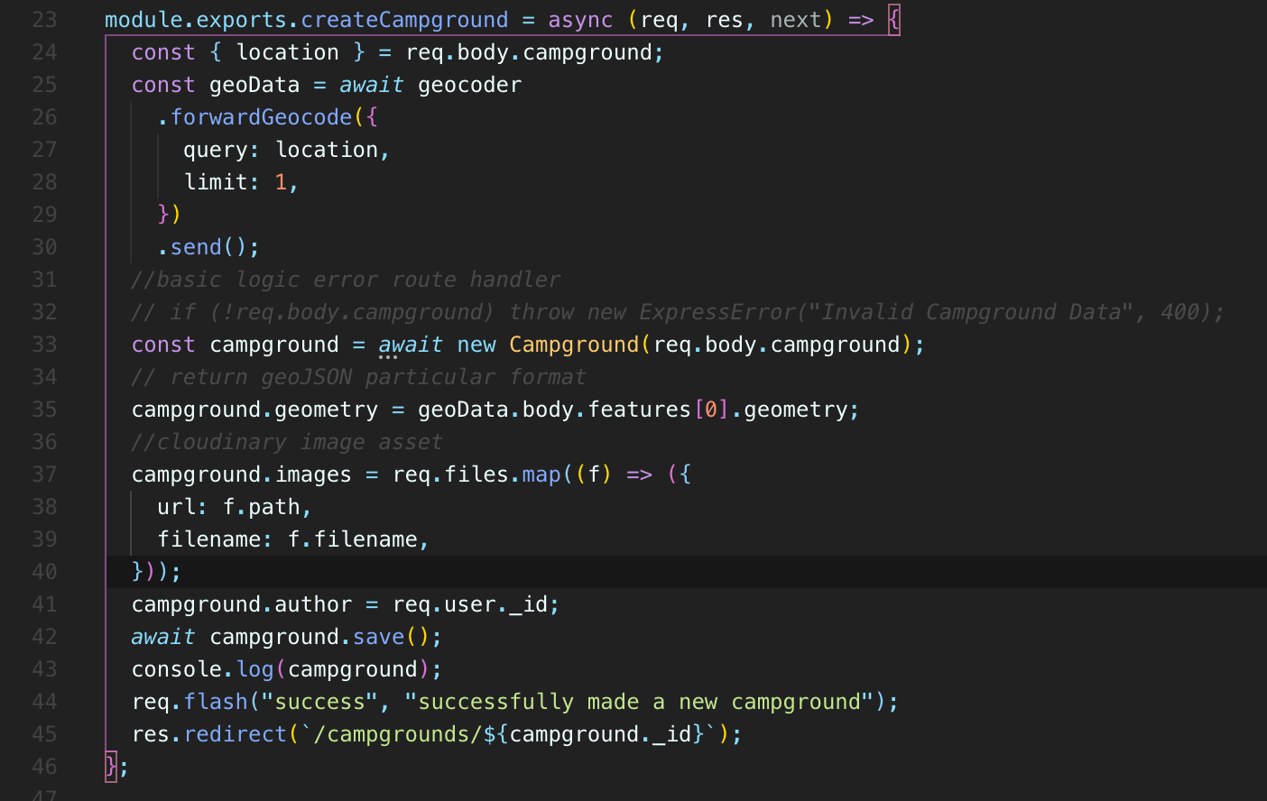
* 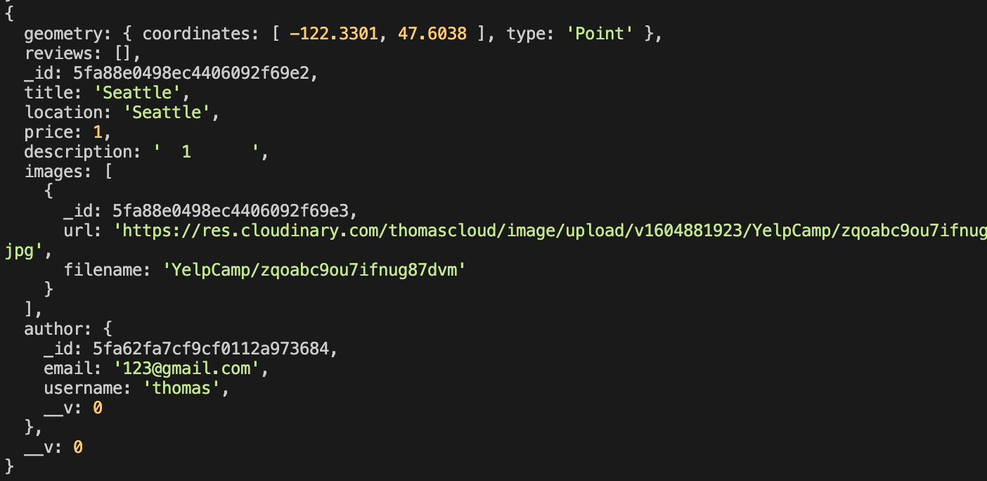
* 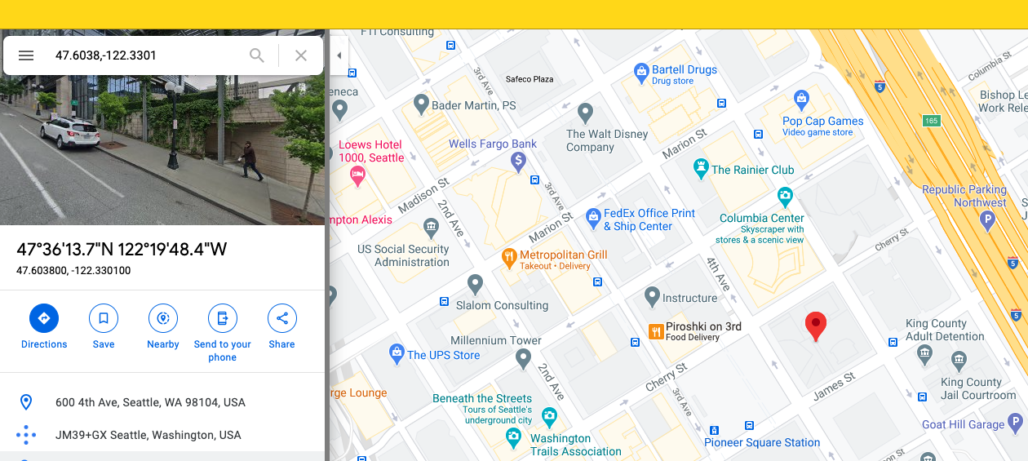

526. Displaying A Map

* **we're going to work on displaying a map on the show page for a campground that eventually will have a pin with the location that we just geocode had of the actual campground.**
* **But to start, let's just get any map to show up at any location.**
* **And to do that, we need to go back to map box.**
* The portion of map box that we'll be using is called the mapbox GL JavaScript API or MAP Library.
* So Map Box comes with a bunch of different things that we can use.
* And we've already seen one, the geocoding API.
* So this map box, mapbox GL JavaScript Library is the tool we use to render these nice interactive maps and you can style them differently.
* You can come up with all fancy access for them.
* There's this tool map box studio I mentioned briefly where you can customize what your maps look like to a very well.
* I have to sign on that, but you can customize them a lot anyway.
* But we need to do is include the JavaScript in text file.
* So they actually show us the CDs and we'll just start with that.
* You know, we can always decide to download the code,

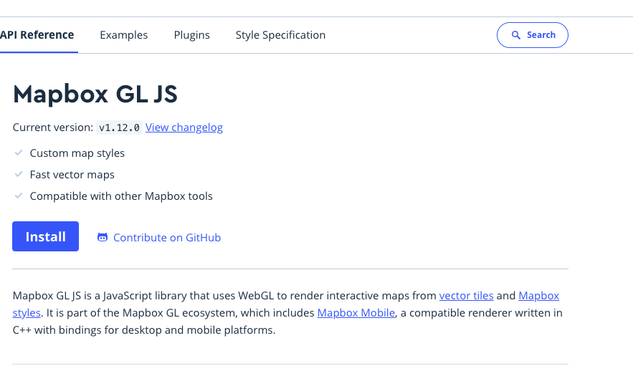

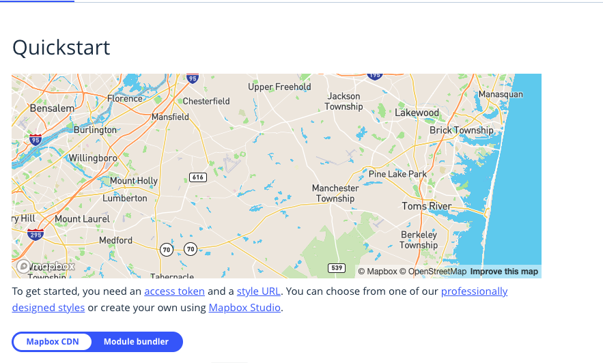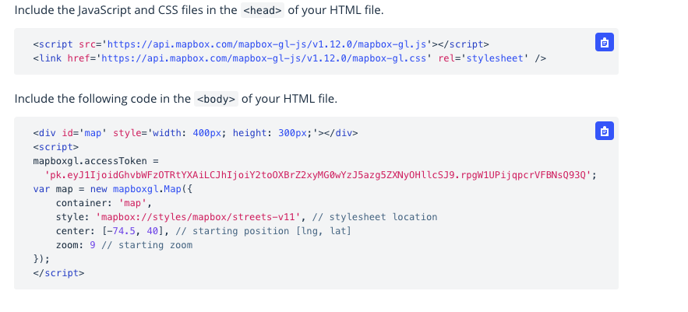

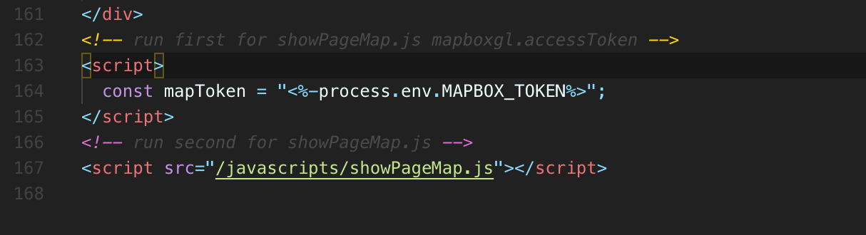

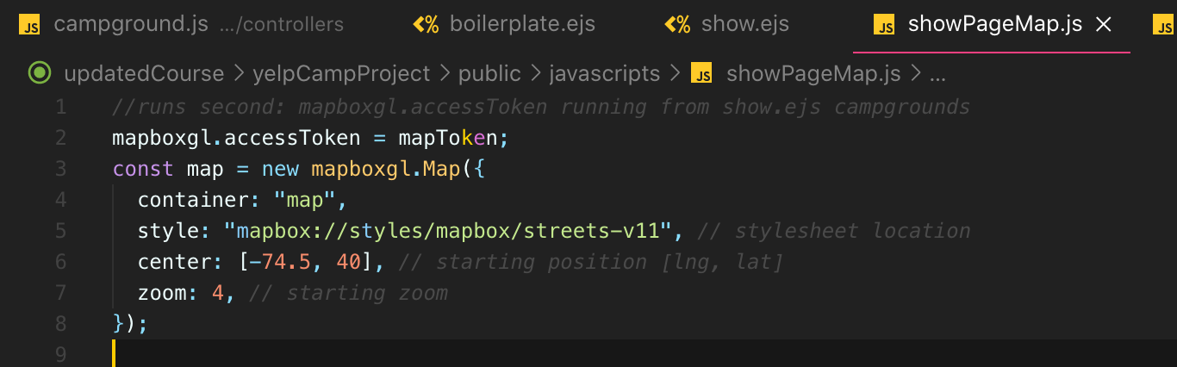

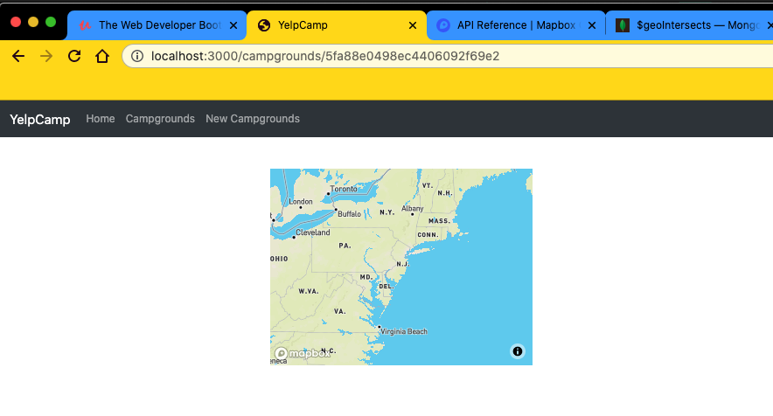

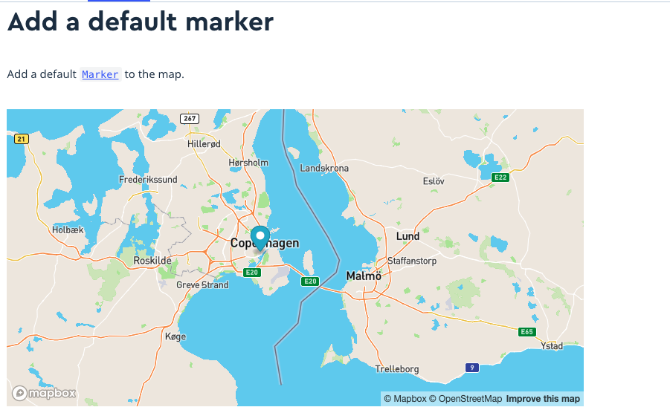

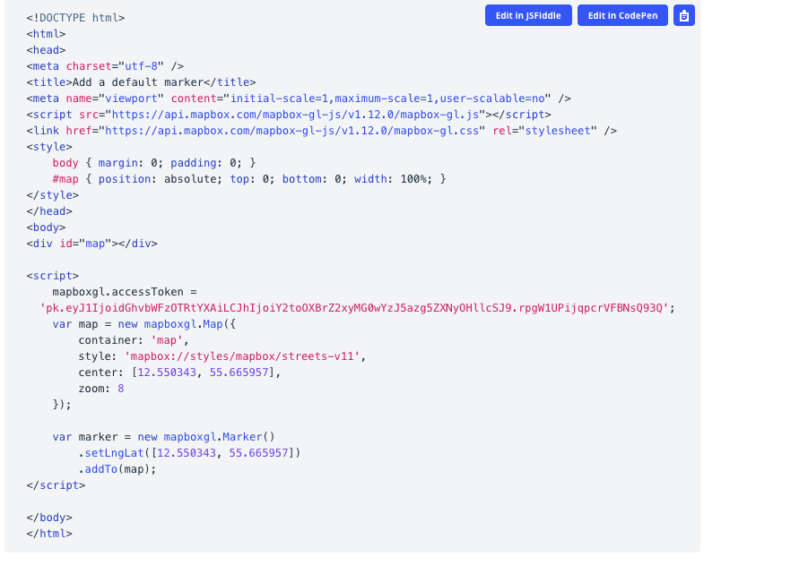

* And if you want to add, you know, a marker, for example, they tell you how to do that.
* So we need to create this is the new stuff, create a new maboxgl.Marker() instance. And then we call set longitude latitude.
* We pass in that array.
* That is in that order we've already seen in our JSON where we have longitude and then latitude, so horizontal and then vertical, just like X,Y.
* 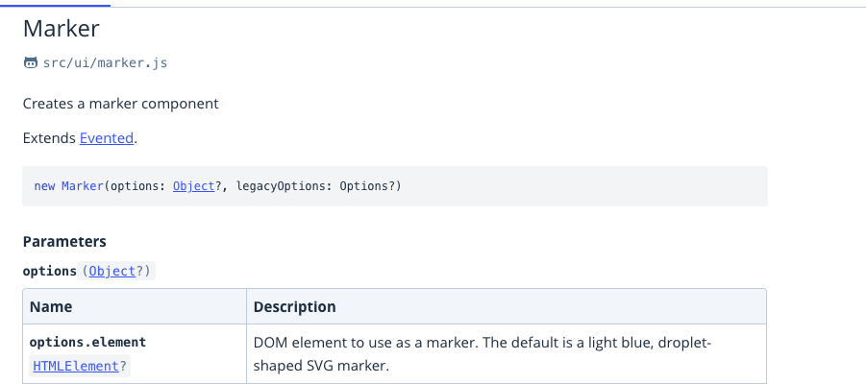
* So what we need to do is basically the same process that we use to get our map token where we use the edges to create a JavaScript variable that we had access to over here in our JavaScript file.
* We're just handing data off from the server side to the client side.
* **Now, there are other ways of doing this.**
* **We could make an API endpoint that we request with Ajax over here.**
* So once our code loads in the browser, then it would make a request back to the server and say, “hey, give me the coordinates or give me the campground information or whatever we need.”
* I'm going to make a map with it.
* But this way, I'm not saying this way is necessarily better, but this way, if I just pass through a campground variable, I'm able to access that immediately on the client side.
* So I'm just going to try putting campground right here, which we already have access to in this template.

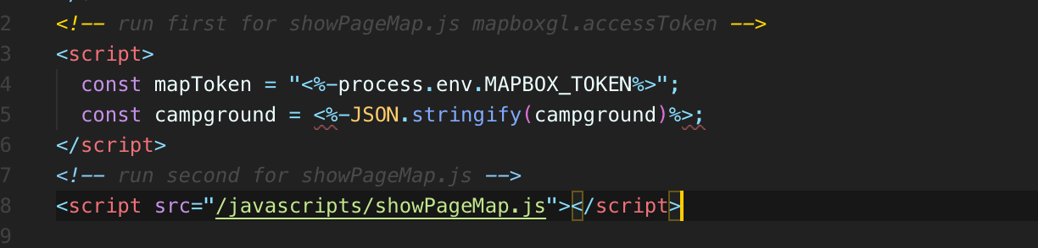

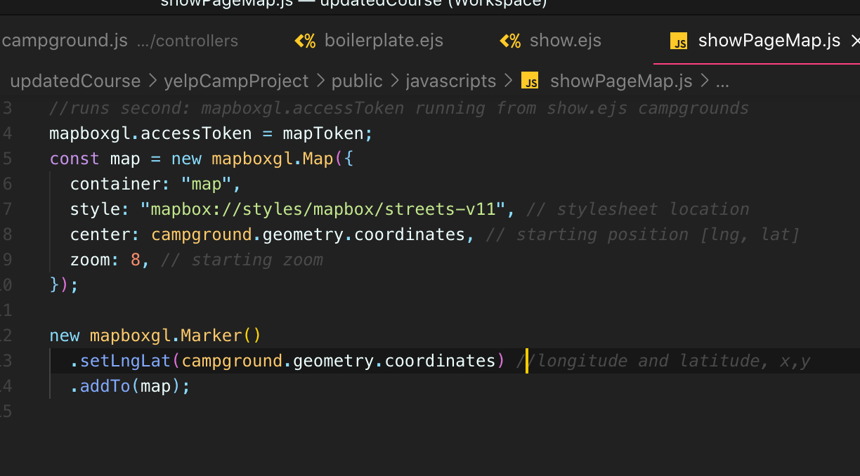

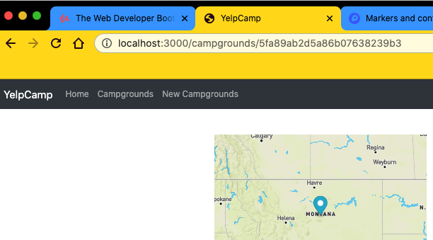

* We can decide.
* Another thing is, you know, we might want the controls to show here.
* We can decide on that as well.
* All that matters is that we have the map on the page and it's correctly showing a pin at the location that we geocode using the user inputs location.
* So, you know, there's lots of things that could go wrong.
* First of all, of geocoding is not perfect.
* And if somebody just enters in something like, you know, Montana, well, it's just going to pick the first result in Montana, which it might be like the capital of Helena.
* I don't know how they decide it might be the most popular high traffic area, but it will be somewhere most likely in Montana.
* But if you misspell things, if you, you know, enter a place that just doesn't exist, then that could be a problem.
* And we're not really handling that at all.
* And this is more just introducing you to working with maps.
* But, you know, you could do some error checking to see if we got something back from or if we got nothing back in our geocoding logic here in our controller.
* If we don't get anything back here from geometry Data, then, you know, flash a message or just pick a default location, like it's really up to you to decide how to handle that situation.
* But we've got maps working.
* That's the good news.
* So, yeah, we could style this a bit, you know, make this look a little bit better if we can change that marker, if we want to change the styles of the map.

527. Centering The Map On A Campground

528. Fixing Our Seeds Bug

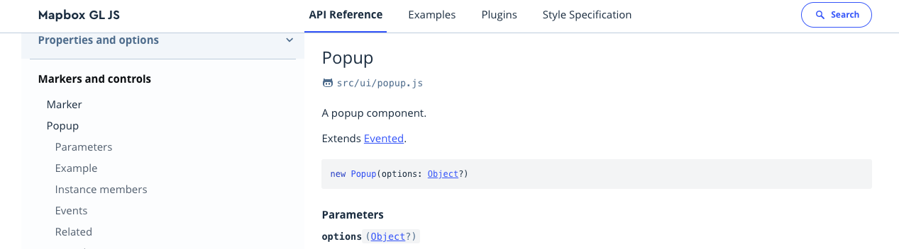

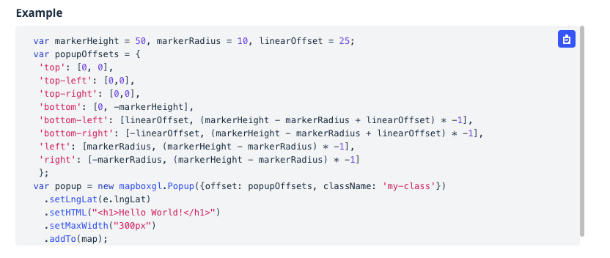

* we're here is add a little pop up when you click on the marker.
* So to do that, it's pretty straightforward.
* If you go to the docs for mapboxgl.js under up markers and controls pop up.
* There's an example somewhere.
* This makes a little pop up that is associated with that particular marker so you can specify a bunch of success,
* 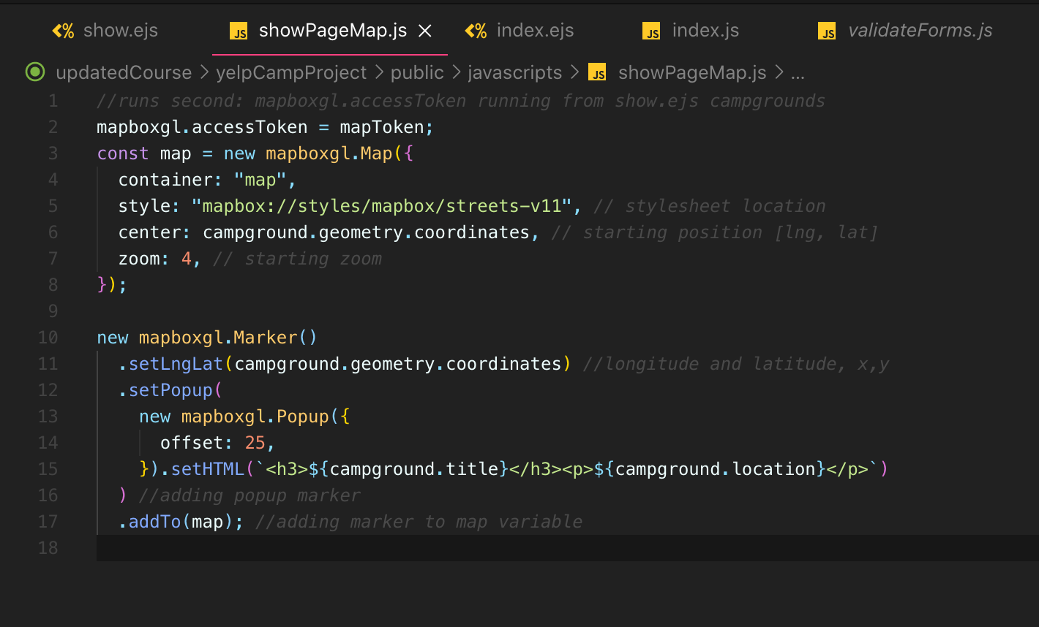
* 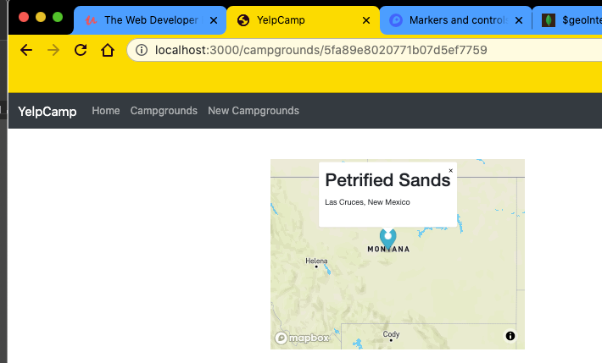
* 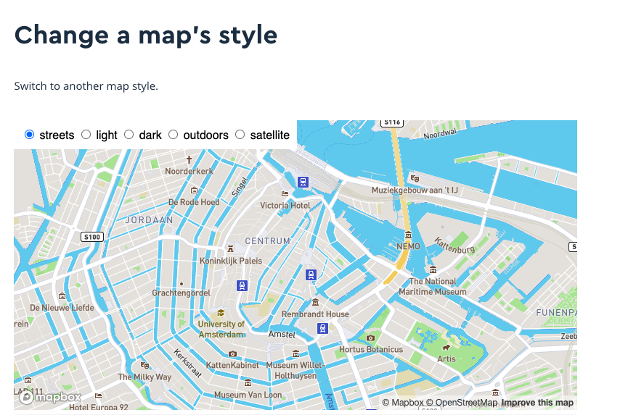
* 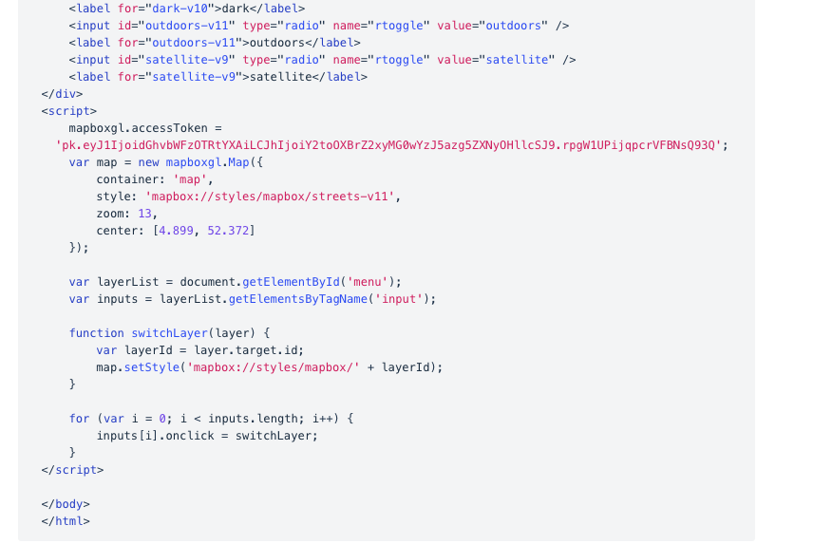
* **basically you just pass in style field this style string and there are many choices.**

**Section 54: YelpCamp: Fancy Cluster Map**

530. Intro To Our Cluster Map

* All right, so next up, **we're going to integrate pretty cool fun feature onto our index page for campgrounds. We're going to add a map.**
* It doesn't have to be this wide, but **this is one example of a finished product, a map that is a cluster map for our campgrounds.**
* **So you've probably seen something like this before where your pins if you have lots of data, it doesn't make sense to display it all at once.**
* **The map is just overwhelming, but instead you display clusters.**
* So, for example, in California, right, there's over 100 campgrounds that are in this database.
* This is a different data set, by the way.
* It's still just random data, though.
* It's seeds it's, you know, fake names and lorem ipsum descriptions.
* But they are distributed across the globe or across the U.S. at least.
* So we get these clusters and then they split off into smaller clusters and smaller clusters until eventually we see individual campgrounds.
* And then I can click and, you know, go to a show page from one of them.
* So we are going to implement this on our own.
* And it sounds intimidating and it kind of is, except that I'm going to be very transparent and honest about how I would go about this and literally show you how I do go about this
* , because this requires code that, you know, I wouldn't be able to ever right off the top of my head.
* But we have documentation.
* We have examples.
* mapbox shows us basically how to do this, and then we just need to tweak it to work with our data set.
* We can change the colors.
* You can change the sizes, the thresholds for when these clusters happen and when they split up, we can change the markers.
* You know what we see here for a single campground, there's so much that we can modify and change.
* But really, this is going to be a process of finding code, copying code and then changing it and keep changing it until it does what we need it to do.
* So I could have, you know, had a solution like I have right now.
* This is already done.
* I could just reference this, have it on my other monitor that you don't know or that you can't see and just copy line by line, you know, and pretend I know it off the top of my head.
* And that might be a smoother experience.
* But I want you to really see the reality of this, that any time somebody is writing a custom map like this, unless they somehow do it every single day, they're going to be referencing the docs and GitHub and finding examples.
* And that's what we're going to do here.
* So it might seem somewhat scary if you had to just do this, you know, from scratch and nobody telling you how to do it.
* But if we pull back the curtain, which I'm going to try and do, and and really show you the process, it won't seem scary at all.
* I think it will just seem more like somebody fumbling through the dark, which is really what most of Web development is.
* So we'll get started in the very next video.

531. Adding Earthquake Cluster Map

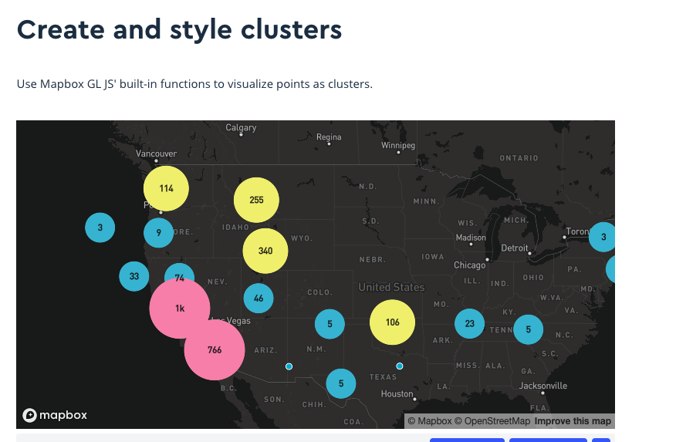

* 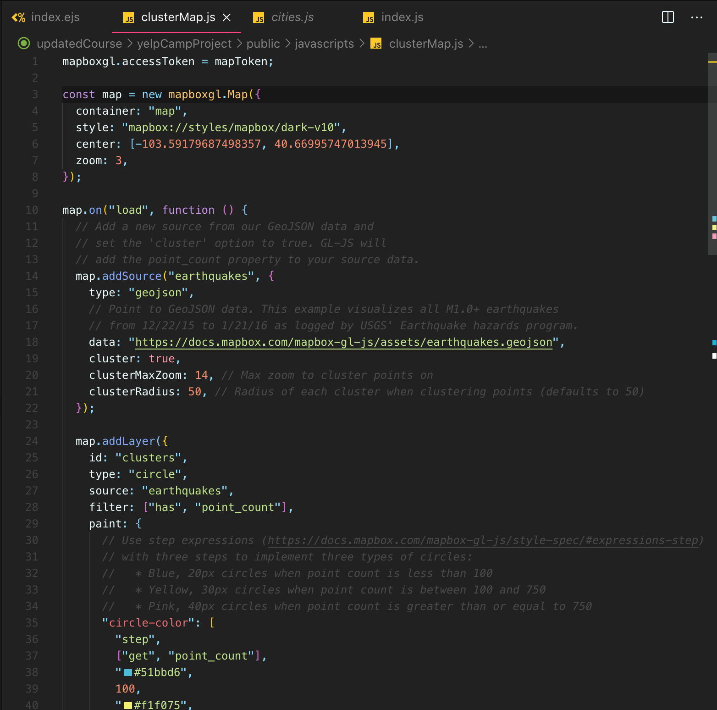

532. Reseeding Our Database (again)

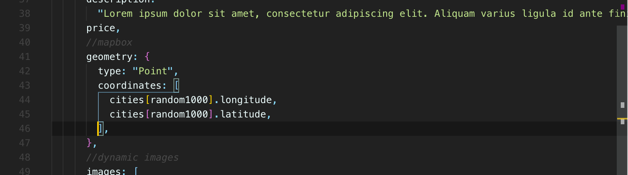

533. Basic Clustering Campgrounds

* we do need to do is pass our data through so that we're using our data set here instead of some data located on some document online.
* We'll just put it in a variable so we can basically do the exact same thing we've already done on our show page

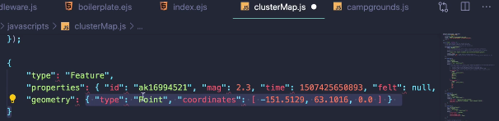

* We have different data, like we have a location and what else?
* Title images, a whole bunch of other stuff.
* But then we do have a geometry section or geometry property that is an object that has types at the point and coordinates is a geo JSON on array.
* Now we don't have this Z, X, Y and Z.
* We just have X and Y longitude and latitude.
* So we have this coordinates array.
* And that's good news because our data looks very, very similar to this.
* 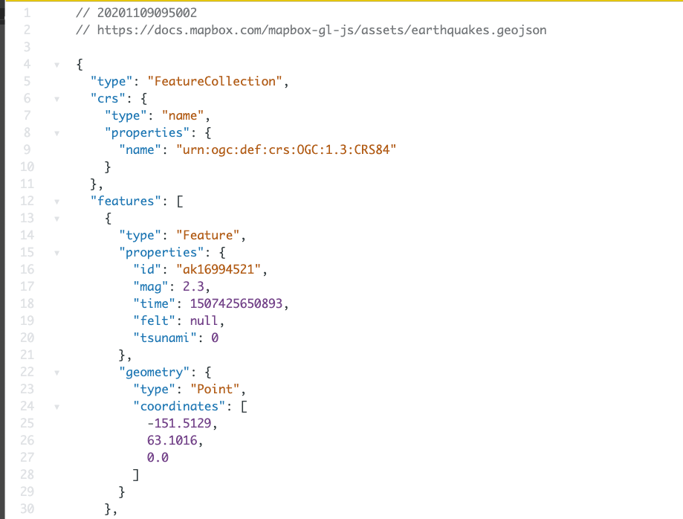

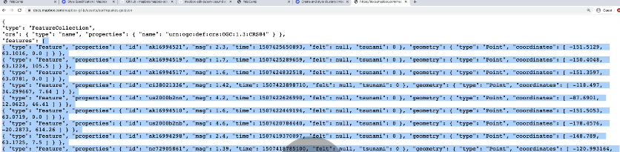

* The reason is that if you look at the data that we get, everything is located.
* This is the earthquake's data.
* **Everything is located under a key of features.**
* And this is pretty standard as well.
* **And our data is not located under a key of features.**
* **It's just an array.**
* **But Map Box is actually expecting an object with the key of features set to an array of all of our data.**
* So we can fix that.
* **We can just have our data conform to that pattern.**
* 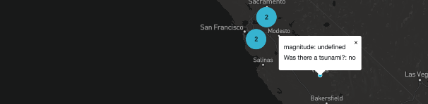

534. Tweaking Clustering Code

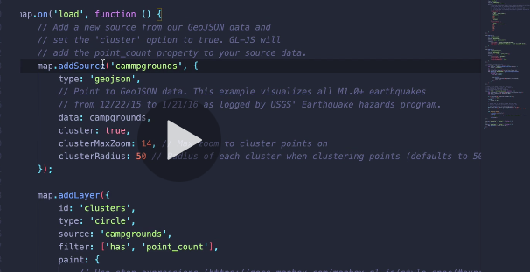

* So any time we're referencing the source, earthquakes, that now needs to be campgrounds.
* So we're like registering a source of data for the map and then referring back to it when we add these different layers.
* So we add a layer where the type is circle, we're going to give it the idea of clusters.
* And source now is campgrounds, which we set up earlier right here.
* 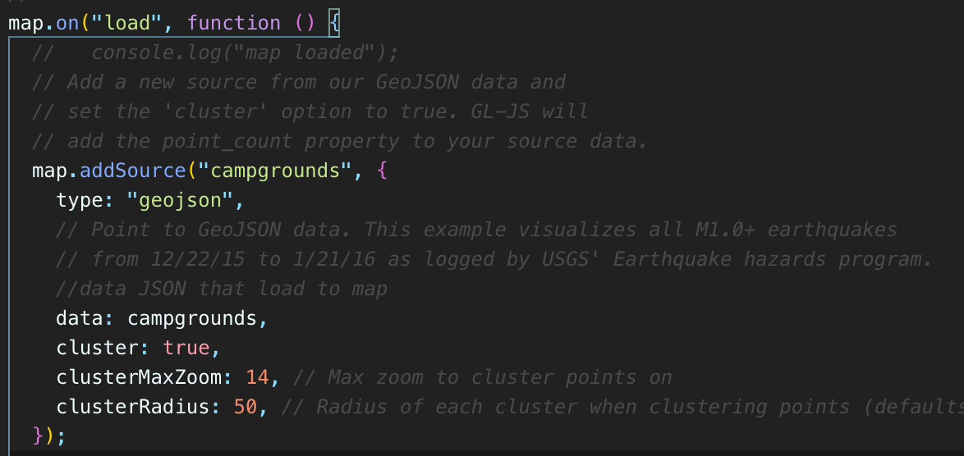

535. Changing Cluster Size and Color

* So then the question becomes basically, when do we want them to cluster and when do we want them to split?
* 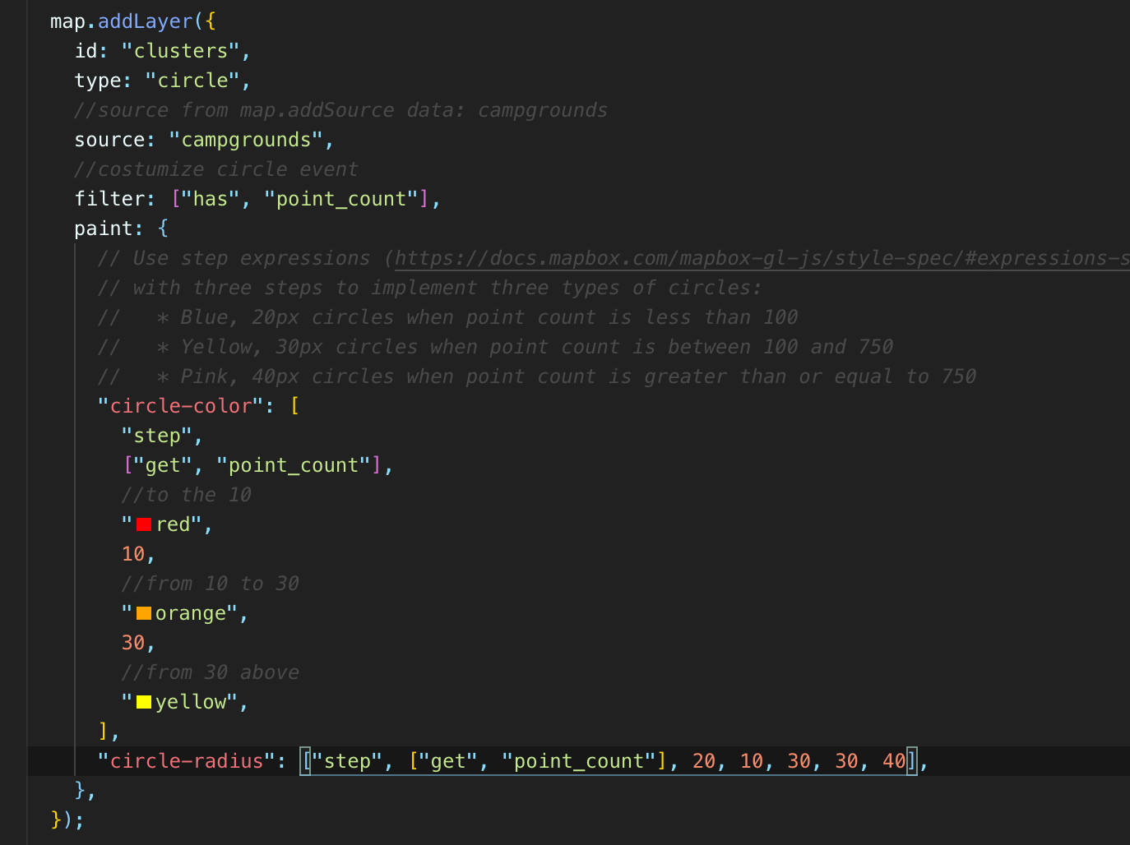

536. Adding Custom Popups

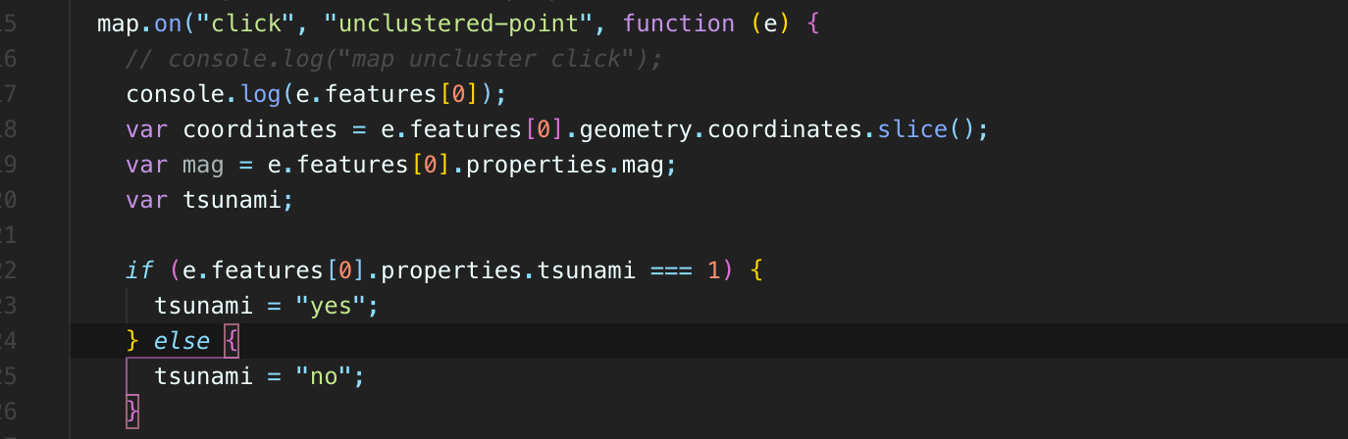

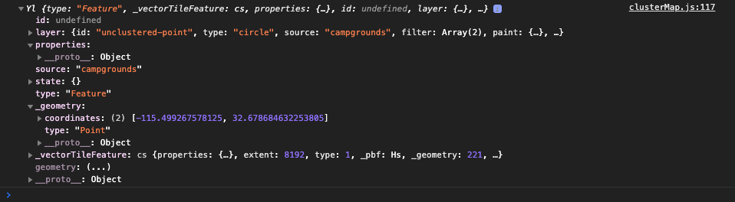

* What happens here when I click?
* So **we end up with this object that has this properties trunk on it, it has this geometry chunk that has our coordinates and our type.**
* **So this is from our campground.**
* **But then we have properties, which is what they're referencing, and ours is just empty.**
* theirs has information, it has tsunami properties.tsunami, properties.mag, for magnitude.
* But why is our campground data not in there?
* Well, this brings us to another point around how points a bad word to use there.
* 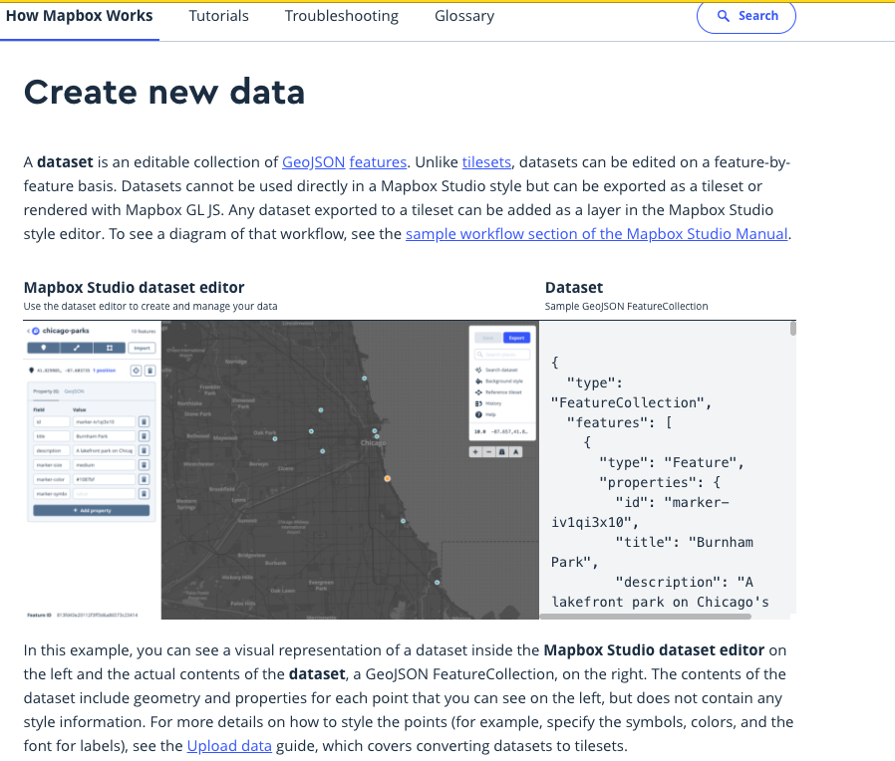
* This brings us back to GeoJSON.
* And the way that map box is expecting our data to be formatted, there's a page in the documentation about this.
* Basically, they expect this is the page.
* I mean, they expect your data to follow a pattern where we have features like we've already done set to an array.
* **But then each object inside of there, it's going to have properties alongside geometry**.
* **So those are two crucial things, properties and geometry, geometry we already have covered.**
* We have type point, we have our coordinates, but then we're just storing the other information in there, not under properties.
* 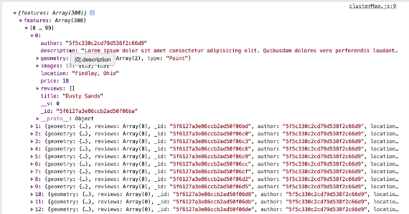
* 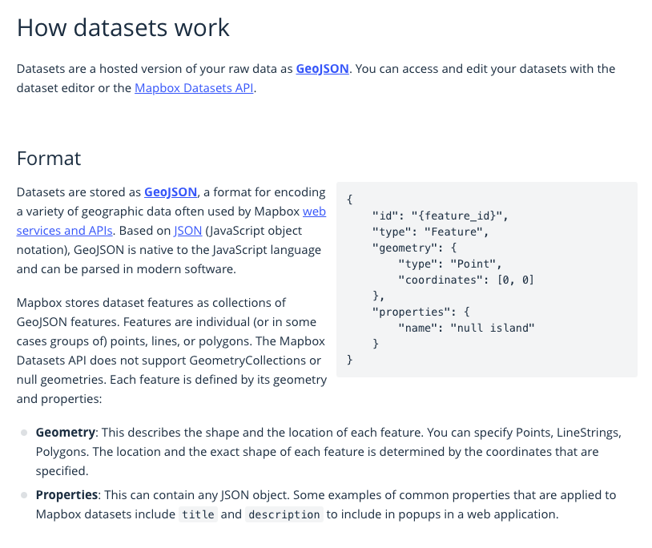
* and {} is what we have features.
* It's an array and then we have geometry, but this stuff here is not located inside of properties.
* And unfortunately, in order for this to work with mapbox, it wants that information.
* It's looking automatically for something stored under properties.
* So we don't need to store everything in there.
* Really, all that we want is some sort of premade description or premade link, something that we could pass right in.
* We want this to just be, I don't know, premade for us.
* Wouldn't that be nice?
* Instead of having to create it ourself, just have it there predefined.
* So to do this, we could just make a virtual property in Mongoose and then automatically have it send back our data with properties added to it.
* And so our information would look something like, you know, for a single campground.title,
* I'll just do an abbreviated version, you know, author is some ID and then we could have properties.
* And then description or, you know, HTML text or something, I don't know what we want to call it.
* We'll just go with description or how about pop up?
* There are pop up text and that could just be made for us as a virtual property where we don't really need to store it there.
* It can be virtual because it's just going to contain things like, you know, an H2 or whatever, including the title and an anchor tag using the ID.
* So it's just going to be a piece of information that's populated for us automatically, that then when
* I load my campgrounds here, every campground will have properties and then pop up text.
* So it will match this pattern.
* But we don't need all the other stuff in property, so we don't need to change our entire schema or change the entire structure of our document.
* So I'll show you how we could do this.
* 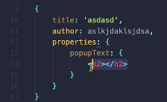
* this doesn't have to be a virtual just to be clear, you could loop over campgrounds here and for each campground you could add a new property called properties and do it via JavaScript.
* But just to make it easier and less logic happening on the client side, I'm going to go into my model.
* 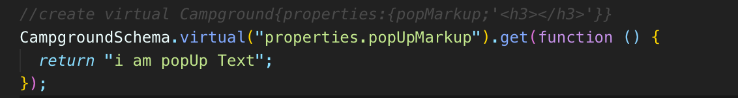
* 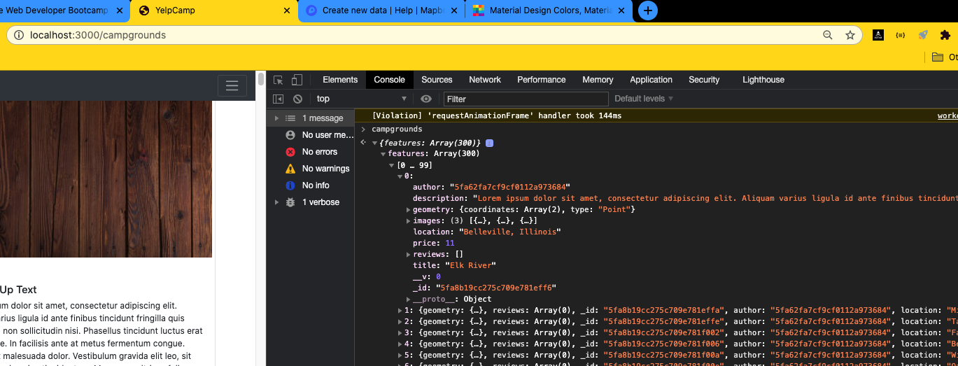

Do not include properties, while already defined virtuals properties.popUpMarkup

* 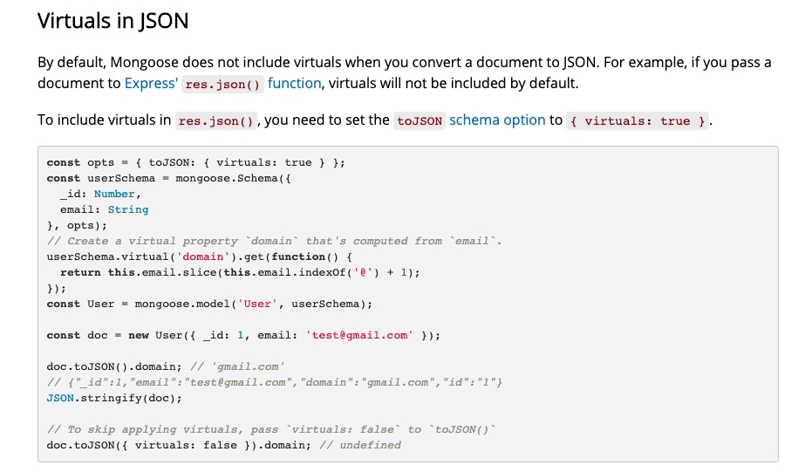
* It says by default, mongoose does not include virtual when you convert a document to Jason.
* So if we want them, we need to set this option here {toJSON: {virtuals: true}}.
* And we pass that into our schema, which is right.
* Where is that?
* Right here after we pass in the object, initializing the schema pattern.
* So I'll just show you on our campground model.
* We will set options to include to Jason Virgil's true, and then we pass that in right here where you can just do it in line.
* 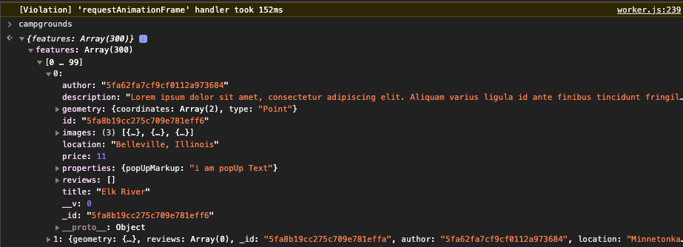
* Yep, and instead of that popUpMarkup
* , so now we can access that from inside of our mapbox code.
* 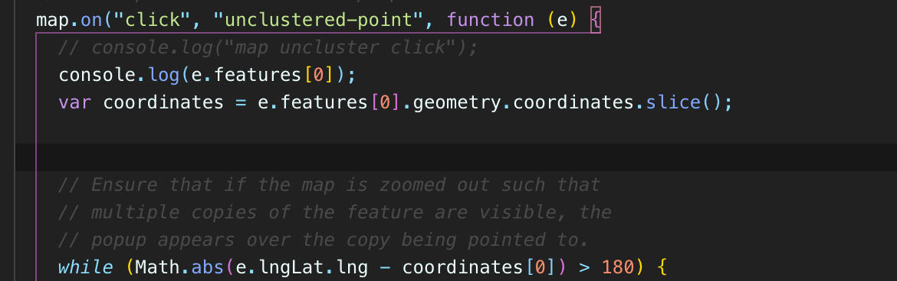
* 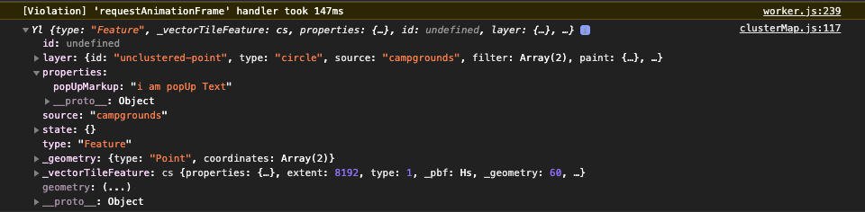
* Instead of properties, there's now information because map boxes automatically looking for a key called properties
* and it takes that information popUpMarkup
* so we could just take that e.properties[0].properties.popUpMarkup
* 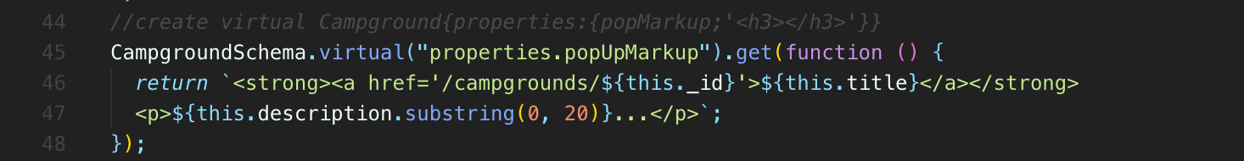
* So we've defined this nice virtual property that it's just going to include some markup now for that pop up on every single campground.
* And that markup is dynamic.
* It's based upon whatever the ideas in the title is.

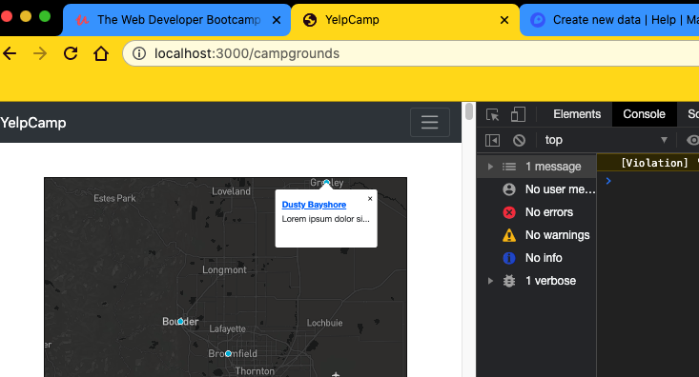

**Styles Cleanup**

537. Styling Home Page

538. Additional Home Page Styling

539. Styling Login Form

540. Styling Register Form

541. Spacing Campgrounds

542. Removing Inline Map Styles

543. Adding Map Controls

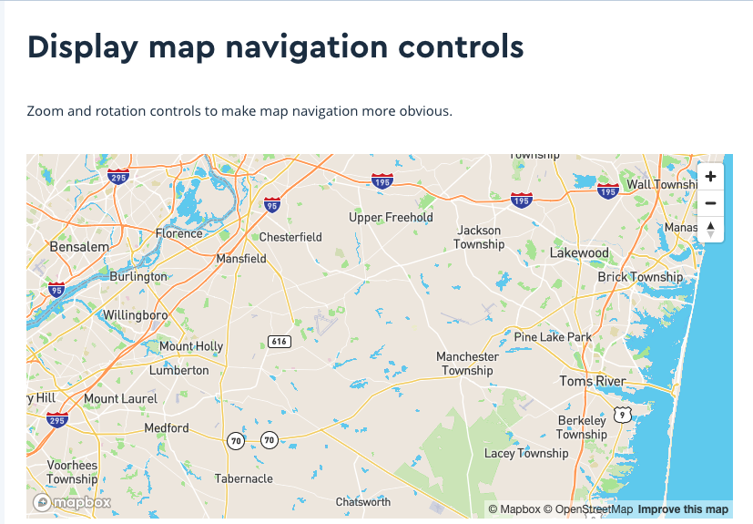

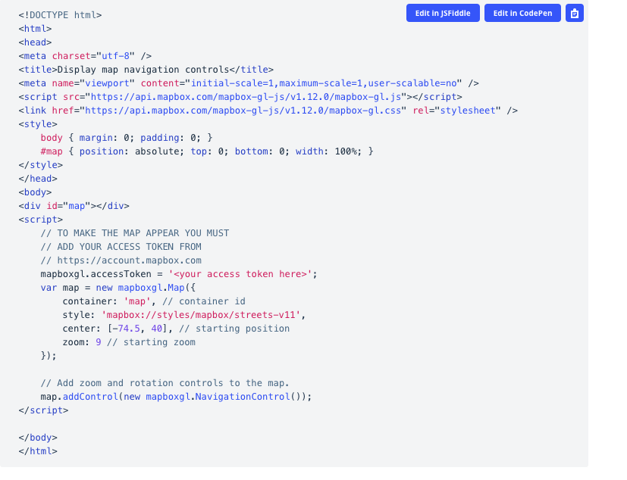

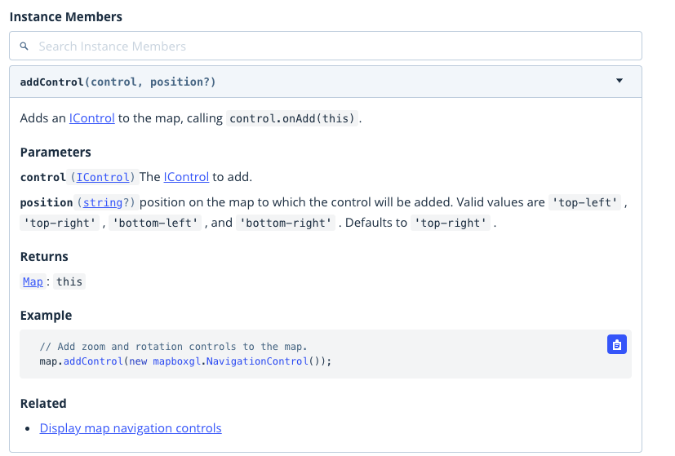

**Section 56: YelpCamp: Common Security Issues**

544. Mongo Injection

* We are just going to hit some of the common, very basic issues.
* **So the first thing we're going to talk about is sequel injection or in our case, it's no sequel mongo injection.**
* **So you may have heard of this term SQL injection before.**
* **It refers to a really common exploit in the world of sequel, where basically you're writing a database query, a sequel query that uses part of some user's input to form the query.**
* **For example, you're doing a search and you have a search field.**
* **A user can type something in there and then you use that search field to populate your query.**
* **You want to use whatever the user is trying to find.**
* Do you want to use that when you're querying the database?
* Now, **the way that sequel injection works is that it takes advantage of the sequel syntax.**
* I'll just show you a really quick example.
* 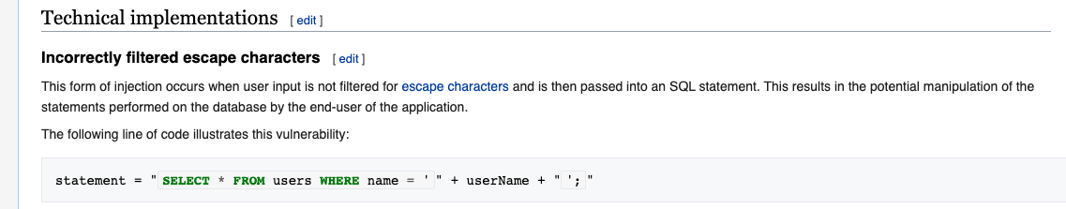
* You know, we don't we don't really know sequel at this point.
* We haven't talked about a sequel, but imagine you have something like this.
* This is what sequel looks like.
* Select star, select everything from the user's table where name equals.
* And then you are adding in some dynamic username, chicken, whatever that username is, it's coming from, let's say a form input.
* So you're supposed to just put a username in and then that's what you're going to search in your SQL database using.
* But in a sequel injection attack, a very basic version, like the simplest sort of 101 version
* I'm going to show you a user doesn't enter just a nice little string of text.
* They enter something in like this right here.
* **What they're doing here is basically closing the first query, this select star from** where name equals.
* **They add in another single quote here to close that query.**
* **They add a semicolon.**
* **That's how you basically designate the end of a cycle query and then they can add in their own query,**
* for example, drop table users.

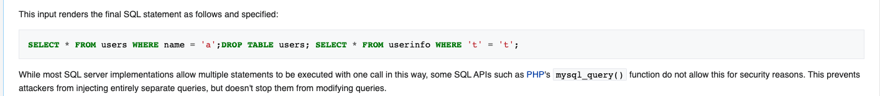

* **That's how you would remove an entire table, an entire collection and Mongo but and sequel to Table.**
* **So delete all users or select everything from user info.**
* **So these are very simple examples I'm showing you.**
* **The concept is that somebody can inject sequel their own queries into some original query.**
* **So a lot of people think that with Mongo, with no sequel databases, we're immune to that. And that's not true.**
* It works differently.
* The issues he exploits are different, but there still is such a thing as Mongo injection.
* Here's a very simple example.
* Imagine that we were, you know, taking some information from a user request, updated username, and we were going to go and try and find a typo here, try and find a user where that username matches whatever is in a form or whatever it is and request up body username.
* 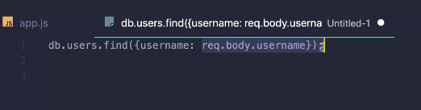
* So if a user enters something like, you know.
* Colts, for example, I think we have that over in my Mongo database if we run that query.
* Here we are.
* We get my with that one user with the username of Colt.
* 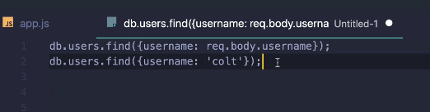
* But if a user were instead to enter something in that looks like this here, instead of Colt being the username, if they instead entered something a little bit more devious like this right here.
* Dollar sign G.T., if you remember, that means greater than quotes.
* What the heck is that?

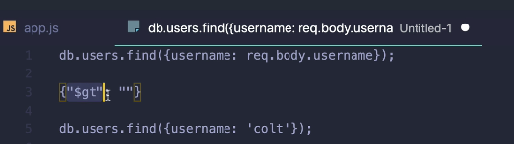

* Well, this is a mongo operator and if I put this in place of Colts' and that was a query coming from the user
* , that was what they entered into a field find users where username is greater than nothing.
* So this is empty, meaning all user names are greater than an empty string.
* So find all users or find where all user names are greater than an empty string, which is always true.
* 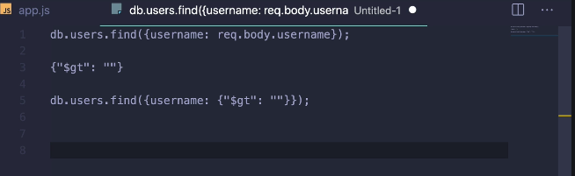

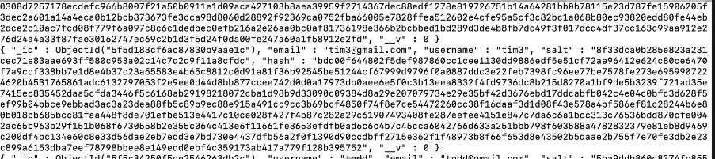

* So find everything in the user's collection.
* And if I run that, that's exactly what happens.
* We find and retrieve all users.
* Now, that's a very simple example, you know, silly.
* This is one you can find all over the place as just a demo and intro to mango injection.
* But it kind of shows the potential issue, the way that mango operators work in, the way queries are constructed, where we use these curly braces.
* Nested objects basically allows for people to manipulate how queries behavior.
* They allow people to manipulate the original query that we're intending to make.
* So all that we need to do, at least to address this basic level of attack is not allow users to have dollar signs.
* Also periods we don't want them in any sort of query that we're going to make any dynamic query coming from a user, any input.
* **So there's a package that helps us do that.**
* **It's called Express mongo Sanitize, and that's pretty much all it does.**

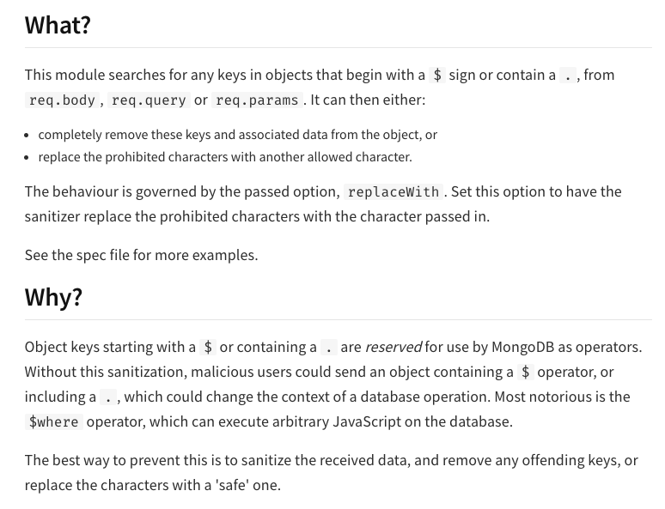

* It removes any keys containing prohibited characters.
* So dollar signs are periods anything from request that body query or programs.
* So I'll just show you really quickly once all this.
* Over here, go to my actual app, NPM.
* If I request this, you are there's nothing in the query string, but if I add something in and again, this is silly, but imagine I have dollar sign.
* 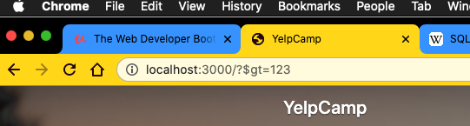
* 
* So that is something we want to prohibit and we don't want to manually filter that out ourselves.
* So this package is going to do that for us.
* All we need to do is include it and then use it after use Mongo sanitized.
* So we'll include it and then use.
* now if I try sending the exact same request, what happens?





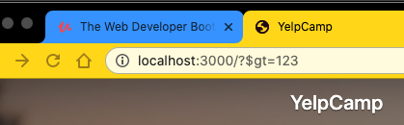

* Our request, that query is empty
* , so it doesn't just delete everything if we have other stuff in there.
* For example, name (non symbol) equals that we still get that second part of the query string
* and the same holds true for req.params and req.body.

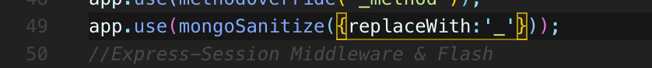

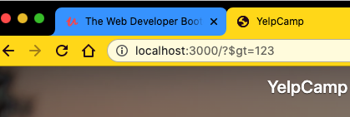

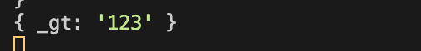

* It's just not going to allow any keys that contain a dollar sign or a period.
* We can also tell it to replace them instead of just removing them entirely.
* You can specify replace with character.
* So if we wanted to do that, just show you briefly.
* Replaced with an underscore, and now if we make the same exact request, we can see that Underscore GT has been added into the query string instead of dollar sign.

545. Cross Site Scripting (XSS)

* 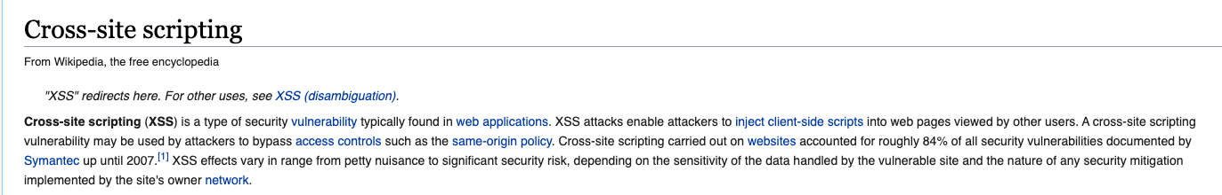
* All right, so the next type of vulnerability we're going to briefly talk about is cross site scripting or XSS.
* So this is a really, really common and potentially very powerful vulnerability.
* The idea is to inject some client side script into somebody else's webpage.
* **So the way that it works is that some attacker is going to inject their own client side code, their own scripts that will run in the browser on somebody else's application.**
* **So whoever let's say they're attacking Yelp camp.**
* Yelp camp is our own app, right?
* It's up and running.
* **The cross site scripting part comes in when somebody tries to inject their own script into our app that typically does something bad, like reports users cookies or steals users information or even it forces users to take actions they don't want to take.**
* **There are lots and lots of historical, not even historical, lots of current examples of cross site vulnerabilities that have been exploited.**
* According to Wikipedia here, it says cross site scripting accounts for roughly 84 percent of all security vulnerabilities documented
* So it's a very prevalent type of attack.
* Now, we are not going to go into a whole lot of detail on how they work.
* It's really fascinating and complicated topic to really get into.
* But one tool I recommend to give you a brief introduction to how it works is this tool called excess game.
* And it's just a couple of levels that introduces the idea.
* You basically play the hacker and it gets harder as you go.
* You have to do some research and use the hints.
* But I'll just show you the basic example.
* Here is the simplest intro to cross site scripting right here.
* This website that we see is asking me to enter some query.
* So whatever that query is, it performs a search with that query and then it just displays the query directly in the document.
* **And that part is important because I can enter something like a script tag or if I were to enter an H1 in here just to start.**
* That shows us, oh, they're just taking exactly what I enter and just embedding it in the HTML document.
* **So what if I did this script alert?**
* **Hey, this is cross site scripting.**
* I'm injecting my own.
* I've been checking my own script to run on somebody else's website.
* And there we go, we get I mean, this is a game, so they noticed today, alerted and they say congratulations, you can advance to the next level.
* **Now, the reason this could be a big problem is that if you can get code to run on somebody else's application, there's information that we would be able to access potentially and do something with.**
* So alerting is a classic demo just to illustrate the concept.
* But there's a lot more that you could do.
* One thing that you can access through JavaScript are cookies.
* Now, we'll actually talk about that in a separate video.
* And it's very easy to make your cookies not available through JavaScript, but a lot of people will have cookies available on there just in their browser under document cookie.
* And if you can inject a script, you could just, you know, console that log document cookie.
* But that's that's not helpful at all.
* What we want to do is actually take that information from a single user and send it off to somewhere else, send it to our bad server that I've created.
* So here's a simple demo.
* This is basically a script that makes a new image element where we set the source.
* And whenever you set the source on an image, your browser is going to send a request.
* So this is just one way of sending a request.
* 
* So image source equals this is some you URL that we've created some server and then we're passing through document dot cookie, which is coming from whoever is loading this Web page.
* So if I put this in a url, for example, you know, something like this here, some website, dot com.
* And then I have this script included in the euro and then I send this link out to a bunch of people.
* Maybe I put it through you URL shortener so it doesn't look so bad.
* People click it in an email.
* 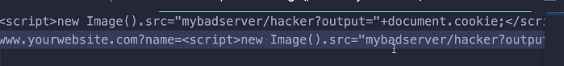
* You've probably heard of these phishing scams.
* You may have come across them before.
* **Basically code is in that you URL and that code is injected and it actually runs and does something bad when a user clicks that link or refresh the page or whatever it is.**
* So this is still very simple example.
* But you know, that demo that I just showed you here for, I refresh the page, the way that it works is it's all based around the URL.
* So if I have script, you know, alerts one more time or let's do a console.log and then close my script.
* You can see it there in the url.
* 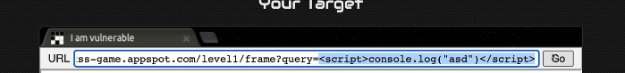
* It's part of the query string, that's just the way that this form is set up to anybody who has this link.
* **If they click on it or if they open this link up, this query will be sent to that script and then that script will execute because it's directly added into the document.**
* So if I did something like this, following that same pattern, I would be able to take users cookies and send them off to my server somewhere by making a request with this little image source shortcut.
* So that's just a really quick intro to cross site scripting.
* There are full courses and certifications you can take to understand more about how it works.
* And there are cheat sheets for people.
* This is actually on the other side of things for people trying to evade cross site scripting filters.
* Like the most obvious thing ever to do is what I just showed you.
* Make a script and just inject that script itself.
* But then there are other options.
* For example, making an image and setting the source, and then there are a ton of other options. These are all exploits, things that you can attempt.
* So it's very complicated and it's just a crazy world that we're not going to get into very much, except for the fact that we should make sure our app is not vulnerable to the most obvious type of cross site scripting attack.
* And that's what we cover in the next video.

546. Sanitizing HTML w/ JOI



* This is not treated as HTML.
* And the reason for that, if I go to my index or actually I guess this is the show page, the reason is that in ejs whenever we use our whereas is an example of that, where are we doing the title right here.
* Whenever we use this bracket with the equals sign, less than percent equals this is going to escape HTML.
* So it does not treat this as an actual HTML H1 tag.
* But if we go to view page source and we scroll down and find it, it ends up escaping it into entity codes.
* 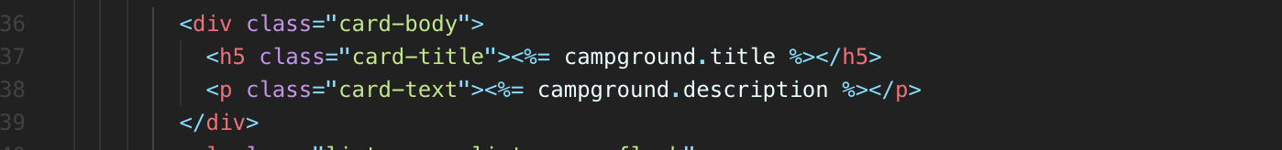
* 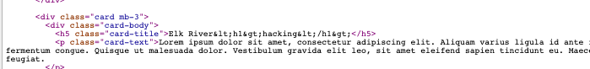
* So a less than tag, a greater than symbol, rather not a tag.
* So the browser does not treat it as HTML and that's good news.
* But there is a problem.
* **We are not invulnerable to this issue because we're not escaping in every single situation or every single scenario.**
* **There's one place right now at least, and we could fix this, but there's one place where our elements are actually being treated as HTML.**
* Pin when we open this up here, right when I mean, it's overflowing here, it's way too large.
* But when we create that description for that pin, we're doing this both on the index and the show page in different scripts.
* 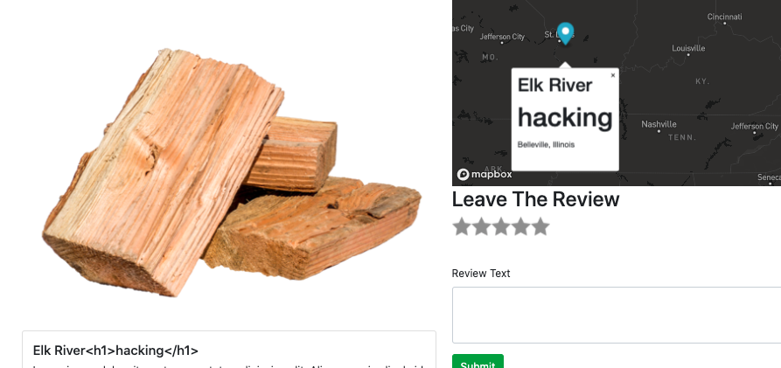
* But if we go to our public, let's look at the show page map here we are making a marker and then filling it with an H3 that has the campground title and campground location.
* So where is that coming from?
* Campground title.
* Let's just start with that.
* Remember that we had to pass our information over from our app, from node and from ejs to actual JavaScript
* so that we have access to campground.
* And that's where we did this quirky little thing here.
* 
* Campground equals and then this does not have our equals sign in it like it was supposed to to escape the HTML.
* And that's important.
* Unfortunately, it will break things.
* We have equal sign because we want it to treat this as JavaScript to make a variable.
* **So, you know, later on, one thing we could do is just work around this entirely and delete this and instead use Ajax to make a request to load our campground data.**
* But at the moment, we're not going to do that.
* **And we're instead going to use this as an opportunity to sanitize our input, to make sure that if somebody creates a campground or edits a campground, they cannot include any sort of HTML elements, especially**
* **they cannot include scripts because that will break things at the moment.**
* 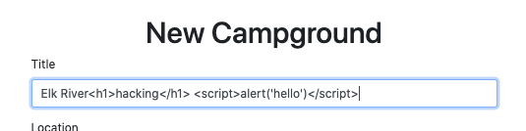
* If I did something like script alert, hello, or how about just haha like that closed my script update.
* 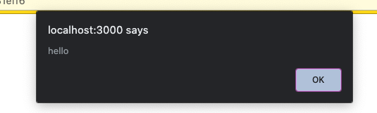
* Oh boy, our script runs so that's not good.
* Somebody could you know at a campground in with a script in its title or somewhere else, you know, they could do something fancy to make it not look as much like a script.
* But basically if anybody has this load on their page, this campground and same thing on the index, actually they're going to see that alert.
* If I go to the campgrounds index, they see that alert.
* Now, an alert is silly, but as I showed you, it's definitely possible to do things like access users cookies and send them off in a request.
* So this is bad.
* It's also breaking our code down here.
* You can see all the stuff showing up.

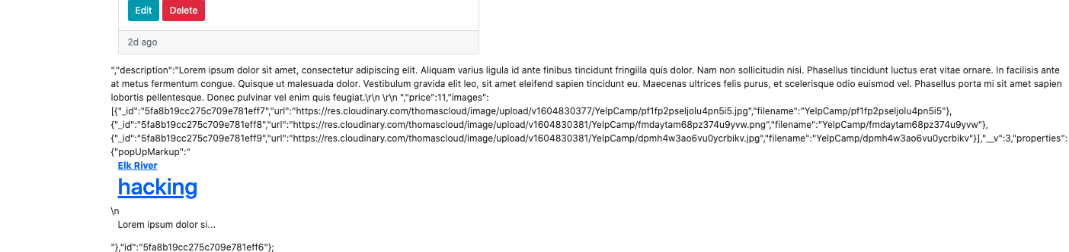

* This is just an annoying side effect of how we're passing this stuff through.
* Campground equals JSON string.
* If I campground, well, the browser gets confused because if we view the page source.
* Come on, here it is, you'll see that we end up with this variable here campground equal to all of this stuff, and then it hits this closing script tag right there.
* 
* And it starts to think that this whole thing from here to here is a script.
* And so it treats that as a script and that breaks everything, and then this is just Mark-Up, and so we see that Mark-Up on the page and you can see it starts with description right there.
* Basically, it just breaks everything.
* Not good.
* **So we don't want to allow a user to enter any sort of script anywhere in any of our fields, and we can validate that.**
* Now, unfortunately, we're using joy, which is not a bad thing, but Joy does not come with its own validation for escaping HTML.
* Here we are in Joi.
* I spent a lot of time digging around to see if it did.
* It doesn't. There is a tool.
* **People use an express called express validator and it does what Joy does and it also offers sanitisation or HTML escaping.**
* **The only reason I didn't use it, honestly, is that I just hate the syntax.**
* You basically write everything in an array as part of your definition.
* 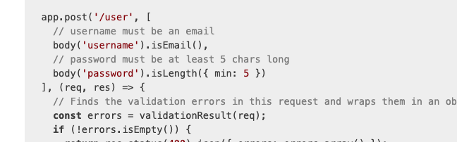
* You pass in this array and you just have these long, long validations.
* But it is very useful.
* But we're just going to write our own version on top of joi.
* So this is a bit of extra credits.
* It's above and beyond.
* You know what we need to do?
* We could just replace Joy with this express validator tool.
* But this is also just an opportunity to show you a bit more about joi.
* So Joi allows us to create extensions.
* And these extensions allow us to define things like on string joi string.
* I could do something like HTML safe, like it has to be HTML safe or escaped HTML or something like that.
* 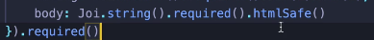
* That doesn't exist at the moment, but I can define my own methods like that that joy will use in its validations.
* So I've already gone and done that.
* It is not at all intuitive, to be honest with you, the way that we write this.

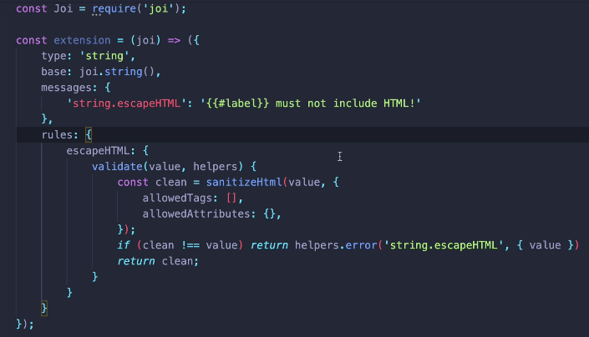

* I have to look at the docs every time.
* I also found out that the way it works has changed in recent versions of joys to the way that I thought
* I knew how to do it had changed.
* Its just a little clunky in my opinion.
* But what I'm doing here is defining an extension on Joydeep String called Escape HTML.
* So the idea is that I should be able to then do not escape.
* HTML on my string properties, OK, and the syntax, again, is kind of odd, but here it is escape HTML.
* It needs to have a function called Validate Joy.
* We'll call this automatically with whatever the value is that it receives.
* **Now I'm also using a package called sanitize-html, which I think here it is, sanitized HTML.**
* I'm going to install that to start.
* 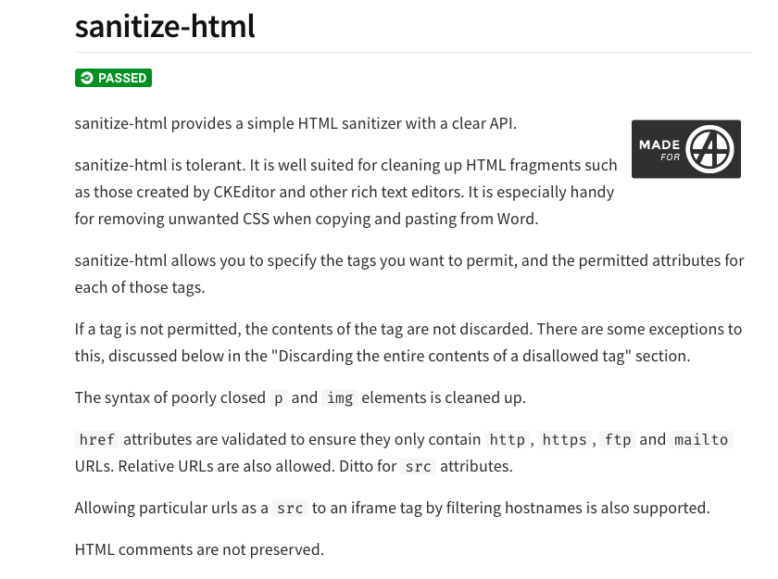
* 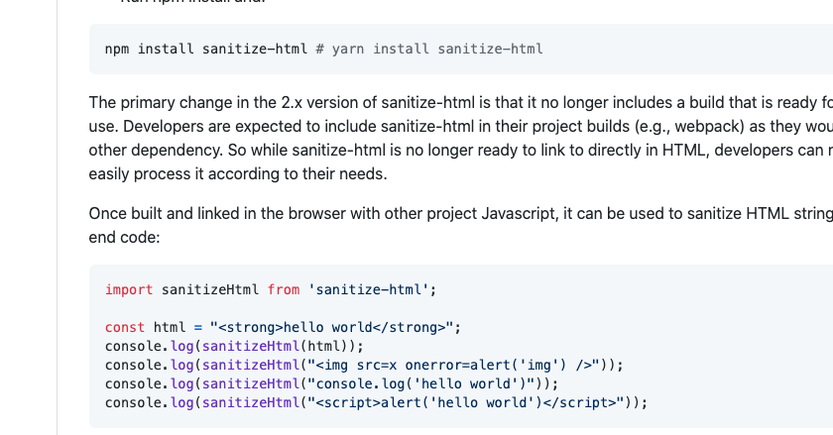
* And this package actually does the job of sanitizing the HTML inputs, right, you pass something in and it's going to strip the HTML tags away or the script tags or the image tags or whatever it is. So I can actually show you that quickly in node if I just open up or if I require sanitize html equal require.
* 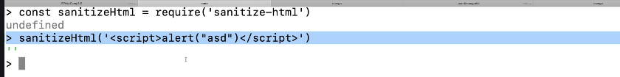
* Sanitize HTML like that, if I call it on some value, like the string, you know, scripts.
* Alert.
* Like that.
* **If I call it on that, it just gives me an empty string, it sanitizes it.**
* I also can provide options.
* Just what I'm doing right here, allowed tags, allowed attributes.
* I'm saying nothing is allowed.
* I'm being very strict.
* You can rule things in or out.
* You can say actually, you know, which ones are fine or paragraphs or whatever, but not scripts.
* But I'm just saying nothing is allowed.
* 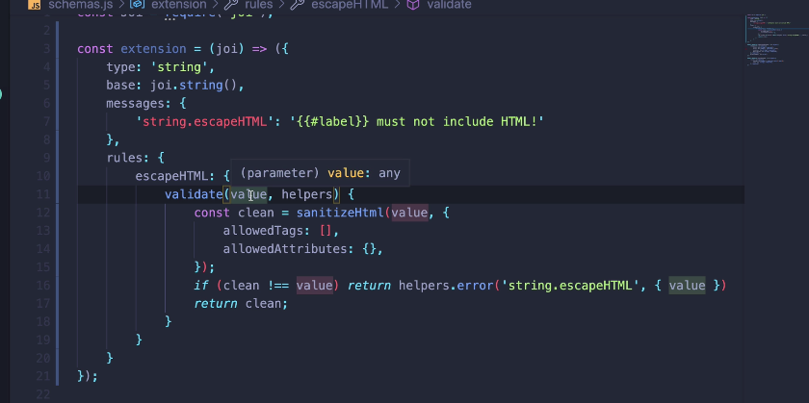
* And then I check to see if there's a difference between the the input that was passed in and then the sanitized output.
* And if there was a difference, that means something was removed.
* Then we just returned this helper's ever string out escape HTML that's defined up here.
* It's all this weird syntax and then the output just says something like campground dot, I don't know, title or review body must not include HTML.
* Now, in order to use this extension, I need to tell Joey to use it and I don't really tell you where to use it, but I basically call a function called Extend on Joy.
* So I'm going to call this base Joy and then I'm going to do a base joy, dot extend and pass in my extension.
* And I'm going to call that thing Joy just so I don't have to change this.
* OK, so Joy now equals the old version, the base version of joy, but extended with this new extension.
* And that now gives me the option, the possibility of using escape HTML.
* So I'm going to do that on the title like that.
* I'm going to do that on location anytime we have text.
* What else, body?
* Cool.
* So if I take this now and I restart my server, get out of node.
* Let's go to some campground.
* You're going to have to log in, huh?
* OK, try that again.
* OK, so as an example, if I try and leave a review and this review says, I don't know script. Alert, high, close the script, it's going to yell at me.
* I think well, it does yell at me, but not for the reason I was hoping sanitized Schimel, that package that we installed, I never required it.
* All right, one more time, make a review script, alert high like that, close the script.
* And moment of truth can include HMO.
* All right, let's try some other parts.
* Let's try editing.
* Can I put it in there?
* Nope, cannot have HTML in their location.
* Well, it's still going to complain about the title, so if I fix the title.
* We're still not making our site, like, magically impenetrable, but we're just preventing that very, very easy attack.
* That's like the quickest win for any attacker that's, you know, 101 first five minutes of any sort of hacking class if there are such things.
* So take a look at this code.
* I wouldn't freak out about it too much.
* If you have questions, feel free to ask them.
* But, you know, it's not intuitive.
* It took me a while to figure this out.
* The sanitizing part's easy.
* It's just the syntax for joy is a bit of a I won't say nightmare, but it's a bit of a.
* A mild nightmare.
* OK, next up, we've got a couple of other things we should talk about around security and vulnerabilities
* 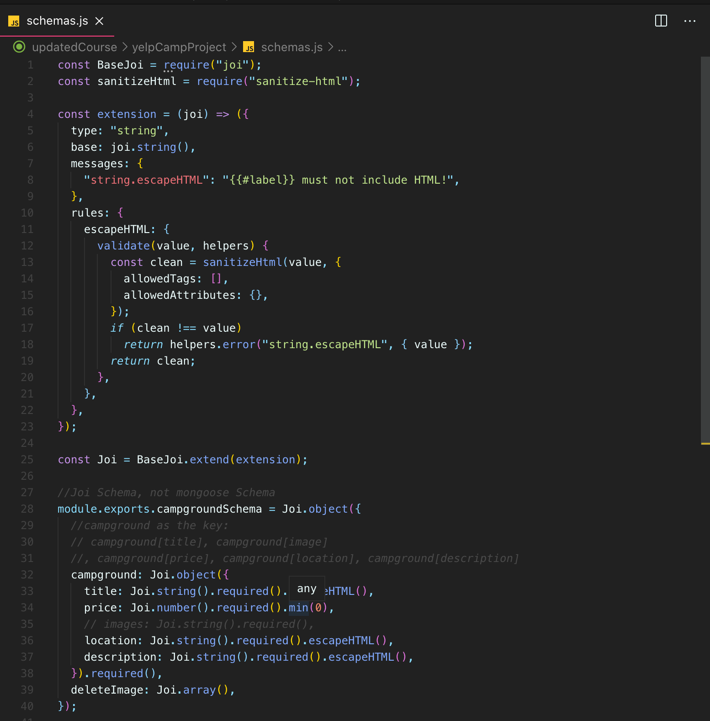
* 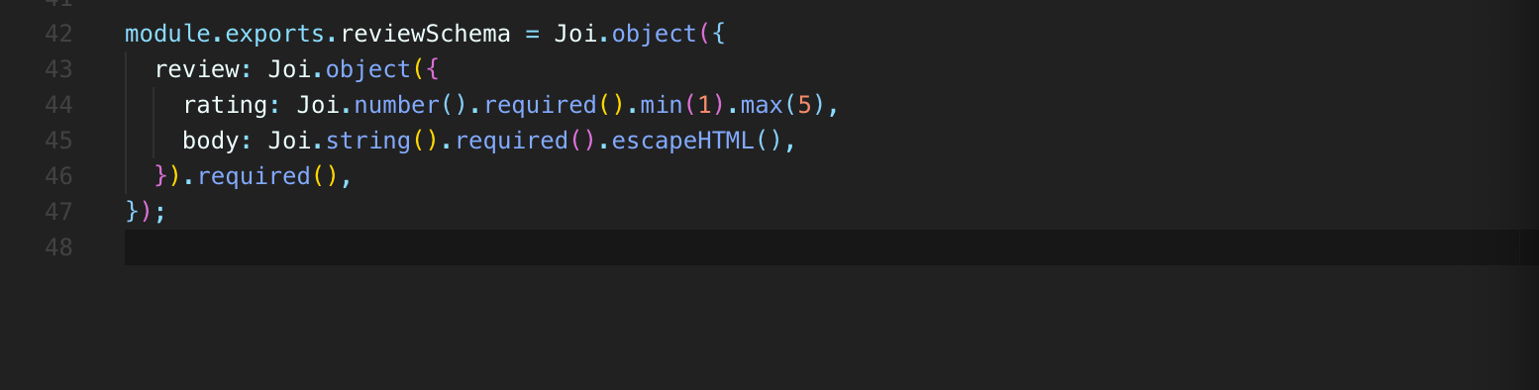
* 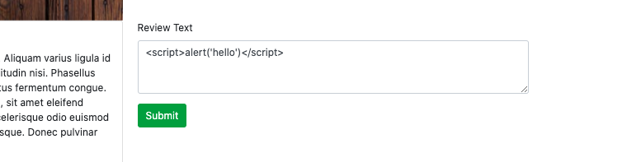
* 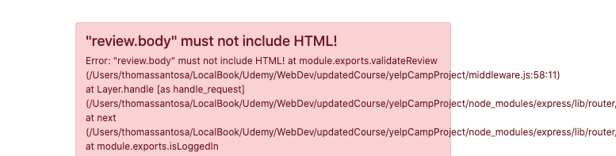

547. Minor Changes to Session/Cookies

* The first thing that we've actually already done, if you remember, I set up this httpOnly thing on the session config object.
* This basically says that our cookies, at least the ones that are set through the session, are only accessible over HTTP.
* They're not accessible through JavaScript.
* So if somebody were to write a script or somehow, you know, write some JavaScript that executes on our site and extracts cookies, they would not be able to see our session cookie.
* 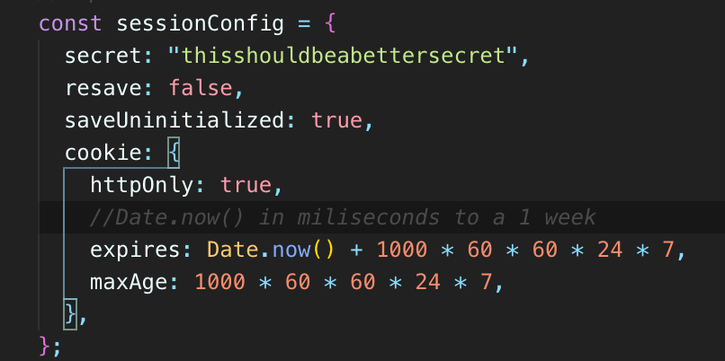
* 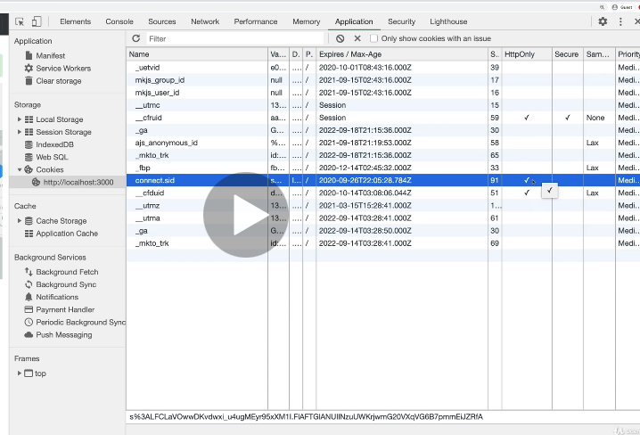
* If I log in here quickly, we just take a look at our application.
* We already talked about this very, very briefly.
* But in here, I think some of these are actually coming from the map, unfortunately, mapbox as all a bunch of cookies in here, but session it right here.
* **httpOnly is checked, so it's not accessible through JavaScript.**
* 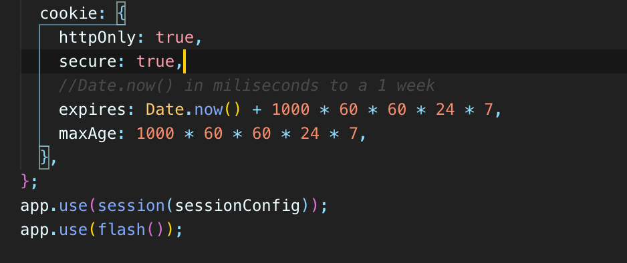
* Also, if we add “secure” and set that to true, this is actually going to break things for us right
* But I'm going to leave it in here and commented out.
* I'll show you how it breaks things.
* Basically, it says that this cookie should only work over https.
* So https: (http secure).
* You've probably seen https before.
* Localhost is not https, it's not secure.
* So that cookie is not going to work if I log in.
* It does not treat me as if I'm logged in, it still says log in.
* 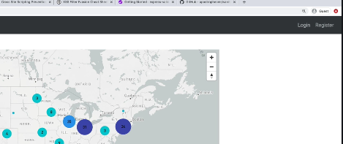
* I don't see the leaks, even though I own this review and I own this campground, and that's because we set up the secure true.
* Now when we deploy, we probably want that.
* We definitely want that to be the case just so people are only accessing or accessing our sites over, or at least the cookies can only be configured over secure connections.
* That's really what it's saying, that the cookies can only be changed or configured over https.
* So I'll leave that in there
* and comment about one other thing we should do.
* That's a quick win.
* 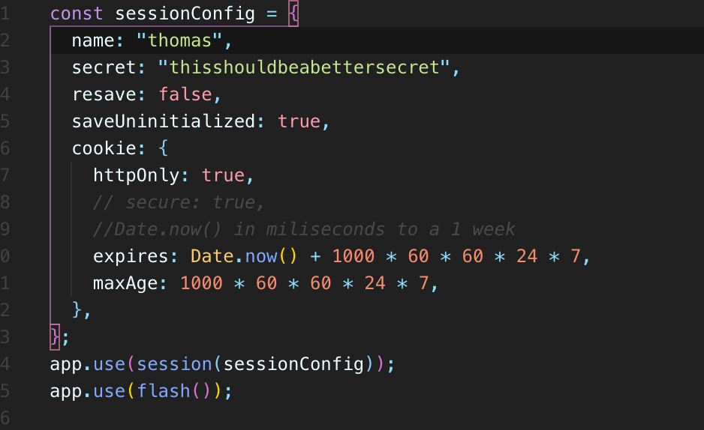
* 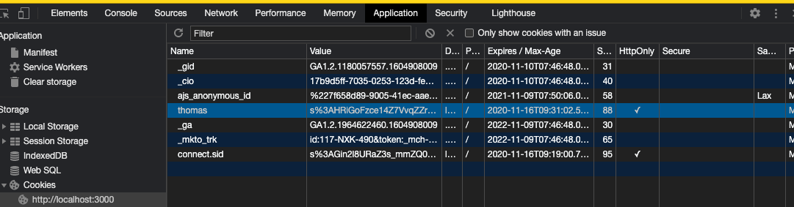
* And it's recommended is change the default name of our session.
* So right now, its next session ID, I believe, but we can actually provide our own name in here like name equals floor just to start.
* And if I refresh the page, I'll log in.
* And go to application again, there's blog now, this is what the name of the cookie is instead of this is the old one that browser still stores instead of session ID or connect side, which is the default, somebody could know.
* You know, that's what I want to look for.
* That's what I'm, you know, hoping to extract from this user.
* I'm going to write a script and I'm going to ask for everybody's can connect session ID and then I'll be able to basically steal their session information and pretend to be them and log in.
* We don't want that.
* So, you know, we've put in some other measures to hopefully protect that or protect against that.
* But one easy one is just to come up with some other name.
* So I wouldn't go with blah, but just some other name.
* That's not the default that, you know, people would already be on the lookout for.

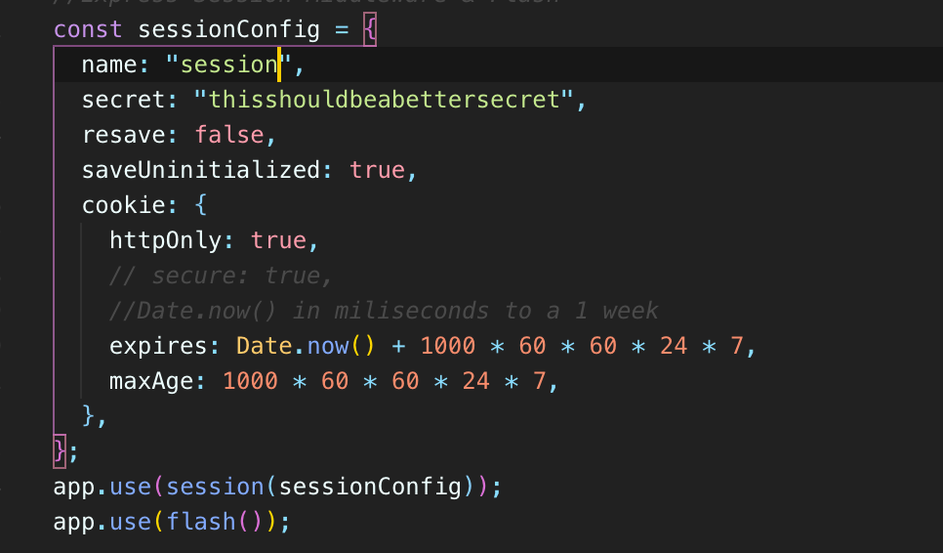

* So probably just session or something just to start.
* We're not trying to hide this.
* It's just we don't want to use the default name.

548. Hiding Errors

* Another thing to be aware of when you are deploying or you're creating an application for production purposes is that you don't want to be giving your users development errors.
* You don't want them to see like a stack trace, for example, which at the moment we are doing.
* 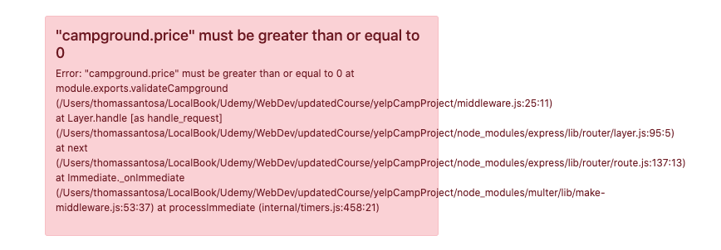
* **But this in here, we don't really want a user to see and that makes sense.**
* **You know, this tells users a bit about how our files are set up, what line is causing things to go wrong and it's just information.**
* It's a bad experience, but also it's information we probably don't want to use her to see.

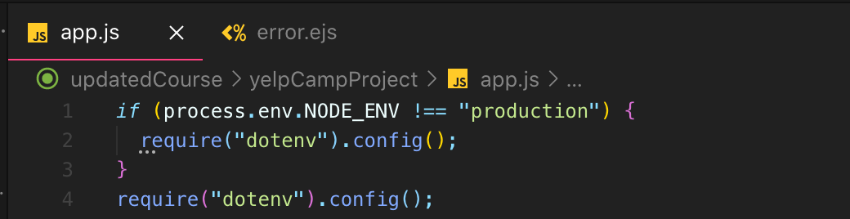

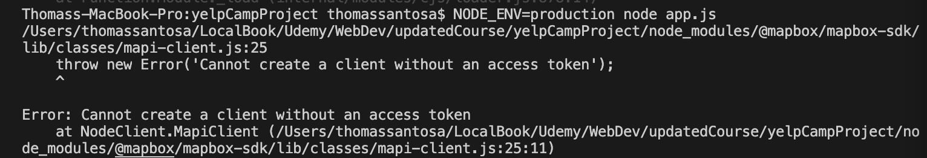

* 
* 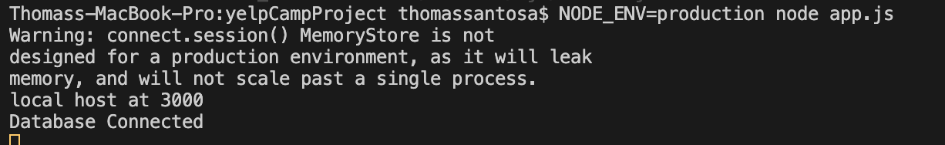
* 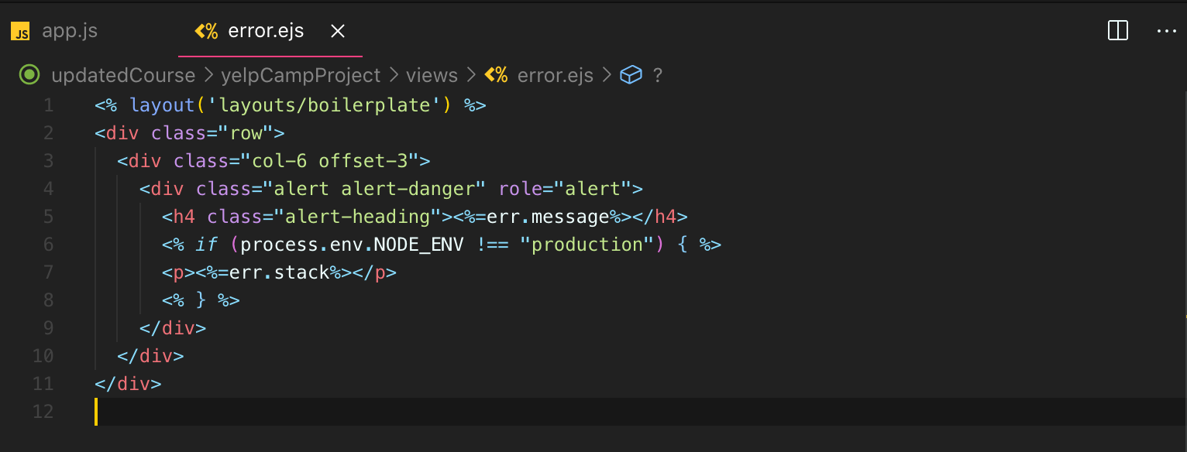
* 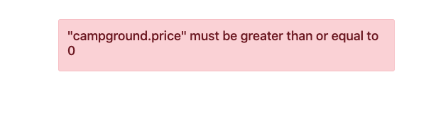
* our map box SDK freaks out because we don't have the access token anymore, if we look at our jobs right, we're requiring this env
* , but that's only in development, not production.
* So if we're in production, those credentials are missing.
* So, I mean, I guess I could just show this to you.
* Just always use those credentials just for now.
* OK, now it's warning me about this memory store, that's fine.
* OK, now it's warning me about this memory store, that's fine.
* We'll fix that now if I log back in.
* And generate some error.
* OK, we don't see this dextrous, so super tiny thing, relatively easy fix, just don't display the error stack outside of development.

549. Using Helmet

* So the final security related topic that we'll cover for now is a package called Helmet.

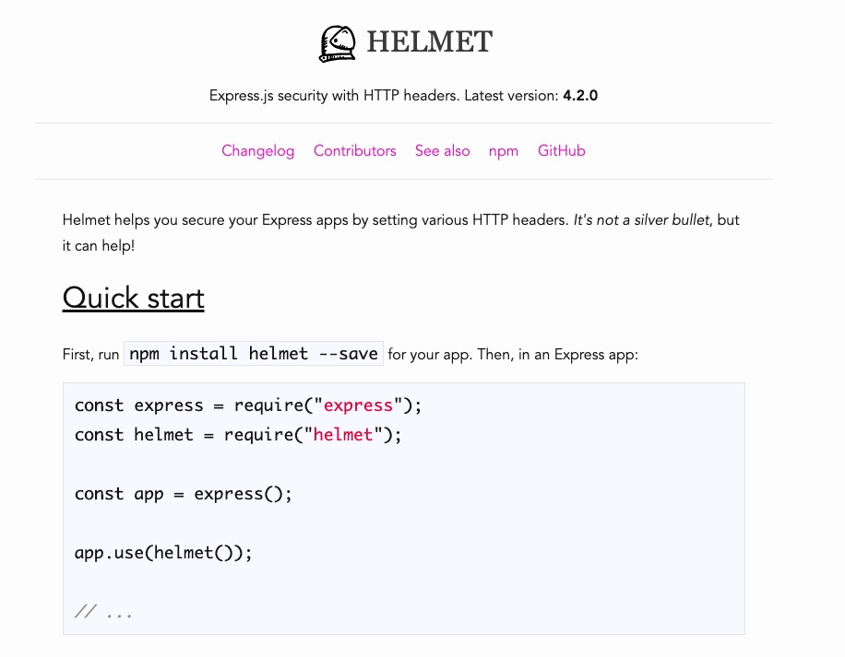

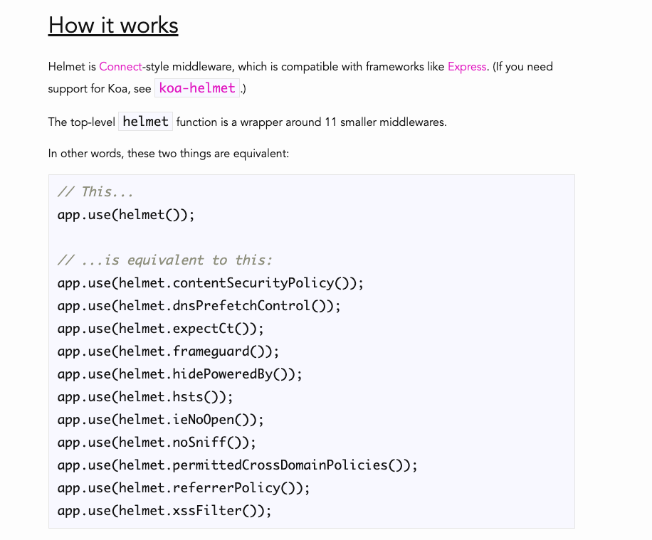

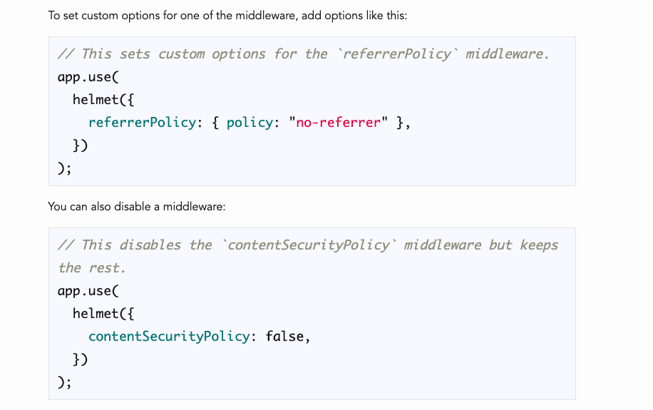

* It's a very popular package that comes with a set of how many 11 middleware that all have to do with HTTP headers changing the behavior , turning on or off or manipulating headers and all in the name of security.
* So we're not going to go over how they all work.
* The docs are pretty good.
* If you have questions about any of them, you know, you can read more information, for example, on what the heck frame guard does and what the extreme options header does.
* It helps you mitigate quick jacking attacks.
* Well, what's click jacking?
* You can read about it here.
* So we don't have time and we don't need to care about how all of this work, although it's definitely worth trying to look into.
* **But the point of helmet is that you don't have to get into the nitty gritty.**
* **You can just tell your app to use it.**
* **Now, there is one thing that will be mildly annoying when we first start using it.**

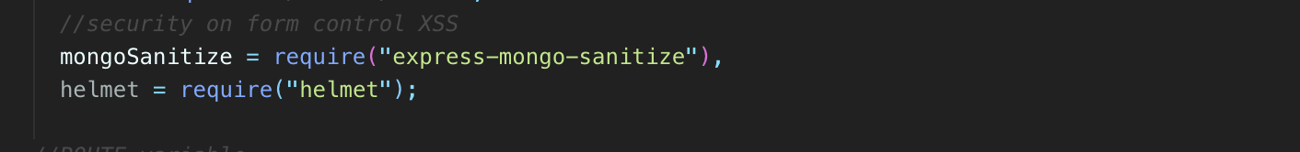

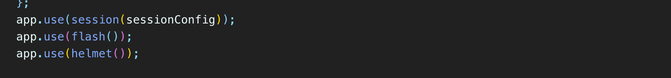

* So if I just go to my app NPM I helmet and we just install it and then we require it in our app.
* We're going to organize this app at some point, but const helmet equals require helmet like that and then we just do an app.use with our helmet.
* I don't know why I said our helmet, **but I use helmet that automatically enables all 11 of the middleware that helmet comes with.**
* 
* **So instead of individually selecting the ones that we want, which we can do, we can just do all of them at once.**
* **But there's one problem which we're going to get into actually in the next video.**
* **One of these called content security policy is not going to be happy with some of our application if I start my app up and I go to localhost anything.**
* Let's just go back to the share of the home page.
* Hmm, my images loading, what's going on?
* What are all these things?
* 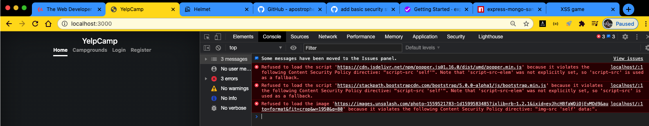
* Refused to load the script popper bootstrap unSplash.
* **And then they all say because it violates the following content security policy directive.**
* Same thing.
* If I go to campgrounds, our maps won't load.
* 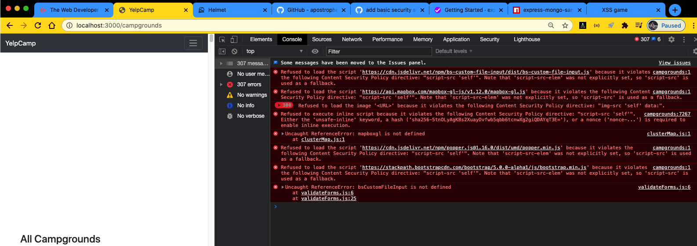
* So something weird is going on and it all has to do with content security policy.
* **And that's because helmets by default includes as one of its middleware, one of 11, this content security policy middleware, which it just for now, let's just say it screws things up.**
* **‘helmet.contentSecurityPolicy()’**
* In the next video, we'll talk about how we can control it.
* **For now.**
* **We can disable it just by passing in an option.**
* **So this is referrer policy.**
* **But if we pass in, you know, an object that says content security policy false, that should disable its content security policy false for now and now if I try and load those pages.**

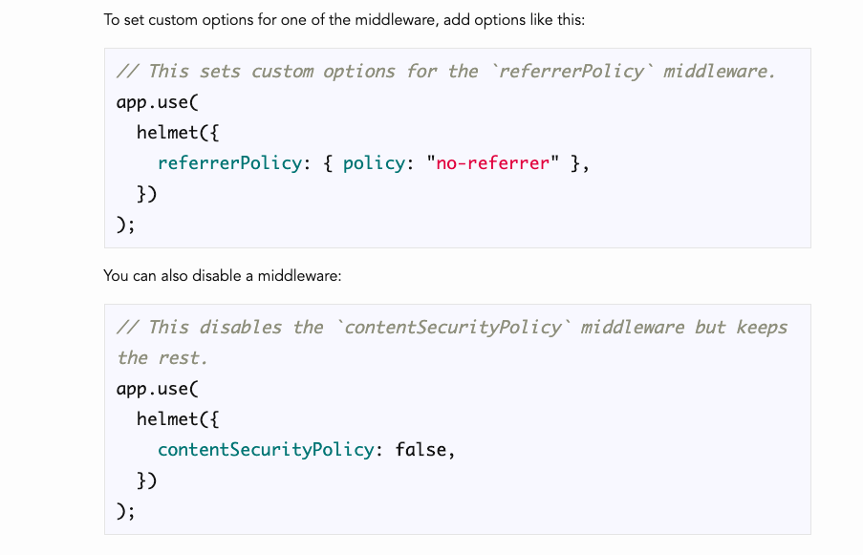

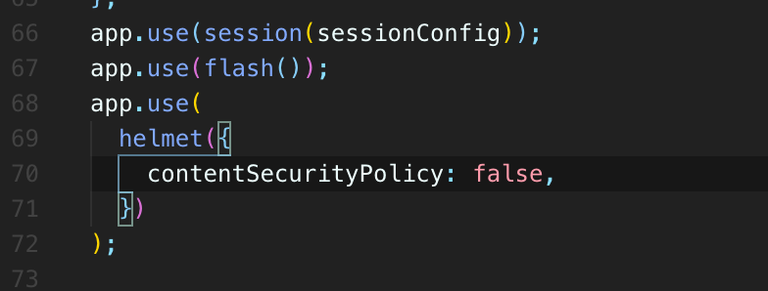

* We're back to normal and it works, so we get the map, we get our images, we get the styles.
* I go home.
* Everything loads correctly.
* OK, so I'll just show you a quick example of what Helmet does.
* If I send a request to get request to localhost campgrounds like that send.
* Let's look at the response headers we get back, there are a couple of them in here that would not be here otherwise.
* So I think I'm going to now disable helmets just so we can compare and contrast.
* OK, so I just made the exact same request.

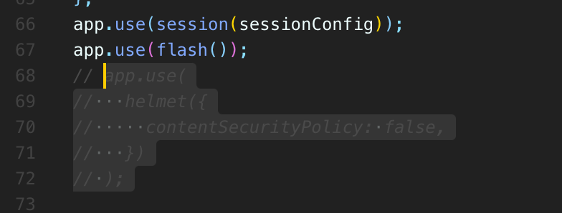

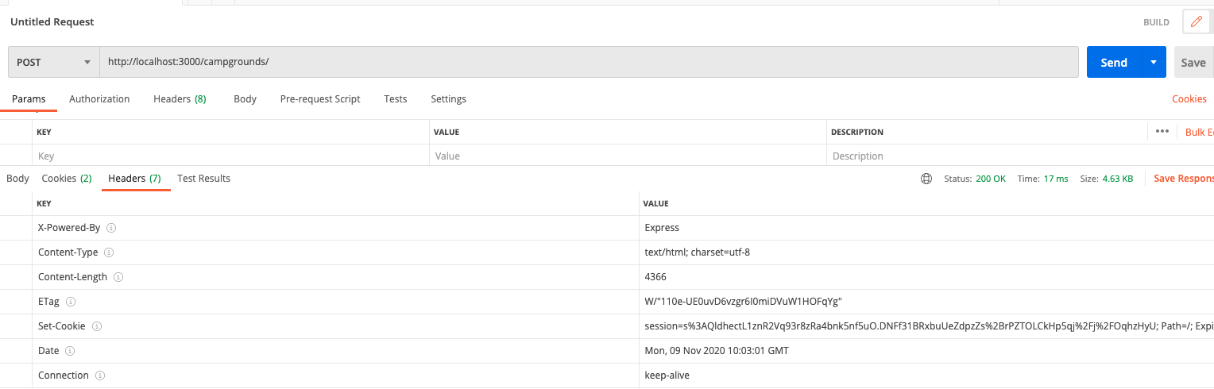

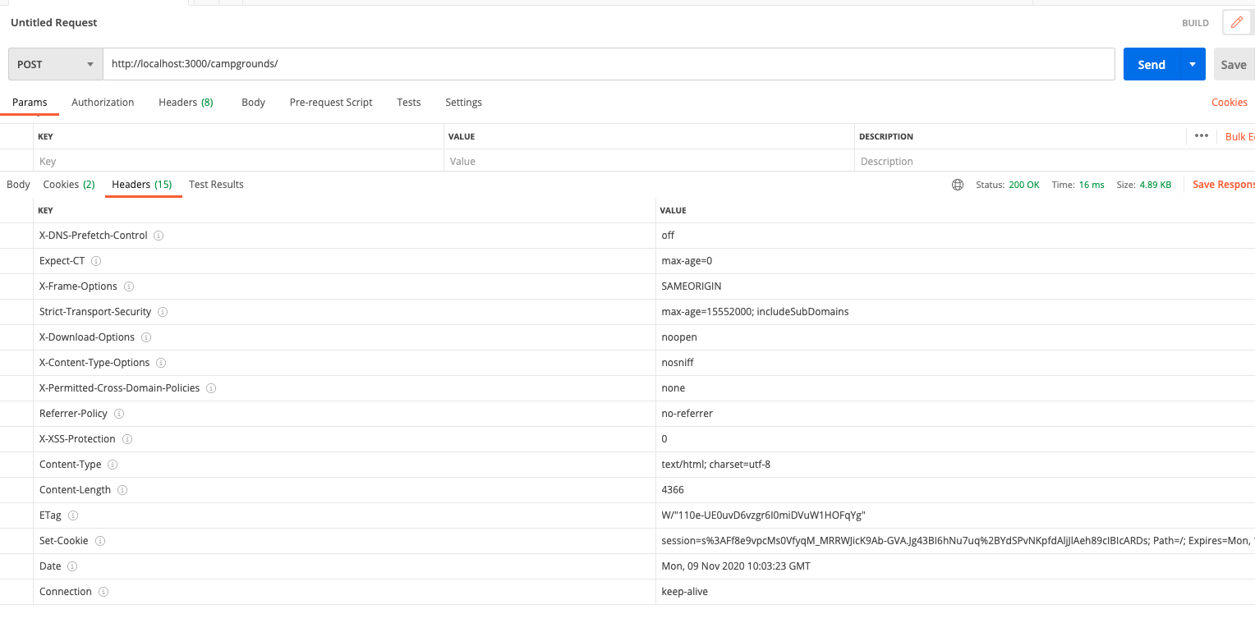

* **Now with Helmet disabled, these are the response letters I get back and then this is what I got back earlier.**
* So there's what, fifteen versus seven?
* We have eight new headers that just weren't there at all.
* And, you know, if we take a look at one of them, for example, X frame options or XSS protection, each one of those is mentioned on here.
* So we said frame guard.
* That sets an X frame options header.
* 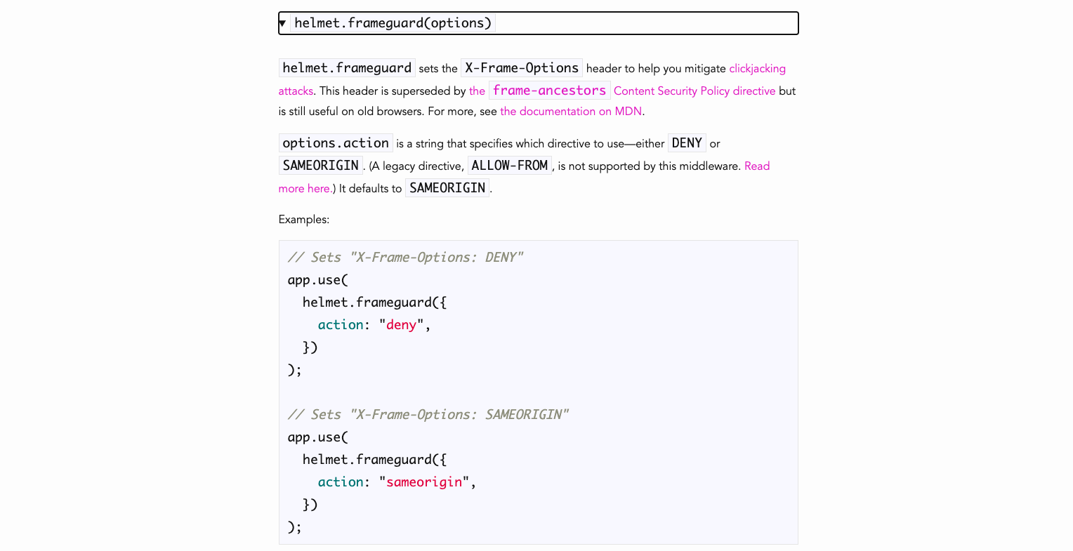
* You can see it there.
* And again, we don't really need to know or care about what that means.
* **It just makes our app more secure, makes it harder to do something called a quick jacking attack filter.**
* We talked about cross site scripting.
* **This actually, somewhat surprisingly, is going to disable built-in cross site scripting filters on older buggy browsers because it is buggy.**
* And it does that by setting this header x-xss protection to zero.
* 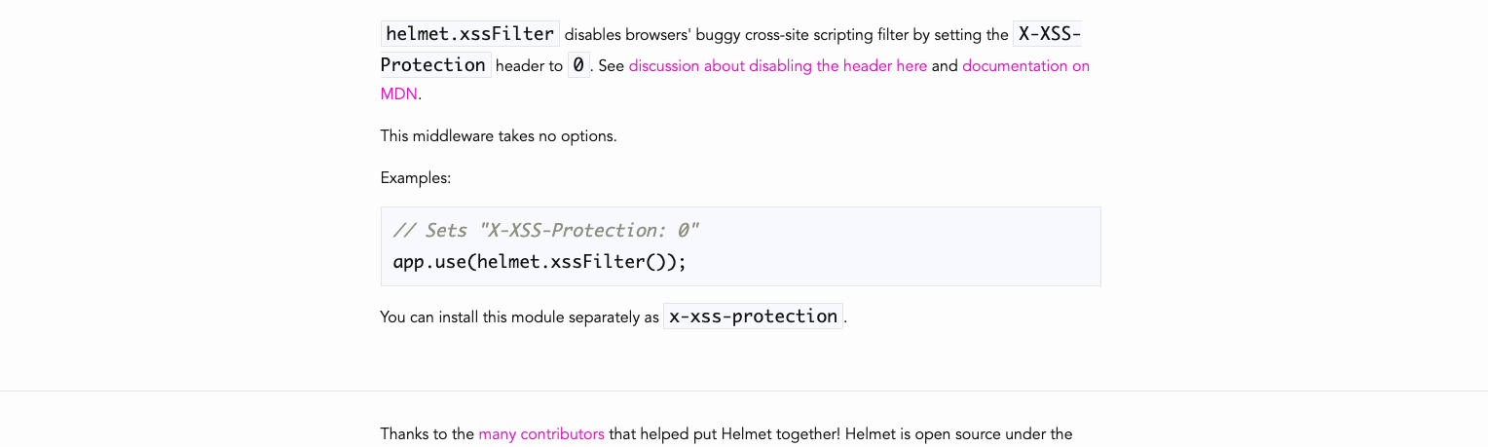
* It also does things.
* You know, let's just take a look at one more.
* No sniff sets the X content type options to know sniff right there.
* 
* **So this is all coming from helmet.**
* **It's just sitting there adding in different headers and manipulating headers in the response.**
* **And they'll have to do with security in this case, setting X content type options to know sniff helps mitigate mime type sniffing.**
* And you can read more about that here and a broken record.
* But that's kind of the point of helmet's.
* You don't have to understand everything.
* **You just need to be able to add it into your app.**
* **And it's large enough.**
* **And, you know, you can trust the fact, I guess in the real world you should.**
* **If this is a production app that had a lot on the line and credit cards involved and lots of users,**
* **then I wouldn't just use a helmet without, you know, digging into exactly what each one of these options actually does.**
* **And, you know, you would have some security experts at that point anyway.**
* **But for us, it's trusted by lots of developers, especially for just a standard express stack.**
* **So that's kind of the basics of helmets I love and built in middleware.**
* **You can pick one or use all of them.**
* **You can single one out to not be used like we're currently doing.**
* **And then in the next video, we will be using this middleware.**
* We just have to talk about what the heck it is.
* OK, that's coming up.

550. Content Security Policy Fun

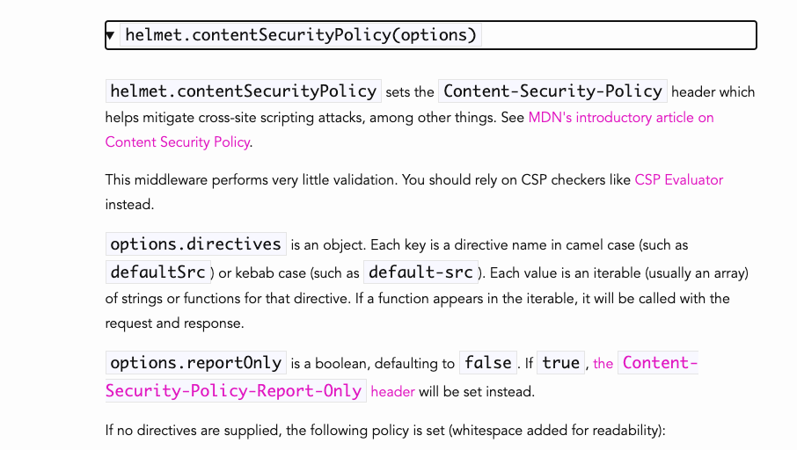

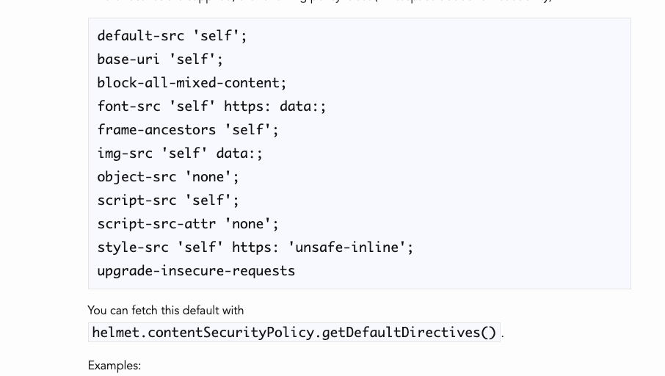

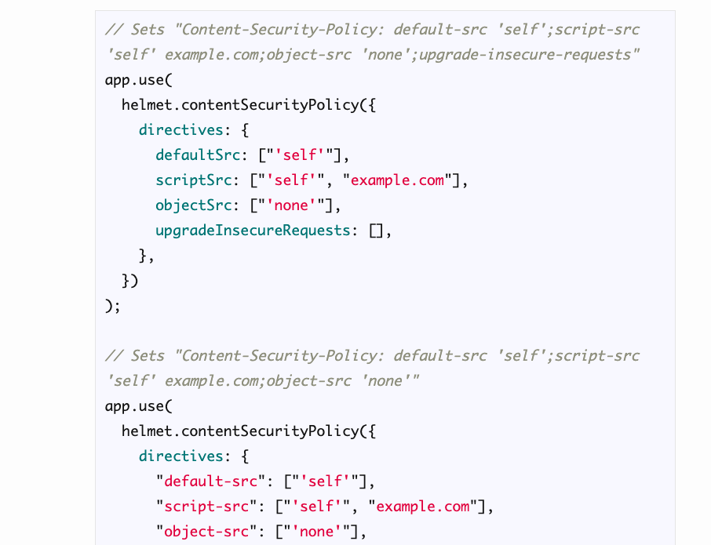

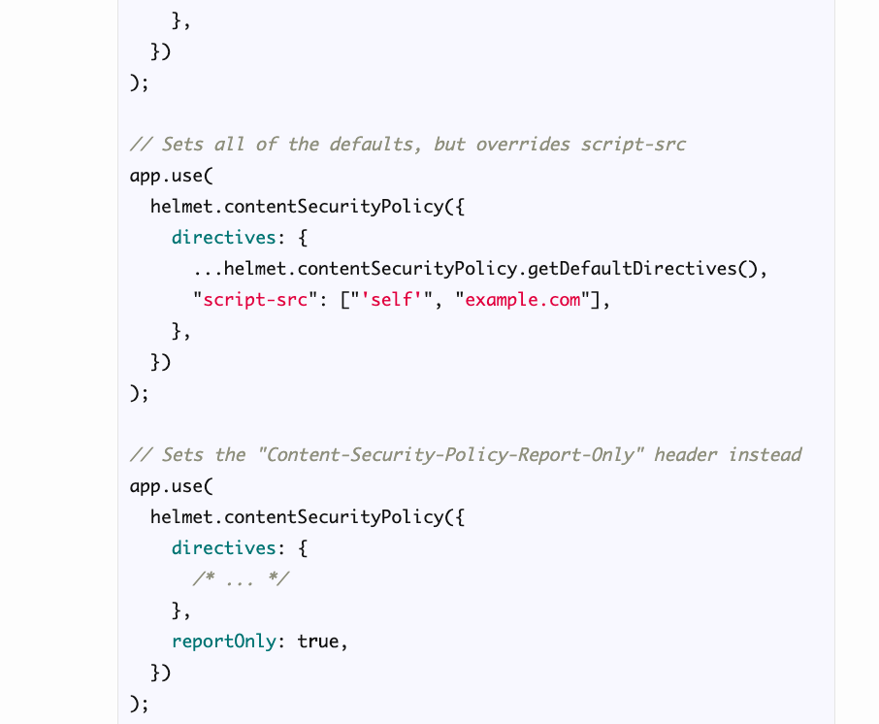

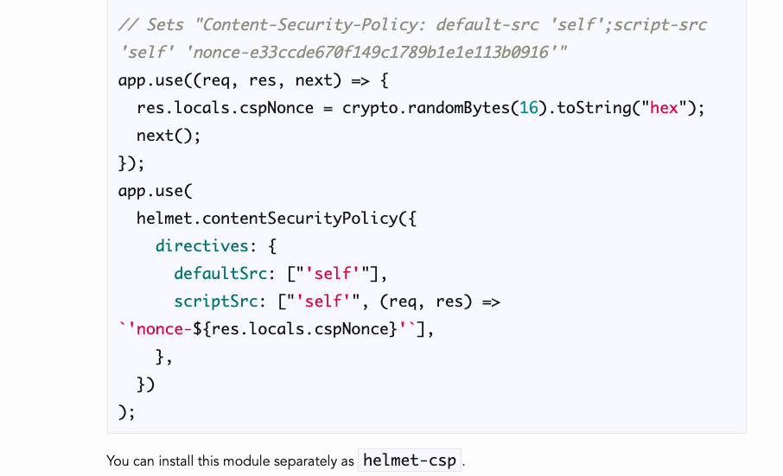

* Well, if we go to helmet and we look at it, it tells us that this one middleware sets the header called Content Security Policy
* **, which helps mitigate cross site scripting attacks. Input form = <script>hijack</script>**
* You can read more about it here.
* So let's go there and let's read more about it.

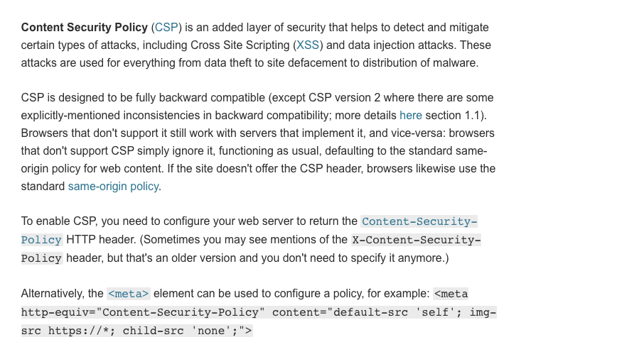

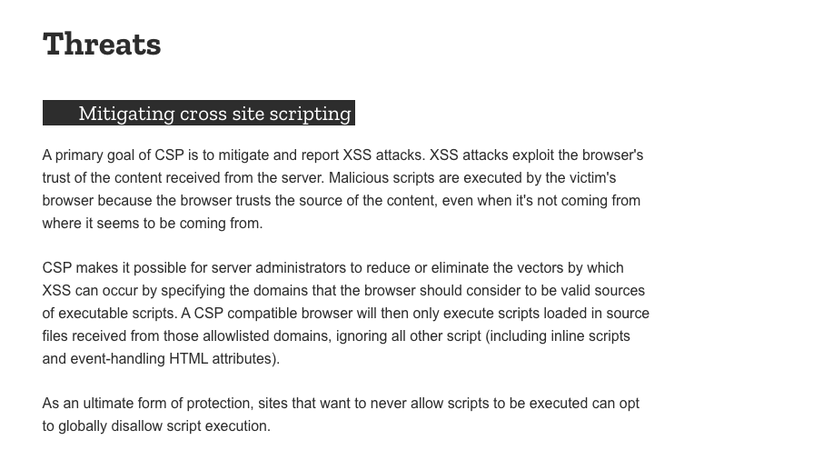

* So **CSP**, is this basically an extra layer of security that allows us to specify on this one application, this one website that you're on right now, you're only allowed to display images from, unsplash.
* You're only allowed to run scripts that come from this website and you're only allowed to display fonts or request fonts from this website or from wherever, like you can specify a list of acceptable sources.
* **And that's kind of the whole point of content security policy.**
* **It's about designating your own policy, what's allowed and what's not allowed for things like images, scripts, fonts, media objects.**
* **There's all these different directives is what they're called.**
* 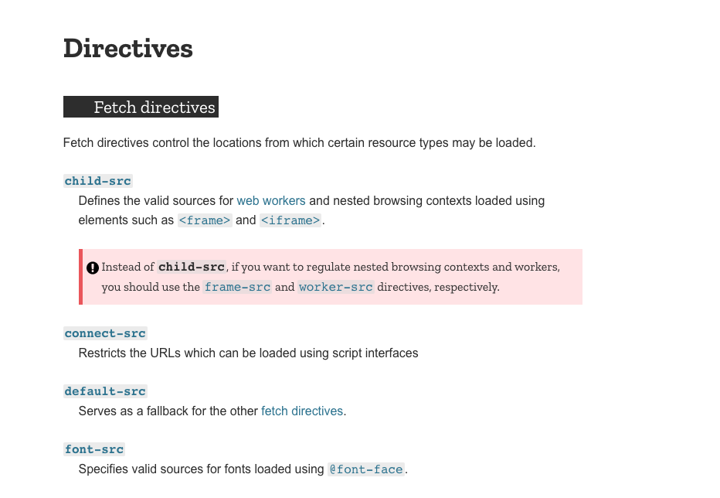
* **And for each one, you can specify the locations that this type of resource is allowed to be loaded or fetched from.**
* **For example, if you're looking at font source, you could specify what you'll see most frequently is things like “self”, which just refers to the same origin where whatever document is being served.**
* **So if we set font source to be self, it would just be saying from our Yelp camp app, if there is a font that we have as a file, but it would not allow us to use fonts from Google fonts, for example, so we could also specify a new URL, Google fonts**
* Anyway, that's the very basic idea.
* Let me show you a simple example here.
* 
* **When we configure the content security policy and helmets, we actually pass in or we can pass in our own options.**
* The default looks like this default source self font, source, self.
* What else?
* Image, source, self.
* So these are all different directives that have been set.

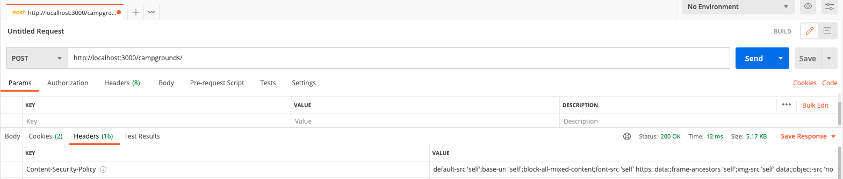

* And in fact, if I send a simple request with Postman, this is what I will get back.
* **Content security policy.**
* I guess, but **it's basically the content security policy, my browser sees that and it decides, oh, I see, we're only allowed to load fonts from this place.**
* **We're not allowed to load fonts from Google fonts.**
* **We're only allowed to load images from self.**
* So unsplash, it's not allowed as an example, but if I have a local image, it would be allowed
* **So to configure our own policy because the default policy is not going to work for us.**
* It looks like this.
* 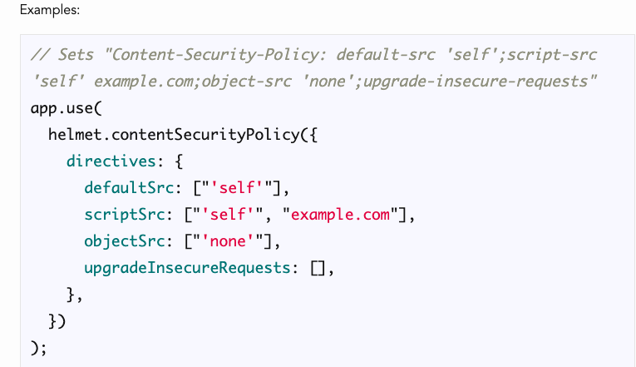
* Content security policy directives, and then we specify default source, script source, object, source, upgrade, insecure requests if we need.
* These are all different things that we can specify and it's kind of a lot of work to do it well.
* So I've already done it here.
* And I just recommend you copy this and tweak it to whatever works for your application if you've made some changes.
* What complicates things right now is that we have quite a few different CDN and different files and scripts that we're loading from non self sources.
* They're they're not local to our application.
* So we could definitely smooth things out if we just downloaded some of those.
* And I probably will do that.
* It just takes kind of an annoying amount of time to do on video to go download the right files, put them in the right folders, link to them correctly.
* It's not a big deal.
* But basically right now I just have some arrays have setup.
* So these are sources for scripts that we want to allow.
* So actually, we're not using Jaquiss.
* We don't need that
* , but we're doing some CDN stuff from JSdeliver some from CloudFlare, mapbox, bootstrap CDN.
* We need that.
* **And then we have the same thing for style source you URLs.**
* These are this is so complicated to really go in depth on.
* So I'm not going to

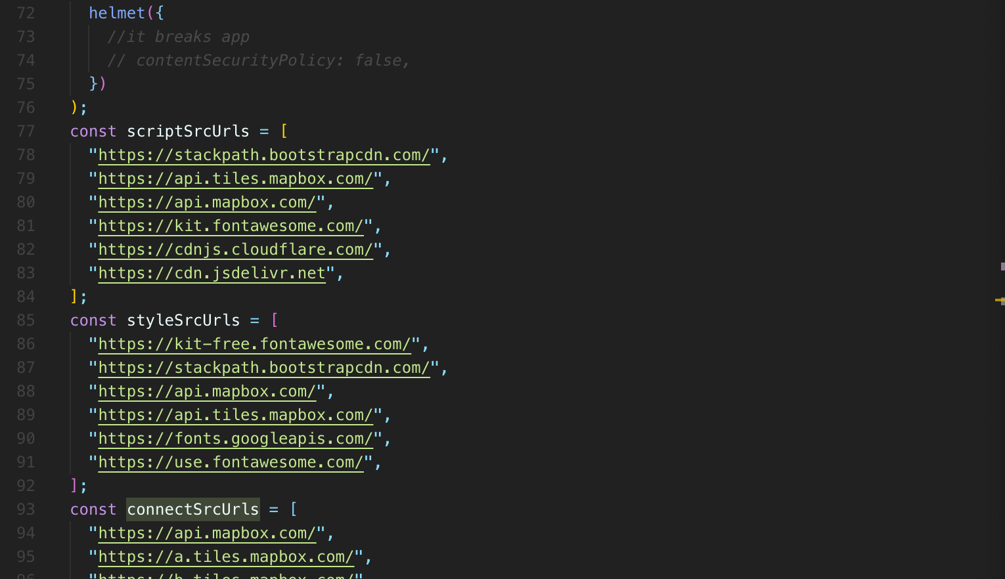

* **basically these are three different arrays.**
* And if, you know, if you realize, oh, I actually also have a script from this other you and I need to include that you can put it in this array.
* Then we actually configure helmet.
* And that's what I'm doing here.
* I'm specifying as an example for images.
* I want images to come from self, which is this URL.
* We're not going to worry about blob and data.
* They do need to be there.
* But again, it's just too much.
* It's a lot of detail to go into.
* **This is something at a large company like one or two people are in charge of and they configure for the entire application.**
* So it's not a huge issue at the moment.
* **I'm just giving you that configured content security policy set up.**
* **And then we want to specify, for example, res.cloudinary.com, whatever your name is that, you know, the images are hosted on for your account.**
* So right now, if I use this, we'll just show you what it generates in Posman.
* This content security policy includes a lot more, and if I try and refresh this page, we should see fewer read errors, but we still have a problem with our images.

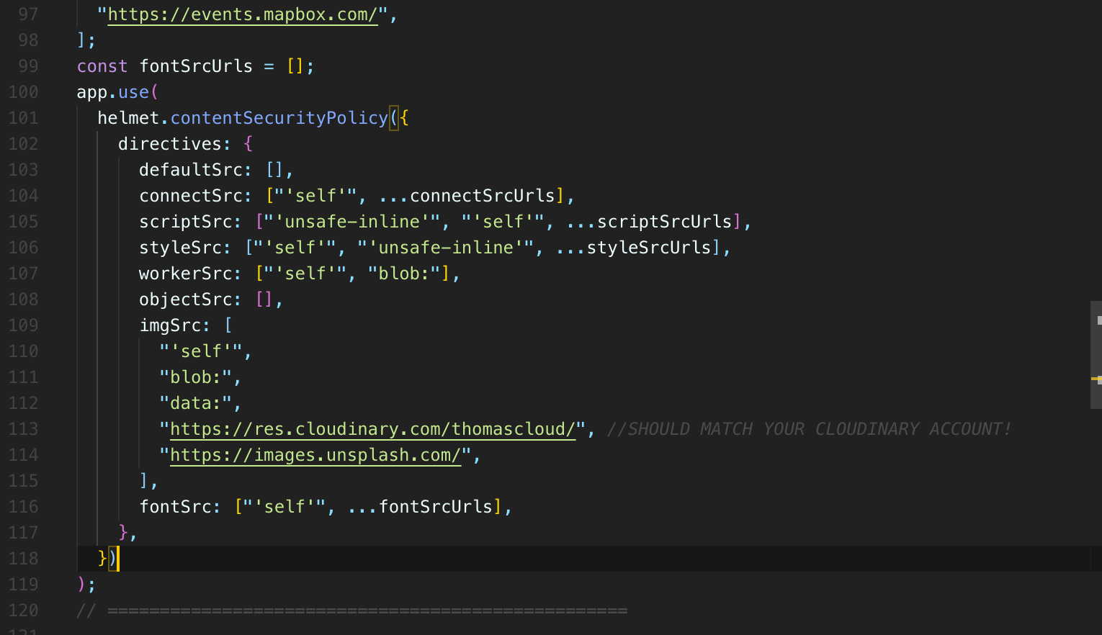

* **Yeah, you can see there because we are not allowing cloud images from my you URLs, which if we just go look at my specific setup**, it's going to be different than yours because you have a different password, not password, but you have a different name on Cloudinary.
* So that's mine right there.
* I also you know, I can look at my .env file, but basically I want to put that to allow images from my cloudinary uploads.
* Now, if I refresh, those images are allowed.
* So, you know, we can take a look, see if we're getting any other issues.
* All looks good so far.
* **And if you do add new scripts in, you want to add those in to this array and we could move this into a separate file.**
* **It's a lot of work, but I hope you can understand the basic idea we're restricting the locations that we can fetch resources from.**
* So I'm only deliberately including mapbox and font-Awesome.
* **And, you know, bootstrap CDN.com as places where I want to be able to have my application fetch scripts from.**
* **So if somebody tries to inject something else in there and there's a request going off to some othee url, some other host that I have not allowed, then it's not going to be allowed by the browser.**
* **So very useful, even if it is quite restrictive at first and a lot to take in.**
* So you could read a ton about how this all works.
* I again want to keep this as brief as possible.
* So I'm just going to stop talking.
* I will put a note in here, though, so let's put a comment, I guess, right there.
* Should match your cloudinary account.
* OK, and that's pretty much it for our basic security setup at this point, do not leave this section thinking, having the false impression that your app is watertight.
* There are still, I'm sure, many vulnerabilities, many issues.
* So we'll fix some of them as students point them out.
* But also, you know, it's just a constant battle, a constant process, especially when we're depending on other tools.
* Some of the packages we have might have their own vulnerabilities and their own issues that, you know, things just can go bad very easily.
* So keep that in mind.
* Right.
* **This is not to make you a security expert.**
* **It's just to show you the bare minimum you should do for your own express apps.**
* **And unfortunately, this one little piece setting that one header content seeker policy or security policy, it's kind of a pain, but it's worth doing.**
* **Just remember, if you do change something in your app and you add in a new font or a new script that**
* **you're loading from somewhere else or a new location for images, you decide to use a different image, API**
* , the **CSP**, **the policy is not going to permit that as it stands currently, so you'll need to modify these somewhere else.**

**Section 57: YelpCamp: Deploying**

551. Setting Up Mongo Atlas

* So this next chunk of videos is all about deploying our application, which is a decent amount of work, **things are different when we go from local development**, right.
* Our own little local mongo database
* , everything on localhost up to the real world.
* There are some changes that need to be made.
* And we're going to start with our mongo database.
* So right now, our entire app, the entire database is in a single local database.
* I think I'm just calling it what, Yelp Camp, yelp-camp.
* **That is not really going to work for us when we are in production.**
* I mean, **we could theoretically connect to the same database, but it's going to be very difficult because of the fact that when we deploy an application, it's no longer running on this machine, on my laptop.**
* **Instead it's running on a server somewhere, a Heroku server and AWS server, somebody else's.**
* **Usually these days, at least, unless you own your own infrastructure, your own servers and all of that, it's usually hosted somewhere else.**
* **And then my database is on my machine.**
* **That Mongo database is here.**
* **So I would have to find a way to serve this mongo database over the Internet myself and then connect to it, let's say, from Heroku, which is what we'll be using.**
* Or I would need to like export my data from this local database and then somehow sync it up with the database that we're using on Heroku.
* It's just not that easy.
* But more importantly, we want a separation.
* **We want a development database and a production, at least a lot of the time we do.**
* That way we can play around with things, tweak things, we can delete data and not worry that it's real user data.
* **So in this video, we're going to set up our production database, which is not going to be a local instance of Mongo at all.**
* **We're going to use something called Atlas, which is one of Mongo's cloud database services.**
* **It's a product for Mongo, a paid product, but there's a free tier and the entire product is basically a Mongo database as a service, a global cloud database service for modern applications.**
* So we're going to create a new mongo database that we don't actually store on our machine at all.
* **It's stored in the cloud and then we can connect to it very easily.**
* Well, relatively easily.
* **And there are other reasons to use Atlas.**
* **One of the main reasons, well, for us at least, is that it makes it very easy to manage permissions and privacy security.**
* **We can set up a user and a password very easily with a graphical user interface.**
* You can manage all of that.
* **You can see all the, you know, fancy visualizations of what's happening with your database.**
* **And it's just used a lot in the real world.**
* So it's a good opportunity for us to use this.
* It's free.
* **The database itself is just like any other mongo database, so we don't need to change any of our logic or anything like that.**
* **Still Mongo, but it's just not hosted on our machine.**
* You can give that cluster name if you want to create cluster.
* So this is minimized on my machine.
* But you probably see something like this.
* These are actually steps we want to go through.
* So the next thing that it's telling us to do is create our first database user.
* And that's something we haven't used so far.
* Database users also exist on our local Mongo instance or right now they don't actually exist.
* We don't have any.
* But it's a capability of Mongo where you can have different users with different permissions.
* **Basically, you know, anybody could connect to this database right now.**
* I mean, it's on my machine only on localhost.
* **But what would stop someone if this was a hosted database like Atlas's and somebody found that URL, they could just connect to that database and that would be a problem.**
* So we set up a user with a password.
* So we're going to do that right now.
* It tells us how database access and then add a new database user and we're going to authenticate with the password as they recommend.
* We're going to come up with some password to start.
* So just auto generate one.
* our-first-user
* Th20o5M94
* And I'm just going to copy that.

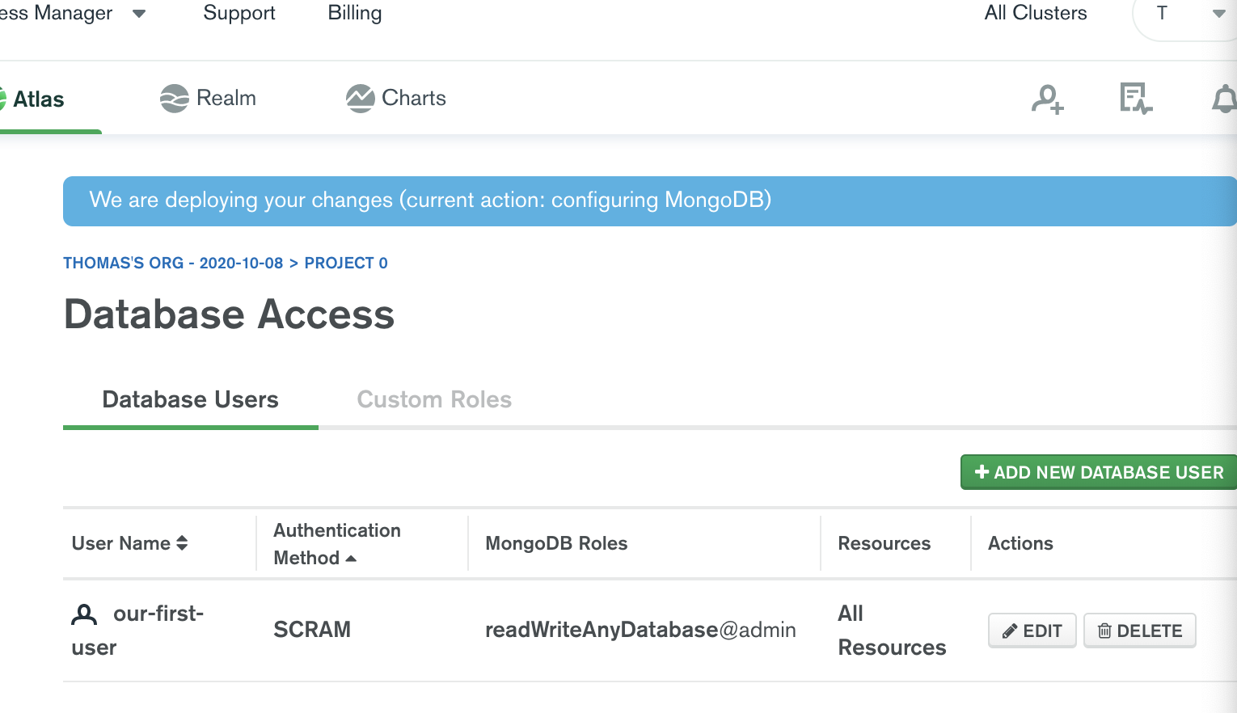

* We will need that password.
* And then we also want to make sure we come up with some username and I'll just call this, our first user.
* It really doesn't matter.
* Our first user greats come up with whatever username that you want there.
* It put a password in there, make sure you have that password database user privileges, read and write to any database.
* That's fine.
* And then we're not going to restrict access.
* You're not going to make it a temporary user.
* Now that we have that done, we can almost connect to our database, the next thing we have to do, which is also kind of annoying, **is whitelist our IP address**.
* **So white listing just means basically approving the IP addresses, which can access our cluster.**
* And right now, there are none that have been approved.
* So we need to go here.
* You can either manually type your IP address, you can allow access from anywhere or add your current IP address, which is what I'm going to do.
* So I'm going to click this and then click confirm.

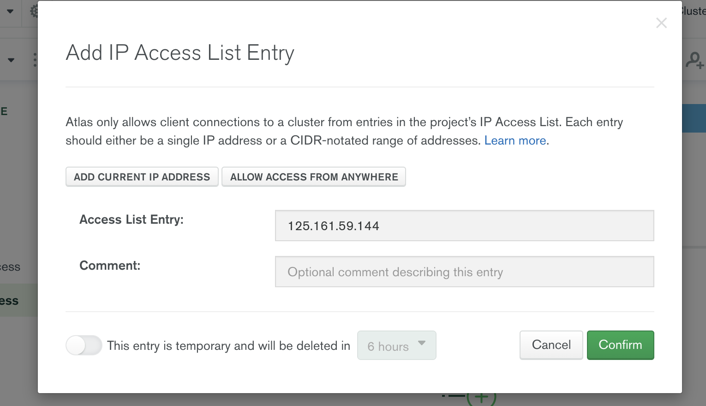

* OK, so that's done.
* And then I'm just going to go to connect to your cluster.
* We click connect here and then we need to specify how we want to connect and we're going to **connect through an application.**
* 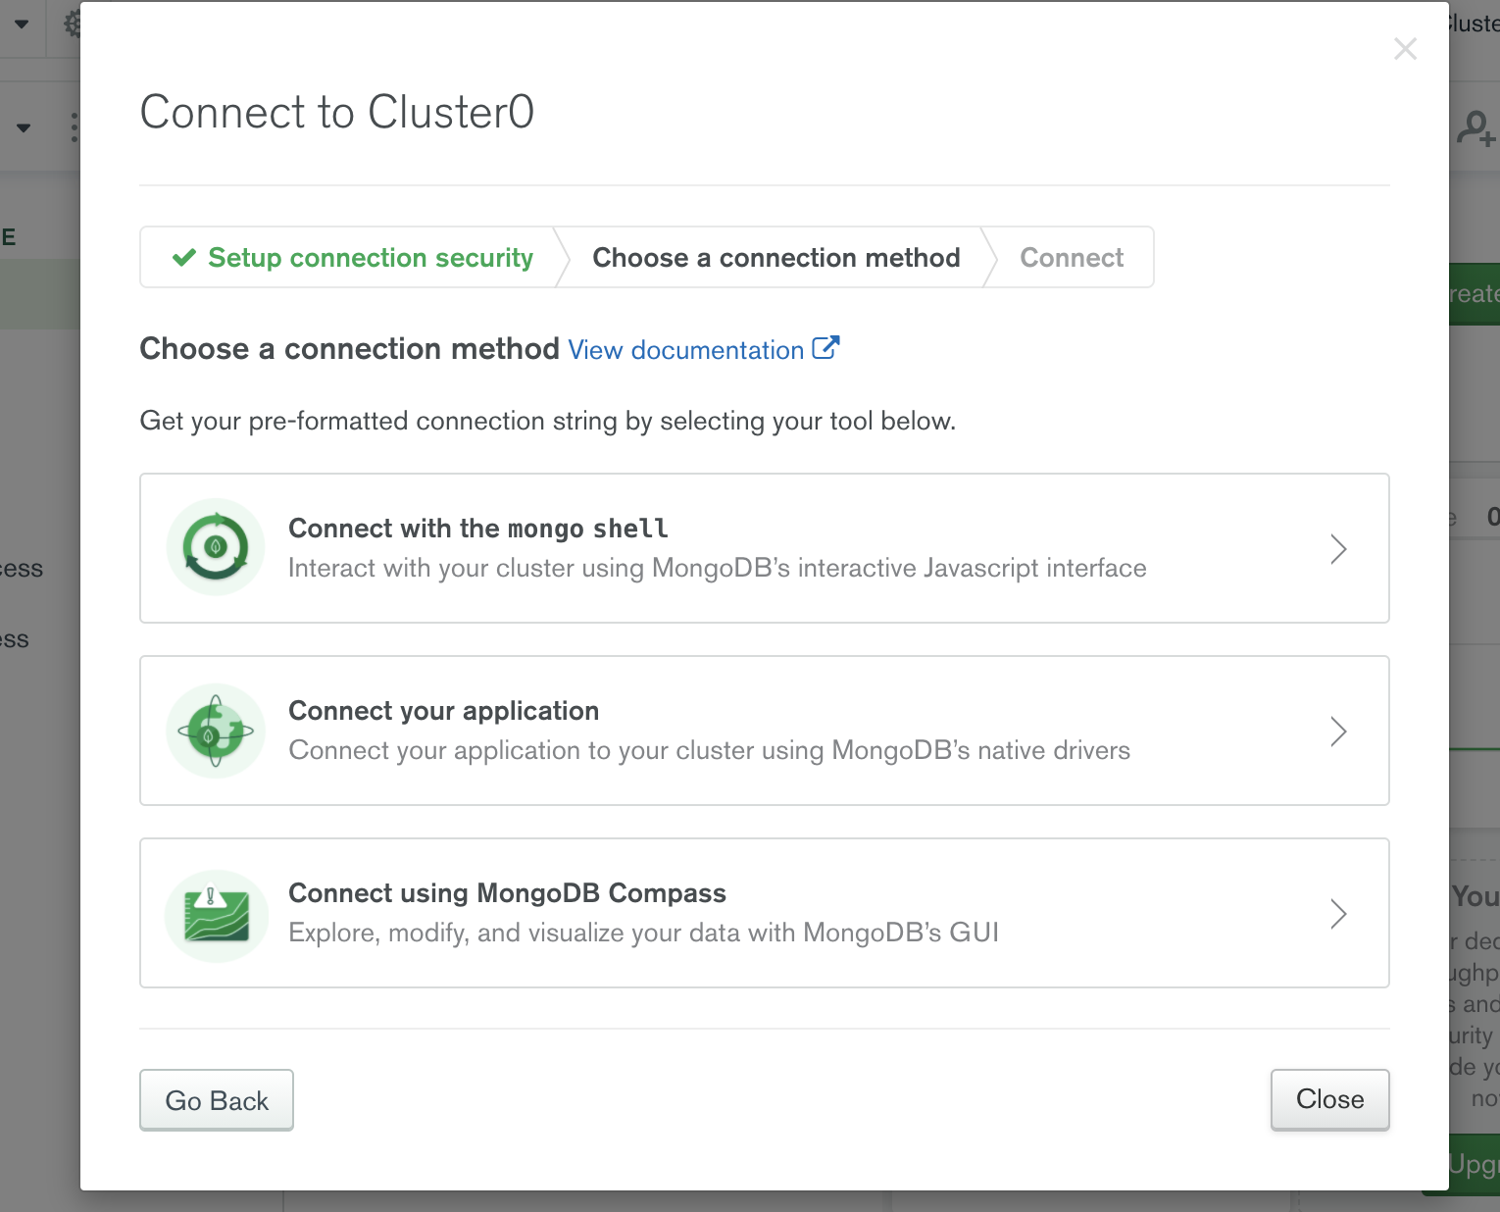
* **And then we can select like a. basically it's just going to give us a new URL.**
* **So if we copy this URL, I'm just going to come over here into my Express app.**
* **mongodb+srv://our-first-user:<password>@cluster0.muh8o.mongodb.net/<dbname>?retryWrites=true&w=majority**
* I'll just paste it for a moment so you can see what this looks like.
* It is your URL, mongodb + srv and then our-first-user.
* **And then it tells me it told me before I moved to this window, I need to actually put the password,** the real password in here.
* And then here's the rest of that.
* So basically, I need to connect to this new URL and fill in my password.
* So what I'm going to do is put this in my file for now.
* So here it is.

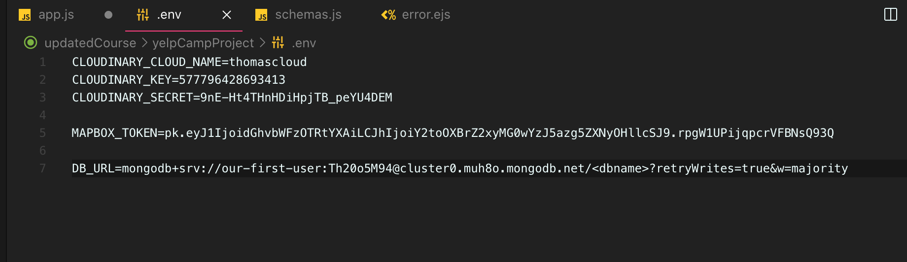

* I'm going to call it just DB_URL
* You are for now equals that and then I'm going to put the actual password in here and safe.
* Now, if everything went well, I should be able to access process.env.DB_URL and I'm going to do.

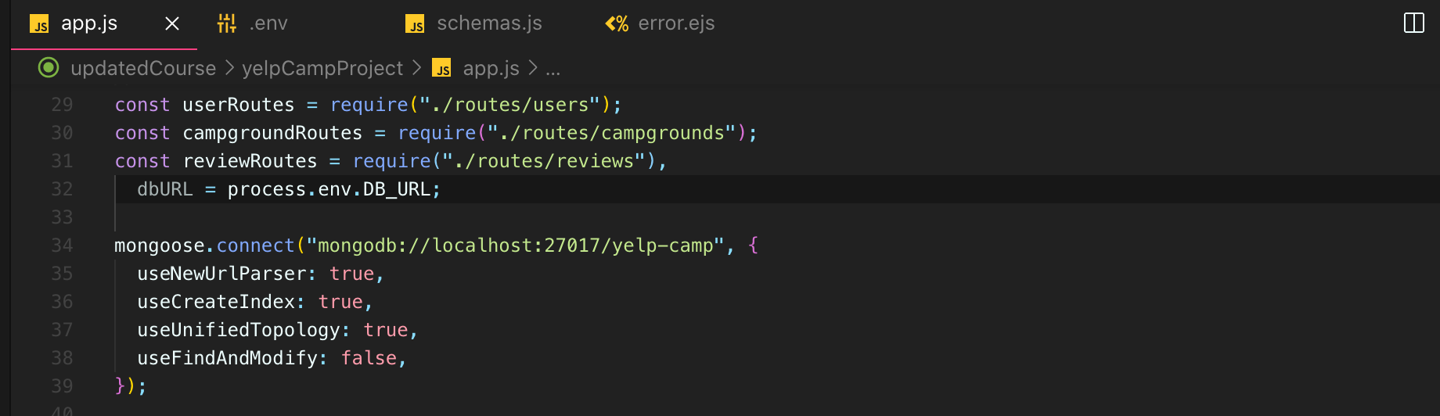

* **And once we get to deploying with Heroku and everything, we actually won't be putting these variables in a file.**
* **We will configure them in a different way.**
* But for now I just want to make sure that this works.
* So I'm going to cut this out.

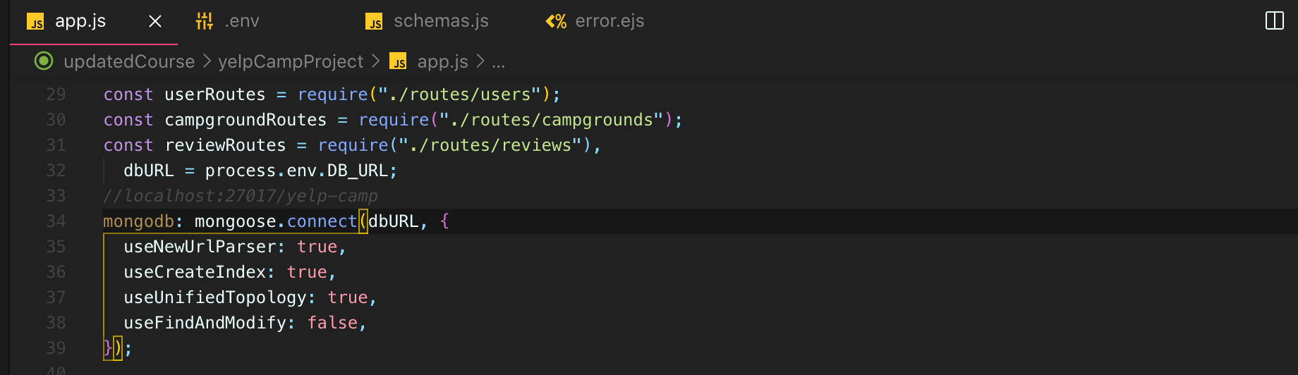

* I'll keep it as a, you know, comments so that if we screw up, we can come back to this new URL.
* But now I'm going to connect to DB_URL, which is just in a variable process.env.DB_URL feedback URL.
* It should be whatever you put in the file.
* And again, we want to do that so that we're not showing people that password.
* If anyone gets access to our code, if you put it on GitHub or something, Mongo doesn't put the password
* in there yourself.
* You still need to fill that password in with the correct password.
* OK, so let's see what happens now.
* If I try and connect in our terminal, it looks OK so far.
* Says Database Connected and we would be able to tell if it worked.
* If I refresh, we shouldn't really see any campgrounds and we don't.
* That's good news.
* I could try just making a new user really quickly.
* This one will be called.
* This is on a completely different database.
* I'm connected not locally, but to my Atlas database.
* And if I can take a look over here, I can click on collections right here.
* And it takes a moment, but I see users as a collection and I can actually view the information in there.
* So, you know, this is obviously important to keep secure and protected.
* But there are is working and this is an important first step for deploying to Hiroku or wherever we
* deploy to.
* But I don't always want to be using this database, certainly not in development mode.
* So what I'm going to do is to just comment that line out for now.
* Keep it there so that when we deploy, we have a record of it, but we're just going to stick with our
* local database for now.
* So I'll just paste that in again.
* All right, so now if I refresh, we should go back to having all of our campgrounds and we do.
* OK, so we have our Atlus database set up.
* We set up a user.
* We set up a password.
* We had to whitelist our IP address.
* By the way, if you got a connection error and it said something about having trouble connecting, it
* usually makes a suggestion like, did you whitelist your IP address?
* Go back and do that if needed.
* You'll know if it's needed and that's pretty much it.
* So that's our first step.
* We're not actually using that database anymore, but it is here so that we can use it going forward
* when we deploy.
* Next up, we're going to configure our session.

552. Using Mongo For Our Session Store

553. Heroku Setup

554. Pushing to Heroku

555. Fixing Heroku Errors

556. Configuring Heroku Env Variables